


National Planning Reform Blueprint
Northern Territory March 2024 progress report

© Northern Territory Government 2024
This publication is available for your use under a Creative Commons Attribution 3.0 Australia licence, with the exception of the Northern Territory Government, photographs, images, signatures and where otherwise stated. The full licence terms are available from http://creativecommons.org/licenses/by/3.0/au/legalcode.
Use of Northern Territory Government material under a Creative Commons Attribution 3.0 Australia licence requires you to attribute the work (but not in any way that suggests that Northern Territory Government endorses you or your use of the work).
Northern Territory government material used ‘as supplied’.
Provided you have not modified or transformed Northern Territory material in any way including, for example, by changing the Northern Territory text; calculating percentage changes; graphing or charting data; or deriving new statistics from published Northern Territory statistics — then Northern Territory prefers the following attribution:
Source: Northern Territory Government Department of Infrastructure, Planning and Logistics
Derivative material
If you have modified or transformed Northern Territory material, or derived new material from those of the Northern Territory Government in any way, then Northern Territory Government prefers the following attribution:
Based on Northern Territory Government Department of Infrastructure, Planning and Logistics data.
Other uses
Enquiries regarding this licence and any other use of this document are welcome at:
Department of Infrastructure, Planning and Logistics
GPO Box 1680
Darwin NT 0801

Contents
Contents ii
Measure 2: Strategic plans and housing supply targets 1
Measure 3: Zoning, planning, land release and other reforms 3
Summary of planning, zoning and land release reforms 3
Measure 4: Development ready land 6
Key findings from a development ready land stocktake 6
Measure 5: Promoting dense, diverse housing 9
Zoning planning and other amendments to support dense, well located housing 9
Reforms to non-planning barriers preventing a diversity of housing 10
Measure 6: Accelerated development and approval pathways 11
Reforms to development approval pathways 11
Existing development approvals which have not been acted upon, and barriers to delivering approved housing 11
Reforms to social and affordable housing approval pathways 11
Barriers to the timely issuing of development approvals, and reforms to address them 12
Initiatives to share planning data and improve visibility of factors affecting housing delivery 12
Planning and inclusionary zoning reforms to support permanent affordable, social and other specialist housing in developments 12
Measure 10: Government land 13
Well located government land suitable for housing 13
Best practice examples of developing government land 15
Case Study – Katherine East Urban Village Precinct 15

Measure 2
Planning Ministers will report to National Cabinet on state, regional and local strategic plans before 1 March 2024 that reflect their jurisdiction’s share of housing supply targets agreed by National Cabinet and links with infrastructure pipelines.
The Northern Territory Planning Commission sets the strategic framework for integrated land use, transport and infrastructure planning and consults with the community to develop strategic plans and policies for inclusion in the Northern Territory Planning Scheme.
The Territory has always had a plan for land release in place to ensure there is land supply available for entry and affordable housing products. Land use planning in the NT is done at a regional scale and is administered through a centralised (state level) planning system. Regional Land Use Plans establish an overarching regional framework to manage growth in the 4 major centres – Darwin, Katherine, Tennant Creek and Alice Springs. Each plan includes a Land Use Structure that identifies development opportunities throughout the relevant region, including a number of locations to accommodate various forms of residential development including urban, peri-urban and rural lifestyle and their associated potential dwelling yields. These plans were developed by the NT Planning Commission through a 3-stage consultation process with the public and relevant government and industry stakeholders (including local government and regional bodies).
Area plans, which give effect to regional targets, contain detail of the expected growth and potential capacity of new dwellings in each area. The number of additional dwelling/population numbers specified in the local plans are based on detailed infrastructure studies that accompany the development of these ‘local’ strategic plans. Regional and local plans in the NT have sufficient existing capacity to accommodate the agreed housing targets.
The Land Development Strategy is a recommendation of the Bringing Land to Market report, and details the forecasted pipeline of land supply in the Northern Territory’s major urban centres for residential housing over the next 20 years, based on potential dwelling yields identified in strategic land use plans.
The Land Development Strategy uses population projections from the NT Department of Treasury and Finance (and the ABS) and considers a low and high growth scenario based on potential economic development that forecasts higher growth, provided by the NT Department of the Chief Minister and Cabinet.
The Land Development Strategy’s forecast of land supply is aimed at providing for the sequencing of land development and in turn the timing for the delivery of district-level enabling infrastructure to support continued land supply. District-level infrastructure includes key structuring roads within districts, and power, water and sewer headworks which are identified and costed in a Land Development Program (the infrastructure program for land), generally recovered through the uplift in the value and sale of Crown land or through infrastructure contributions.
The district-level enabling infrastructure delivered by the Northern Territory Government enables land development and housing supply that could be undertaken by the private sector. In a number of remote towns, the Northern Territory Government also undertakes the land development role.

Measure 3
Planning Ministers will undertake planning, zoning, land release and other reforms, such as increasing density, to meet their jurisdiction share of housing supply targets agreed by National Cabinet.

Summary of planning, zoning and land release reforms

Bringing land to market report
In progress.
The NT has recently reformed the planning system to give effect to the ‘Bringing Land to Market Report’ which includes 23 recommendations to achieve a titled land supply that satisfies the market demand (including for affordable housing) in a timely and efficient manner.
The Bringing Land to Market Report was commissioned by the NT Government in 2021 to identify improvements to bring titled land to the market to keep pace with Territorian’s needs. Further information and a copy of the report can be found here: https://dipl.nt.gov.au/strategies/land-development-process-report-and-recommendations.
All 23 recommendations are currently being implemented, some of which include:
- finalising and adopting a Land Development Strategy that prioritises future Land Supply for the next 20 years;
- addressing land and infrastructure constraints through stand-alone infrastructure plans, inclusion of land constraint mitigation measures, and developing Infrastructure Contribution Guidelines to facilitate equitable cost sharing;
- policy consideration ensuring provision of titled land for affordable and social housing; and
- implementing options for fast track approvals processes.

Increased maximum floor area for second dwellings
Enacted 1 December 2023
On 1 December 2023 an amendment to the NT Planning Scheme took effect that increased the maximum floor area of independent living units (second dwellings) allowed on single dwelling lots (without any planning approval being necessary) from 50m2 to 75m2.
This change provides for the increased utilisation of infill land for social and affordable housing purposes.

New design responses for mixed use developments
Enacted 17 February 2023.
On 17 February 2023 an amendment to the NT Planning Scheme took effect, which amongst other changes, included incorporating design responses for mixed use development contained in strategic land use plans as development requirements within the scheme. For example, replacing set density requirements for apartments and mixed-use buildings with a significantly more flexible plot ratio.
Introduction of a residential plot ratio for medium-high density development will provide greater flexibility in design and assist with achieving greater density.

Extended exemption from approvals for remote subdivisions
Enacted 3 March 2023.
On 3 March 2023 a time limited exemption under the Planning Act 1999 was extended to June 2028, conditionally removing the need for subdivision approval for land development in remote communities as part of the $1.1 billion remote housing program, as long as these are supported by the community and Traditional Owners (through land tenure agreements).
This exemption provides for the fast-tracked release of land for social and affordable housing purposes.

Katherine Densification Policy – denser townhouses
Enacted 7 October 2022.
On 7 October 2022 an amendment to the NT Planning Scheme took effect, known as the Katherine Densification Policy. This facilitates townhouse development at a density of 1 dwelling per 400m2 (rather than 1 dwelling per 800m2 as is normally the case) for standard Low Density Residential (Zone LR) lots in Katherine East.
This change provides for the increased utilisation of infill land for social and affordable housing purposes.

Planning approval process improvements - reduced red tape
Enacted 31 July 2020.
On 31 July 2020, an amendment to the NT Planning Scheme took effect (associated with Government’s Planning Reform Initiative) which amongst other things, reduced regulatory burden and red tape associated with the planning approval process specifically for housing by:
- Introducing streamlined tracks of assessment for all ‘housing’ development applications (as well as a number of other types of developments). These applications now have the option of being assessed against only the basic ‘tick box’ planning requirements (such as height, setback, car parking etc.) and not whether or not they are appropriate in the location.
- Removing the need for a planning application for fully compliant duplex developments.
- Creating a much more flexible outcomes based system which emphasises the importance of strategic ‘placed based’ planning. This includes identifying higher density infill development opportunities to streamline rezoning approvals.
The amendments provide expedited pathways for the delivery of housing, as well as for the achievement of increased housing densities in appropriate locations (above those normally allowed for within the existing zone).

Measure 4
Planning Ministers will identify well-located ‘development ready’ land before 1 March 2024, having appropriate regard to the protection of land with key attributes e.g. environmental or economic.

Key findings from a development ready land stocktake
Urban land supply
The Northern Territory’s Land Development Strategy (LDS) that is currently being prepared identifies development ready land as ‘Land Under Development’ which is land that is in the hands of developers, with reticulated infrastructure service connections to be provided through the subdivision development process to produce titled land to market in Greater Darwin, Alice Springs, Katherine and Tennant Creek.
The below table identifies:
- estimated number of lots and dwellings within Land Under Development for new development areas;
- infill opportunities identified in Area Plans that have current development approvals in place;
- vacant undeveloped lots within existing developed urban centres with infrastructure capacity; and
- an estimated supply timeframe based on each urban centre’s 10-year average dwelling take-up rate.
Table 1 – Estimated dwellings in infill and land under development
Region | Estimated Dwellings, including Attached |  | Estimated Years of Supply
Region | Land Under Development | Infill opportunities and vacant land | Estimated Years of Supply
Greater Darwin | 4451 | 1931 | 10 years
Katherine | 102 | 128 | 9 years
Tennant Creek | 34 | 97 | 16 years
Alice Springs | 97 | 66 | 4 years
Total | 4684 | 2222
Social and affordable housing
Across the NT’s 4 major centres (Greater Darwin, Alice Springs, Katherine and Tennant Creek) the NT Government has identified land holdings that will be utilised to deliver up to 100 new social housing dwellings under the Social Housing Accelerator.
The NT Government is also in planning for the delivery of approximately 460 social and affordable dwellings committed under the HAFF. Including Shiers Street, six Government owned sites (both greenfield and brownfield) have been identified for development as part of the first phase of delivery, with work also underway to identify and assess for suitability further sites for potential development as part of a second phase of delivery over the forthcoming five years to June 2029. Options to deliver the first six sites are currently under consideration by the Northern Territory Government and any decisions to undertake development will be made publicly available in the second quarter of 2024.
An estimated future potential allocation of social and affordable lots has been identified from Crown land greenfield developments. Estimated numbers are based on the Department of Infrastructure, Planning and Logistics’ policy targets for land for social, community and affordable housing within Crown land greenfield developments and are included in the below table.
Table 2: Potential new social housing lots in the next 5 year
 | Potential lots within the next 5 years,  5% Social | Potential lots within the next 5 years,  10% Affordable
Land Under Development
Greater Darwin | 16 | 78
Future supply-Current Commitment with full funding
Greater Darwin | 30 | 60
Katherine | 7 | 15
Tennant Creek | 3 | 5
Alice Springs | 3 | 5
Future Supply-Partially funded, future funding required
Greater Darwin | 15 | 30
Grand Total | 74 | 193

When undertaking redevelopment of existing social and affordable housing sites, the NT Government aims to deliver a minimum one-for-one return of dwellings wherever possible, based on the principle of no-net-reduction in social and affordable housing stock. Where possible, brownfield developments also aim to increase and/or optimise dwelling yield within the parameters allowed under the NT Planning Scheme.

Remote housing
The delivery of housing through the remote community subdivision program aims to deliver 853 lots across 20 communities. As at 30 November 2023, 309 lots have been completed, 174 lots are under construction, and 370 lots are in the planning phase. Of the 174 lots currently under construction, 77 lots are anticipated to be finalised in January 2024 (subject to inclement weather). These lots are located in Wadeye (30 lots), Ngukurr (20 lots) and Galiwinku (27 lots).
Work is currently underway to determine future land release requirements to support up to an additional 2700 new remote public housing dwellings across 70 plus remote communities and selected town camps to be built over the next 10 years.

Measure 5
Planning Ministers will streamline approval pathways and prioritise planning control amendments to support diverse housing across a range of areas, including promoting medium and high-density housing in well-located areas close to existing public transport infrastructure connections, amenities and employment.

Zoning planning and other amendments to support dense, well located housing
Also see Measure 3.

Holtze development – new strategic land use plan

A new strategic land use plan (which is a new policy) for the Holtze residential development area (located centrally within the Greater Darwin Region), has been publicly exhibited and will be considered by the Minister for Infrastructure, Planning and Logistics for inclusion in the NT Planning Scheme. This is a planning policy that was completed by the NT Planning Commission in late 2023, and has been through a three stage public consultation process.

This land use plan has been developed based on the Compact Urban Growth Policy, which is included within the NT Planning Scheme and promotes high and medium density housing in a well located area, close to existing public transport, infrastructure connections, amenities and employment.
Greater Holtze will be the location of a large proportion of the new housing stock to be provided in the NT over the next 5 years. The development is expected to yield a minimum of 530 dwellings at the end of 2025.

Social housing requirements for greenfield land
The NT Government incorporates provisions akin to inclusionary zoning for affordable and social housing within many greenfield land releases in urban areas of the NT, through development agreements between the NT Government and private developers.
The NT Government is able to influence the proportion of new development that must be allocated for social and affordable housing.

Specific use zones
The use of Specific Use Zones within the Northern Territory Planning Scheme continues to enable flexibility to provide a range of lot sizes within new land developments.
Ability to provide smaller lots for purchasers at the lower end of the affordability spectrum.

Reforms to non-planning barriers preventing a diversity of housing
Lack of scale (i.e. population) in the NT strongly impacts the commercial viability of higher construction cost, large scale single buildings or integrated developments generally.

Measure 6
Planning Ministers will create accelerated development pathways and streamline approval processes for eligible development types, particularly in well-located areas, including to support the rapid delivery of social and affordable housing.

Reforms to development approval pathways
Relevant measures already identified in Measure 3, noting that the NT Planning Scheme 2020 applies Territory-wide, and the NT Government has sole responsibility for the administration of planning in the NT. Therefore, there is no disconnect between local government and Territory level strategic and statutory planning policy.

Existing development approvals which have not been acted upon, and barriers to delivering approved housing
The NT currently tracks all approved development applications for multi-storey unit complexes and reports on a monthly basis on land under development including tracking of all lots with approved subdivision/development permits (for detached dwellings and townhouses) throughout the Northern Territory. Compliant single detached houses, granny flats, and duplexes do not require planning consent in the NT.

Reforms to social and affordable housing approval pathways
The NT Government recognises the need to ensure the ongoing supply of new land within greenfield urban Crown land releases to support the delivery of social, community and affordable housing in the NT. In August 2023, Government introduced the Land for Social, Community and Affordable Housing Policy which specifies the provision of a minimum of 5% social and community housing, and 10% affordable housing within commercially viable greenfield releases of Crown land. It is noted that the development of Crown land is the predominant means of land release in the NT, and this Policy therefore provides an effective means of implementing inclusionary zoning. The policy does not add to the cost of construction as the cost of setting aside land for social and affordable housing purposes is able to be achieved in a cost effective manner through Crown Land Development Agreements with private developers.

Barriers to the timely issuing of development approvals, and reforms to address them

Key barriers that have a significant impact on the delivery of new social and affordable housing supply include negative (not-in-my-back-yard) community sentiment, seasonal weather patterns (delivery delays), constrained construction industry capacity and skilled labour shortages, and high construction costs relative to land and property values.

Initiatives to share planning data and improve visibility of factors affecting housing delivery
NT is supportive of sharing any relevant data.

Planning and inclusionary zoning reforms to support permanent affordable, social and other specialist housing in developments
Response to inclusionary zoning identified in Measure 5.

Measure 10
All levels of government will ensure the efficient use of government land, including the identification of surplus land suitable for housing and the delivery of best practice projects to support housing supply, diversity and affordability.

Well located government land suitable for housing
The Northern Territory is unique in that the majority of its new greenfield developments are on vacant Crown land, particularly in the regional urban centres.
The table below outlines the anticipated dwellings expected from Crown land greenfield developments, categorised within the 4 stages of development and in accordance with the Land Development Strategy as follows:
- Land Under Development (LUD): land that is in the hands of the developers, with reticulated infrastructure service connections to be provided through the subdivision development process to produce titled land to market. This land is identified in measure 4 whereas the Land Under Development below is solely Government owned land.
- Land for Enabling infrastructure (LEI): is land that has design and construction of enabling infrastructure underway.
- Land Under Investigations (LUI): Land that requires consideration of environmental, geotechnical works and land tenure.
- Land Use Planning (LUP): is land that is undergoing or has underdone strategic integrated land use and infrastructure planning including subregional land use planning and area planning.
Projected years of supply is also included based on population projections from the Northern Territory’s Department of Treasury and Finance (and ABS data).
The table below identifies ample supply of government-owned land to support the next 20 years of growth and beyond.

Table 3: Supply of Government owned land in the Northern Territory
 | Land Under Development | Land for Enabling Infrastructure | Land Under Investigations | Land Use Planning | Total estimated lot and dwelling supply across region | Years of supply*
Greater Darwin
Detached (lots) | 2,276 | 900 | 0 | 4,400 | 7,576
Attached (dwellings) | 606 | 90 | 0 | 440 | 1136
Total Dwellings | 2,882 | 990 | 0 | 4,840 | 8712 | 10 years
Katherine
Detached (lots) | 83 | 383 | 0 | 200 | 666
Attached (dwellings) | 19 | 165 | 0 | 0 | 184
Total Dwellings | 102 | 548 | 0 | 200 | 850 | 31 years
Tennant Creek
Detached (lots) | 6 | 0 | 100 | 150 | 256
Attached (dwellings) | 28 | 0 | 0 | 0 | 28
Total Dwellings | 34 | 0 | 100 | 150 | 284 | 36 years
Alice Springs
Detached (lots) | 67 | 362 | 200 | 630 | 1259
Attached (dwellings) | 30 | 0 | 0 | 163 | 193
Total Dwellings | 97 | 362 | 200 | 793 | 1452 | 34 years
* Based on average take up with population projections
Note: the numbers are estimates and are subject to change.
The NT Government has also identified land suitable for immediate development to support the delivery of up to 100 new dwellings under the Social Housing Accelerator (SHA). New supply to be constructed as part of the SHA, including expected distribution across different locations is outlined in the NT SHA Implementation Plan: https://treasury.gov.au/housing-policy/shap
In September 2023, the NT Government released an Expression of Interest for the redevelopment of a medium density brownfield public housing site in Darwin’s inner suburbs (Shiers Street, The Narrows). The site is approximately 14,400 square meters and has a potential yield of up to approximately 170 dwellings. The site previously had 76 public housing dwellings on it (constructed in the 1970s) and was significantly underutilised. The intent of this redevelopment initiative is to deliver a new mixed tenure Build-to-Rent development, incorporating social, affordable and market rental housing, in addition to (potentially) owner-occupied affordable and market housing. The future redevelopment of the Shiers Street complex meets a commitment to grow the Community Housing Sector in the NT and will be a community housing provider-led project. The project is being structured to leverage funding through the Housing Australia Future Fund (HAFF) and is expected to require co-investment from private financiers and the NT Government.
- https://tfhc.nt.gov.au/housing-and-homelessness/housing-initiatives-and-strategies/shiers-street-redevelopment
- https://dipl.nt.gov.au/projects/shiers-street-housing-redevelopment
Attached is a best practice example of the development of Crown land in Katherine to achieve broader whole of government priorities. The concept plan identifies the delivery approach and vision for the precinct which includes affordable and social housing, commercial land and community land for supporting services. Enabling district-level infrastructure such as key structuring streets and power, water and sewer headworks is delivered by the Northern Territory Government to facilitate future land releases through transparent market processes and to enable private sector land development.

Best practice examples of developing government land

Case Study – Katherine East Urban Village Precinct
This development is a best practice example of the development of Crown land in Katherine to achieve broader whole of government priorities. The concept plan identifies the delivery approach and vision for the precinct which includes affordable and social housing, commercial land and community land for supporting services. Enabling district-level infrastructure such as key structuring streets and power, water and sewer headworks is delivered by the Northern Territory Government to facilitate future land releases through transparent market processes and to enable private sector land development.
The Vision - Local shopping and urban opportunities
A new neighbourhood centre is planned to support the existing and emerging Katherine East community as part of a Katherine East Urban Village Precinct.
The Precinct
Will incorporate a range of uses that are framed and focussed around a central park and linear open space link. The intent is to foster a range of urban living opportunities, including mixed use apartment living.
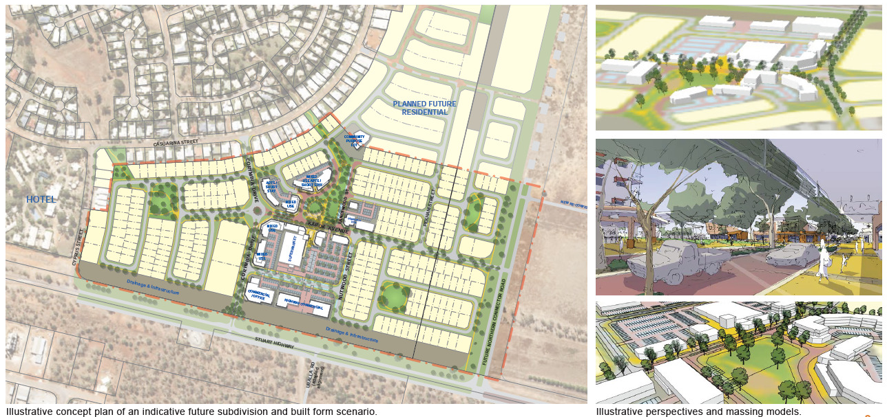
Delivery approach and construction progress – enabling infrastructure, key roads and superlots
Key structuring streets and enabling headworks infrastructure are being constructed. These works have been partially funded via a commonwealth agreement.
A range of lots and englobo lots will be made available to the market for development in sequence with the residential development front coming down from the north.
An Expressions of Interest process has been run for a commercial superlot. Responses were low. It is anticipated that greater interest will result from smaller sites and that the village can evolve in a more natural fashion.
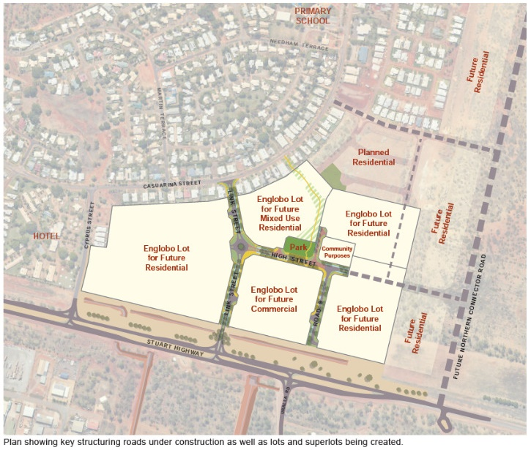
There is potential for the broader Katherine East area to deliver a further 600 dwellings, which accounts for approximately 40 years supply at current baseline take-up rates. It is anticipated that the provision of key strategic urban amenity elements will help foster the delivery of these dwellings in a greater variety of forms.
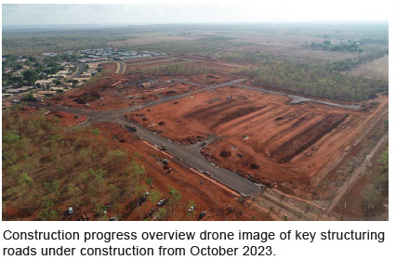

For the purpose of this report it is assumed that development ready means land with infrastructure that is ready to sell and/ or construct
Where appropriate and where such zoning and planning does not add to construction costs e.g., through the use of incentives such as density bonuses

