
Review of the Reconnect program – Final Report
Department of Social Services
28 June 2024


Nous Group acknowledges Aboriginal and Torres Strait Islander peoples as the First Australians and the Traditional Custodians of country throughout Australia. We pay our respect to Elders past, present and emerging, who maintain their culture, country and spiritual connection to the land, sea and community.
This artwork was developed by Marcus Lee Design to reflect Nous Group’s Reconciliation Action Plan and our aspirations for respectful and productive engagement with Aboriginal and Torres Strait Islander peoples and communities.
Disclaimer:
Nous Group (Nous) has prepared this report for the benefit of the Department of Social Services (the Client).
The report should not be used or relied upon for any purpose other than as an expression of the conclusions and recommendations of Nous to the Client as to the matters within the scope of the report. Nous and its officers and employees expressly disclaim any liability to any person other than the Client who relies or purports to rely on the report for any other purpose.
Nous has prepared the report with care and diligence. The conclusions and recommendations given by Nous in the report are given in good faith and in the reasonable belief that they are correct and not misleading. The report has been prepared by Nous based on information provided by the Client and by other persons. Nous has relied on that information and has not independently verified or audited that information.
© Nous Group

Contents
Executive summary 6
1 Introduction 14
2 Overview of the Reconnect program 18
3 Review findings: Appropriateness of the Reconnect program 20
4 Review findings: Efficiency of the Reconnect program 31
5 Review findings: Effectiveness of the Reconnect program 39
6 The future of Reconnect 53
Appendix A Review approach 61
Appendix B Program Logic 70
Appendix C Literature review: Youth homelessness in Australia 71
Appendix D National, state and territory government youth homelessness strategies 75
Appendix E State and territory government service mapping 77
Appendix F Endnotes 83

Glossary
Acronyms and abbreviations | Definition
AIATSIS | The Australian Institute of Aboriginal and Torres Strait Islander Studies (AIATSIS) is an independent Commonwealth Government statutory authority devoted to Aboriginal and Torres Strait Islander studies. The institute is a leader in ethical research and the handling of culturally sensitive material.
AOD | Alcohol and Other Drugs
AWP | The AWP outlines activities and deliverables grant recipients will complete over a period of time to meet obligations in their Reconnect grant agreements. The AWP Report details an organisation’s progress against activities and deliverables in the agreed AWP. The AWP Report also informs and facilitates conversations about service delivery between an organisation and their Funding Arrangement Manager, which is useful to inform future AWPs.
AWP report | The AWP reports from Reconnect Service Providers are referred to collectively as the ‘AWPs’. The AWPs consist of 388 reports over the past five years that have been provided by the Department of Social Services to Nous Group as part of this Review of the Reconnect program.
Bellberry | Bellberry Limited, the Human Research Ethics Committee through which ethics approval was sought for this Review.
CALD | The term 'culturally and linguistically diverse' (CALD), refers to people from a range of countries and ethnic and cultural groups. It includes people of non–English speaking background as well as people born outside Australia but whose first language is English, and encompasses a wide range of experiences and needs. CALD is identified as a priority group for the Reconnect program.
COSS Model | The ‘Community of Schools and Services’ (COSS) Model is an early intervention service-delivery and reform-orientated model focusing on community collaboration, early identification, early intervention support with families, and robust, embedded longitudinal monitoring and measurement of outcomes.
COVID-19 | Coronavirus Disease 2019
CPI | Consumer Price Index
DEX | Data Exchange
DSS | Australian Government Department of Social Services
EAG | Expert Advisory Group
FAM | Funding Arrangement Manager
GP | General Practitioner
HREC | Human Research Ethics Committee
KLE | Key Line of Enquiry
LGBTIQA+ | Lesbian, Gay, Bisexual, Transgender, Intersex, Queer/Questioning, Asexual, +
NAYS | Newly Arrived Youth Specialists
NDIS | National Disability Insurance Scheme
NGO | Non-governmental organisation
NHHA | National Housing and Homelessness Agreement
Protective factors | A protective factor is a characteristic that is associated with reductions in the negative impact or likelihood of a problem outcome. For young people at risk of homelessness, a protective factor may include: relationships with family, engagement with education and employment, and awareness of available support services.
Reconnect Service Provider; Provider | Organisations funded to deliver services through the Reconnect program.
Reconnect; Reconnect program; the Program | The Reconnect program, an early intervention and prevention youth homelessness program funded by the Australian Government. Reconnect is a place-based program that is delivered through 70 organisations across 101 activities across Australia.
Reconnect activities | ‘Reconnect activities’ are the 101 funded activities across Australia.  Sometimes these are also referred to as services.
Reconnect outlets | Reconnect activities are sometimes delivered across multiple outlets (i.e. the same funded activity across multiple locations). ‘Reconnect outlets’ refer to Reconnect’s 191 separate service delivery locations.  Sometimes these are also referred to as sites, for example when referring to a Reconnect site visit.
Review | Review of the Reconnect program
SCORE | Standard Client/Community Outcomes Reporting (SCORE), which allows organisations funded by DSS to measure client and community outcomes using their own self-selected tools and methods, and to report these outcomes in a way that is consistent and comparable.  SCORE outcomes are recorded on a scale of 1-5, with the number showing the mean change across the cohort between an individual’s first recorded SCORE (on entry) and their last (on exit). SCORE is generally recorded towards the beginning and end of a funded activity to best assess change pre and post service delivery. If the service provided is longer term, then an interim assessment should also be recorded.  For descriptions of specific DEX SCORE outcome domains, please see Section 7 of The Data Exchange Protocols: https://dex.dss.gov.au/data-exchange-protocols.
SHS | Specialist Homelessness Services
Specialist Cohorts | Cohorts of the children and young people population considered to be a priority group. Specialist cohorts include children and young people who identify as CALD, Newly Arrived Youth, First Nations, LGBTQIA+ and/or with disability.

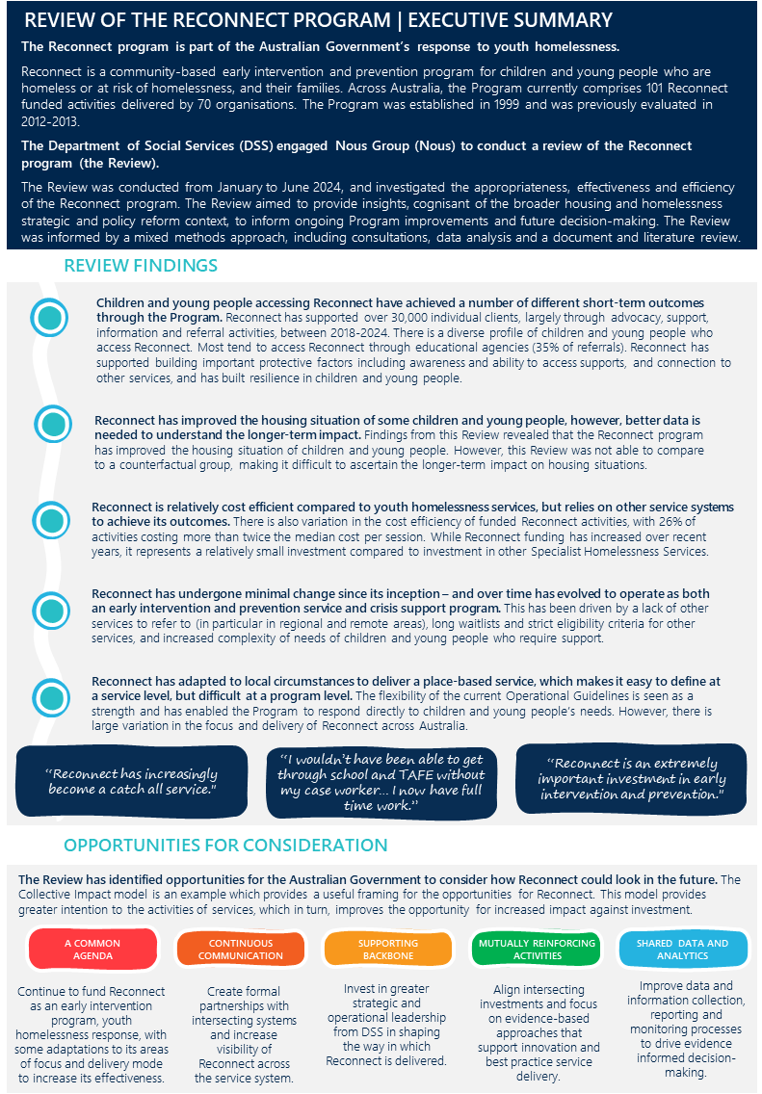


Executive summary

In 2021, there were more than 45,000 children and young people in Australia experiencing homelessness. This figure has increased in recent years, and people aged 0 to 24 years old now make up just over a third (37%) of the total number of people experiencing homelessness. Not only are the numbers increasing, but Specialist Homelessness Services (SHS) data suggests that these young people are presenting to support services with multiple and complex needs – often citing housing crisis, family and domestic violence, and/or a relationship or family breakdown as the reason they seek support.
One of the levers that the Australian Government has to reduce youth homelessness is the Reconnect program. It is an early intervention and prevention service designed to reduce the risk of 12 to 18-year-olds (or 12 to 21-year-olds for newly arrived youth) from entering or escalating further into homelessness. This Program was established in December 1999, and largely delivers individual case management, group work, mediation and referrals to other support services. It does not provide housing, instead it works with the children, young people, their families and support people to keep a young person in their home when it is safe to do so. Reconnect builds on the evidence that building children and young people’s protective factors (e.g. relationships with family, engagement in education) can minimise occurrence or reoccurrence of homelessness.
The Australian Government has not reviewed its investments in Reconnect since 2013, and in that time, the children, youth and homelessness landscapes have changed significantly., In particular, the Australian Government has renewed its investment in social and affordable housing through a renegotiated National Housing and Homelessness Agreement with state and territory governments, and housing supply delivered through Housing Australia as part of the Housing Accord and Housing Australia Future Fund. At the same time the Department of Social Services (DSS) is leading the development of the National Housing and Homelessness Plan and overseeing the implementation of other key national plans in adjacent policy areas, including early years, disability, child protection, and domestic and family violence. The findings of this Review and its implications for these strategic reforms will be important.
Nous Group (Nous) understands that the current service agreements for Reconnect Service Providers are due for renewal in 2026. It is in this context that DSS engaged Nous to review the Reconnect program (the Review) to answer four questions:
- Are the Reconnect program’s desired outcomes appropriate for community needs, policy priorities and operating context?
- To what extent is the Reconnect program achieving its desired outcomes? For whom?
- Does the Reconnect program represent value-for-money for the Australian Government?
- What are some of the ongoing or emerging findings that could support the short-term adjustment of the Reconnect program?
To answer these questions Nous used a mixed methods approach that drew on primary and secondary data sources, including focus groups with over 170 Reconnect clients, support people and staff; 234 client survey responses, 138 Provider survey responses, 29 sector survey responses, 8 state and territory government survey responses; up to 14,111 DEX SCORE data entries; and 388 Activity Work Plans (AWPs).
DSS engaged Nous to do a whole-of-Program Review, and therefore deliberately does not compare the performance of individual Providers. Likewise, due to limitations in the data available for this Review, it does not use an experimental design to determine the attribution of outcomes. Below we summarise the findings and opportunities for the Australian Government’s consideration.

REVIEW FINDINGS
Children and young people accessing Reconnect have achieved a number of different short-term outcomes through the Program.
Historically, early intervention and prevention has been important in reducing the incidence of youth homelessness, with early intervention (including the Reconnect program) appearing to account for most of the decrease in youth homelessness from 2001 to 2006 in Australia. This builds on the evidence that early intervention and prevention initiatives can minimise the severity and reoccurrence of youth homelessness, and reduce a young person’s need for long-term social system support through building important protective factors.,
Reconnect has supported over 30,000 individual clients through 470,501 sessions between 1 July 2018 to 31 December 2023. The Review found that the Reconnect program is still effective and has supported children and young people achieve different short-term outcomes. The data outlines that the Reconnect program has improved Reconnect clients’:
- Understanding of how to access supports and services if needed
- Relationships with family or relevant support person
- Engagement with education and training, employment, and the community
- Resilience and emotional self-regulation
- Housing situation.
Figure 1 illustrates the design of the Program and the range of outcomes that have been improved through children and young people accessing Reconnect.
Figure 1 | Snapshot of Reconnect client outcomes
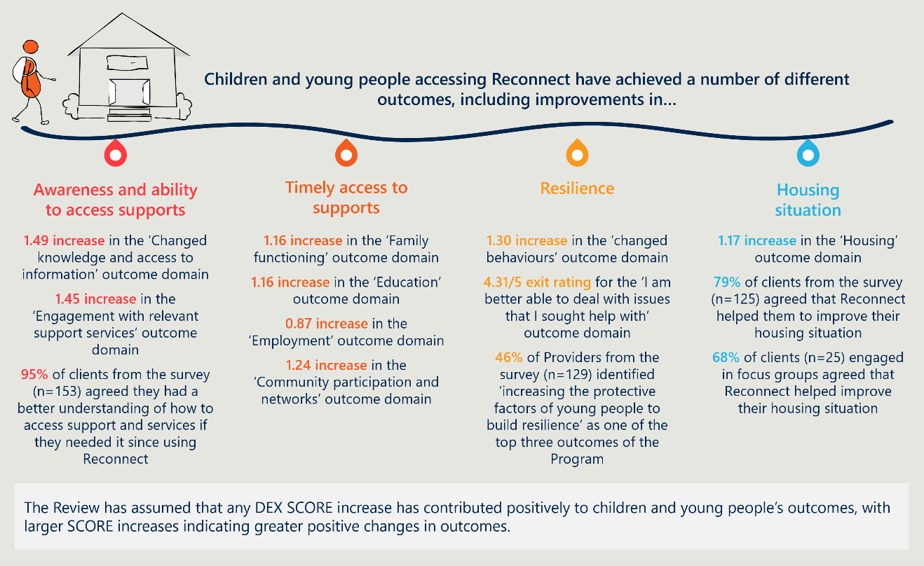
Interviews and surveys suggested that the place-based approach to delivering Reconnect is key to achieving these outcomes. It gives the Program the flexibility to deliver highly specialised support (e.g. working with children of mothers that are in prison), as well as build effective place-based service networks that can meet their specific needs (e.g. local mental health services, or housing providers).
Interviews, surveys and AWPs further suggested that Reconnect is highly dependent on the schooling system for referrals into its service. AWPs indicated that 100% percent of Reconnect Service Providers work with schools in their area and the DEX data shows that educational agencies make up 35% of all inbound referrals. However, arrangements with schools are not systematised and are usually driven by individuals’ relationships. This can act as a barrier for earlier identification and referral when it does not work well.
Providers also commented that there are some limitations in the current Operational Guidelines, such as a minimum age of 12, the three-month service duration and the location restrictions. Most Reconnect Service Providers wanted greater flexibility to work around this, with some already doing so (for example, 46% of Reconnect clients appear to access the service for longer than 3 months).

Reconnect has improved the housing situation of some children and young people, however, better data is needed to understand the longer-term impact.
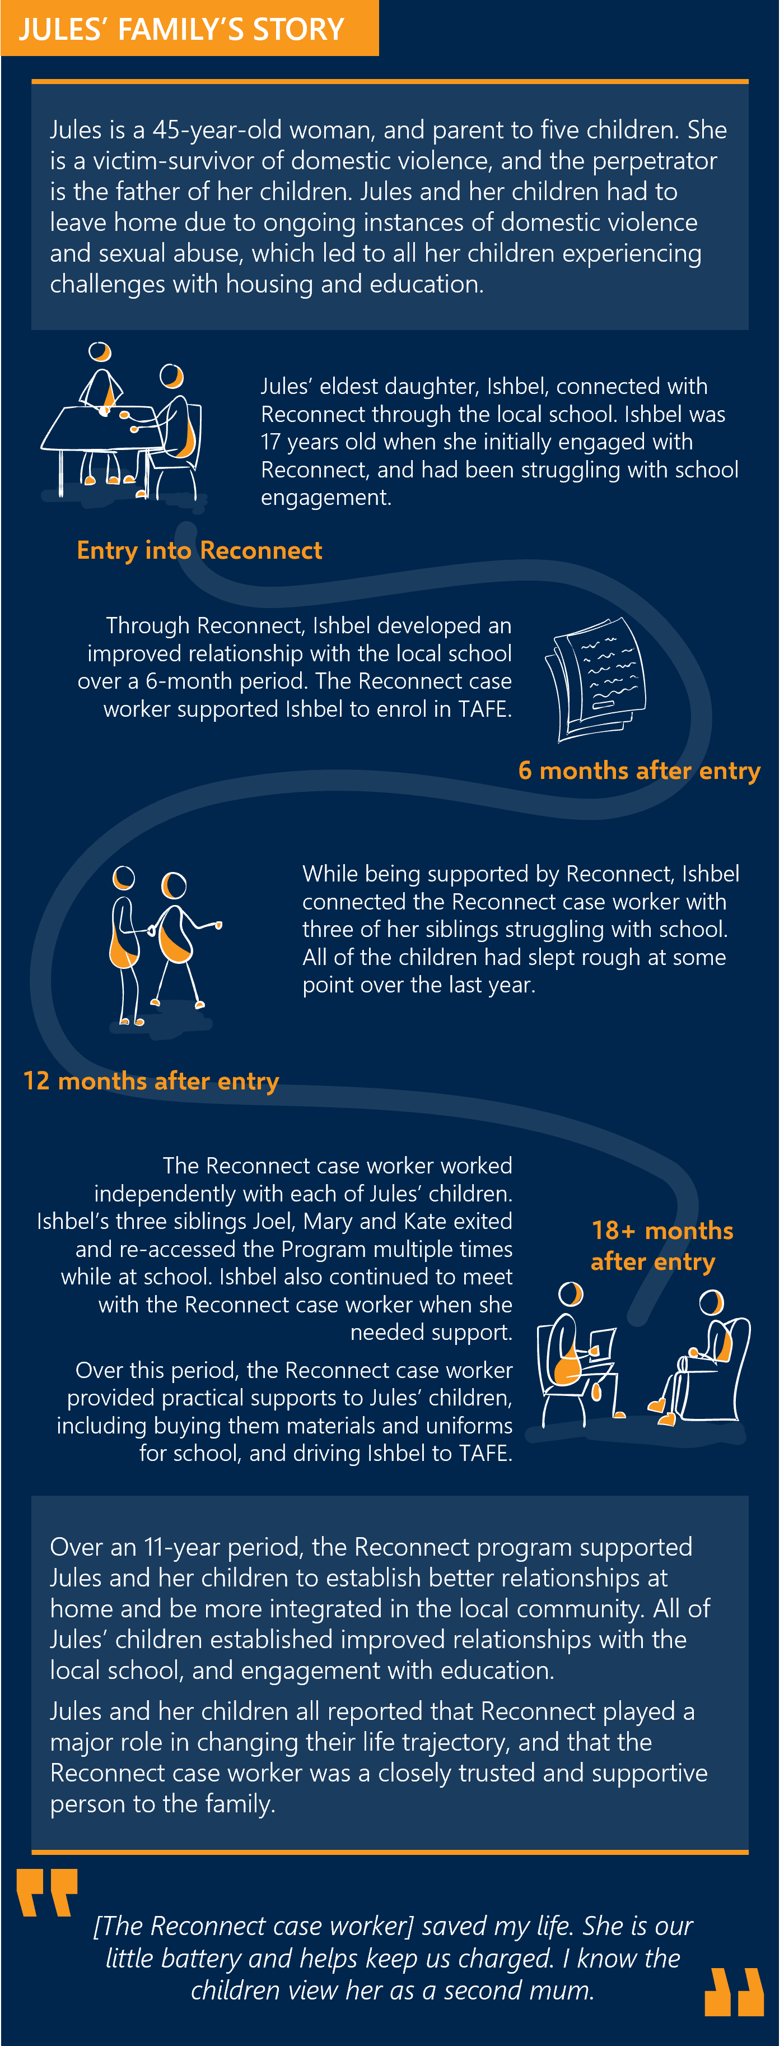
DEX data and Provider survey responses outlined that the Reconnect program has improved the housing situation of children and young people. DEX data showed a mean increase of 1.17 (out of 4) in the housing situation of a young person between their first engagement with Reconnect, and their last. Furthermore, 85% of Providers that responded to the survey reported that the Program is effective at reducing the number of young people entering into homelessness.
However, only 4% of Providers reported that they connected a young person with safe, secure and stable housing. This may be driven by several factors, including the limited availability of safe and secure housing for children and young people, and the fact that Reconnect works with the young person and their family to improve their home situation and potentially keep the individual at home where it is practicable and safe to do so.
The case study to the right details anecdotal long-term outcomes achieved by the Reconnect program (names and information have been adjusted to ensure client anonymity).

Reconnect is relatively cost efficient compared to youth homelessness services, but relies on other service systems to achieve its outcomes.
Reconnect is relatively cost-efficient for DSS, costing $2,175 per individual. When compared to other youth focussed early intervention and prevention programs, this suggests it is relatively cost efficient. Below we summarise some of these programs and their cost per individual (see Section 4 for more detail):
- Functional Family Therapy – Child Welfare (FFT-CW) - $16,828 (not including establishment costs)
- Homeless Youth Assistance Program - $21,127
- Multi-Systemic Therapy (MST) - $30,581 (not including establishment costs)
- Youth Foyers -$39,971.
If DSS is able to improve the way it collects longitudinal data on the housing status of people that have accessed Reconnect, it should then consider further cost effectiveness or cost benefit analysis to compare programs over time.

There is variation in the cost efficiency of Reconnect Service Providers, with 26% of funded Reconnect activities costing more than twice the median cost per session.
The median cost of delivering Reconnect is $429 per session. Most Reconnect activities are clustered around this figure. However, 26% of Reconnect activities are delivering a service that is more than twice the cost per session than the median. This suggests that there is an opportunity to work with Providers to understand why this variation is occurring and to make service delivery more cost efficient.

While Reconnect funding has increased over recent years, it represents a relatively small investment compared to investment in other SHS services.
The Australian Government funded Reconnect at $29.1m in FY23, which is a relatively small investment compared to other homelessness services (for example, it is 2% of the $1.4 billion invested in SHS each year). For Reconnect, the average funding per Reconnect Service Provider has increased over time from 2018/19 to 2022/23 due to the Australian Government’s indexation and supplementation payments. The annual rate of increased funding over this period is larger than the increase in annual inflation, with the largest relative annual increases in funding from 2020/21 to 2021/22 (15.9%), and 2021/22 to 2022/23 (9.2%). It is also worth noting that the average number of sessions per Reconnect activity decreased from 847 to 748 between 2021/22 to 2022/23,meaning Providers were getting more funding for less sessions than the year before. Despite this, Providers commented that their funding increase is less than the increases they are experiencing in the cost-of-service delivery – which is impacting on their ability to meet demand.

Reconnect has adapted to local circumstances to deliver a place-based service, which makes it easy to define at a service level, but difficult at a program level.
Reconnect Service Providers operate in very different circumstances – including responding to different children and young people with varying needs based on their geographical area, level of socioeconomic disadvantage, organisational maturity and scale. Reconnect’s current Operational Guidelines (described in more detail in section 2.1), are recognised as a key strength of the Program and have supported the delivery of many different activities through the Reconnect program.
This has allowed Providers to adapt over time to their local circumstances described above, and create a unique role for themselves in that network. Many stakeholders think the flexibility is a strength as it enables the Program to respond to the child and young person’s needs. However, this shift has meant there is large variation in the way Reconnect is delivered to support children and young people and their families across Australia. This has made it difficult for stakeholders, including Reconnect Service Providers, to understand the scope of Reconnect and its impact at a program level.
Reconnect Service Providers also commented they would like more operational and strategic guidance from DSS and their Funding Arrangement Managers (FAMs) to support them to deliver the Reconnect program.
Consultations suggest that Providers place different emphases on key program characteristics, including:
- doing more crisis response (this was particularly highlighted by regional and remote Reconnect Service Providers who are limited by availability of supporting services to refer to)
- working with children and young people outside the 12-18 age range (or 12-21 age range for newly arrived youth)
“A high number of referrals are coming in at crisis point, rather than the early stages of identified issues.”
- Reconnect Service Provider

- working with children and young people outside their catchment area
- being variably linked into key intake and referral systems (e.g. schools and crisis housing support services)
- working with children and young people for longer than the advised 3-month period, sometimes for years at a time.
In each instance of these variations, Providers commented that the adaptations were made to deliver value for the children and young people in their community. However, given the relatively small investment by the Australian Government it raises the question of whether this investment is being as targeted as it could be at a system level.

OPPORTUNITIES FOR CONSIDERATION
The Review has identified opportunities for consideration by the Australian Government to influence the system through a more targeted design and implementation of the Reconnect program. This includes defining the role of the Reconnect program in the system and acknowledging the role that key partners and agencies play in its delivery.
The Collective Impact model is an example which provides a useful framing for the opportunities for Reconnect and provides an option for the Australian Government for implementation of these changes. This model provides greater intention to the activities of services, which in turn, improves the opportunity for increased impact against investment. Table 1 below summarises the opportunities for improvement against the Collective Impact frame (see Section 6 for more detail).
Table 1 | Opportunities to improve Reconnect at a program level
Opportunities | Actions
A COMMON AGENDA
a) Continue to fund Reconnect as an early intervention, youth homelessness response, with some adaptations to its areas of focus and delivery mode to increase its effectiveness. | - Revise the Operational Guidelines to define Reconnect’s role and model in the system including:  - Being more explicit about the youth homelessness focus  - Building protective factors and its focus on early intervention and prevention  - Supporting younger years (below 12) with appropriate considerations  - Greater focus on family and carer engagement  - Acknowledging the role partners/connected services play in the delivery of Reconnect – including the referral pathways in and out  - Revising the length of service to be linked to the type of support (e.g. type of activity to the corresponding need) of children and young people they are supporting.
CONTINUOUS COMMUNICATION
b) Create formal partnerships with intersecting systems to improve the way that young people are identified and supported through Reconnect and to increase its visibility across the service system. | - Create a formal partnership with the school system to improve the way that children and young people are identified and supported through Reconnect.  - Undertake regular forums with relevant government counterparts to promote the Program and identify greater opportunities for intersection between state and territory-based government programs (housing and education).
SUPPORTING BACKBONE
c) Provide greater strategic and operational leadership from DSS in shaping the way in which Reconnect is delivered, supporting their Providers to flourish and align to the overall system objectives. | - Improve the overall service level efficiency, focusing efforts to uplift service performance and share good practice from those Providers that are achieving good outcomes for children and young people.  - DSS to provide more operational and strategic support to provide guidance at a service level around activities aligned to considerations of what works within the local service system.  - Undertake population-based mapping in the future to understand whether Reconnect activities and outlets are in the right geographical locations with incidence of socio-economic need and demand to support future planning – specifically, where there are opportunities to scale the Program, where place-based approaches need to continue, and where there is greater demand, particularly for specialist cohorts.
MUTUALLY REINFORCING ACTIVITIES
d) Align intersecting investments and focus on evidence-based approaches that support innovation and best practice service delivery. | - Deliberately identify similar and interconnected investments to Reconnect across DSS and how they can mutually reinforce the activities and outcomes of the Program and the system. This includes ongoing system level work such as development of the National Housing and Homelessness Plan, and delivery of aligned initiatives such as Strong and Resilient Communities.  - Re-establish the Community of Practice for Reconnect, ensuring alignment to evidence-based practice and supporting continuous improvement.
SHARED DATA AND ANALYTICS
e) Improve data and information collection, reporting and monitoring processes to drive evidence informed decision-making and understanding the collective impact of the Program. | - Re-design the DEX outcome measures and reporting process to align and support changes to the Operational Guidelines (see Action 1).  - Streamline reporting and enhance monitoring and data collection processes to ensure the consistent collection of data aligned to the Program objectives.  - Provide training for Reconnect workers based on the revised DEX reporting and monitoring process.  - Share reported program data back to Reconnect Service Providers to support continuous performance improvement and decision-making.
Nous acknowledges that moving to a Collective Impact model from a grant model would require a transition period and possible additional funding. However, the actions under the proposed model have been designed to manage risk, building on the good elements of the current Program, and minimise service gap risk if the Australian Government decided to recommission all services within the Program at once.
To support this transition, several factors should be considered to aid the preparation and implementation of the proposed changes to Reconnect. This will need to be driven by the Reconnect policy team, drawing on other areas of DSS to support with key activities including the DEX and data visualisation teams, the Family Policy Branch and Children’s Policy Branch, and the FAMs (through the Community Grants Hub). These factors are:
- Clear governance and accountability. Successful implementation needs clear governance arrangements and an ultimate point of accountability to monitor progress, hold people to account and coordinate the involvement of the stakeholders.
- A clear engagement approach that brings the sector on the journey of the reform. This needs to be supported by transparent communication and provide opportunities for input through the preparation and implementation stages.
- The right resourcing and capacity. Implementation needs to be resourced appropriately – both within the Reconnect policy team and with the FAMs. Planning for this needs to be targeted and considered for the time period required for reform.
- Investment in partnerships and relationships within DSS and across the system. Implementation will require investment to strengthen partnerships within DSS, across the Australian and state and territory governments and with the sector.
More detail on the proposed approach to implementation can be found in Section 6.


Introduction

The section outlines the background, purpose and scope of the Review.

Background to the Review
The Department of Social Services (DSS) engaged Nous Group (Nous) to conduct an independent Review (the Review) of the Reconnect program. The Reconnect program is a national community-based early intervention and prevention program for children and young people (aged 12 to 18 years old, or 12 to 21 years for newly arrived youth) who are homeless or at risk of homelessness, and their families. The Program aims to prevent youth homelessness by intervening early to stabilise and improve children and young people’s housing situations and their engagement with family, education, training, employment and local communities. Reconnect was established in 1999, and previously evaluated in 2012-2013.

Purpose and methodology
The Review aimed to provide insights to inform ongoing Program improvements and future policy and budget decision-making for the Reconnect program. This Review was conducted from January – June 2024, and investigated the appropriateness, effectiveness and efficiency of the Reconnect program through four Key Lines of Enquiry (KLEs):
- Are the Reconnect program’s desired outcomes appropriate for community needs, policy priorities and operating context?
- To what extent is the Reconnect program achieving its desired outcomes? For whom?
- Does the Reconnect program represent value-for-money for the Australian Government?
- What are some of the ongoing or emerging findings that could support the short-term adjustment of the Reconnect program?
Nous conducted this Review in accordance with the Review’s Ethics Protocol, ensuring adherence to the Bellberry Human Research Ethics Committee (HREC) guidelines, and the National Statement on Ethical Conduct in Human Research (2018). This Review took a mixed methods approach, drawing on primary and secondary data sources to collect quantitative and qualitative data and information. The Review triangulated Program and population level data and included a review of literature and Program documentation, and consultations to answer the four review KLEs outlined above. The Review involved:
- An extensive desktop review of available Reconnect program documentation, and publicly available literature and grey literature regarding youth homelessness.
- Analysis of Reconnect program data which included DEX and DEX SCORE data measuring the service delivery outcomes of Reconnect clients, Reconnect program financial data, and AWPs.
- Eight site visits with Reconnect Service Providers based across Australia (one per state or territory). Each site visit involved delivery of three in-person focus groups with a sample of local Reconnect clients, support persons for children and young people, and Reconnect Service Provider staff.
- Two online surveys, including one online survey of Reconnect clients and one online survey of sector representatives (including Reconnect Service Providers, state and territory government policy and program staff, community services organisation, youth peak bodies and housing and homelessness organisations).
- Eight interviews with a broad cross-section of stakeholders – including sector representatives, DSS and other Australian Government staff, academics, and specialist Reconnect Service Providers.
- Six forums with targeted stakeholder groups – including state and territory government housing and homelessness policy staff, state and territory government education policy staff, DSS policy staff, Reconnect Funding Arrangement Managers (FAMs) and Reconnect Service Providers.
- Ongoing Review administration and delivery meetings – this included DSS Reconnect Policy team meetings, DEX data experts, and FAMs.
- Establishment of and engagement with an Expert Advisory Group (EAG) to provide advice on Review processes, and contextualise Review findings and considerations. More information is provided below on the Review’s governance arrangements.
The Review’s governance arrangements (see Figure 2) were designed to ensure Review processes and outcomes were culturally safe, reflective of the sector and ongoing reform, and independent.
Figure 2 | Governance arrangements
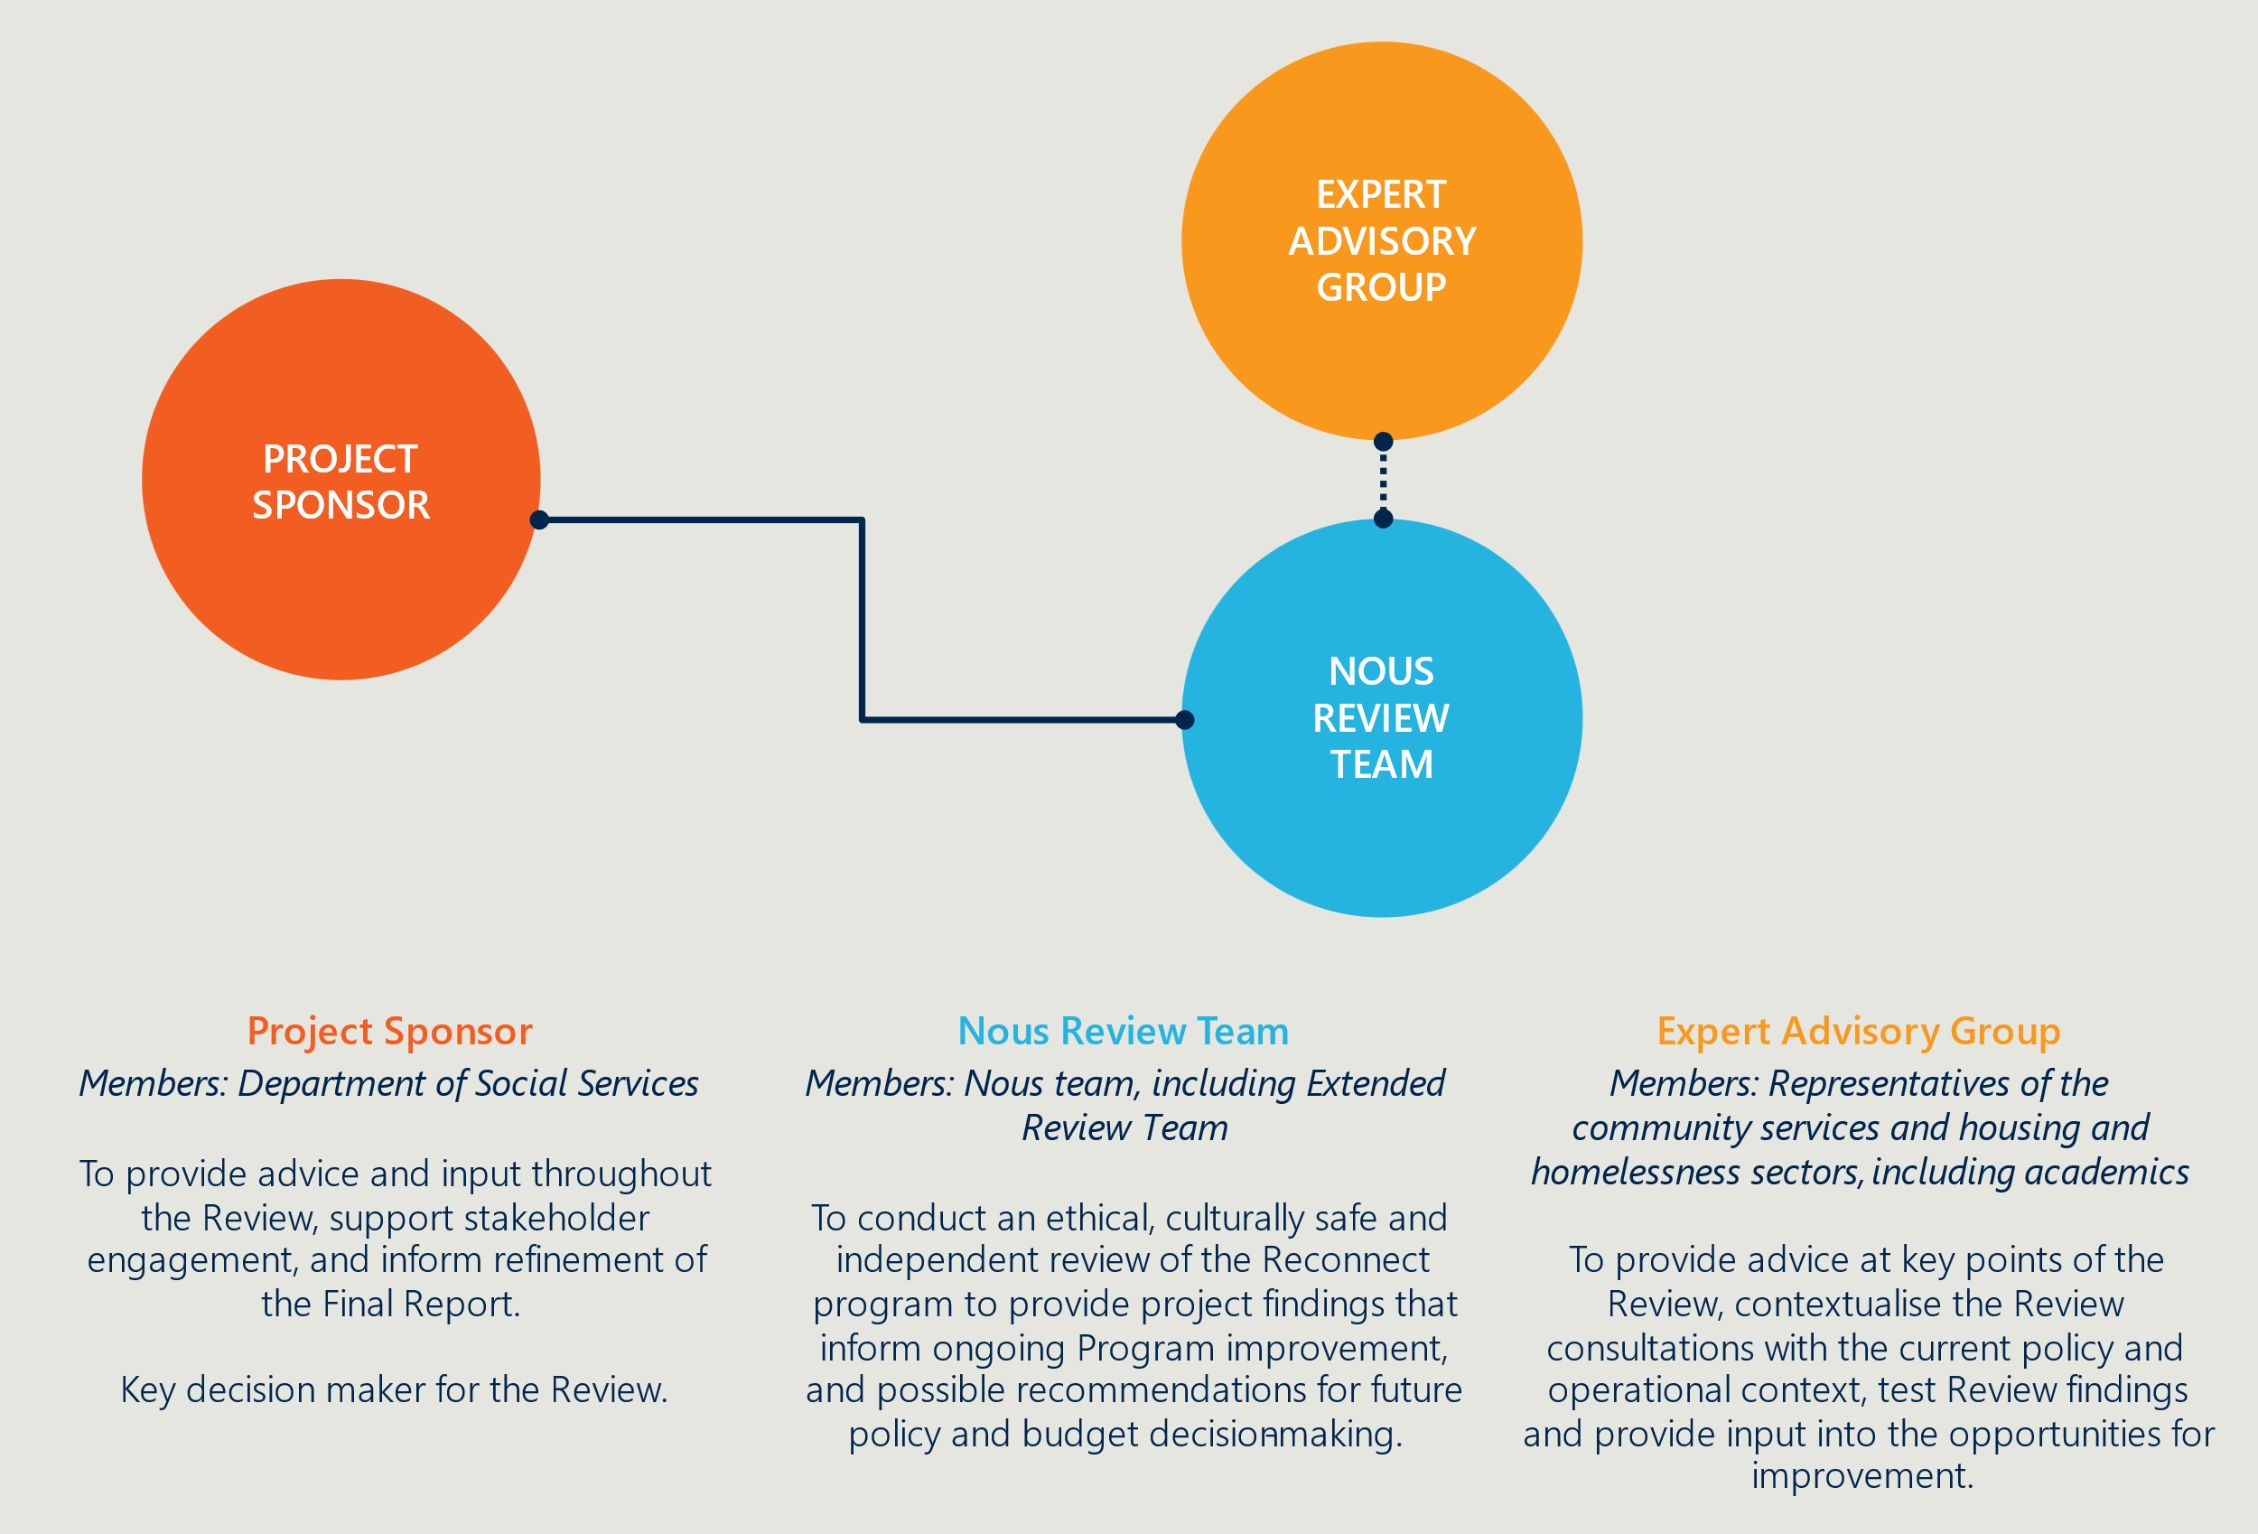

Limitations of the Review
There were some limitations with the Review methodology (described in more detail in Appendix A). Where possible, the Review triangulated data sources to minimise limitation impacts (e.g. drawing on survey and consultation feedback to provide insights regarding Program outcomes where DEX Data was unclear).
- A specific focus on how Reconnect supports Aboriginal and Torres Strait Islander people was not part of this Review, as the timeframe for securing ethical approval did not allow for progressing through a culturally appropriate ethics process. This means that the Review has reported on the outcomes attained for Aboriginal and Torres Strait Islander children and young people but has not investigated in detail the reasons behind these outcomes. This will likely require further investigation if DSS wishes to understand the reasons behind the attainment of outcomes for Aboriginal and Torres Strait Islander children and young people.
- Selection bias likely existed in the Review’s primary data collection, particularly in the recruitment of children and young people and support persons for consultations. The Review made efforts to mitigate this bias through the inclusion and exclusion criteria of the focus groups and client survey. However, it is likely that children and young people and support persons recruited had notably positive or negative experiences of the Program, and those with a neutral experience or who were disengaged with the Program were excluded. Therefore, the views of children and young people recruited to participate in the Review is likely not representative of the entire population who have accessed Reconnect. However, this was not of significant concern to the Review’s findings due to being able to triangulate findings with other data sources.
- The quality and completeness of the data limited the inferences drawn from DEX. Due to these limitations, the DEX SCORE data outcomes may not be fully representative of the population’s outcomes on entry and exit of Reconnect. This is because:
  - DEX SCORE data is a static measure, typically recorded using an initial SCORE towards the beginning of service and a subsequent SCORE either at the end of service delivery, or at regular intervals into the future to track a client’s progress. As DEX SCORE data is recorded by date rather than at a specific point in a client’s service period, assumptions were made to determine if the SCORE was recorded on entry and exit to the Program. This means there was no way to ascertain if the SCORE was recorded on entry or exit to the Program for clients with multiple episodes of service.
  - DEX SCORE measures may not be comparable between service providers, as they may interpret outcome measures differently (e.g. Reconnect Service Providers may interpret a ‘change’ in employment outcomes differently, which reduces the comparability of scores provided).
  - DEX and DEX SCORE data may only include a subset of the entire population as the partnership approach only requires 50% or more of clients to be reported on.
- The Review did not have a randomised control trial design, which limited the ability to draw conclusions on the effectiveness and efficiency of the Program. Conducting an appropriate counterfactual analysis or cost effectiveness analysis was limited as: a matched control group could not be established using DEX data; the Review did not have ethical permission to access similar programs for comparison; there was limited Program data on reductions in homelessness; DEX SCORE data only included short-term outcomes data and does not provide longer-term outcomes data for children and young people who have exited the Program.
- There were also limitations in the cost efficiency data, including:
  - Though 2023/24 funding data was available at the time of the Review, 2022/23 data has been used for analysis. This is due to the reporting period for the 2023/24 period not being finished at the time of the Review, and therefore accurate activity data could not be captured for the 2023/24 period.
  - Total sessions data incorporates a combination of individual client sessions, group client sessions and support person sessions. A session may contain more than one client and any combination of individual clients, support persons and group clients. Therefore, there is not an accurate way to break down these sessions into individual client, group client and support person sessions.
  - There was limited data on the breakdown of funding between different expenditure items. Where Reconnect Service Provider Activity Work Plans provided details on funding, only some provided a more detailed breakdown on this funding. Furthermore, this was provided for only budgeted expenditure and not actual expenditure.
  - Funding per individual has been calculated based on the median number of sessions a client engages with during the Program.
- There were limitations in providing insights on the differences in cost efficiency between Reconnect Service Providers across remoteness levels, and specialist or non-specialist services. This is due to a lack of service activity data for Providers across these domains to understand how service delivery may differ across these Providers. This will likely require further investigation by DSS to understand the differences in cost efficiency.

About this report
This report presents the final insights of the Review. It includes:
- Overview of the Reconnect program (Section 2)
- Review findings: Appropriateness of the Program (Section 3)
- Review findings: Efficiency of the Program (Section 4)
- Review findings: Effectiveness of the Program (Section 5)
- The future of Reconnect (Section 6).

Overview of the Reconnect program

The section provides an overview of the Reconnect program, including where and how it is delivered across Australia.

The Reconnect program is an early intervention and prevention program for young people delivered across Australia

Reconnect is part of the Australian Government’s response to youth homelessness and includes 101 services nationally.
Reconnect was established in 1999 as an Australian Government response to youth homelessness. It is funded by the Australian Government and administered by DSS. The Australian Government has committed to invest $91.7 million into the Program over 2023-2026. Reconnect is a place-based program that is delivered by 70 organisations through 101 funded activities (also referred to as services in this report) across Australia. There are two types of Reconnect services: generalist services that deliver the core model, and specialist services that tailor the Program to support specific groups of children and young people in their local context. This includes a focus on young people that identify as LGBTIQA+, youth leaving detention, First Nations young people, newly arrived youth, youth experiencing mental health challenges, and Culturally and Linguistically Diverse (CALD) young people. Figure 3 provides an overview of Reconnect’s service footprint across Australia.
Figure 3 | Reconnect service footprint across Australia
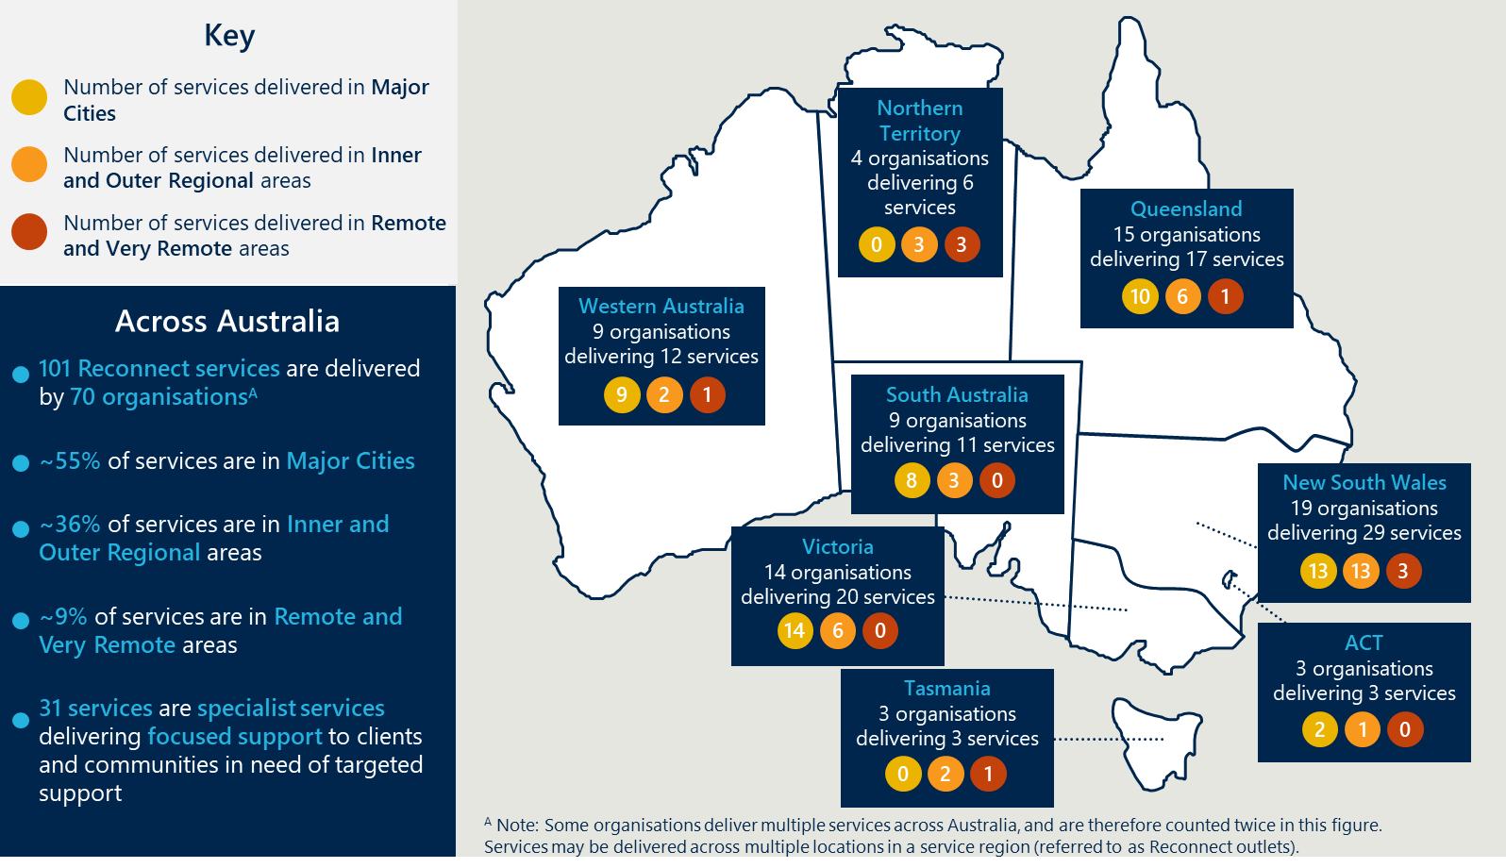

The Reconnect program provides a variety of supports including case management to children and young people, usually over a three-to-four-month period.
Reconnect services commence with a needs assessment process, where the Provider will determine whether the child or young person would be appropriately supported by Reconnect, or may be better served by another service (in which case the Provider will support a referral). Where a child or young person can be supported by Reconnect, a Provider will then match the needs to the existing range of services on offer. Figure 4 provides an overview of the Reconnect program, including the type of supports it provides to children and young people. It also depicts the common program objectives and the guiding Good Practice Principles.
Figure 4 | Overview of the Reconnect program
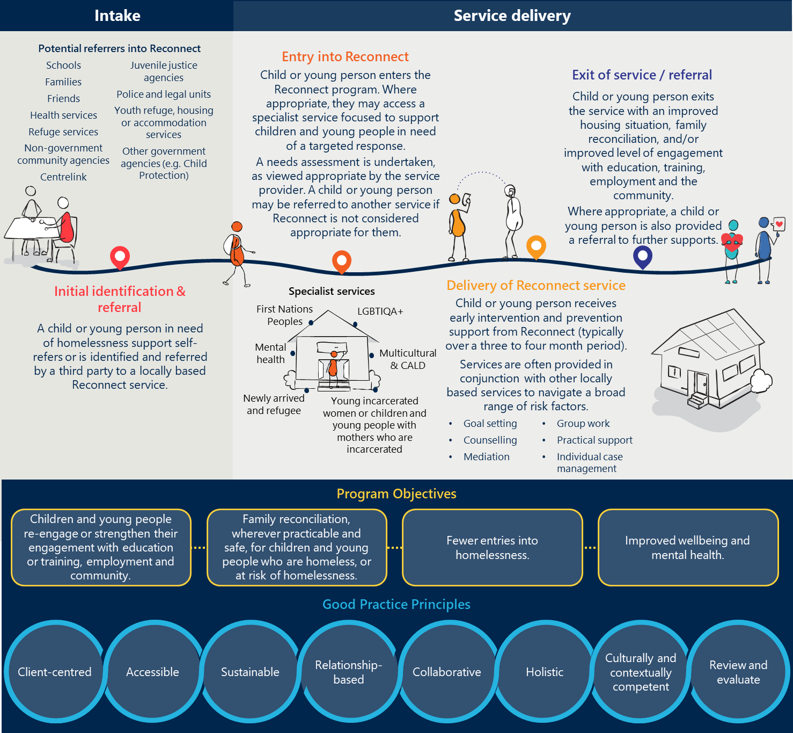

Review findings: Appropriateness of the Reconnect program

The section seeks to answer the following Review KLE: Are the Reconnect program’s desired outcomes appropriate for community needs, policy priorities and operating context?

Early intervention and prevention initiatives build protective factors which can reduce future interactions with the service system and reoccurrence of youth homelessness

Building protective factors can minimise the severity and reoccurrence of youth homelessness, and reduce a young person’s need for long-term social system support.
The research highlights the importance of addressing the broader social, health and educational problems that can lead to homelessness before at-risk groups find themselves without appropriate housing or accommodation. Children and young people are understood to become homelessness for a variety of reasons often outside of their control (described in more detail in Appendix C). Common reasons for youth homelessness include family conflict, violence and relationships breakdown. Given the close correlation of family relationship breakdown with homelessness building a child or young person’s protective factors, including relationships with family, engagement with education, employment, access and awareness of other services, is important. Evidence suggests that early intervention and prevention continues to be a useful mechanism to build protective factors for children and young people at risk of homelessness. The research outlines that this is an effective mechanism to support children and young people reduce long term experiences of homelessness and future interactions with other service systems.,

Evidence indicates that early intervention and prevention services and place-based responses are effective responses to youth homelessness.
Tailored early intervention and prevention support and outreach services are effective in identifying children and young people at risk of or experiencing homelessness. Research from Canada highlighted that homelessness crisis responses (e.g. emergency shelters or Housing First approaches) for young people and children can struggle to effectively reduce long-term experiences of homelessness. Canada shifted its approach in 2018 to focus on early intervention and prevention (with early intervention being identified as one of the five key elements to prevent youth homelessness), with emerging research indicating this helps to reduce the likelihood of chronic homelessness for young people. In Australia, early intervention and prevention has also been recognised as important to reduce incidence of youth homelessness, with early intervention (including the Reconnect program) appearing to account for most of the decrease in youth homelessness from 2001 to 2006 in Australia.
However, early intervention and prevention initiatives are difficult to evaluate as early interventions intersect with a broad range of causal factors impacting a child or young person’s experience (described in more detail in Appendix C). To deliver an effective response, evidence indicates early intervention and prevention responses must reflect youth homelessness’ broad system intersections, and employ a place-based approach to collaborate with actors inside and outside of local housing and homelessness systems. This reflects emerging social services research suggesting that complex social issues are not effectively responded to by a single organisation or service, and require coordinated and aligned service responses (i.e. the Collective Impact model).
Some early intervention and prevention programs prioritise a Collective Impact approach, such as the Community of Schools and Services (COSS) Model. The COSS model is currently being trialled overseas in Canada, the US and Wales, and was first piloted in Australia through the Geelong Project. Other programs across Australia have also leveraged the COSS model, such as Logan Together. Best practice features (described in Table 2) from other domestic and international programs provide important lessons about how to deliver effective early intervention and prevention supports for children and young people experiencing homelessness.
Table 2 | Early intervention best practice features
Best practice features
Other aspects of early intervention and prevention best practice identified from the literature include:
- Coordinated entry, supporting a standardised ‘no wrong door’ approach for children and young people in need of supports.
- Person-centred case management, focused on supporting development of a child or young person’s capacity for independence.
- Effective data collection and monitoring that can inform practical ongoing improvements.
- Tailored services, sensitive to the specific needs of children and young people (and particularly those identified at higher risk of homelessness).
- Culturally appropriate and trauma-informed services, supporting a child or young person’s connection to their culture and ability to leverage cultural strengths, and acknowledging that many children and young people may have likely faced experiences of trauma.
- Strengths-based services, focused on building upon a child or young person’s existing strengths to build protective factors and enhance resilience.
- Trusting and respectful relationships, with services focused initially on establishing rapport and trust with a child or young person.

The Reconnect program is the Australian Government’s flagship investment in early intervention and prevention for children and young people experiencing homelessness

The Reconnect program aligns with Australia’s broader policy and strategic landscape.
Reconnect’s early intervention and prevention focus to prevent children and young people entering or escalating further into homelessness supports many national policy and strategic directives and reforms, including DSS’ 2023-24 Corporate Plan (Outcomes 2 and 4), and national homelessness priorities, including the National Housing and Homelessness Agreement (NHHA). Reconnect also aligns with existing state and territory government housing and homelessness strategies (see Appendix C for more detail regarding state and territory youth homelessness political landscapes).
“The Reconnect program represents the Federal Government’s investment in the future of young people nationwide.”
- Reconnect Service Provider
Reconnect complements and aligns to broader Australian Government strategies and priorities to support children and young people in need of targeted intervention responses. These include Australia’s Disability Strategy 2021-2031, the National Plan to End Violence against Women and Children 2022-2032, and government programs such as Strong and Resilient Communities, and Helping Children Heal. These strategies and initiatives recognise housing and homelessness as a challenge that has disproportionate impacts on some population groups, and the need for increased early supports to improve outcomes for people at risk of or experiencing homelessness.
Further, to help more Australians access safe and affordable housing, the Australian Government is currently developing a National Housing and Homelessness Plan (National Plan). The National Plan recognises the need for cohesive national action across the housing spectrum, and looks to build on the work of state and territory governments to develop objectives supporting the agreed aspirational 10-year national vision. It is expected that prevention and early intervention will be a key focus for this new reform agenda and will inform the direction of government policies and programs. Reconnect has strong potential to play a key role in this broader reform agenda, given the potential long-term benefits that can be provided to children and young people when they are provided support early.

The Reconnect program is highly valued by the communities it supports, however, its visibility and intersection with the broader service system is varied

The Reconnect program is highly valued by communities it has direct involvement with.
Reconnect is highly valued by young people, their support persons and Reconnect Service Providers. Stakeholders including Reconnect Service Providers, young people and their support persons were hugely complimentary of the long-standing program, emphasising its value and impact to local communities and the networks that it is able to influence.
Surveyed sector representatives (including youth peak bodies, housing organisations and community services organisations) reported to be aware of and familiar with Reconnect, with 61% of 23 respondents reflecting they were ‘Very familiar’ or ‘Familiar’ with the Program. These stakeholders reported that the Program has had a positive impact on youth homelessness outcomes, and achieving its desired outcomes.
“I'm very grateful that I was able to get access to the Program and that we found it.”
- Reconnect client

Reconnect clients engaged during site visits and in the survey (total of 184) also reported positive experiences with the Program, with:
- 65% rating the Program as ‘Excellent’, and
- 29% rating the Program as ‘Very good’.
Reconnect clients value the young-person centred approach delivered by Reconnect, and the stability it provides through consistent and holistic supports (including counselling, goal setting and practical supports).

A large part of the service system, however, does not know that Reconnect exists.
A large number of stakeholders engaged throughout the Review, including state and territory government housing and education policy staff, had limited knowledge of Reconnect or its role in the system. State and territory government policy staff engaged through the survey and the forums reported that they were not familiar with organisations delivering Reconnect in their jurisdiction, and had limited to no interaction with Reconnect. Thirteen per cent of 23 surveyed sector representatives reflected they were not familiar with the Program.
“Reconnect has a strong brand in certain areas… but is not well known in others.”
- Australian Government stakeholder
Stakeholders not familiar with Reconnect emphasised that more could be done to increase its visibility and intersection across the system (this is described in more detail in section 3.4).

While many aligned programs are delivered across Australia, there appears to be a gap in targeted early intervention and prevention initiatives for children and young people experiencing or at risk of homelessness.
Nous’ mapping of the housing and homelessness service landscape through publicly available data and consultations (see Appendix E for more detail) indicated:
- While some states and territories deliver aligned programs to Reconnect, these tend to not be targeted at children and young people experiencing or at risk of homelessness.
- Where early intervention and prevention supports are delivered, these tend to be attached to crisis response services such as transitional accommodation.
- Services tend to target older cohorts of young people (15 to 24 years old), and there are few early intervention services delivering a targeted specialist or priority population service.
Many stakeholders emphasised that Reconnect plays a unique role in the service landscape and fills an important gap. Surveyed Reconnect Service Providers reported limited knowledge of other targeted early intervention and prevention initiatives for children and young people experiencing or at risk of homelessness. Further, specialist Reconnect services were reported as an invaluable service offering, supporting different cohorts and communities who need targeted responses. Sector representatives, including peak bodies, housing and homelessness organisations and community services organisations also reported Reconnect as filling a gap (73% of respondents (n=11) strongly agreed that Reconnect fills a gap in local service systems).
Figure 5 overleaf provides an excerpt of Reconnect Service Providers’ responses regarding the Reconnect program’s value in the landscape.
Figure 5 | Reconnect Service Provider reflections regarding the Reconnect program
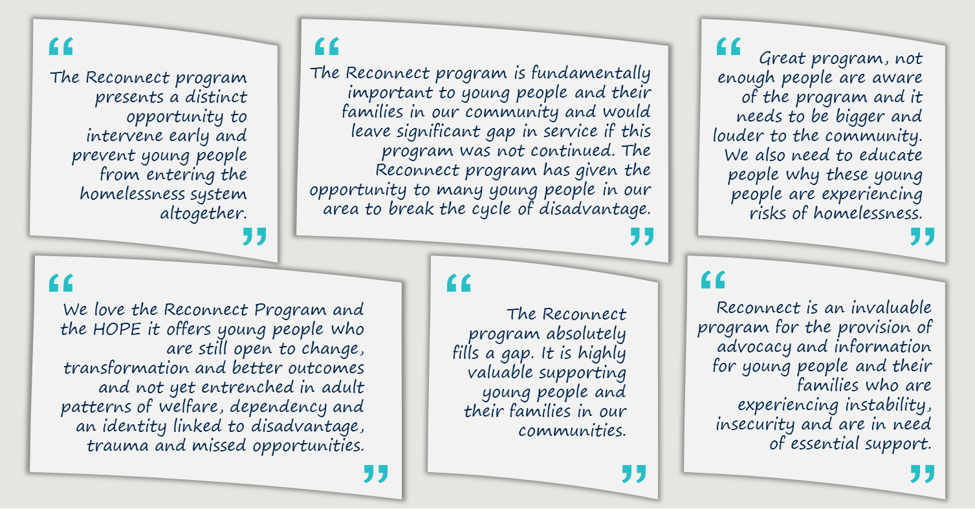

Since Reconnect was established, the service system has shifted and the Program has adapted accordingly

Reconnect is a long-standing Program that has undergone minimal changes since its inception.
The Reconnect program has experienced minimal changes since its introduction. A review of Reconnect’s current and past Operational Guidelines and consultations with stakeholders indicated:
- The key objectives of the Program and the services it delivers have remained largely unchanged. Throughout its existence, the Program has consistently aimed to enhance children and young people’s engagement with family, employment, education, training, and the community.
- The service model has remained consistent in the Operational Guidelines and included goal setting, counselling, mediation, group work, practical support, and case management.
- Specialist services catering to specific participant groups needing targeted responses, for example those who identify as First Nations, LGBTIQA+ or CALD, have always been part of the service provision.
- The Program has emphasised place-based responses to youth homelessness (in line with best practice) between Reconnect Service Providers and local service providers to support referrals and the transition of children and young people and their families to and from other services as required.
- Good Practice Principles have always underpinned delivery of the Program (see Figure 4 in Section 2).
- The number of services has remained relatively consistent, with the total number of national Reconnect services only growing by 5 between 2003 and 2024 (from 96 to 101).

The housing and homelessness sector has evolved since Reconnect was introduced in 1999.
Beyond Australia’s significant recent housing supply and demand challenges (see Appendix C), the Review found that COVID-19 has had a substantial impact on rates of homelessness, with some states and territories recording over double the number of rough sleepers in 2020 in comparison to 2016. The research outlined that the pandemic has also contributed to increased levels of disengagement with education and student attrition. Stakeholders emphasised the visible impacts of COVID-19 on children and young people’s needs, including their mental health and disengagement with school. Forty-one per cent of Reconnect Service Providers cited COVID-19 as the biggest challenge currently facing the delivery of Reconnect – and many provided similar responses through the survey, described in Figure 6.
Figure 6 | Reconnect Service Provider reflections on changing landscape
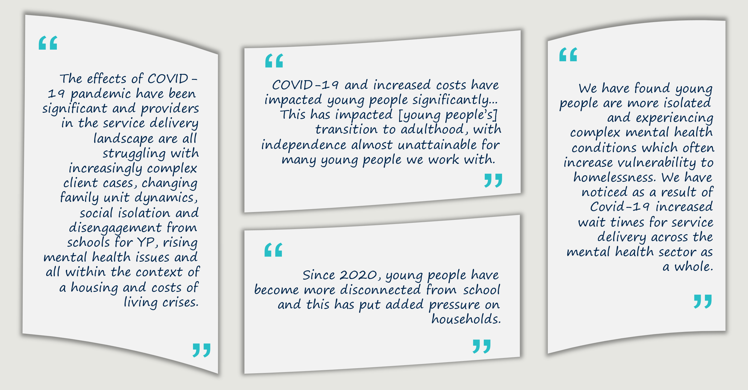
Other changing environmental factors reported to impact Reconnect clients’ needs and the delivery of Reconnect included:
- Increased rates of domestic and family violence and family conflict leading to more young people leaving home. Reconnect Service Providers reported they are seeing increased rates of family and adolescent violence, and family breakdowns which causes a lot of children and young people to leave home. They also emphasised that these have become more complex and multifaceted (requiring a more systemic response, as opposed to a standalone service response).
“Poor relationships lead to family breakdown, increased domestic and family violence - this decreases the safety net for families to prevent young people becoming homeless, or families becoming homeless.”
- Reconnect Service Provider
- Increased complexity of client need. These needs were reported to correlate with increased demand for Reconnect Service Provider services and other intersecting services (including mental health services, access to the NDIS and housing supports). Seventy-four per cent of reviewed AWPs identified this as a current delivery challenge.
- Children and young people being at risk of homelessness younger. Reconnect Service Providers reported young people, and particularly children, as experiencing increased rates of isolation and mental health challenges, and in need of earlier intervention supports earlier. This was reported through consultations and the survey to cause Reconnect clients to require increasingly complex supports (necessitating longer periods of service) by the time they are eligible to access Reconnect.
- Increased costs and workforce recruitment and retention challenges. Reconnect Service Providers reported the challenge of increasing service delivery cost (100% of Providers identified this through consultations). Workforce attrition, training and recruitment was also identified as an increasing challenge (89% of reviewed AWPs identified this as a current delivery challenge).

Reconnect is delivered in a place-based way that adapts to local needs and context.
Reconnect Service Providers operate in very different circumstances – including responding to different children and young people with varying needs based on their geographical area, level of socioeconomic disadvantage and organisational maturity and scale. Context is important when analysing outcomes and the experiences of key stakeholders, including the Providers. These differences include:
- The types of services delivered, and clients supported. Reconnect Service Providers vary significantly in their focus, particularly Specialist Providers. This means that services delivered, clients engaged, and key intake and referral pathways tend to vary for Reconnect Service Providers (although schools tend to be reported as the primary intake pathway).
- Levels of remoteness. Reconnect is delivered across metropolitan, regional, remote and very remote landscapes which experience varying levels of demand, complexity of demand, local service capacity and community challenges. This means Reconnect Service Providers operate in diverse service landscapes with distinct service enablers and barriers.
- Organisational size and maturity. Some Reconnect Service Providers deliver Reconnect as one activity at one outlet, and as their only service (i.e. do not deliver services funded outside of Reconnect), while others operate nationally with multiple Reconnect activities and outlets, complemented by other separately funded services. This means Reconnect plays a different role for each Provider (e.g. a core source of funding for some smaller Providers), and some aspects of program delivery (e.g. administration and reporting) can be more burdensome for some Providers.

There is large variation in the way Reconnect is delivered to support children and young people and their families.
Reconnect’s flexible Operational Guidelines (described in more detail in section 2.1) are recognised as a key strength of the Program which has supported the delivery of many different activities. This has allowed Providers to adapt over time to their circumstances, create a unique role for themselves in their network and respond directly to the needs of children and young people. However, this shift has meant there is large variation in the way Reconnect is delivered to support children and young people and their families across Australia. Reconnect’s variation at a program level also makes:
“Reconnect has increasingly become a catch all service."
- Australian Government stakeholder
- Reconnect’s scope difficult for stakeholders to understand. State and territory government education policy officers reflected that Reconnect’s broad remit makes it hard to conceptualise what the Program does and how this intersects (or could intersect) with schools (see further below).
- Reconnect is challenging to evaluate and report on. This is particularly the case when looking to understand the Program’s outputs and impacts at a program level (this is further described in section 5.4).
The Review found that Providers place different emphases on key program characteristics, detailed below.

Many are operating more as a crisis response service.
Many Providers reported that they support young people in crisis, and provide supports over and beyond Reconnect’s remit of early intervention and prevention. This creates a challenge for service delivery as Reconnect Service Providers are placed under significant pressure to provide crisis interventions and/or undertake rapid referrals to crisis services (such as accommodation or mental health services). Providers emphasised this places increased risk on their organisation and contributes to increased rates of workforce stress and burnout.
“A high number of referrals are coming in at crisis point, rather than the early stages of identified issues.”
- Reconnect Service Provider

The Review found that this has been driven by:
- A lack of other services to refer to. This was a significant challenge reported by Reconnect Service Providers through consultations and the AWPs, in particular in regional and remote areas.
- Difficulties establishing relationships with referral organisations. Metropolitan Reconnect Service Providers reported challenges in developing long-standing relationships with referral organisations (especially where these organisations experience high attrition rates). Regional and remote Providers tended to report closer relationships with local services, noting they are often limited with options to refer to (as outlined above).
“The Reconnect program engages well with youth when they are low risk, but it creates challenges when the program refuses to intake young people deemed as too high a risk. This can cause young people in need to be left without a service.”
- State and territory government policy officer
- Long waitlists for other services. Reconnect is reported to work closely and provide referrals to GPs, NDIS services, mental health services and local community services. These services tend to have long waitlists, causing Providers to be pressured to provide more holistic supports (e.g. counselling).
- Strict eligibility criteria for other services, in particular mental health services and other housing and accommodation services. Age is reported as often the greatest barrier for accessing these services.
- Increased complexity of children’s and young people’s needs, particularly since COVID-19 (see above).

Some Providers are still purely focused on early intervention and prevention.
Some Reconnect Service Providers reported they focus solely on providing early intervention and prevention support to children and young people. Fifty-nine per cent of AWPs (of 100) identified connecting young people with timely and appropriate supports as a key outcome achieved by the Program, indicating they are providing support and then connecting them to other services, as intended.
The Review found that the focused delivery of early intervention and prevention supports is enabled by:
- Effective engagement with local schools to connect Reconnect with young people in need of supports as early as possible. Families engaged through this Review identified that the Reconnect workers played a key role in working with them and attending meetings at the school acting as an intermediary.
“Reconnect provides stability for a young person early, and irons out challenges they may be experiencing.”
- Reconnect Service Provider

- Strong relationships with referral organisations who Reconnect can refer to when children and young people are in crisis. In particular, Reconnect Service Providers cited the importance of pathways and relationships to local mental health services and other health services so they do not have to ‘hold’ children and young people longer when they are needing more intensive support.
- Working closely with families and support persons. Many Providers emphasised the importance of working closely with families and other support persons when supporting children and young people through the Program. Given the Program’s focus on family reconciliation (where practicable and safe to do so), some Providers emphasised the importance of family mediation to achieve positive longer-term outcomes compared to a child or young person entering into the homelessness system. However, practically this can be difficult when families are disengaged or transient, and when the Reconnect case workers are experiencing high demand for support.
Further, most see building protective factors and other early intervention and prevention initiatives as the most important thing that Reconnect can achieve given the system constraints. Most Reconnect activities are delivered to increase young people’s understanding and application of protective factors (reported by 89% of Providers in their AWP), including building awareness of services, risk factors and improving relationships with their families.

Some do not see Reconnect as a youth homelessness program – and feel limited in their ability to influence housing outcomes.
Some clients and their support persons reported that they were not at risk of, or experiencing homelessness when they accessed Reconnect, and were surprised that this was the focus and intent of the Program. Many Reconnect Service Providers tend to support children and young people in the school setting or experiencing other issues (but still living at home). Families cited they were discouraged to access Reconnect due to its homelessness criteria, despite being told they could still access the Program for other reasons. Reconnect clients also reported struggling to self-identify as ‘at risk of homelessness’ when in need of other supports (e.g. struggling with disengagement from school). Many stakeholders commented on the need for the focus and remit of the Program to be clearer to those wanting to access it across the system.
“Reconnect (as a brand and name) makes sense, but the homelessness aspect, not so much.”
- Support person

Further, some Providers reported that they are limited in their ability to support children and young people experiencing homelessness. These Providers emphasised that they are constrained by broader housing supply issues, with many commenting on the long waitlist for housing in their local areas – and most not providing accommodation services through their organisation. Despite this being the focus of the Program, few Providers observe connecting young people with safe, secure and stable housing as a key achievable outcome of the Reconnect program (identified by 4% of 138 survey respondents).

Reconnect Service Providers reported the Program’s intended age range, catchment areas and intended service period can limit their ability to appropriately support cohorts in need.
Reconnect Service Providers reported some service delivery challenges associated with the Program, including the Program’s:
- Age eligibility. Reconnect Service Providers reported challenges delivering services to children and young people aged 12 to 18 years old (and up to 21 years old in the case of newly arrived youth). Most emphasised that they are seeing more children and young people in need of support (e.g. below the age of 12 and as young as 8) and often meet their out-of-scope threshold with this group. This is exacerbated in more remote areas where there are limited other services – and when younger siblings of clients need support. Reconnect Service Providers noted that working with younger age groups would likely deliver more effective early intervention supports for children and young people at risk of homelessness. More information on Reconnect’s outcomes delivered for different age cohorts is provided in section 5.5.
“The young people I’m supporting were turning 18, and I had to refer them into other programs delivered by my organisation so I could keep giving them the support they need.”
- Reconnect Service Provider
Reconnect Service Providers also reported challenges seeing older cohorts in need of support. Where a young person near the age of 18 accesses the Program, Reconnect Service Providers reflected they had to prioritise quick referrals of the young person to another service to continue providing support. Some Providers reflected that older cohorts aged 16-18 tend to be transitioning to independence, and are in greatest need of Reconnect’s support (e.g. practical supports like applying for Centrelink, and enrolling for Medicare).
- Prescribed catchment areas. Reconnect Service Providers reported challenges delivering services in a prescribed region given demand for services and the complexity of need. Some Providers identified that children and young people in crisis tend to be transient, which can create service delivery challenges when they are accessing Reconnect but have moved outside of the prescribed region. Further, not all Reconnect services provide outreach as they are constrained by resources. Specialist Reconnect Service Providers emphasised this challenge as there are fewer services focussed towards priority populations and high demand for the service within and beyond their prescribed catchment area.
- Timeframe of support. Reconnect Service Providers reported challenges delivering services to a young person within three to four months. DEX data indicates that 54% of Reconnect clients accessed the Program for less than 90 days, with a median of seven sessions. Some clients engage with the Program for much longer (41%). Reconnect Service Providers reported that the initial three to four months is often how long it takes to build rapport and trust with children and young people. They emphasised that this means they often are prematurely exiting children and young people from the service. Children and young people also emphasised that this time period was too short – and some noted that this has resulted in them reengaging with the Program after exiting.
“The 12 weeks of service was not close to enough to support my child. We had to re-access the program a year later as my child was not ready to leave the program at the end of the service period.”
- Support person

The operational administration and management of the Reconnect program could be strengthened
The Reconnect program is delivered by DSS’ Housing and Homelessness Program Delivery Branch, who manage overall program design and delivery. State and territory-based FAMs support delivery of the Program acting as the first point of contact for Reconnect Service Providers, and providing assistance with program planning, data and reporting and administration.
DSS staff reported administration and management of the Reconnect program as generally effective. The AWPs were reported as an effective reporting mechanism for DSS, which help provide useful insights around what is being delivered by Reconnect Service Providers. Qualitative reporting in the AWPs is reported as particularly valuable, which provides DSS with case study examples of the Program, and an understanding of what is working well and not so well. Some Reconnect Service Providers also reported the AWPs as effective and appropriate in length and detail for the size of the Program.
However, DSS and Reconnect Service Providers experience some administration challenges associated with the Program, detailed in Table 3.
Table 3 | DSS and Reconnect Service Provider administration challenges
DSS administration and management challenges include: | - Using DEX. DSS staff reported accessing and analysing DEX data as a challenge, and that it can be difficult to clearly understand what is being reported by Reconnect Service Providers through the platform.  - Engagement with aligned government agencies. DSS reports challenges engaging with other federal and state and territory government agencies to appropriately promote and coordinate the Reconnect program across the sector.
Reconnect Service Provider administration and reporting challenges include: | - Recording data through DEX. Reconnect Service Providers reported limited training and guidance on how to use DEX, and that they often learn to use DEX through trial and error. DEX was also identified as often duplicating data entry, as Reconnect Service Providers tend to record data on their own internal systems. Reconnect Service Providers reflected that as they do not receive any outputs from data entered into DEX, they need to collect and record their own data to inform service decision-making.  - Working productively and efficiently with FAMs. Some Reconnect Service Providers reported challenges engaging with their FAM, particularly where the role had been subject to staff turnover. Regular virtual calls were reported as helpful to keep Reconnect Service Providers up to date of Reconnect program processes, streamline DEX reporting and ensure FAMs are familiar with Reconnect Service Provider’s services. Some Reconnect Service Providers also reported challenges adjusting AWP goals and targets with FAMs.
DSS and Reconnect Service Providers also reported some challenges regarding DEX and attribution of DEX SCORE domains to program outcomes. This is described in more detail in section 5.7.
“Having regular engagement with our FAM is really helpful – it helps to get us both on the same page, and allows us to showcase what we are delivering through Reconnect.”
- Reconnect Service Provider

Review findings: Efficiency of the Reconnect program

The section seeks to answer the following Review KLE: Does the Reconnect program represent value-for-money for the Australian Government?

Reconnect funding has increased with indexation over time
The average funding per Reconnect activity has increased over time from 2018/19 to 2022/23. The annual rate of increased funding over this period of time is larger than the increase in annual inflation, as highlighted in Figure 7. The largest relative annual increases in funding are from 2020/21 to 2021/22 (15.9%), and 2021/22 to 2022/23 (9.2%).
Figure 7 | Average funding per Reconnect activity from 2018/19 to 2022/23
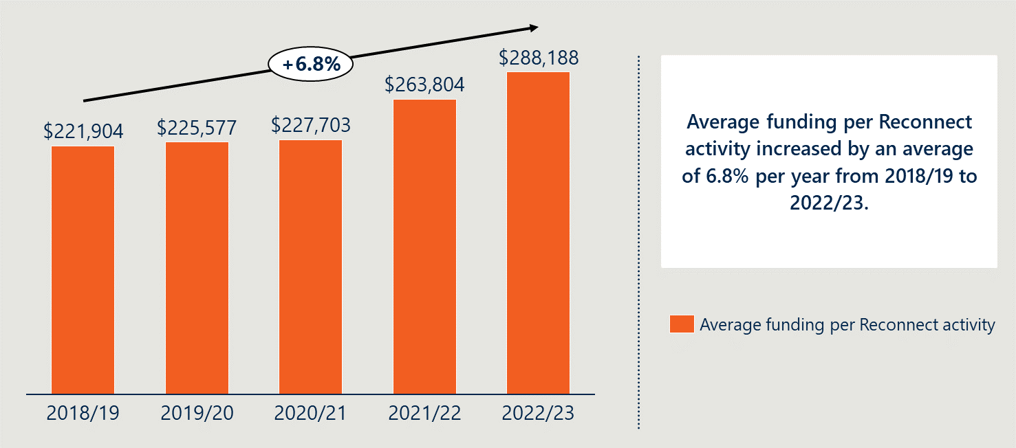
Though funding has increased over this period, Reconnect Service Providers perceived that funding had not kept pace with inflation or the increasing cost of delivery (which includes staffing costs, administration costs, operational costs and brokerage). If the Program’s funding had not increased in-line with the cost of delivery, this may explain why the average number of sessions per Reconnect activity decreased each year from 2019/20 (where the average number of sessions would be expected to increase with higher levels of funding). However, Figure 8 demonstrates that, despite the increased level of funding each year, the number of sessions has decreased since 2019/20.
Figure 8 | Average funding and average number of sessions per Reconnect activity from 2018/19 to 2022/23
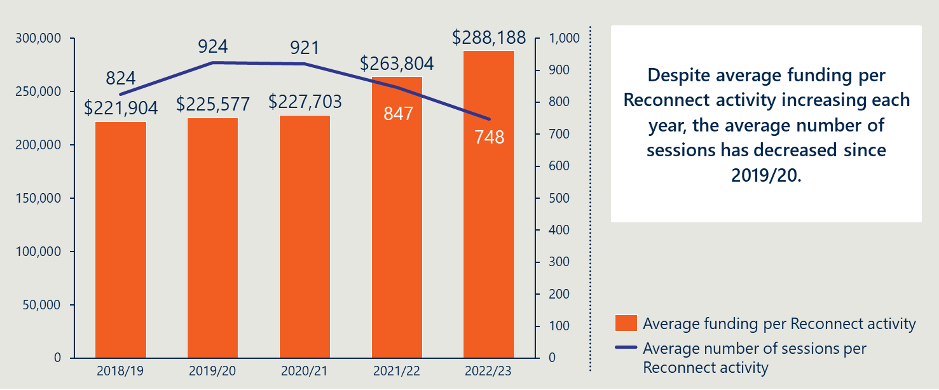

Most Reconnect Service Providers reported they do not cross-subsidise funding and do not receive other program grants to support Reconnect clients.
Majority of Reconnect Service Providers do not cross-subsidise Reconnect and do not receive additional funding for programs that support Reconnect clients. Seventy-eight per cent (n=94) of Reconnect Service Providers reported in the survey they did not receive additional funding to deliver services that also support Reconnect clients. However, interviews revealed that Reconnect Service Providers often deliver other programs and services including SHS, family-based services and other early intervention and prevention programs.
These interviews suggested that Reconnect Service Providers may not be directly cross-subsidising Reconnect or supporting Reconnect clients through other early intervention and prevention programs. However, they may be utilising other program resources or their broader overheads (such as additional staff or office space) to support the Program when needed. This would support Reconnect Service Providers to service the demand for Reconnect in light of what they perceive as increased costs of delivery above the Program’s annual indexation payment, and would mean that the cost to service clients is actually greater than the funding provided. The quantitative data makes this assertion unclear, as the average number of sessions per Reconnect activity has reduced despite increased level of funding above the rate of inflation. This warrants further investigation by DSS.

Reconnect is relatively cost efficient to deliver compared to other early intervention and prevention programs
The cost to deliver the Reconnect program was approximately $2,175 per individual across 2018/19 to 2022/23. The cost to deliver the Reconnect program per individual has been compared to similar programs in Table 4, including those that focus on youth, early intervention and prevention, homelessness and that provide housing. Whilst this includes a breadth of programs, it is important to include these different comparisons as there is no exact comparison program to Reconnect as an early intervention and prevention program that is focussed on preventing youth homelessness but does not provide housing.
It is also worth noting the Review has not conducted a cost effectiveness analysis (where the cost of producing specific outcomes is compared) as there is not available data on the extent to which a child or young person avoids homelessness through the Reconnect program. Therefore, the cost effectiveness of the Program in contributing to the avoidance of children and young people entering into homelessness cannot be accurately measured.

Table 4 | Comparison of cost efficiency
Program | Description | $ per client ($ 2022/23) | Youth focus | Early intervention and prevention | Homelessness | Housing attached
Youth Foyer | Integrated learning and accommodation settings for young people, typically aged 16-24, to live in for up to two years. This integrates housing, education, employment and life skills. | $39,971 | P | P | P | P
Sustaining Young People’s Tenancies | Mobile support services to assist young people aged 16-25 who are in social housing and are at risk of losing their tenancy and becoming homeless, to sustain their social housing tenancy. | $9,383 | P | P | P
Homeless Youth Assistance Program | Supports unaccompanied children and young people aged 12-16 access to integrated support and accommodation services – with a focus on reunifying children and young people with their families and broader support networks, as well as enabling them to transition to longer-term support accommodation. | $21,127 | P | P | P
SHS | All services provided by specialist homelessness agencies to support clients who are homeless or to prevent homelessness from occurring among those at risk of homelessness. | $3,499 | □ | □ | P | □
Functional Family Therapy – Child Welfare (FFT-CW) | A short-term family therapy that aims to address problems within a family that may result in a child or young person entering Out of Home Care. | $16,828  (not including establishment costs) | P | P
Multi-Systemic Therapy (MST) | An intensive family and community-based treatment that addresses the multiple causes of serious antisocial behaviour in juvenile offenders. | $30,581  (not including establishment costs) | P | P
Tenancy Support | Tenant support programs under the previous National Partnership Agreement on Homelessness in Victoria, South Australia and Western Australia. | $2,732 |  |  | P
The Cottage | Program for people who are homeless or at risk of homelessness and require hospital in the home services and assistance with managing medication and personal care. | $6,211 |  |  | P
Housing Support Workers Corrective Service | Housing support worker programs for people exiting correctional institutions | $11,245 |  |  | P

These figures suggest that Reconnect is relatively more cost efficient to deliver per individual, compared to other similar programs (particularly those that are early intervention and prevention or focussed on reducing homelessness). Additionally, the total funding for the Reconnect program is much smaller than government investments in other similar services. For example, the recurrent expenditure on SHS was $1.4 billion in 2022-23. The expenditure on Reconnect in the same year was $29.1 million, which is comparatively approximately only 2% of the SHS expenditure.

Within the Program delivery, there is a large ‘tail’ of activities delivered at a high-cost point, suggesting more can be done to improve operational efficiency
Of the 101 Reconnect activities, each activity’s funding per session in 2022/23 has been calculated and graphed as illustrated in Figure 9.
Figure 9 | Cost efficiency across the Reconnect activities in 2022/23
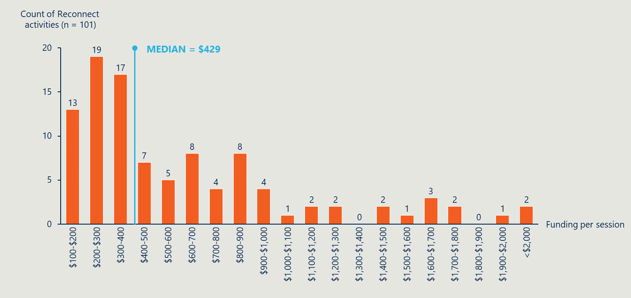Key insights from assessing the cost efficiency across Reconnect activities include:
- Most Reconnect activities were delivered in a cost-efficient way, with more than half (55.4%) of these activities delivered at less than $500 per session, and most (18.8%) spending approximately $200-$300 per session. This may be driven by the fact that Reconnect does not provide housing, and has a less intensive model compared to some other services. It is worth noting that Reconnect does rely on other services to achieve outcomes (which they refer clients to), and those costs are not attributed here (see further in section 5.2).
- There is large variability in the funding per session across Reconnect activities; the median funding per session is approximately $429, yet 26 (25.7%) Reconnect activities have funding per session that is more than double this amount. Reconnect activities operating well above the median typically operated with low throughput numbers during the 2022/23 period. This could be due to Reconnect activities having low demand, higher intensive models with longer session times, poor performance, or referral networks not working as effectively as they should.
- Additionally, there are two Reconnect activities who deliver the Program at above $2,000 per session – at $5,014 and $14,390 per session. These are likely outliers in the data, as the activities receive funding amounts that are greater than the median, but report a relatively low number of individual client sessions. These Providers are not reporting a high number of total client sessions (which include support person sessions) which indicate there is likely underreporting/data quality issues.
- Overall, there is opportunity for DSS to understand why some Reconnect activities are delivering a much more cost-efficient service and to understand how this data translates to outcomes. This further analysis will help identify how some Reconnect activities could be operating in a more cost-efficient way and ideally lead to a more efficient delivery of outcomes across the service.

The cost efficiency per remoteness level is lowest for regional areas and highest for major city and remote areas.
The data suggests there is a variation in the cost of service delivery across Australia:
- Across different levels of remoteness, activities in inner regional and outer regional areas have the lowest median cost per session ($359 and $216, respectively). This may be due to Reconnect activities in regional areas operating with effective referral networks, which was identified by Reconnect Service Providers through consultations and AWPs.
- Reconnect activities across metropolitan ($500 median cost per session), remote ($641 median cost per session) and very remote ($626 median cost per session) areas are relatively less cost efficient. This may be due to higher staffing and transport costs in remote regions, identified by Reconnect Service Providers through the survey, consultations and AWPs. However, the high cost for major city activities may require further investigation. Additionally, the median cost of remote activities has been skewed due to a large outlier and a small count of activities, and would be $472 excluding this outlier.
This is further described in Table 5 below.
Table 5 | Cost efficiency across Reconnect activities per remoteness level in 2022/23
 | Low | High | Average | Median | Count
Overall | $103 | $14,390 | $767 | $429 | 101
Major city | $129 | $5,014 | $740 | $500 | 57
Inner regional | $178 | $1,622 | $554 | $359 | 21
Outer regional | $103 | $1,086 | $324 | $216 | 14
Remote | $180 | $14,390 | $3,272 | $641 | 5
Very remote | $399 | $1,6401 | $823 | $626 | 4

Non-specialist services are slightly more cost efficient compared to specialist services.
The median cost per session for non-specialist services ($410) is relatively lower than the median cost for specialist services ($500). Consultations with specialist services highlighted that they often provide individualised support to clients rather than group work, which would create higher costs to deliver per session. However, further investigation would be required to understand this difference.
This is further described in Table 6 below.
Table 6 | Cost efficiency across Reconnect activities per specialist and non-specialist services in 2022/23
 | Low | High | Average | Median | Count
Specialist | $134 | $14,390 | $1,085 | $500 | 31
Non-specialist | $103 | $5,014 | $626 | $410 | 70

Reconnect has several cost drivers and is largely driven by staffing costs
A number of cost drivers were identified that impact on managing and operating the Program. These cost drivers have been detailed in Figure 10 below.
Figure 10 | Cost drivers for Reconnect Service Providers
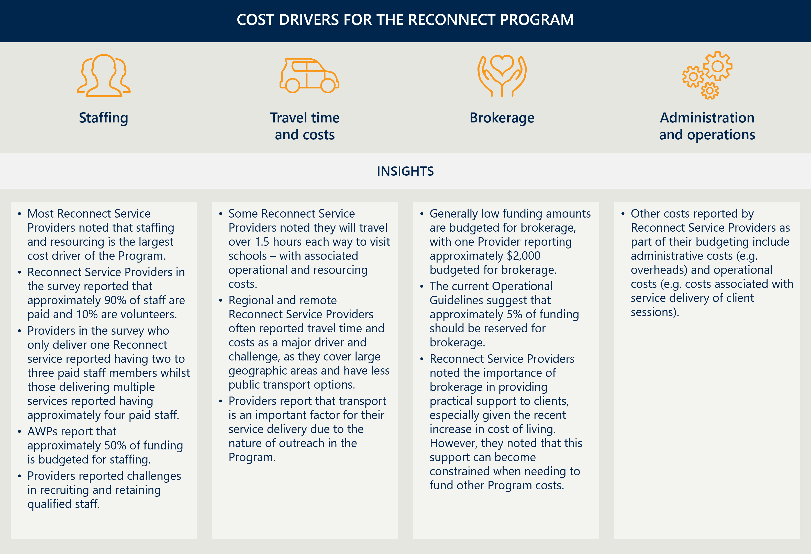

Review findings: Effectiveness of the Reconnect program

The section seeks to answer the following Review KLE: To what extent is the Reconnect program achieving its desired outcomes? For whom?

Reconnect has supported over 30,000 clients across over 470,000 sessions
Reconnect supports a broad range of children and young people with specific demographics and needs, supporting over 30,000 individual clients across over 470,000 sessions from 1 July 2018 to 31 December 2023. Figure 11 further details the demographic spread of children and young people over this period.
Figure 11 | Reconnect client profile snapshot
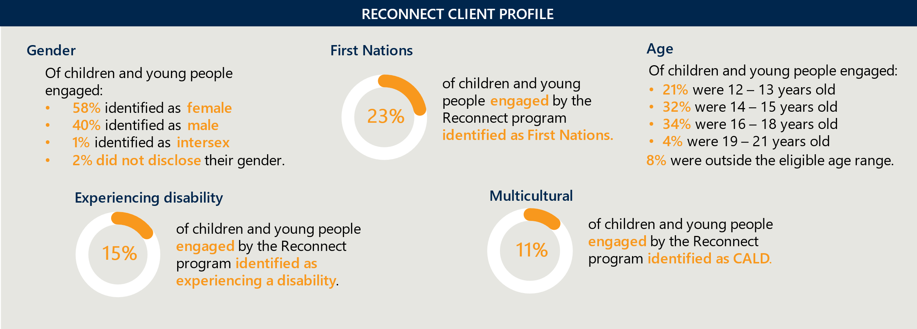
The key insights from the Reconnect client profile includes:
- A higher proportion of females engaged with the Program.
- The proportion of clients outside the eligible age range was within the 10% range that Providers can use for out-of-scope clients.
- Clients who identified as First Nations (23%) were overrepresented compared to the general population (3.8% in 2021), but broadly aligned to the proportion of the homeless population (20% in 2021).
- Clients who identified as experiencing disability (15%) was broadly aligned with the general population (17.7% of the population in 2018), but slightly higher than that of those experiencing homelessness (9.5% of SHS clients in 2022-23 identified as experiencing disability).
- 11% of clients identified as CALD (noting DEX defines CALD specifically as being both born overseas and speaking a main language other than English at home). Further investigation would be required to determine if those who identify as CALD are underrepresented in the Reconnect Program.

Children and young people usually enter Reconnect through educational agencies and are supported within the 3-4 month timeframe
Clients through Reconnect have a varied journey which typically lasts for a median of 77 days (approximately 2.5 months) over 7 sessions, and the DEX data outlines that this is predominantly through advocacy/support, intake/assessment and information/advice/referral sessions. Figure 12 summarises the overall client pathway through the Program, using service activity data collected from 1 July 2018 to 31 December 2023.
Figure 12 | Reconnect client journey snapshot
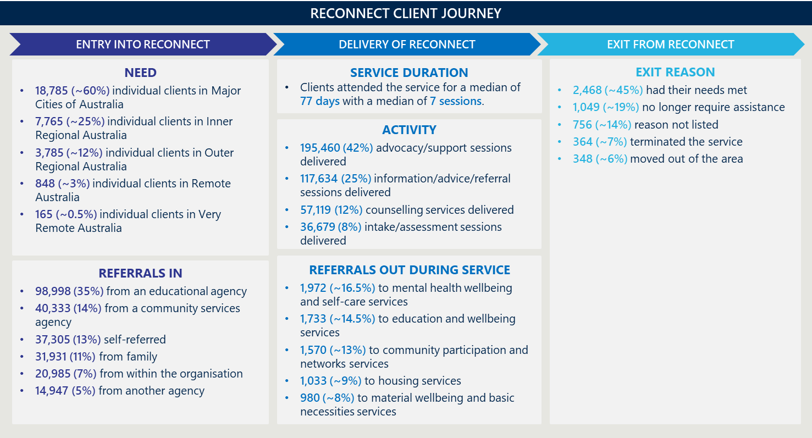The key insights from the service activity data includes:
- As educational agencies were the greatest referral source for the Program (35%), building local relationships with schools and awareness of the Program is important for early identification of those at risk. However, consultations revealed that relationships with schools are varied, and Reconnect Service Providers have different levels of access to schools (see further detail in section 5.8 below).
- The types of activities provided were less focused on targeted interventions, such as counselling or family mediation services. However, consultations with Reconnect Service Providers identified that these interventions were often provided in a range of different ways, not just through targeted sessions, for instance providing counselling whilst transporting a young person between services, or interacting with a support person when transporting a young person home. Therefore, the specific activity data may not be fully representative of the types of services provided. Further, Reconnect Service Providers reported the way they report on the activities in DEX may not be aligned to the definition or intent of the DEX categorisation.
- The median service duration of 77 days suggests that clients access Reconnect for a shorter time than the 3-4 month period suggested in the Operational Guidelines, though consultations emphasised this period is too short.
- Clients are most often referred out to mental health, education/wellbeing and community participation services. Consultations identified that clients were often referred out to a range of services, with mental health, health and practical services being most cited. Young people emphasised being connected to Centrelink and Medicare, and support to get their driver’s license and Tax File Number was valued.
- The program seemed to have been effective in servicing clients and meeting their needs. The majority of clients exited the service as they do not need to access the service anymore (approximately 64%), with nearly half having reported that their needs were met. However, the data does not provide further detail about what constitutes a young person no longer needing assistance and this could be further explored by DSS. It should also be noted that only a small proportion of clients have an exit reason recorded in DEX. Consultations with children and young people revealed that they have re-accessed the service after exiting as they did not feel 3-4 months was long enough to get the support they needed.

Reconnect has supported attainment in relevant short-term outcomes for children and young people
A Program Logic has been developed which outlines the outcomes Reconnect is expected to achieve (see Appendix A). The Review has drawn from a range of sources to outline the extent to which the Program has contributed to improved outcomes aligned to the Program Logic, illustrated on the next page. It is worth noting that only the attainment of short-term outcomes could be reported on using these sources. These outcomes align to the evidence that early intervention and prevention initiatives are an effective response to youth homelessness – as they build protective factors, including awareness of supports, relationship with family, engagement with education and employment and can support the earlier identification of risk factors before children and young people enter homelessness (see section 3.1).
Reconnect Service Providers emphasised the importance of building protective factors as part of their service delivery: 89% of Reconnect Service Providers through AWPs (n=100) indicated ‘increasing young people’s understanding, use and application of protective factors’ was a key intended outcome of their service delivery, and 46% of Providers in the survey (n=129) identified ‘increasing the protective factors of young people to build resilience’ as one of the top three outcomes of the Program.
As outlined in the figure overleaf, the key insights on Reconnect’s attainment of short-term outcomes includes:
- Reconnect was most effective at helping children and young people build their understanding of supports they can access and helping them engage with these, as well as building the resilience of individuals. The Program was also effective at supporting children and young people to improve their understanding of risk factors.
- Reconnect has improved the housing situations for some children and young people, albeit there is limited data to understand the extent to which this has been achieved long-term.
- Reconnect has helped children and young people access timely and appropriate supports, improving their connection with family, employment, education and community connection, though the Program was relatively less effective at supporting children and young people to improve their engagement in employment.
- Reconnect has supported family, carers and the community to identify risk factors of homelessness and support children and young people at risk of homelessness, and to increase their awareness of available supports and facilitate a child or young person’s access, though both of these outcomes were not key focus areas for Providers.
- Reconnect has improved the relationship of families and their ability to manage conflict, through family mediation activities – with many Reconnect Service Providers emphasising the importance of family mediation to achieving positive longer-term outcomes compared to a child or young person entering into the homelessness system.
- The Program is inconsistent in improving system coordination, which often differs across remoteness levels (often done most effectively in regional and remote areas).

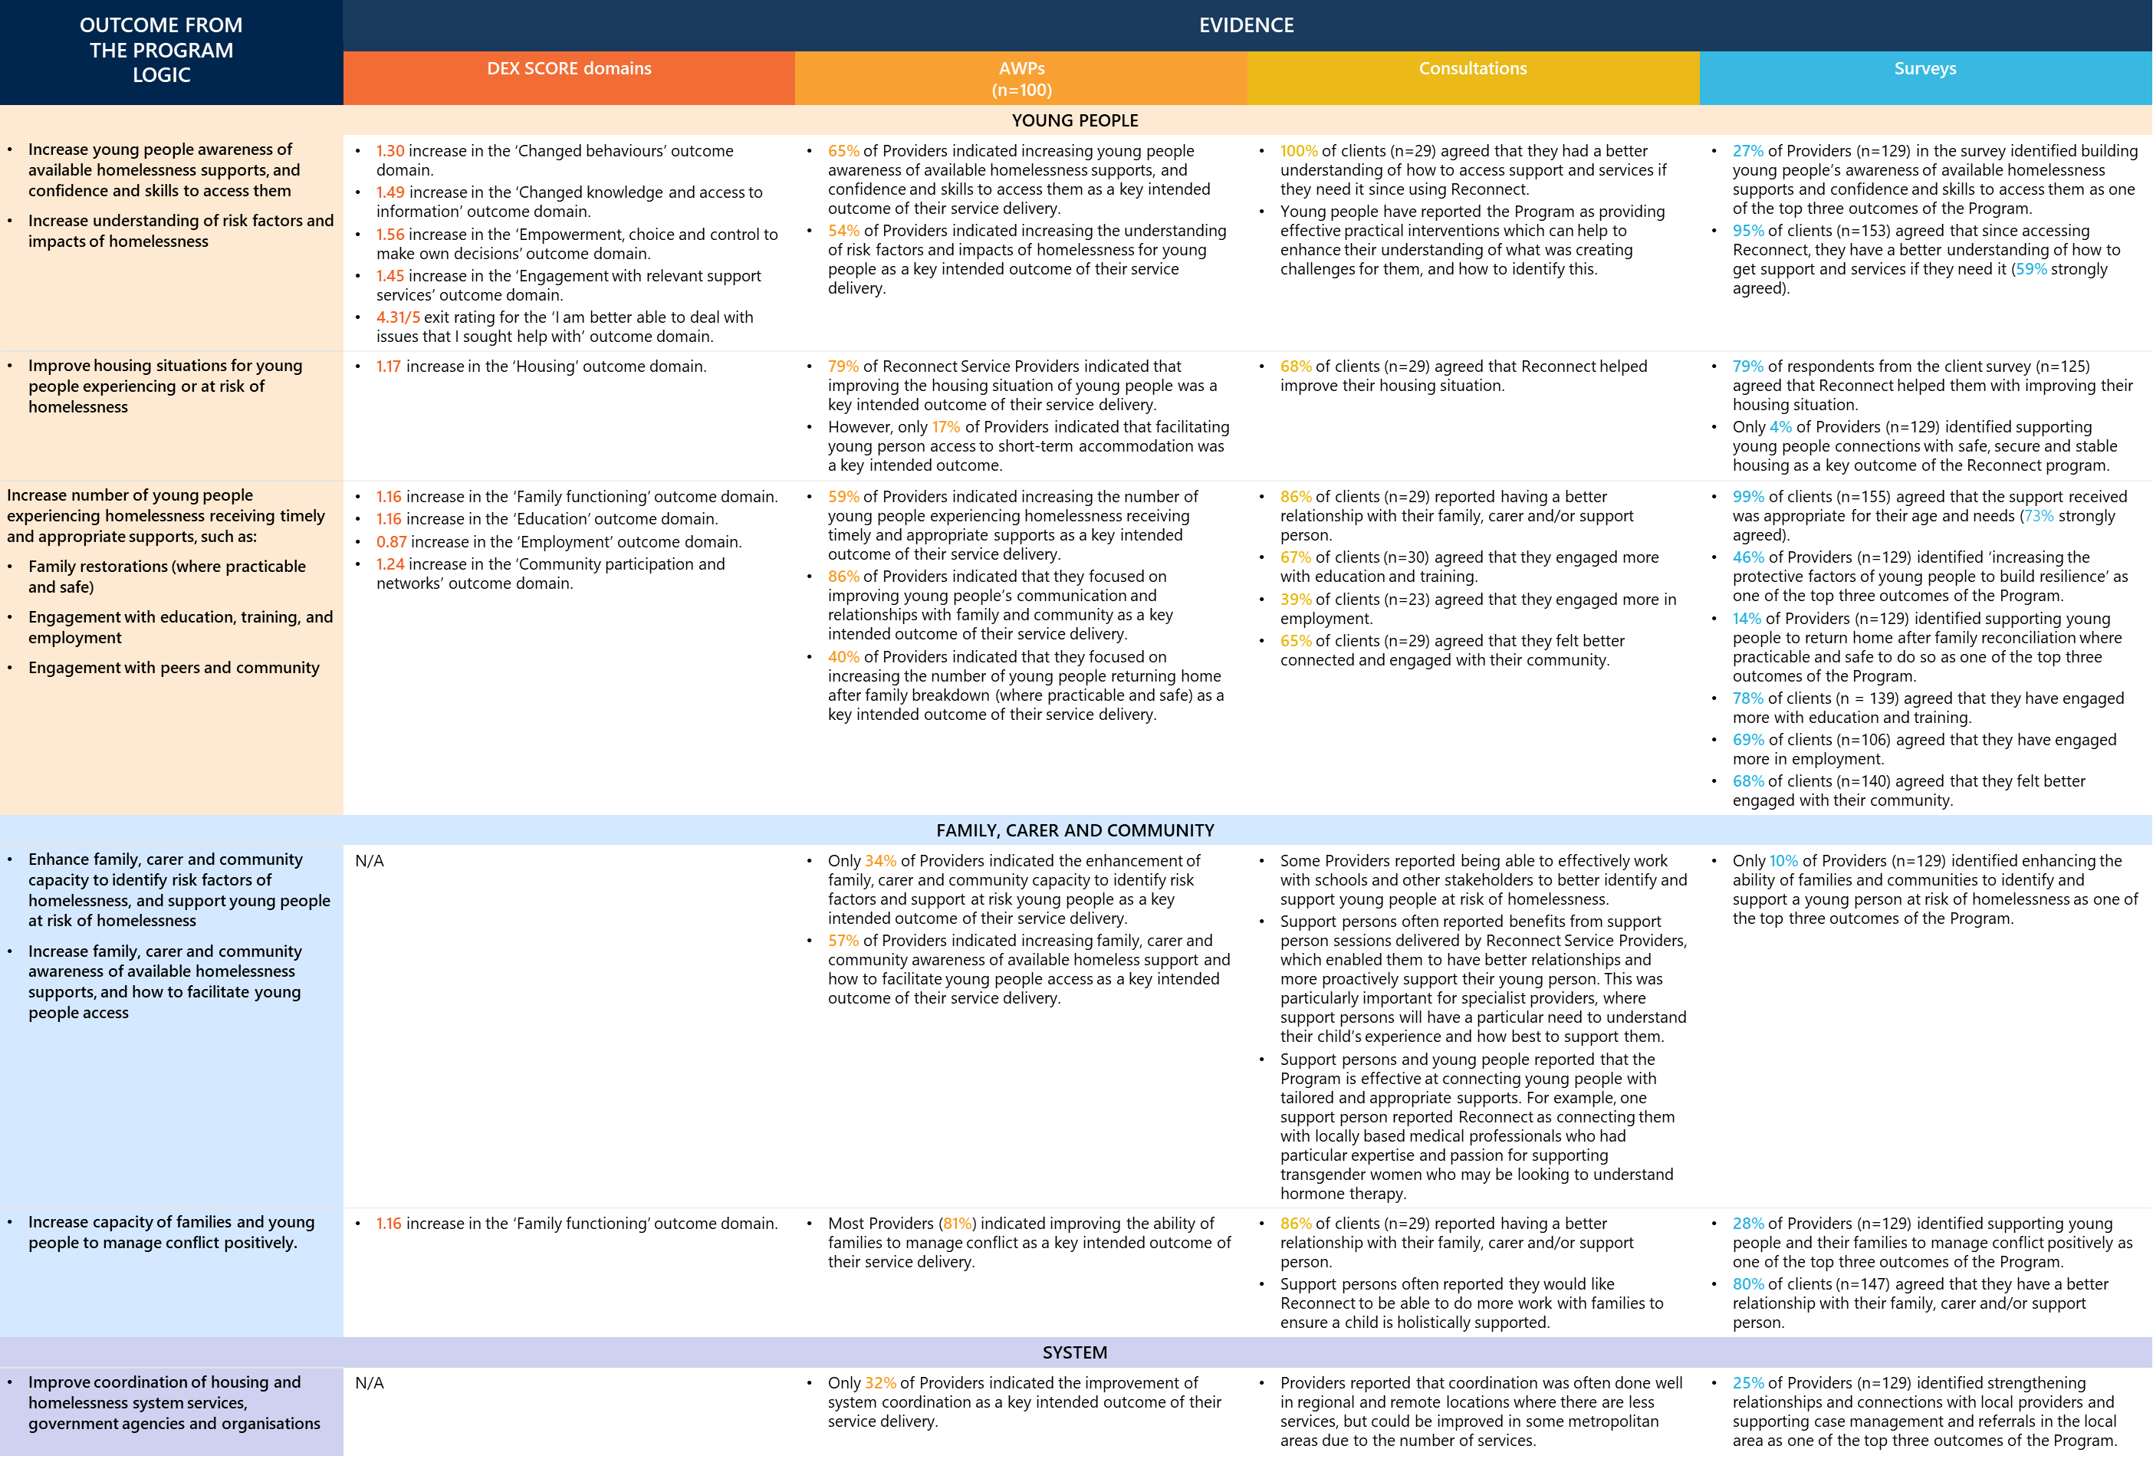

Reconnect can improve the housing situation of some children and young people, however, better data is needed to understand its longer-term system impacts

Data suggests that Reconnect has improved the housing situation of some children and young people in the short term.
As outlined above, the DEX and survey data demonstrate that Reconnect has improved the housing situation of some children and young people in the short term:
- There was an increase of 1.17 in the DEX SCORE for a client’s housing indicator (describes improvements in the client’s housing stability or in addressing the impact of poor housing to improve independence, participation and wellbeing).
- Eighty-five per cent of Reconnect Service Providers in the survey (n=97) report that they observe the Program to be effective at reducing people entering into or further into homelessness (50 strongly agree, 32 somewhat agree).
- Seventy-nine per cent of clients in the survey (n=125) reported that Reconnect helped improve their housing situation.
Though the Program Logic identifies medium-term (0 to 6 months after exiting the Program) and long-term outcomes (6 months to 2 years after exiting the Program) that Reconnect aims to achieve, the data collected for the Review predominantly identifies client outcomes close to exiting the Program. Therefore, it is difficult to comment on the extent to which medium-term or longer-term outcomes have been achieved. For instance, DEX data only reports on clients before they exit the Program and does not provide outcomes data for clients in the duration after they have accessed the Program. Further, this Review was not able to compare to a counterfactual group, making it difficult to ascertain the extent to which the Program prevented people from avoiding homelessness in the long-term.

The Program is anecdotally reported to have made positive long-term impacts to the housing situation of children and young people.
Despite this, many Reconnect Service Providers anecdotally reported significant long-term client outcomes achieved by the Program. Reconnect clients and their support persons also highlighted the impact of the Program in improving their housing and overall situation, including their relationships with families and caregivers. This also aligns to historical data which highlighted that early intervention (including the Reconnect program) appeared to account for most of the decrease in youth homelessness from 2001 to 2006 in Australia.
The quotes below and two case studies, shown overleaf in Figure 13, detail Reconnect’s long-term reported impacts. These case studies are based on real stories heard throughout the Review, although some details (e.g. names) have been changed to ensure client anonymity.
“I wouldn’t have been able to get through school and TAFE without my case worker… I now have full time work.”
- Young person
“Our family wouldn’t have survived, [this Program] has supported us through everything.”
- Support person
Figure 13 | Reconnect’s long-term impacts case studies
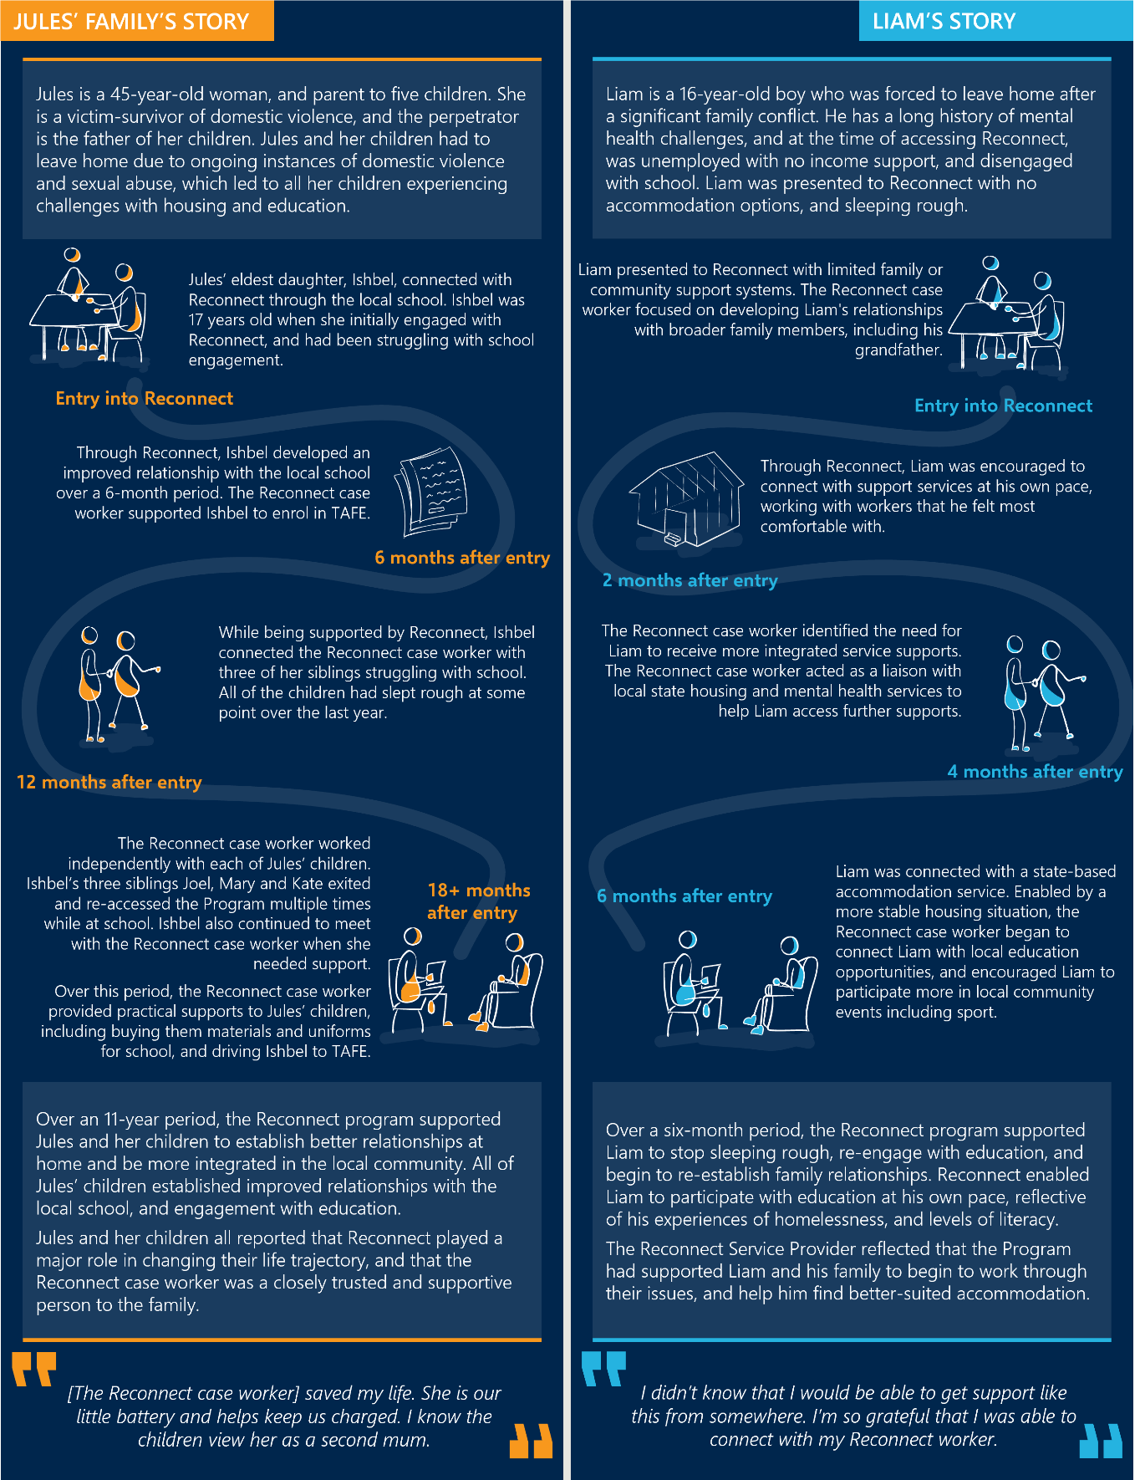

However, there is not a good understanding of the extent to which the Program’s impact translates into the number of people that avoid homelessness over a defined period.
Though the available Program data suggests that Reconnect has improved some children and young people’s housing situations in the short term, the Review was not able to identify the extent to which Reconnect supports people to avoid homelessness over a defined period. The Program in this way could not be compared to a relevant counterfactual and its impact on preventing entries into homelessness is unclear as:
- The Program is an early intervention and prevention program that seeks to reduce entries into homelessness before children and young people enter into homelessness. A low number of children and young people accessed homelessness supports, but this does not illustrate the avoided costs of children and young people entering into the homelessness system (which has limited quantifiable value). For instance, less than half of Reconnect clients reported to have been connected specifically to housing support: 27% of clients in the survey (n=172) and only 8.6% of clients in the DEX data reported accessing housing services as part of Reconnect. Therefore, it is unclear the extent to which other clients at risk were supported so they would not need to access housing supports.
- The Program supports family reconciliation (where practicable and safe), but it is difficult to quantify the avoided cost of homelessness for these children and young people in these cases. Reconnect Service Providers emphasised the importance of family mediation and working closely with families supporting children and young people at risk of or experiencing homelessness. Many Providers noted they were successful in supporting children and young people to stay safely with their families at home (and not enter homelessness). However, this Review was not able to determine the long-term outcomes for these individuals (i.e. whether they experienced homelessness at a later stage). Providers emphasised that they focus working with families where possible to support children and young people not to enter homelessness (and stay in their family homes), as they are often limited in their ability to connect young people with safe, secure and stable housing.
- Additionally, there are limitations for the homeless indicator used in the DEX data. It is not mandatory to report on this indicator and there is no protocol for when in the client’s journey this should be completed. Furthermore, there is no way to assess whether a client’s homeless indicator changed throughout the Program and therefore whether a client was able to access safe and secure housing through Reconnect.

The DEX SCORE data reveals that Reconnect has achieved better outcomes across different client demographics

The DEX SCORE data suggests that Reconnect has been more effective in achieving short-term outcomes for children and young people from a CALD background and those with a disability, and less effective for Aboriginal and Torres Strait Islander children and young people.
In comparing the short-term outcomes Reconnect has achieved for different cohorts, the DEX SCORE data suggests that the Program has achieved better outcomes for people that identify as CALD and people that identify as experiencing disability, and relatively poorer outcomes for people who identify as Aboriginal and Torres Strait Islander. The longer service duration identified through the DEX data and typical provision of individualised support identified by Reconnect specialist Providers are likely factors in this achievement of outcomes, and are detailed further in Figure 14 below.
Figure 14 | Short-term outcomes for clients across different cohort groups
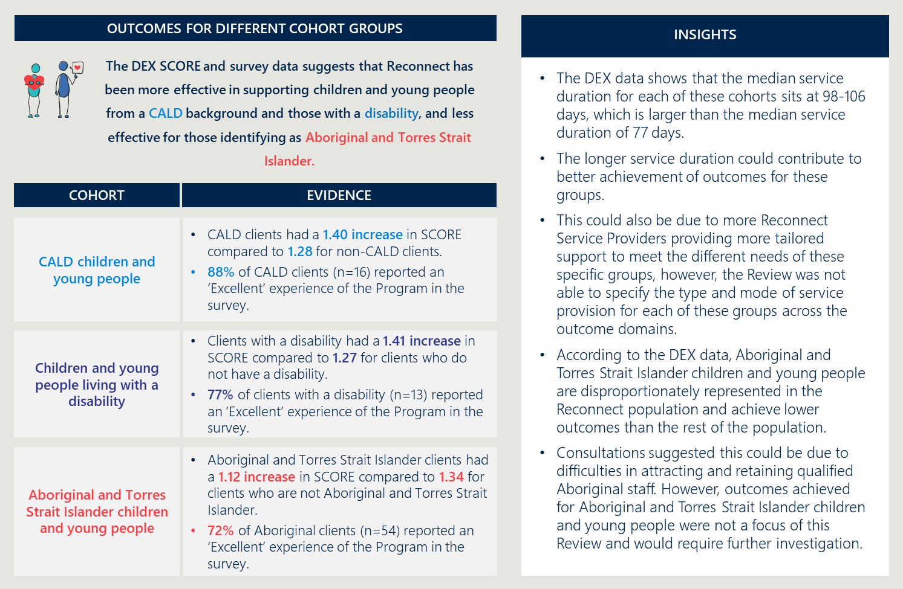

The DEX SCORE data suggests that Reconnect has been more effective in achieving short-term outcomes for older cohorts.
In comparing the short-term outcomes for clients across different age groups, the DEX SCORE data suggests that older cohorts achieved better outcomes compared to younger cohorts. This was mostly due to older cohorts achieving relatively better outcomes across employment and housing supports (as older cohorts are more likely to access and be in need of these supports given the stage they are at), detailed further in Figure 15 below.
Figure 15 | Short-term outcomes for clients across different age groups
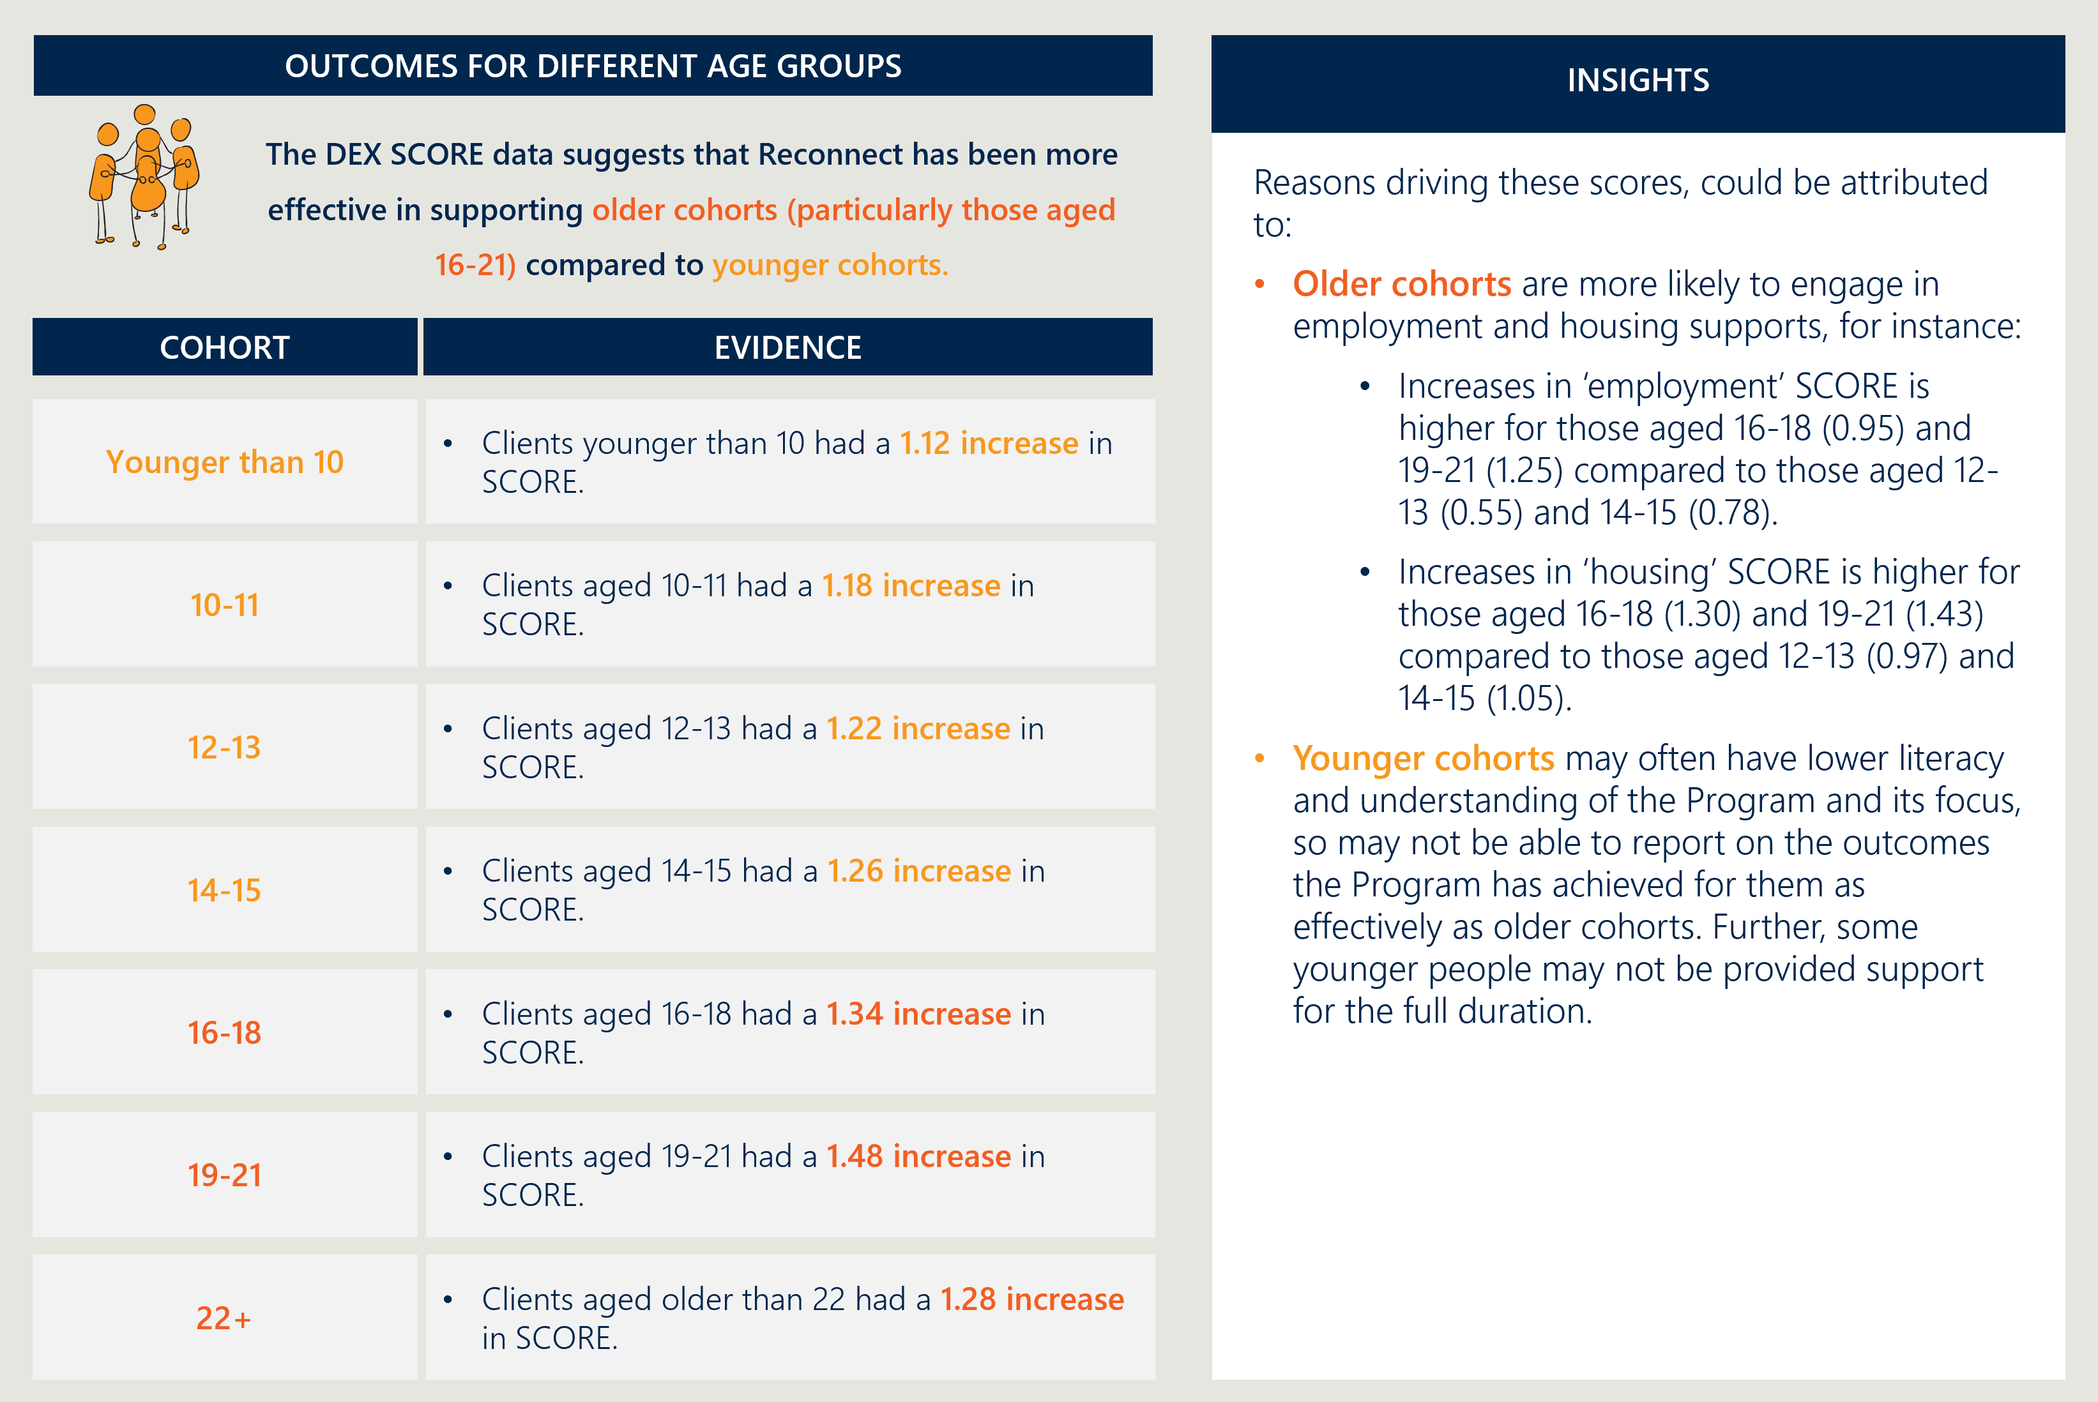

The DEX SCORE data suggests that Reconnect has been more effective in achieving short-term outcomes for children and young people from non-specialist Providers compared to specialist Providers.
In comparing the short-term outcomes for clients across types of Reconnect services, the DEX SCORE data suggest that clients from non-specialist Providers reported slightly higher outcomes. This is detailed further in Figure 16 below.
Figure 16 | Short-term outcomes for clients across types of Reconnect services
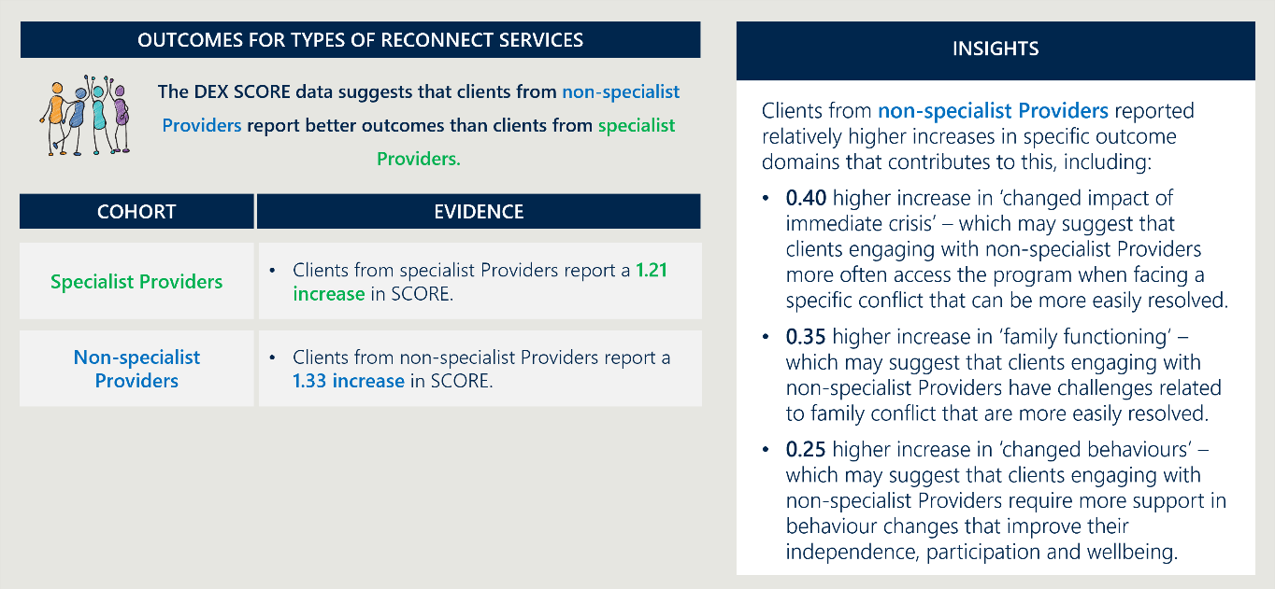

The DEX SCORE data suggests that Reconnect has been more effective in achieving short-term outcomes for children and young people in metropolitan and regional areas compared to remote areas.
In comparing the short-term outcomes Reconnect has achieved for children and young people across metropolitan, regional and remote areas, the DEX SCORE data suggests that those in remote areas achieved relatively lower improvements in outcomes. This is likely due to the lack of available services, staff recruitment and retention challenges, further detailed in Figure 17 below.
Figure 17 | Short-term outcomes for clients across different geographic locations
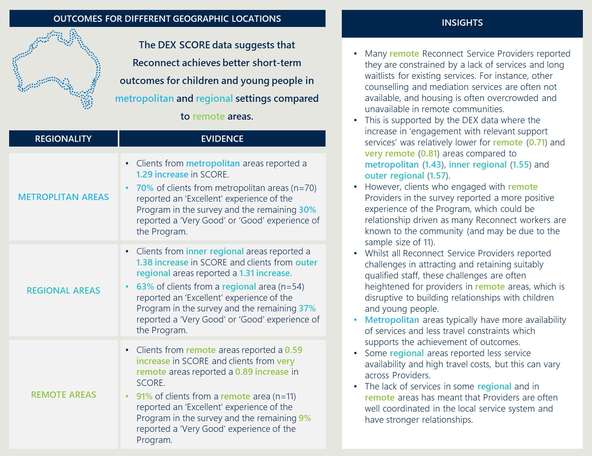

Several key factors contribute to the effectiveness of Reconnect’s service access, reach and achievement of outcomes
A number of key factors that impact service access, reach and achievement of outcomes were identified through the literature and consultation with Reconnect Service Providers. These factors occur at three key levels, as detailed below in Figure 18.
Figure 18 | Key factors that impact service access, reach and achievement of outcomes

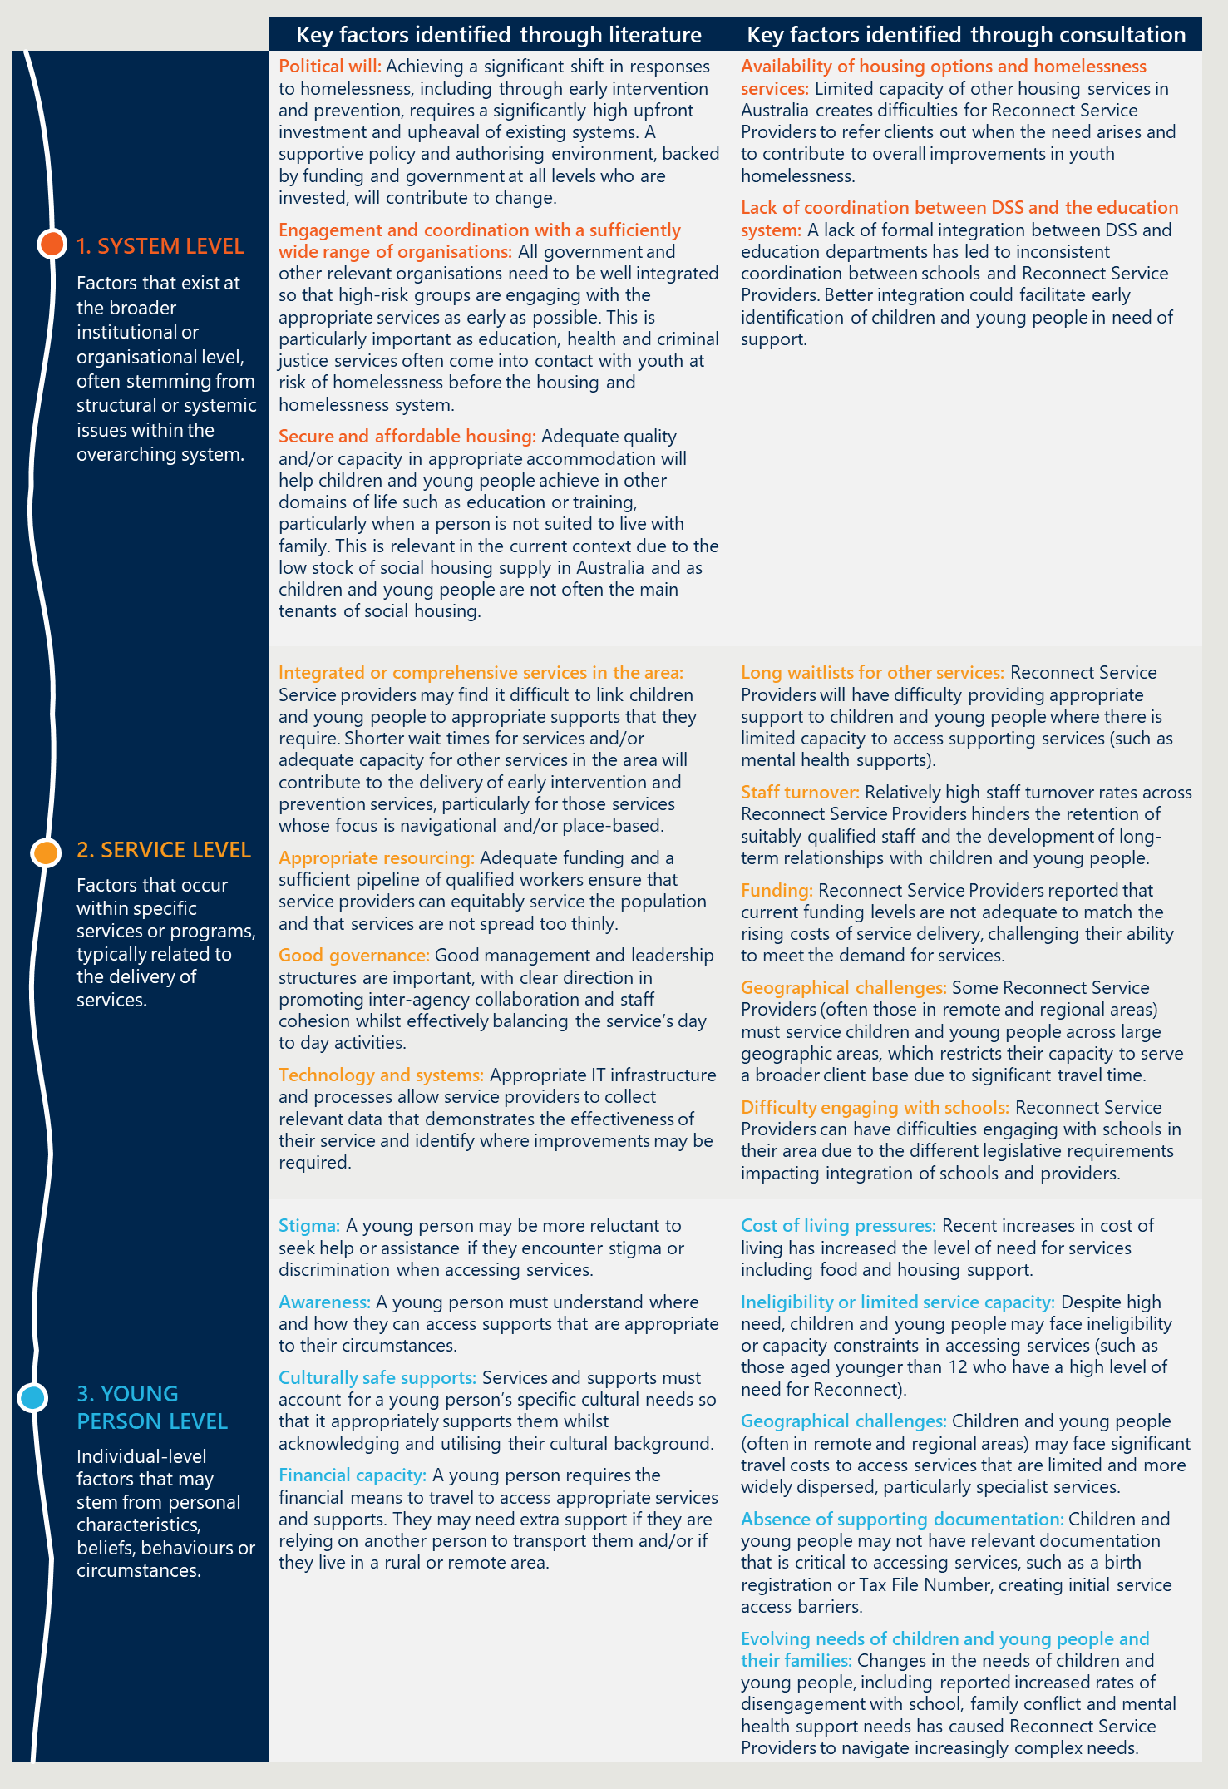

The existing Data Exchange performance indicators could be improved to better measure Reconnect’s effectiveness
Reconnect Service Providers reported that the Data Exchange (DEX) performance indicators are not an effective way to measure Reconnect’s outcomes, with only 43% of surveyed Reconnect Service Providers (n=94) agreeing that the DEX outcome measures are an appropriate measure of the Program’s effectiveness. This can be due to:
- It being challenging for Reconnect Service Providers to interpret DEX SCORE measures. The Review found some Service Providers are potentially interpreting outcome measures differently, making it difficult to compare DEX SCORE data across the Program. For example, Reconnect Service Providers may interpret a ‘change’ in employment outcomes differently which reduces the comparability of scores provided.
- Reconnect Service Provider data recording challenges when reporting on different measures. For example, the gender of clients, the number of group clients that have attended, the type of activity, the number of people who have accessed different types of services where multiple Reconnect services are delivered by the Provider (e.g. separate group work and counselling activities).
“DEX data entry doesn’t capture the whole picture. (It can be similar to) ‘choosing the lesser of two evils’. You know young people aren’t living in ideal conditions but it’s safer than other options.”
- Reconnect Service Provider
- Outcomes being difficult to capture in DEX for support persons. Support persons were reported as an important aspect of service delivery (especially for family mediation activities), but DEX was reported to provide limited outcome reporting opportunities for support persons as a cohort.
- DEX outcomes relating to effectiveness not being reported back to Providers. Through consultation, Reconnect Service Providers indicated that they would value acknowledgement and feedback on the reported program data to DSS through the DEX system and the AWPs. It was reported that it would be valuable to hear feedback from DSS on the reports to understand their individual performance and how this compares to the performance at a program level.

Reconnect has been reliant on supporting systems and services to achieve positive outcomes for its clients

The availability of supporting services facilitates positive outcomes for children and young people.
Though Reconnect has demonstrated it is largely effective in achieving its intended outcomes, the Program has been reliant on other services and supports to achieve these outcomes. This is both through identification and referral into the Program, and referral out to different supports outside of the Program (as outlined previously in Figure 12). Reconnect Service Providers reported that other organisations act as a key intake pathway and that they struggle to provide effective supports to children and young people without the support of other dedicated services, particularly where they have more complex mental health or housing needs.
The importance of having available supporting systems and services
means that achieving positive outcomes varies depending on the specific context of Providers. This has been outlined in the outcomes across remoteness areas (refer to Figure 17), where outcomes achieved in metropolitan and regional areas were relatively higher than those in remote areas, with Providers reporting this was due to greater service availability. Further, Providers in regional and remote areas reported the lack of other services to refer to, often means they are providing more support to children and young people outside of the scope of Reconnect’s intended model. This includes providing more support to young people in crisis (see section 3.4).
“We often refer clients or their families internally to our other services – which is more efficient than referring between separate organisations. This represents economies of scale.
- Reconnect Service Provider
Additionally, larger organisations (i.e. those with more internal supporting services and staff) reported being able to provide more wrap around support to clients, and to refer in and out of other programs and services they deliver, benefiting children and young people.

Schools are a key supporting stakeholder for Reconnect Service Providers, but integration with schools varies across states and territories.
Reconnect Service Providers reported that schools are a major stakeholder that contributes to positive outcomes for clients as the key referral in source to Reconnect. For instance:
- 35% of referrals into the Program were through educational agencies (the largest referral source into the Program).
“We have worked really hard to keep strong relationships with the school wellbeing teams… we know the staff and the staff know us.”
- Reconnect Service Provider
- 80% of Reconnect Service Providers in the survey (n=96) reflect they work with the education system ‘very often’, with a further 19% reflecting they work with the system ‘often’.
- 100% of AWPs (n=100) identified schools as a key stakeholder as part of their service delivery.
Therefore, schools are a major stakeholder for Providers to integrate with, as schools play a key role in enabling the identification and referral of children and young people into the Program. As an early intervention and prevention program, it is particularly important that the identification and referral of children and young people happens as early as possible. If this is conducted too late, the child or young person will likely be engaged in a service elsewhere, such as a crisis service.
“We have a good relationship with the primary and secondary schools… but the other Reconnect worker has struggled for a long time with getting access to the schools.”
- Reconnect Service Provider
Despite the importance of schools as a stakeholder for the Program, Reconnect Service Providers reported a mixed view on the strength of their relationship with local schools. Some Reconnect Service Providers will work with more than 10 local schools and have strong relationships to support referral pathways. However, other Reconnect Service Providers have faced barriers to working effectively with the schools and do not have any arrangements with the local schools. Further, engagement with schools tends to vary across states and territories given the different legislative requirements that Reconnect Service Providers face, such as consent from parents and having Reconnect staff presence on-site. Effective integration between Reconnect Service Providers and schools will support the early identification and referral into the Program, contributing to the effectiveness of Reconnect as an early intervention and prevention program.

The future of Reconnect

The section seeks to answer the following Review KLE: What are some of the ongoing or emerging findings that could support short term adjustment of the Reconnect program? It also provides opportunities for Reconnect in the future for the Australian Government to consider – aligning to the investment and direction of the National Housing and Homelessness Plan.

Reconnect is a long-standing program that has supported the Australian Government’s response to youth homelessness. It is also the Commonwealth’s only investment in early intervention and prevention for children and young people at risk of or experiencing homelessness. It is highly valued by the communities it works with and has improved short term outcomes for children and young people. It also represents value for money, as the Program is cost efficient for the Australian Government and is a relatively small investment compared to other homelessness programs. However, Reconnect Service Providers operate in very different circumstances – including responding to different children and young people with varying needs based on their geographical area, level of socioeconomic disadvantage, organisational maturity and scale.
These factors and the changing service landscape have resulted in the Reconnect program being implemented differently across the 101 funded activities across Australia and makes it difficult to understand the impact at a Program level. Whilst this model works for the Providers and the communities it supports, there is an opportunity for DSS to be more intentional in the design and implementation of Reconnect to bring a greater return on investment in the service system landscape.
What should Reconnect be in the future?
As outlined in section 5.3, the evidence outlines that early intervention and prevention initiatives build protective factors which can reduce future interactions with the service system, and the occurrence and reoccurrence of youth homelessness. The literature outlines eight key best practice features in early intervention and prevention responses to youth homelessness in Australia and overseas, including: coordinated entry, person-centred case management, effective data collection and monitoring, tailored services, culturally appropriate and trauma informed, strengths based, and trusting and respectful relationships. Similar to the evaluation conducted in 2012-2013, this Review found that the Reconnect program already aligns to best practice and plays a key role in the service system.
There is still a role for Reconnect in the future as an early intervention and prevention service. However, there are changes that could support a transition and implementation of a more integrated, effective and efficient model. Change to the Reconnect program needs to be driven by, and cognisant of the broader system context, including:
- The Australian Government’s focus on prevention and early intervention initiatives and coordinated service responses in the National Housing and Homelessness Plan.
- The large difference in the need, context, service model and reliance on other services for the Reconnect program to be effective.
- The need for some formal, evidence-based structure to influence the system to achieve outcomes (e.g. the Collective Impact model).
These factors and the findings from this Review provide opportunities and considerations for the Australian Government on how Reconnect could look in the future. It also provides possible options for improvement framed by the Collective Impact model (detailed below).

Why the Collective Impact model?
Collective Impact is based on the premise that there is no one model for service-based program delivery that will be effective for solving complex social issues. It acknowledges the interactions and complexity between service responses that require contributions from many actors within a system. It is a collaborative approach to addressing complex social issues, consisting of five conditions: a common agenda; continuous communication; mutually reinforcing activities; backbone support; and shared measurement.
The Review has identified opportunities for the Australian Government to consider to influence the system through a more targeted design and implementation of the Reconnect program. This includes defining the role of the Reconnect program in the system and acknowledging the role that key partners and agencies play in its delivery. The Collective Impact model provides a useful framing for Reconnect’s opportunities as it provides greater intention for Reconnect activities which in turn, improves opportunities for impact against investment.
This tightening of focus and approach will be a change for currently funded Providers, some of whom may only partly be operating in this way. Being clearer through the Operational Guidelines about the Collective Impact frame and the role of Reconnect will help services to understand that DSS is seeking a more deliberate and targeted intervention. Whilst there are limitations to this framework, DSS has the levers to embed good practices to support its success, including engaging closely with the sector and Reconnect Service Providers during this process and ensuring their voices are guiding the reform.
A summary is provided in Figure 19 – and is further detailed below.

Figure 19 | Opportunities for Reconnect in the future
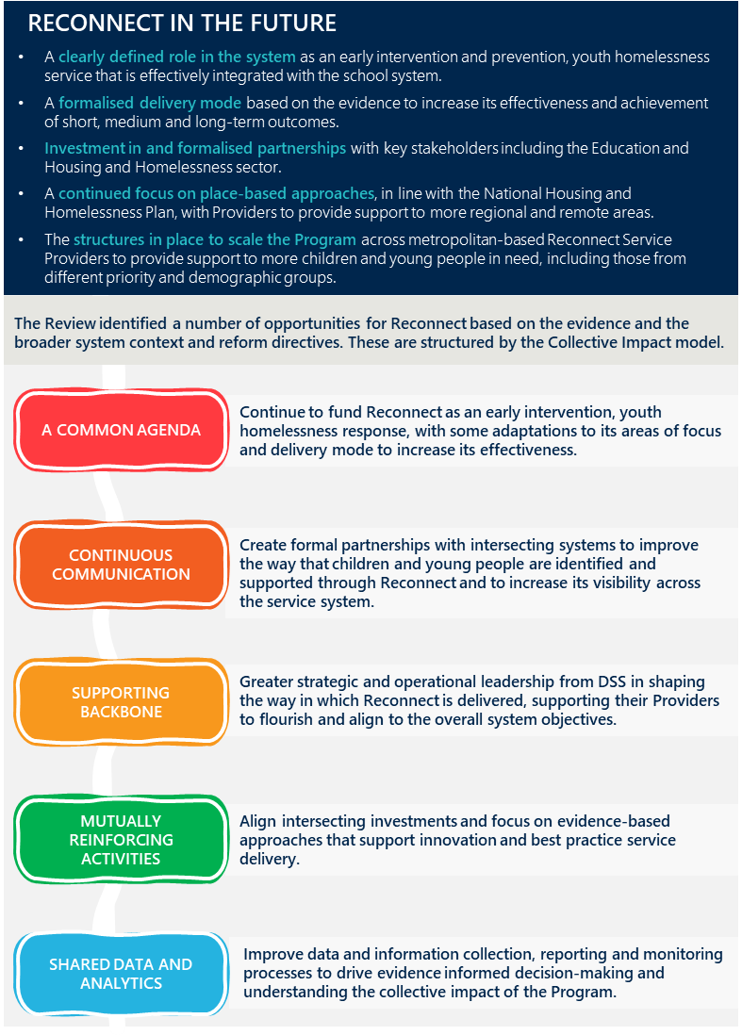
The Review has identified specific actions related to the above opportunities. These are detailed in Table 7 overleaf.
Table 7 | Actions to support implementation of the new Reconnect model
Opportunities | Actions | Rationale
A COMMON AGENDA
a) Continue to fund Reconnect as an early intervention, youth homelessness response, with some adaptations to its areas of focus and delivery mode to increase its effectiveness. | - Revise the Operational Guidelines to define Reconnect’s role and model in the system including:  - Being more explicit about the youth homelessness focus  - Building protective factors and its focus on early intervention and prevention  - Supporting younger years (below 12) with appropriate considerations  - Greater focus on family and carer engagement  - Acknowledging the role partners/connected services play in the delivery of Reconnect – including the referral pathways in and out  - Revising the length of service to be linked to the type of support (e.g. type of activity to the corresponding need) of children and young people they are supporting. | Reconnect has evolved over time, filling local needs and delivering a broader service than originally intended.  The Reconnect program is highly valued by Reconnect clients, their families and support persons and the Reconnect Service Providers. The Review found that Reconnect plays an important role in Australia’s national housing and homelessness landscape – and should continue to be funded. However, there is an opportunity for adaptations to Reconnect’s areas of focus and delivery mode to increase its effectiveness.  The flexibility of the current Operational Guidelines has driven Reconnect to evolve its service offer and deliver a broader and, in some cases, diluted service than intended. Stakeholders emphasised that there needs to be a greater awareness of and information about Reconnect’s role, model and its partners in the guidelines to support its delivery and management.
CONTINUOUS COMMUNICATION
b) Create formal partnerships with intersecting systems to improve the way that young people are identified and supported through Reconnect and to increase its visibility across the service system. | - Create a formal partnership with the school system to improve the way that children and young people are identified and supported through Reconnect.  - Undertake regular forums with relevant government counterparts to promote the Program and identify greater opportunities for intersection between state and territory-based government programs (housing and education). | Reconnect is heavily reliant on schools for identifying children and young people eligible for their service but are not well connected.  Some Reconnect Service Providers will work with more than 10 local schools and have strong relationships to support referral pathways. However, other Reconnect Service Providers have faced barriers to working effectively with the schools and do not have any arrangements with the local schools (see section 5.8).  As educational agencies are the biggest referrer into the Program (~35%) – the Review found that a more formalised partnership with the school system should be developed to support more efficient referrals and greater identification of children and young people at risk before entering homelessness.  Reconnect is not as visible across the system as it could be.  Further, as the Program has mixed visibility across the system – there are opportunities for greater collaboration across state and territory government counterparts to promote the Program, identify greater opportunities for coordination and intersection between the housing and education systems.
SUPPORTING BACKBONE
c) Provide greater strategic and operational leadership from DSS in shaping the way in which Reconnect is delivered, supporting their Providers to flourish and align to the overall system objectives. | - Improve the overall service level efficiency, focusing efforts to uplift service performance and share good practice from those Providers that are achieving good outcomes for children and young people.  - DSS to provide more operational and strategic support to provide guidance at a service level around activities aligned to considerations of what works within the local service system.  - Undertake population-based mapping in the future to understand whether Reconnect activities and outlets are in the right geographical locations with incidence of socio-economic need and demand to support future planning – specifically, where there are opportunities to scale the Program, where placed based approaches need to continue, and where there is greater demand, particularly for specialist cohorts. | Greater strategic and operational support is required – both through the administration of the Program and through the FAMs.  The Review found that DSS needs to provide greater strategic and operational leadership in shaping the way Reconnect is delivered. Building on the findings from this Review, DSS should improve the overall service level efficiency, focussing resources on uplifting service performance where required to maximise the government’s investment in the Program.  Reconnect Service Providers emphasised that they would value greater input and support from FAMs, especially in cases where there has been high turnover in these roles across the board. There is appetite for the FAMs to provide more consistent support, regular communication and to connect Providers in similar areas to share insights and good practice.  It is unclear the extent to which Reconnect outlets are in the right location based on the need and demand.  Finally, whilst not in scope for this Review, previous evaluations and stakeholders reported that Reconnect activities and outlets may not be in the right geographic locations for current socio-economic need. There is an opportunity for DSS to undertake this population-based mapping and to understand the demand for support for children and young people, including those from specialist cohorts. This will support the transition to place-based approaches and scale up opportunities in the future.
MUTUALLY REINFORCING ACTIVITIES
d) Align intersecting investments and focus on evidence-based approaches that support innovation and best practice service delivery. | - Deliberately identify similar and interconnected investments to Reconnect across DSS and how they can mutually reinforce the activities and outcomes of the Program and the system. This includes ongoing system level work such as development of the National Housing and Homelessness Plan, and delivery of aligned initiatives such as Strong and Resilient Communities.  - Re-establish the Community of Practice for Reconnect, ensuring alignment to evidenced based practice and support continuous improvement. | Greater alignment to similar investments across DSS is required.  The housing and homelessness system is undergoing reform and there are a myriad of strategic frameworks, directives and investments in programs that are interconnected with Reconnect. Currently, there is no targeted or systematic approach to mapping these inter dependencies or opportunities for mutually reinforcing activities to drive greater collective impact (see section 3.1).  The program needs to integrate evidence-based approaches that support innovation and continuous improvement.  As Reconnect is unique and is delivered by 70 different organisations operating in different circumstances – it is important that evidence-based and best practice approaches are underpinning and supporting the continuous improvement of the Program.  Evidence suggests that early intervention and prevention continues to be a useful mechanism to identify children and young people at risk of homelessness based on their associated risk factors and support the development of their protective factors. A continued focus on these aspects and what works in early intervention and prevention will be an important focus (see section 3.1 for more detail).  These need to be reflected through the Operational Guidelines (see Action 1), shared by DSS through regular forums and communication with Providers (see Action 5 and below).  Greater connection and collaboration opportunities for the Providers would be valued.  Reconnect Service Providers emphasised that they valued the opportunities to participate in forums with other Providers to share insights and good practice. It was reported that these are no longer being delivered consistently and Providers would value the opportunity for these to be re-established through a Community of Practice.
SHARED DATA AND ANALYTICS
e) Improve data and information collection, reporting and monitoring processes to drive evidence informed decision-making and understanding the collective impact of the Program. | - Re-design the DEX outcome measures and reporting process to align and support changes to the Operational Guidelines (see Action 1).  - Streamline reporting and enhance monitoring and data collection processes to ensure the consistent collection of data aligned to the Program objectives.  - Provide training for Reconnect workers based on the revised DEX reporting and monitoring process.  - Share reported program data back to Reconnect Service Providers to support continuous performance improvement and decision-making. | There are ongoing challenges with the DEX system – and its measures do not support the reporting on the collective impact of the Program.  As highlighted throughout this report, there are a number of limitations with the DEX system and the reporting process (see section 5.7). Stakeholders emphasised the ongoing challenges with the DEX system, including that the system/reporting system can be duplicative and not an accurate depiction of service activity. This is consistent with the 2003 evaluation of Reconnect, which highlighted that the quality of data could be improved to understanding Reconnect’s ongoing effectiveness.  Training on DEX reporting and feedback on reported data would be valued.  Further, the 2012-2013 evaluation recommended that training be conducted to improve the overall capability of both DSS staff and Reconnect Service Providers in using and managing Reconnect’s online data platform. This was consistent with findings from this Review (see section 3.6).  Reconnect Service Providers also reported they don’t get feedback or further program impact information to support them with monitoring their performance or understanding the impact at a program level. Reconnect Service Providers reported that it would be valuable to hear feedback from DSS on the reported program data to understand their individual performance and how this compares to the performance at a program level.

What are the critical success factors?
Nous acknowledges that moving to a Collective Impact model from a grant model would require a transition period and possible additional funding. However, the actions under the proposed model have been designed to manage risk, building on the good elements of the current Program, and minimising the service gap risk if the Australian Government decided to recommission all services within the Program at once. To support this transition, several factors should be considered to aid the preparation and implementation of the proposed changes to Reconnect. This will need to be driven by the Reconnect policy team, drawing on other areas of DSS to support with key activities, including the DEX and data visualisation teams, the Family Policy Branch and Children’s Policy Branch, and the FAMs (through the Community Grants Hub).
These factors are:
- Clear governance and accountability. Successful implementation needs clear governance arrangements and an ultimate point of accountability to monitor progress, hold people to account and coordinate the involvement of the stakeholders.
- A clear engagement approach that brings the sector on the journey of the reform. This needs to be supported by transparent communication and provide opportunities for input through the preparation and implementation stages.
- The right resourcing and capacity. Implementation needs to be resourced appropriately – both within the Reconnect policy team and with the FAMs. Planning for this needs to be targeted and considered for the time period required for reform.
- Investment in partnerships and relationships within DSS and across the system. Implementation will require investment to strengthen partnerships within DSS, across the Australian and state and territory governments, and with the sector.
How to get there?
This section outlines how DSS can transition to this new model, recognising that the next 12 months will be focussed on preparatory activities to mobilise and support the transition. Implementation of the new model should commence at the completion of the current funding period and Operational Guidelines timeframe (end of 2026).
Table 8 below provides the blueprint for DSS to implement the actions identified above.

Table 8 | Implementation plan
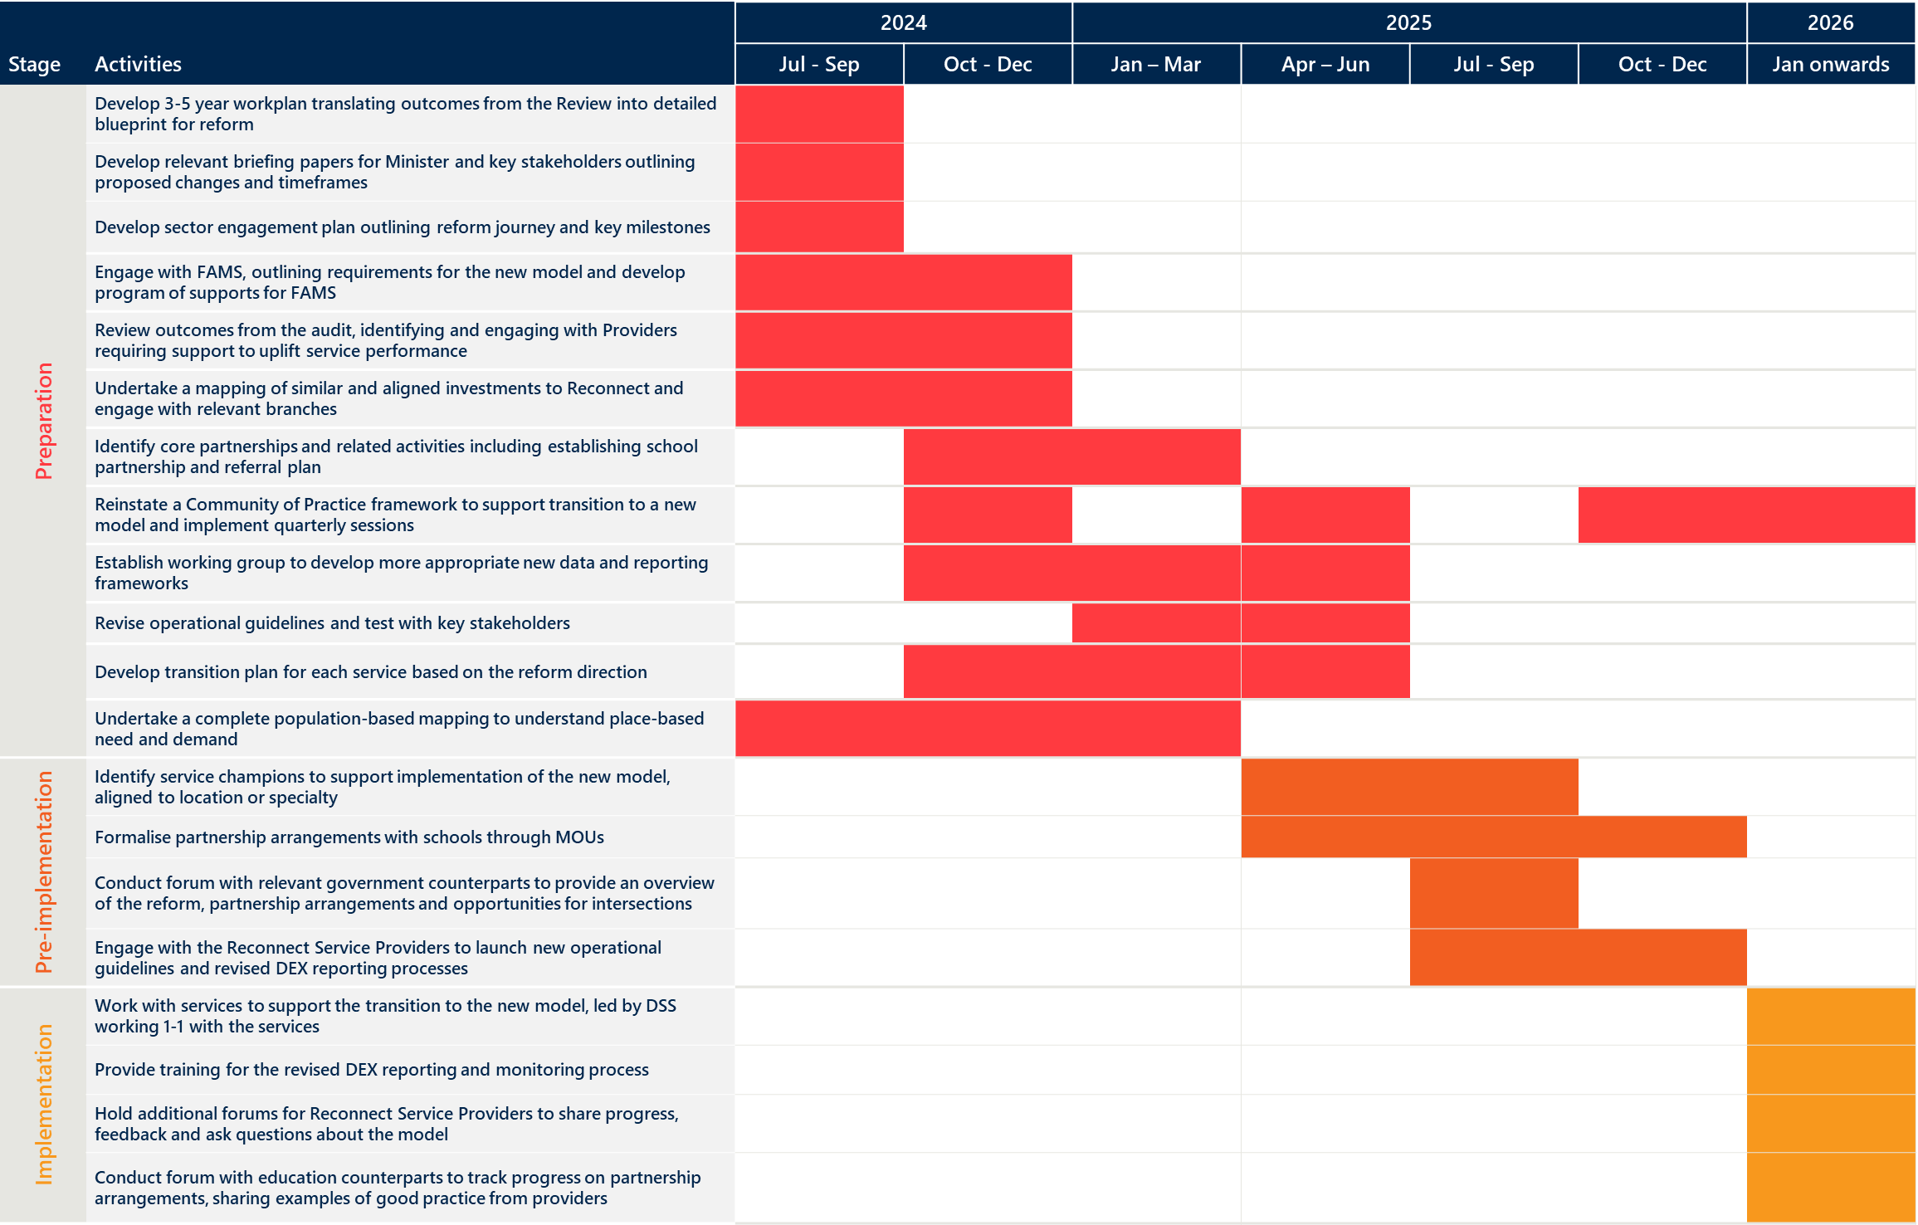
- Review approach

This section outlines the Review’s methodology and key data collection activities, including the:
- Literature review
- Review and analysis of program documentation and data
- Consultations.

Review methodology
The Review was delivered through a mixed methods approach, drawing on primary and secondary data sources to collect quantitative and qualitative data and information. Nous’ Organisation Architecture Framework was adapted to guide the analysis, findings and recommendations for this Review. It deconstructed different elements of the Program and its service model to provide structure for the findings and recommendations for the Review.
The Review investigated four Key Lines of Enquiry (KLEs):
- Appropriateness (KLE 1): Are the Reconnect program’s desired outcomes appropriate for community needs, policy priorities and operating context?
- Efficiency (KLE 2): Does the Reconnect program represent value-for-money for the Australian Government?
- Effectiveness (KLE 3A): To what extent is the Reconnect program achieving its desired outcomes? For whom?
- Effectiveness (KLE 3B): What are some of the ongoing or emerging findings that could support the short-term adjustment of the Reconnect program?
Table 9 provides an overview of the Review’s KLEs and Sub-KLEs.
Table 9 | Review KLEs and Sub-KLEs
KLEs | Sub-KLEs
1. Appropriateness  Are the Reconnect program’s desired outcomes appropriate for community needs, policy priorities and operating context? | 1.1 What is the Reconnect program? (e.g., service delivery models, system access points, reach, intended client groups)
 | 1.2 Does early intervention and prevention remain relevant to helping prevent youth homelessness?
 | 1.3 What does best practice in early intervention and prevention responses for youth homelessness look like?
 | 1.4 What are the key enablers or barriers for early intervention and prevention response models?
 | 1.5 What is the nature and extent of the problem in youth homelessness across Australia, and need for early intervention and prevention responses?
 | 1.6 To what extent does the Reconnect program’s desired outcomes respond to the identified need? (e.g. is it culturally appropriate, of sufficient scale, relevant to specific client groups)
 | 1.7 To what extent does the Reconnect program align with policy priorities for the Australian Government and DSS?
 | 1.8 What other programs seek to respond to youth homelessness?
 | 1.9 How does the Reconnect program intersect with existing early intervention and prevention supports, and broader initiatives across the housing continuum?
 | 1.10 How have the economic, environmental and social conditions changed since establishment of the Program?
 | 1.11 How have the Reconnect program’s outcomes changed since establishment of the Program?
 | 1.12 To what extent is the Reconnect program being implemented as intended?
 | 1.13 To what extent is the Reconnect program meeting the needs of children and young people, including those from different priority and demographic groups?
 | 1.14 To what extent is delivery of the Reconnect program filling a gap in local service systems?
2. Efficiency  Does the Reconnect program represent value-for-money for the Australian Government? | 2.1 What resources (direct funding, capital investment, and people) have been deployed, and for what purposes?
 | 2.2 What is the cost per output/activity/person?
 | 2.3 What is the cost per outcome?
2.4 How cost effective has the delivery of outputs been considering:
- Average service costs across the Program
- Comparable early intervention and prevention programs
- Other services delivered across the housing continuum
3A. Effectiveness  To what extent is the Reconnect program achieving its desired outcomes? For whom? | 3.1 To what extent is the Reconnect program achieving its intended short-term outcomes for children and young people, family, carers and community, and the system? (see Program Logic in Appendix B)
 | 3.2 To what extent is the Reconnect program achieving its intended medium-term outcomes for children and young people, family, carers and community, and the system? (see Program Logic in Appendix B)
 | 3.3 To what extent is the Reconnect program achieving its intended long-term outcomes for children and young people, family, carers and community, and the system? (see Program Logic in Appendix B)
 | 3.4 What factors have helped or hindered service access, reach, and achievement of outcomes? (e.g., resourcing; service capacity; eligibility for services; service access; coordination; community awareness or perception)
 | 3.5 Are the existing Data Exchange performance indicators adequate as a measure of the Program’s effectiveness?
3B. Effectiveness  What are some of the ongoing or emerging findings that could support the short-term adjustment of the Reconnect program? | 3.6 What are the pragmatic changes that can be made in the short term to improve achievement of Reconnect program outcomes?

Literature review
A rapid desktop review and analysis of literature was undertaken to investigate Reconnect’s context, and explore best practice in early intervention and prevention youth homelessness responses.
The literature review included analysis of:
- Academic / grey literature documents
- Australian, state or territory government policy documents
- Previous evaluations of Reconnect.
These are detailed in this document’s endnotes in Appendix F.

Review and analysis of program documentation and data
The Review involved analysis of Reconnect program documentation and data to explore what has been delivered and funded through the Program, and impacts and outcomes. This included analysis of:
- The Reconnect program’s Operational Guidelines to understand intended program outcomes, and Reconnect program changes over time.
- 388 Activity Work Plans (AWPs) to understand what Reconnect Service Providers intend to deliver through the Reconnect program, program outcomes, costs and key delivery partners. The AWPs also supported qualitative analysis of Reconnect Service Provider experiences.
- DEX and DEX SCORE data to understand what has been delivered through the Reconnect program over time, funding data, and SCORE impacts and outcomes associated with the Program.
Data was analysed through qualitative and quantitative data analysis methods, detailed in Table 10.
Table 10 | Qualitative and quantitative analysis methods
Qualitative analysis methods | Thematic analysis was used to deliver illustrative qualitative insights regarding the data, and key insights and messages.  The qualitative analysis provided an additional level of detail to reviewed secondary data, and delivered key insights regarding individual experiences with Reconnect, and identified what works, for whom, in what context.
Quantitative analysis methods | - Descriptive statistics. This analysis method investigated what was delivered by the Reconnect program and how this varies across Australia and different service types. Descriptive statistical analysis was conducted to analyse survey responses, Reconnect program data (e.g. DEX SCORE data) and population level data. Due to the nature of the study, comparisons between participant demographics were exploratory only.  - Cost efficiency analysis. This analysis method was used to assign a monetary value to the cost to deliver per session (using total funding and total number of sessions) for comparison across the Program. This analysis method was also used to assign a monetary value to the cost to deliver Reconnect per individual as a comparison to other youth homelessness or homelessness programs. Note that given the absence of detailed session and program cost data for individuals, this figure was calculated using data on the cost to deliver one session, and the median number of sessions an individual partakes in. This was undertaken through quantitative analysis of DEX data.

Consultations
The Review engaged with a broad cross-section of stakeholders across Australia through interviews, targeted focus groups, forums, and national surveys. Table 11 provides an overview of key stakeholder groups engaged.
Engagement activities subject to ethics approval were conducted in accordance with the Review’s Ethics Study Protocol.
Table 11 | Stakeholders engagement activities conducted
Engagement activity | Stakeholder group | Attendees / Respondents
Forums | DSS | 13 attendees
 | FAMs | 25-30 attendees  Note: 13 FAMs were engaged twice to support site visit activities.
 | Reconnect Service Provider staff | 106 attendees
 | State and territory government education policy officers | 20 attendees
 | State and territory government housing and homelessness policy officers | 13 attendees
Interviews / focus groups | DSS policy and program staff | 24 attendees
 | Specialist Reconnect Service Providers | 12 attendees
In-person site visits | Reconnect clients | 35 attendees
 | Support persons of Reconnect clients | 19 attendees
 | Reconnect Service Provider staff | 33 attendees
Survey | Reconnect Service Providers, state and territory government policy/program staff, and sector organisations | 185 respondents
 | Reconnect clients | 239 respondents
Engagement with EAG | EAG | 6 members  Note: 2 young people with lived experience also participated in one of the EAG meetings.

In-person site visits were undertaken with eight Reconnect sites (detailed in Table 12). These were randomly selected with adherence to three criteria:
- One site in every state in Australia
- A mix of metropolitan, regional and remote area sites
- A mix of services including specialist services focused to support clients and communities who may need targeted responses.
Table 12 | Reconnect Service Provider in-person site visit locations
Reconnect Service Provider | Location
Colony 47 | Hobart (Tas)
Gugan Gulwan Youth Aboriginal Corporation | Wanniassa (ACT)
Anglicare N.T. | Nhulunbuy (NT)
Salisbury Reconnect (Uniting Communities) | Paralowie (SA)
Albany Youth Support Association | Albany (WA)
Barnardos Australia | Gilgandra (NSW)
Open Doors Youth Service | Fortitude Valley (QLD)
North East Support & Accommodation for Youth | Wangaratta (VIC)

Limitations and considerations
The scope of the Review was limited to the Reconnect program. The Review focused on investigating the appropriateness, effectiveness and efficiency of the Program, including its impact, administration and management, and how the Program intersects with the broader housing and homelessness sector (including ongoing reform). DSS’ broader operating model, governance structure and other functions were outside the scope of this Review.
Review data collection activities faced a number of limitations, detailed in Table 13. Where possible, the Review triangulated data sources to minimise limitation impacts (e.g. drawing on survey and consult feedback to provide insights regarding Program outcomes where DEX Data was unclear).
Table 13 | Review limitations
Review activity / data collection method | Limitation
Analysis of DEX data | Limitations across all DEX analysis includes:  - DEX was established in 2014 which hinders historical analysis of outcomes.  - The Review only looked at data post-2018 as data before this time was inconsistently completed across providers so this was not a limitation to the Review findings.  Limitations related to DEX activity and funding analysis includes:  - The number of Individual Clients does not represent a unique count of people since it is a count of client IDs, and when a client is serviced by a different Organisation they will be assigned a different client ID. Further, an Organisation may assign multiple client IDs to a single individual if the Organisation fails to recognise that a returning client is the same person that has been previously serviced.  - It is not possible to definitively determine the number of Group Clients based on DEX data since these clients are by their nature unidentified. When an Organisation conducts multiple group client sessions it is not possible to determine whether the people who attended the first session also attended subsequent sessions. As a result the number of Group Clients is an estimation.  - A single client may contribute to the counts of multiple outlet SA3 categories if they were serviced by Outlets from different SA3s. As a result, adding up the number of clients across the Outlet SA3 categories may not equal the total number of clients.  - A client’s geographic location (i.e. Client SA3 2021) is based on the clients last address recorded in the DEX portal. It does not necessarily reflect the client’s address at the time they attended a session.  - Due to these limitations, there may be slight inaccuracies in the DEX activity data e.g. total number of individual clients, total number of clients supported across remoteness locations.  - Limitations on 'unit cost' calculations include complexity in the calculation and breakdown of costs for individual and group clients.  - There were limitations in conducting a cost effectiveness analysis due to the complexity in calculating unit cost due to differences in: individual services supports and group service supports; service delivery locations across Reconnect Service Providers; Reconnect and other 'like' programs may have different program models including intensity, duration and specific supports.  Limitations related to DEX SCORE analysis includes:  - DEX and DEX SCORE provides limited outcomes data for clients whose homelessness indicator changes. This is because: SCORE/Outcome data may not be entered in DEX for all Reconnect clients (the Partnership Approach requires at least 51% of clients to have SCORE data entered); and where the homelessness indicator is entered, this is a static measure and does not provide time/series data for clients.  - DEX SCORE measures may not be comparable between service providers, as they may interpret outcome measures differently (e.g. Reconnect Service Providers may interpret a ‘change’ in employment outcomes differently which reduces the comparability of scores provided).  - The delivery mechanism of DEX SCORE data is varied (the practitioner or the client may fill it out).  - DEX SCORE data is recorded by date, so there is no definite way to know at what point in a client's service period this data is collected (i.e. it could be midway or at the end of their service period).  - The DEX SCORE data does not specify whether a client has exited and returned to use Reconnect, so the DEX SCORE data when they return is not necessarily a result of their first DEX SCORE data.  - The point in-time at which DEX SCORE data is recorded can be inconsistent (i.e. some clients may have their DEX SCORE data recorded mid-way through their service period, others when they are close to exiting Reconnect).  - There is no benchmark for what constitutes a small, moderate or significant increase in SCORE. Therefore, the Review has assumed that any DEX SCORE increase has contributed positively to children and young people’s outcomes, with larger SCORE increases indicating greater positive changes in outcomes.  - Due to these DEX SCORE limitations, DEX SCORE outcomes may not be fully representative of the population’s outcomes on entry and exit of Reconnect, which may impact the Review’s findings on outcomes attained by the Programs. However, this was not a concern to the Review findings, as this aligned to the findings triangulated from other data sources.
Cost analysis | - To calculate cost efficiency of Reconnect, only individual client sessions were used. This is due to limitations in calculating a total number of sessions that incorporates group client sessions accurately (which accounts for approximately 3-4% of total sessions). These group client sessions would not have a large impact on the funding per individual as they only account for a small number of total sessions, but the cost efficiency to deliver Reconnect is understated without the inclusion of group client session figures.  - There were also limitations in the cost efficiency data, including:  - Though 2023/24 funding data was available at the time of the Review, 2022/23 data has been used for analysis. This is due to the reporting period for the 2023/24 period not being finished at the time of the Review, and therefore accurate activity data could not be captured for the 2023/24 period.  - Total sessions data incorporates a combination of individual client sessions, group client sessions and support person sessions. A session may contain more than one client and any combination of individual clients, support persons and group clients. Therefore, there is not an accurate way to breakdown these sessions into individual client, group client and support person sessions.  - There was limited data on the breakdown of funding between different expenditure items. Where Reconnect Service Provider Activity Work Plans provided details on funding, only some provided a more detailed breakdown on this funding. Furthermore, this was provided for only budgeted expenditure and not actual expenditure.  - Funding per individual has been calculated based on the median number of sessions a client engages with during the Program.  - There were limitations in providing insights on the differences in cost efficiency between Reconnect Service Providers across remoteness levels, and specialist or non-specialist services. This is due to a lack of service activity data for Providers across these domains to understand how service delivery may differ across these Providers. This will likely require further investigation to understand the differences in cost efficiency.
Analysis of AWPs | - Nous undertook qualitative analysis of 100 AWPs, reviewing all received Reconnect Service Provider AWPs for the most recent funding round (2023-2026). Where an AWP was not received for 2023-2026, the most recently dated AWP received was reviewed. This means the Review was limited in the extent to which that it could report on qualitative AWPs insights overtime.  - Nous undertook quantitative analysis of all 388 received AWPs. This analysis focused on analysing detailed cost data, and staffing numbers in the AWPs. This analysis was limited, however, as:  - Many AWPs did not detail cost or staffing data  - Data entry varied and sometimes included errors and typos  - Cost figure reporting was often unclear, with some cost figures also reporting GST inconsistently.  - The AWPs reviewed had varying levels of fidelity, limiting the extent to which the Review could draw detailed insights from the AWPs. Some Providers described planned activities for the period (with little focus on outcomes), while others focused more on outcomes and impacts of the service. Activity descriptions also varied significantly. Additional comments (i.e. qualitative additions at the end of AWPs) were also not often provided.
Surveys of Reconnect clients, and sector representatives | Survey of Reconnect clients:  - The survey was distributed through Reconnect Service Providers to ensure adherence with the Review’s ethics requirements, and client confidentiality and privacy. This means there may have been a selection bias throughout distribution of the survey, with only clients who had positive experience with Reconnect receiving the survey (or who are known to a Reconnect Service Provider as engaged and supportive of the Program). Therefore, the views of clients from the survey are likely not representative of the entire population who have accessed Reconnect.
Desktop review and service mapping | It is likely that the number of programs responding to children and young people who are homelessness or at risk of homelessness is understated in the service mapping, as service mapping excludes:  - Services not exclusively targeting children and young people (e.g. those also catering to young adults).  - Broader early intervention and prevention initiatives that do not specifically mention children and young people who are homeless or at risk of homelessness as the primary focus (e.g. programs that develop general life skills, even if they could potentially help prevent youth homelessness, have been excluded).  - Many services not considered early intervention and prevention, crisis accommodation or transitional accommodation (e.g. social housing, market housing). These services were less prominent in the analysis and considered less relevant to the service mapping.  - Services with limited publicly available information including the number of services they may operate in a given jurisdiction.
Consultations | Limitations across all consultations includes:  - No targeted consultations were undertaken with Aboriginal and Torres Strait Islander representatives or stakeholders (beyond specialist Reconnect Service Providers supporting Aboriginal and Torres Strait Islander children and young people). Further, the Review did not apply for ethical oversight from the Australian Institute of Aboriginal and Torres Strait Islander Studies given Review timeframes. This means the extent to which the Review could investigate particular experiences of Aboriginal and Torres Strait Islander children and young people were limited, and the Review (in line with Bellberry HREC requirements) could not undertake targeted data analysis of Reconnect’s outcomes and impacts for Aboriginal and Torres Strait Islander communities. The Review did report on observed outcomes attained for Aboriginal and Torres Strait Islander children and young people, however. Further investigation is likely required if DSS wishes to understand the reasons behind attainment of outcomes for Aboriginal and Torres Strait Islander children and young people.  Site visits:  - Site visits only engaged with a small number of Reconnect Service Providers. The Review undertook in person site visits at 8 Reconnect Service Provider sites, randomly selected based on criteria agreed with Belberry HREC. This means the views of some Reconnect Service Providers may be emphasised in the Review. This limitation is mitigated, however, by the sampling criteria applied which supported selection of a diverse group of Reconnect Service Provider sites, and other engagement activities undertaken including:  - the Reconnect Service Provider survey  - focus groups with specialist Reconnect Service Providers.  - Reconnect Service Providers management recruitment of children and young people and support persons for participation in focus groups. This means recruitment was likely subject to a selection bias. The Review made efforts to mitigate this bias through inclusion and exclusion criteria, however, it is likely that children and young people engaged were easier for Reconnect Service Providers to engage, and had notably positive or negative experiences with the Program. Therefore, the views of these children and young people, and support persons is likely not representative of the entire population who have accessed or engaged with Reconnect. However, this was not a concern to Review findings due to being able to triangulate from other data sources.

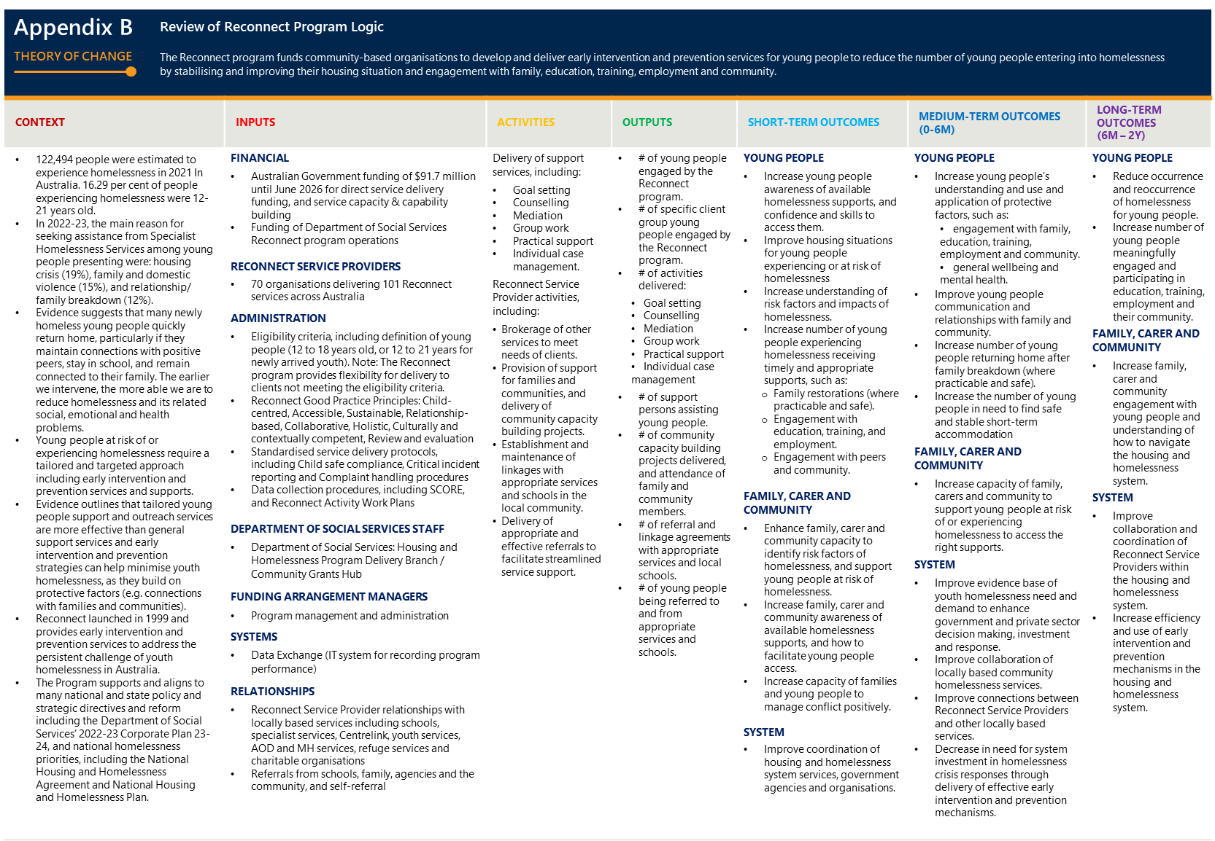
- Program Logic

- Literature review: Youth homelessness in Australia

Youth homelessness is a significant national challenge, exacerbated by individual and system, demand and supply challenges.

Youth homelessness is a persistent and significant issue in Australia.
On any given night, approximately 122,000 people in Australia experience homelessness. Children and young people aged 24 and younger represent 37% of people experiencing homelessness (while representing approximately 31% of Australia’s population). Most children and young people experiencing homelessness are not visible, with only 3% of young people sleeping rough. The majority of young people experiencing homelessness reside in:
- Severely crowded dwellings (58%)
- Support accommodation (17%)
- Couch surfing (11%)
- Boarding houses or other temporary lodging (11%).
While rates of homelessness for most age groups have decreased since 2016, national rates of youth homelessness have steadily increased over the last decade. Further, young people experiencing homelessness is substantially higher in remote or very remote regions of Australia (6.2%), in comparison to those living in major cities (0.8%). Figure 20 provides an overview of youth homelessness across Australia, recognising that these figures likely underrepresent the extent of youth homelessness due to transience of children and young people and a high number being not visible to the system.
Figure 20 | Homelessness statistics in Australia
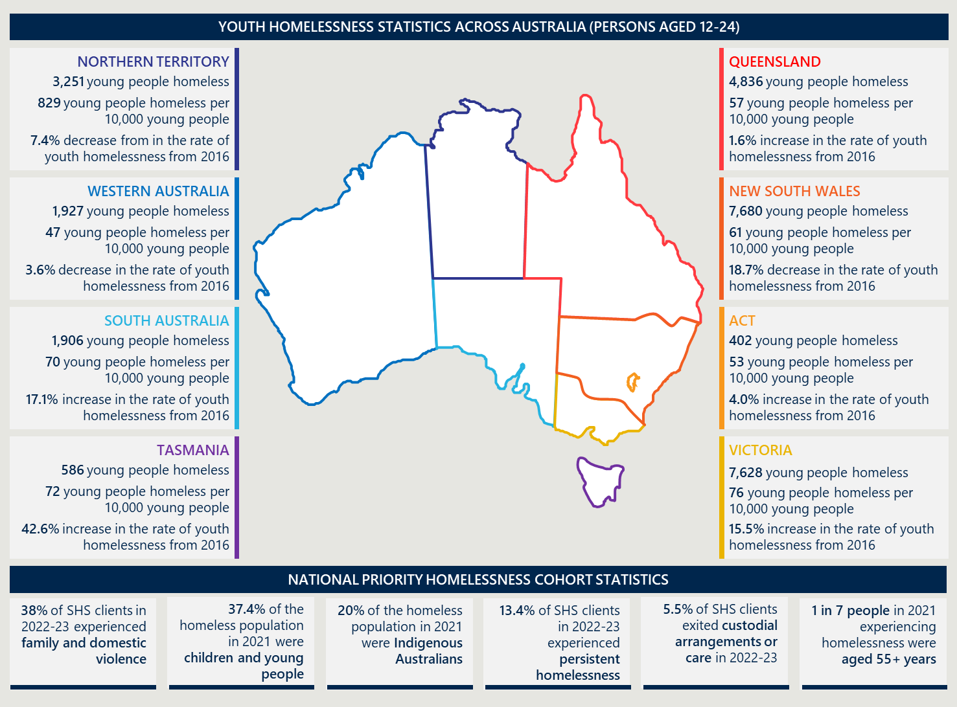

Youth homelessness is both the cause and consequence of personal, social and economic factors.
The main causes cited by children and young people as leading them to experience homelessness are housing crises, family and domestic violence, mental health and challenges associated with AOD use, inadequate or inappropriate dwelling conditions and relationship/family breakdowns. Children and young people often experience several of these vulnerabilities that can interact with each other in complex ways. Of people experiencing homelessness in Australia, approximately 39% experienced a mental health condition in the last year, and approximately 43% experience AOD challenges. The literature outlines that the prevalence of mental health and/or challenges associated with AOD use means children and young people are less likely to be able to maintain employment, a regular income or engage meaningfully in community. This creates barriers for them to access traditional, transitional and crisis housing options and increases likelihood of entering homelessness.

Children and young people experiencing homelessness are a particularly vulnerable cohort that sit between the intersection of the voluntary support and government service systems.
Numerous national and state strategic and policy directives, including the NHHA to identify children and young people as a priority cohort that require targeted support and investment from the system. Children and young people at risk of homelessness also sit at the intersection of voluntary support and the child protection and other health, justice and human service systems. This means that there may be legislative requirements for children and young people to enter the child protection system depending on their need and individual circumstances. This creates a challenge for voluntary support services supporting this cohort of young people with literature indicating that SHS often work with the same families and children as child protection authorities. Further, children and young people exiting youth justice systems, interacting with the child protection system, or transitioning to independence are at a higher risk of homelessness.
Despite overrepresentation of children and young people in the homelessness system, children and young people tend to access limited housing and homelessness supports. Young people account for 3% of principal tenants in social and public housing, and are less likely to qualify for priority social housing access. Children and young people also tend to be less visible to the service system, given reluctance to access general housing support services, and other health and mental health support services.
Support for children and young people is best delivered when it is provided early before pressures or problems of homelessness become critical or chronic or significantly impact their life trajectory. Children and young people experiencing homelessness are vulnerable to enduring harm due to disruption to their education and transition to employment, and the formation of stable and healthy social networks. The experience of homelessness and the associated trauma also compromises mental, social and emotional development and increases the chance of children and young people experiencing homelessness again later in life.

Priority populations and demographic groups are disproportionately impacted by homelessness.
Homelessness is understood to disproportionately impact marginalised population groups, as outlined in Figure 21.
Figure 21 | Priority groups disproportionately impacted by youth homelessness
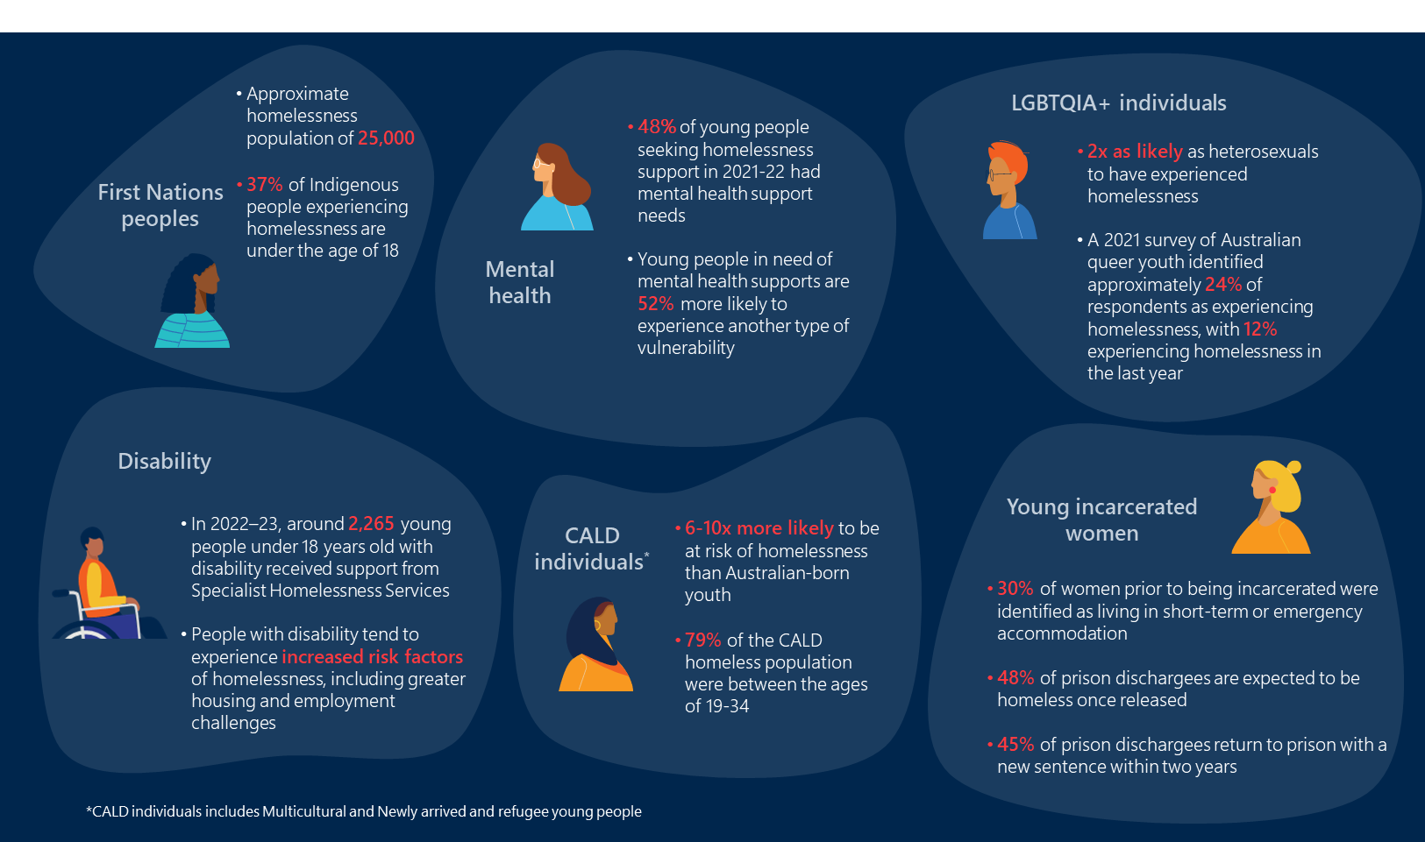
These groups tend to experience increased rates of homelessness for a variety of reasons, including increased experiences of discrimination and racism, and more challenging access barriers to traditional housing and homelessness supports.

The broader housing supply challenge also increases the risk and rates of homelessness.
At a system level, housing shortages and affordability exacerbate rates and severity of youth homelessness. Over 2023, housing pressures including increased rent, home prices, and cost of debt, reduced access to private housing for Australians across the country, particularly for low income and socially vulnerable households. Social housing is also under pressure, with Australian population growth over 2011-2020 outstripping social housing expansion by almost three times. As at June 2022, 418,400 households were accessing social housing, with the vast majority being low-income households. A further 188,300 households were waiting to access social housing (of which approximately 40% had a ‘greatest need’ for support). Children and young people face significant hardships when they miss out on social housing, as this can lead to homelessness, living in-substandard sharing arrangements or remaining incarcerated given their lack of access to a home.
Demand for homelessness support services is also outstripping supply. Approximately 114,000 requests for Specialist Homelessness Service support were left unaddressed in 2020-21 (an increase of 20% from 2016-17). Homelessness Australia identifies homelessness service providers as often turning away individuals seeking support, and service capacity as becoming a critical issue. Homelessness Australia identifies a lack of funding as the leading cause of limited capacity, with recent homelessness funding increases not matching CPI. The challenges on the broader housing and homelessness system means that vulnerable cohorts including children and young people, are often left with limited support and options to prevent them entering homelessness.

- National, state and territory government youth homelessness strategies
Table 14 outlines alignment of existing government strategies across Australia with the Reconnect program.
Table 14 | Reconnect alignment with national, state and territory government strategies
Jurisdiction | Key strategies | Alignment of Reconnect
 |  | Youth homelessness | Early intervention and prevention
  National | State and territory government NHHAs | ✓ | ✓
 | DSS Corporate Plan 23-24 | ✓ | ✓
  QLD | The Queensland Housing Strategy 2017-2027 | ✓ | ✓
 | QLD Housing and Homelessness Action Plan 2021-2025 | ✓ | ✓
  NSW | Housing 2041 | ✓ | ✓
 | NSW Homelessness Strategy 2018 – 2023 | ✓ | ✓
  VIC | Homes for Victorians | ✓ | ✓
 | Victoria’s Homelessness and Rough Sleeping Action Plan | ✓ | ✓
  ACT | ACT Housing Strategy | ✓ | ✓
  SA | Our Housing Future 2020-2030 |  | ✓
 | South Australian First Nations Housing Strategy 2021-2031 | ✓ | ✓
  NT | Northern Territory Housing Strategy 2020-2025 |  | ✓
  WA | WA Housing Strategy 2020-2030 | ✓ | ✓
 | All Paths Lead to a Home, Western Australia’s 10-Year Strategy on Homelessness 2020-2030 | ✓ | ✓
  TAS | Tasmanian Housing Strategy 2023-2043 | ✓ | ✓
 | Tasmanian Housing Strategy: Action Plan 2023-2027 | ✓ | ✓

- State and territory government service mapping

Figure 22 details a snapshot of each state and territory government’s aligned housing and homelessness services based on Nous desktop research.
Nous’ service mapping, the survey of sector representatives and Reconnect Service Providers, and consultations suggest:
- The extent to which state and territory government housing and homelessness programs deliver early interventions for children and young people vary. Most states and territories are reported to deliver more crisis focused housing and homelessness supports for children and young people. These services tend to provide out of home care supports (e.g. Tasmania’s Youth2Independence program), and support young person pathways to independent housing (e.g. Queensland’s Youth Housing Essentials program). Policy officers reflected that most of their funded homelessness services are responsive, and as they support young people with more acute needs, they tend to not closely interact with the Reconnect program. States and territories engaged, however, report that an increasing focus is being placed on early intervention and prevention programs, which will likely involve more significant intersections with Reconnect.
- While states and territories may deliver aligned early engagement programs to Reconnect, these tend to not be targeted at children and young people at risk of or experiencing homelessness. The states and territories deliver many programs that seek to broadly support children and young people early and deliver similar objectives to Reconnect (e.g. increased engagement with education, improved relationships with family). These programs were identified in service mapping to generally not have a housing or homelessness focus.
- Other services focused on supporting children and young people who are homeless or at risk of homelessness tend to be transitional or crisis accommodation services. These services prioritise transitioning children and young people to independence, which may be supported with accommodation services (e.g. through temporary housing and delivery of practical supports). These services also tend to provide more broad holistic supports for children and young people in crisis, such as case management, practical skill building and goal setting (although they attached to delivery of their homelessness crisis response).
- Other homelessness early intervention and prevention programs focus on reducing a young person’s disengagement with education. These programs (e.g. utilising the COSS model) emphasise a collaborative approach to service delivery with schools, and look to support families where they are escalating toward a potential crisis and homelessness. The COSS model was first implemented in Australia in Geelong as part of the Geelong Project in 2010.
- Most housing and homelessness services across Australia are funded by the states and territories, and delivered through NGOs. Large NGOs tend to deliver services nationally or in most states and territories, with these services tailored to the specific state or territory they are delivered in. This aligns with delivery of Reconnect, with large NGOs tending to deliver multiple Reconnect services across Australia (e.g. the Uniting Church, Anglicare, Mission Australia).
- Services tend to target older young people (aged between 15 to 24), particularly services offering accommodation. Fewer services are available to those younger than 15 years old, and very few services are available for those younger than 12 years old.
- There are few homelessness services available delivering a specialist or priority population focused service. Reconnect Service Providers reported specialist services (e.g. NAYS) as a gap in many service landscapes.

Figure 22 | Service mapping of youth homelessness services across states and territories
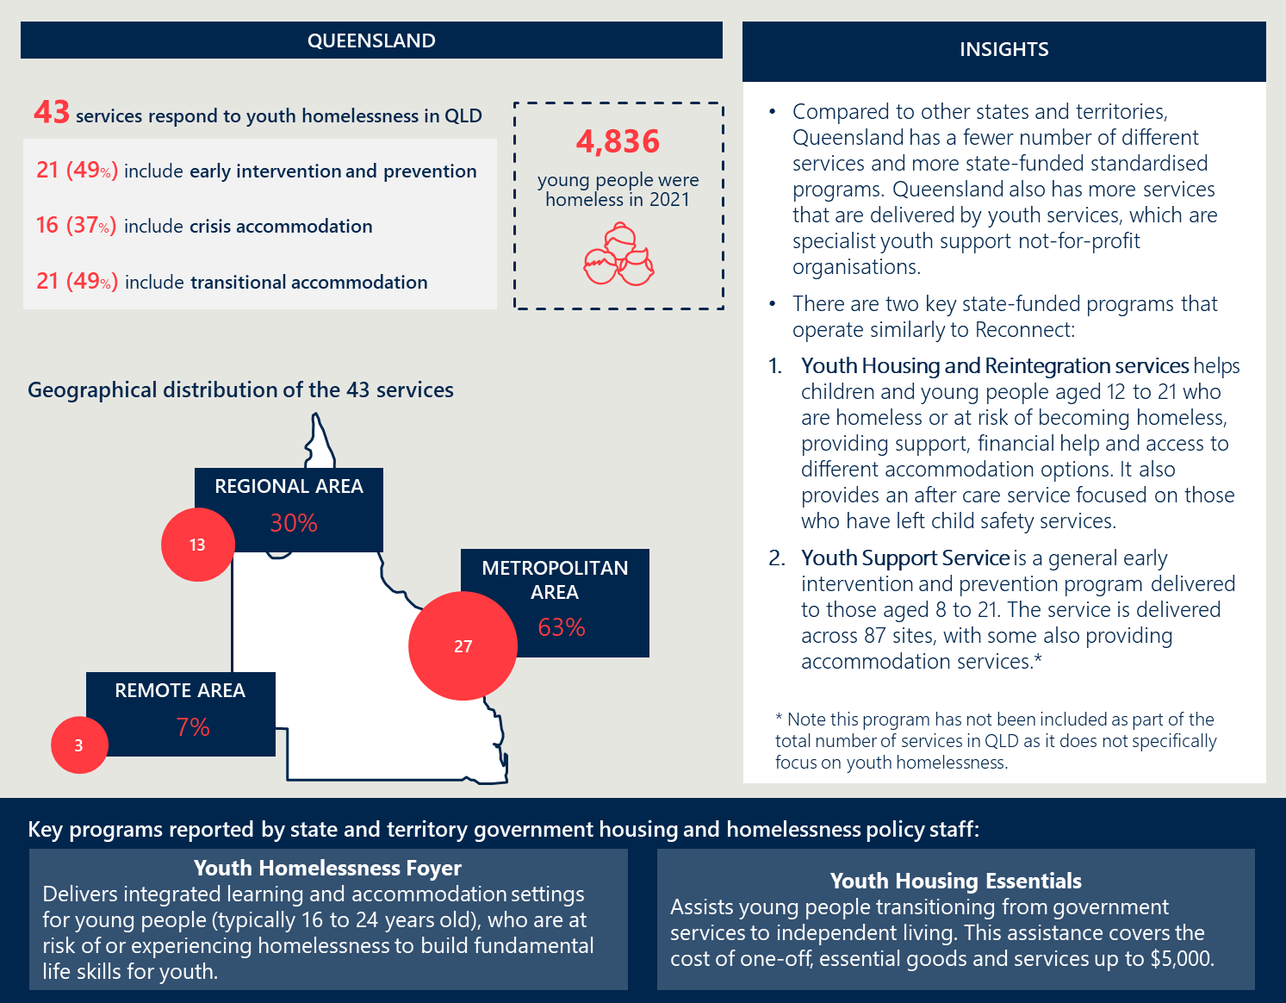
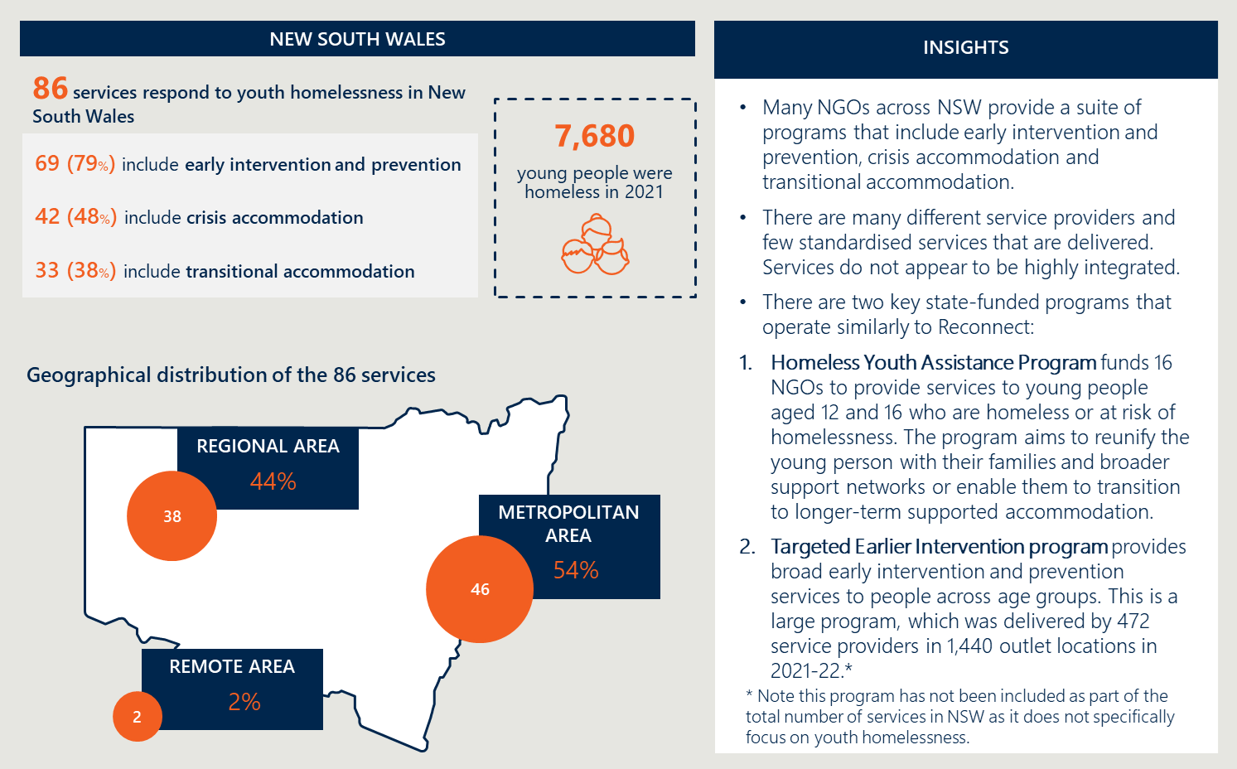
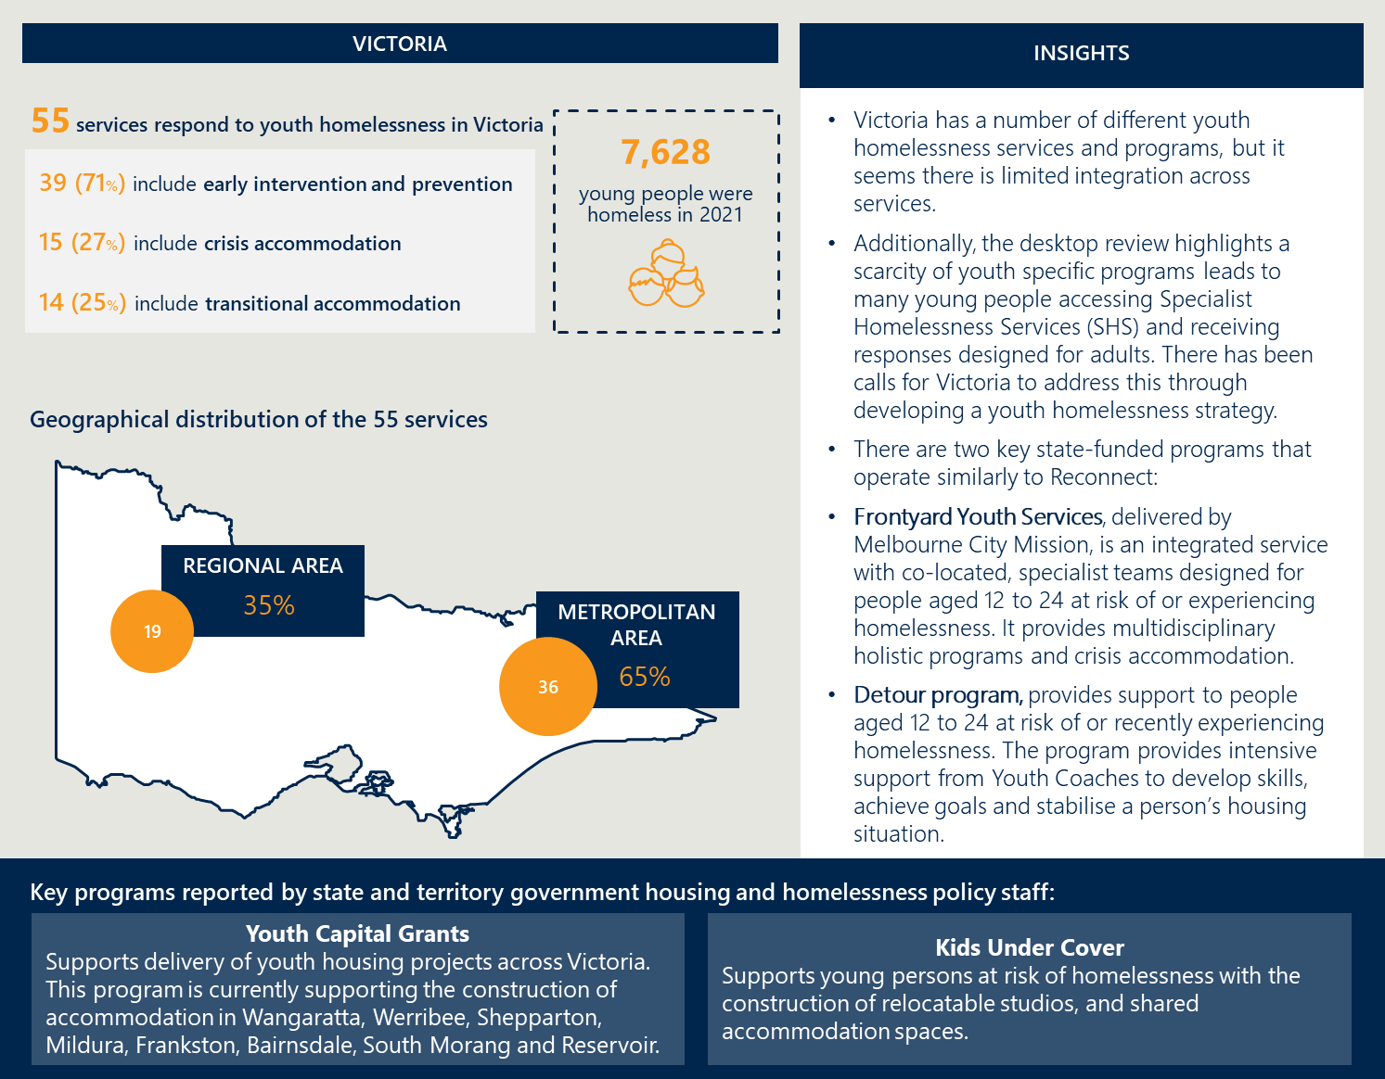
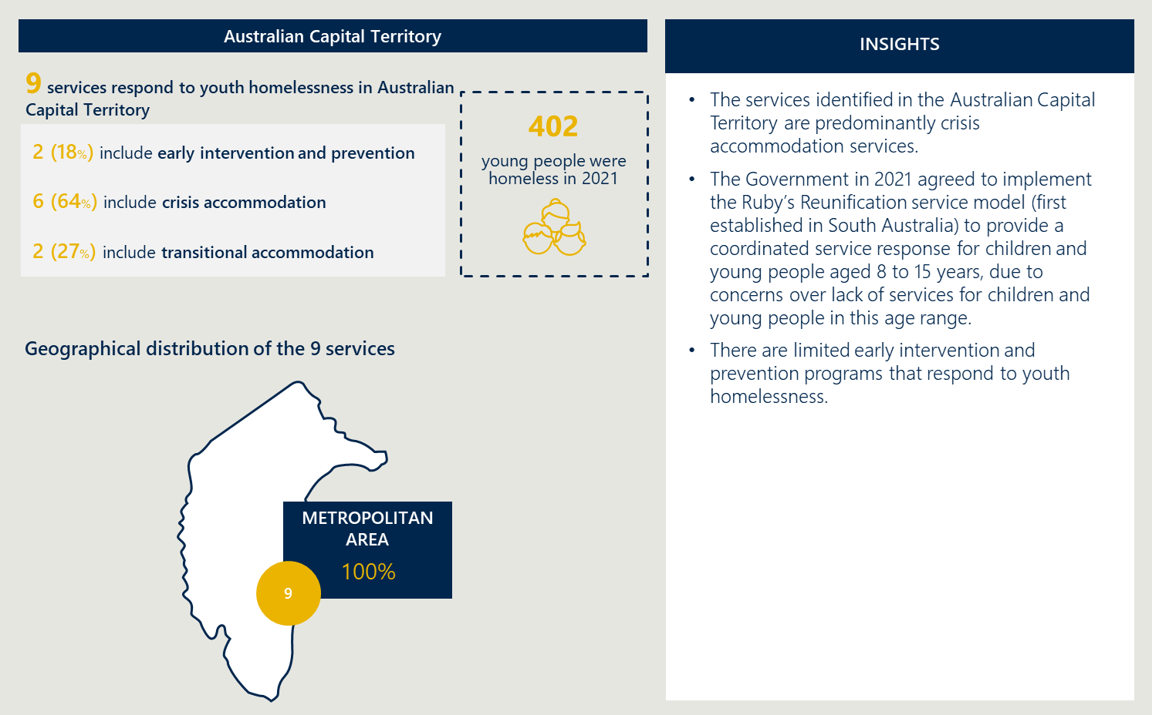
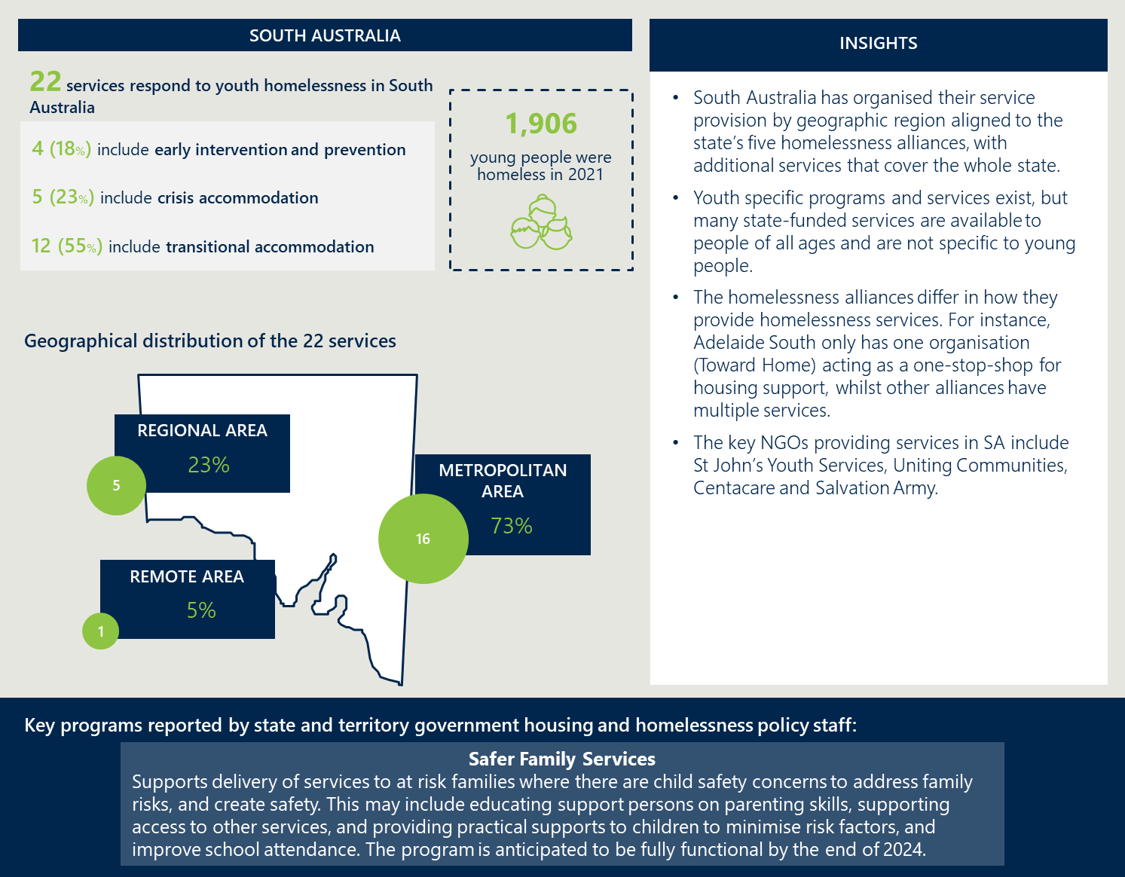
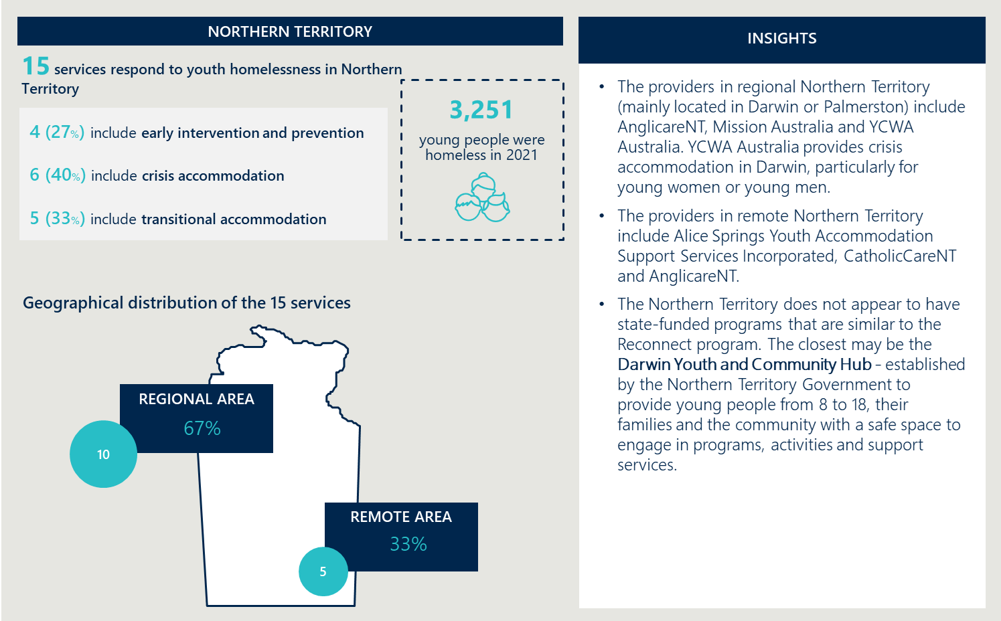
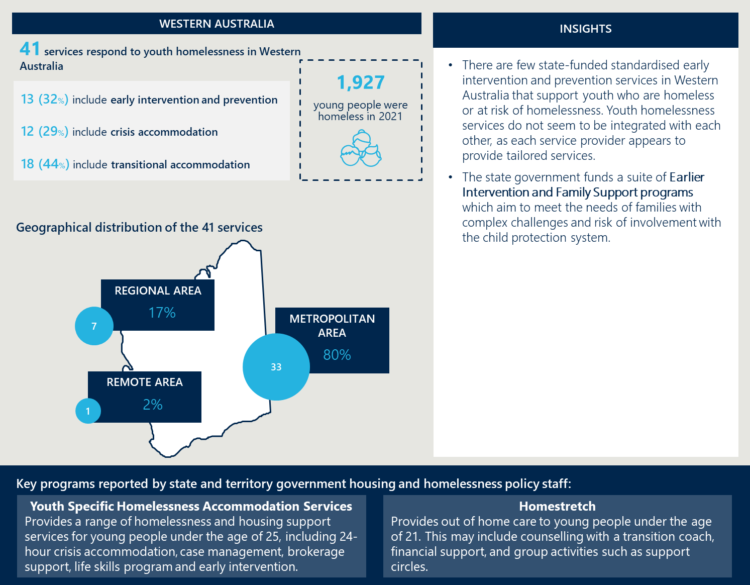
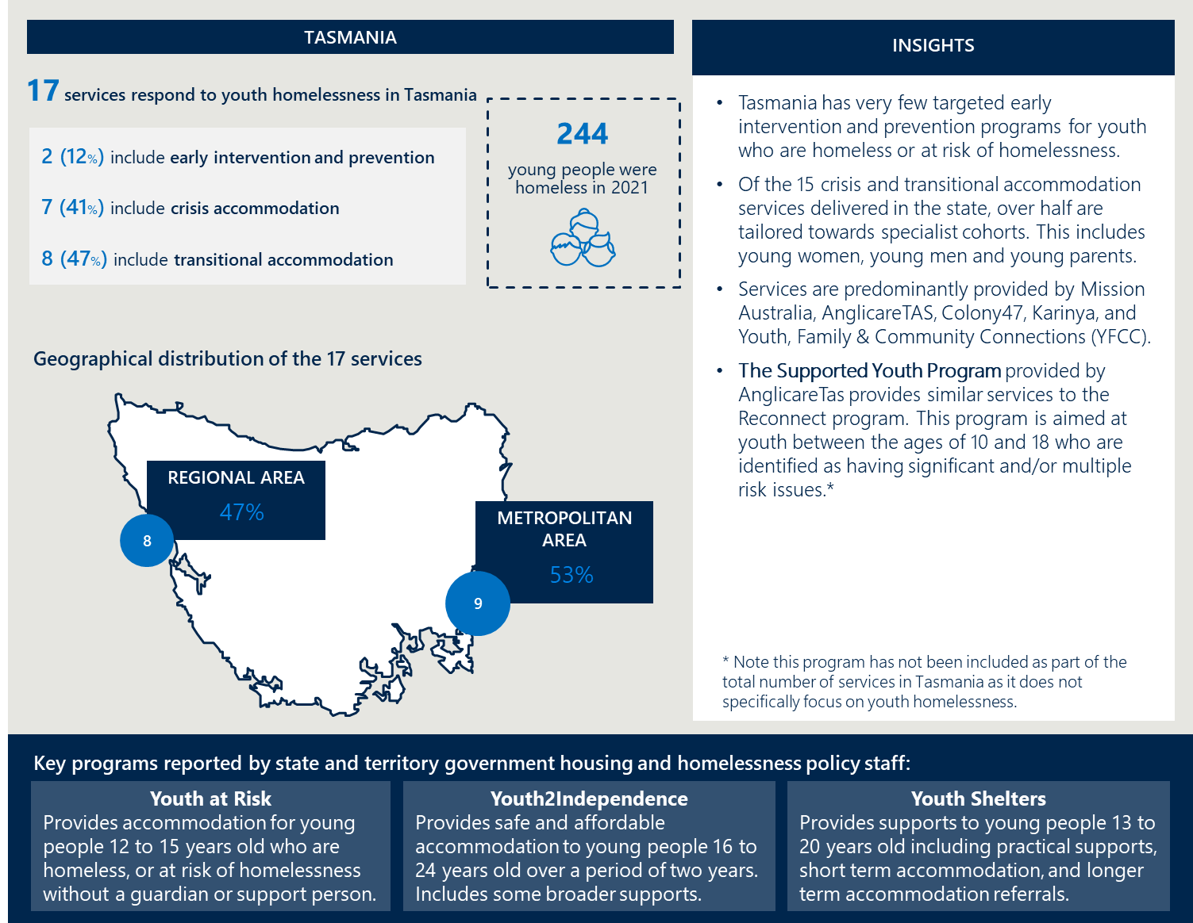

- Endnotes

Throughout this report, children and young people is used to refer to people under the age of 21 in line with industry standard practice. See, e.g.: Judicial Commission of New South Wales (2024), Equality before the Law Bench Book: Children and young people, https://www.judcom.nsw.gov.au/publications/benchbks/equality/section06.html.
The Reconnect program, the Program and Reconnect are all used interchangeably throughout this report.
Note: The total survey response numbers include partial responses.
Note: A protective factor is a characteristic that is associated with reductions in the negative impact or likelihood of a problem outcome: O’Connell et al (2009), Preventing mental, emotional, and behavioural disorders among young people: Progress and possibilities, Washington (DC): National Academies Press (US), Accessed 18 June 2024.
Please note that SCORE outcomes are on a scale of 1-5, with the number showing the mean change across the cohort between an individual’s first recorded SCORE (on entry) and their last (on exit); for descriptions on the specific DEX SCORE outcome domains, please see Section 7 of The Data Exchange Protocols: https://dex.dss.gov.au/data-exchange-protocols.
‘Reconnect Service Providers’ and ‘Providers’ are used interchangeably throughout this report.
It is assumed that educational agencies are referring mostly to schools. Schools were identified through other Review activities as the main educational agency Service Providers engage with.
Please note the age range is a Program-specific requirement which is legislated.
The Review has assumed that any DEX SCORE increase has contributed positively to children and young people’s outcomes, with larger SCORE increases indicating greater positive changes in outcomes.
This is the extent to which Reconnect has improved the client’s housing stability or addresses the impact of poor housing to improve their independence, participation and wellbeing.
‘Reconnect activities’ are the 101 funded activities across Australia.
This figure has been calculated using the total number of sessions from DEX, which incorporates a combination of individual client sessions, group client sessions and support person sessions.
Considerations could include working with younger siblings of those already being supported, making sure there are key adults involved and involvement with other agencies as required. It is important to recognise that lowering the age requirement will require change to the Financial Framework (Supplementary Powers) Regulations 1997. If this is not possible, increasing the 10% flexibility in the Operational Guidelines should provide Reconnect Service Providers to support younger or older cohorts as needed.
Cohorts of the children and young people population considered to be a priority group. Specialist cohorts include children and young people who identify as CALD, NAYS, First Nations, LGBTQIA+ and/ or with disability.
The Reconnect program, the Program and Reconnect are all used interchangeably throughout this report.
Note that two young people with lived experience participated in one of the EAG meetings.
Note: A protective factor is a characteristic that is associated with reductions in the negative impact or likelihood of a problem outcome: O’Connell et al (2009), Preventing mental, emotional, and behavioural disorders among young people: Progress and possibilities, Washington (DC): National Academies Press (US), Accessed 18 June 2024.
Up to 10 per cent of a Reconnect Service Providers’ participant caseload can be out-of-scope clients who are either outside the target group, including age range or who live outside of the funded geographic area. See Operational Guidelines, Section 3.4.
Reconnect activities are the 101 funded service activities across Australia.
This figure has been calculated using the total number of sessions from DEX, which incorporates a combination of individual client sessions, group client sessions and support person sessions.
Please see the Quantitative analysis methods section in Table 10, Appendix A for more detail on how this was calculated.
Note that some but not all SHS will have a youth focus.
Note that some but not all SHS will have an early intervention and prevention focus.
Note that some but not all SHS will provide housing.
These figures do not include group clients or group client sessions, as their demographic and Reconnect engagement data is not individually captured in DEX.
Of the 8% of children and young people outside of the eligible age range, 4% of children and young people were under the age of 11, and 4% of children and young people were 22 years or older; 11% of children and young people engaged did not disclose their disability status.
Despite intake/assessment sessions only accounting for 8% of total activity, they are recognised as a key activity for Reconnect clients as they are likely undertaken by each client that accesses the Program.
Note: Referrals into the service has excluded those categorised as ‘unknown.’
It is assumed that educational agencies are referring mostly to schools. Schools were identified through other Review activities as the main educational agency Service Providers engage with.
For the DEX SCORE domains, SCORE outcomes are recorded on a scale of 1-5, with the number showing the mean change across the cohort between an individual’s first recorded SCORE (on entry) and their last (on exit). The Review has assumed that any DEX SCORE increase has contributed positively to children and young people’s outcomes, with larger SCORE increases indicating greater positive changes in outcomes.
These cohort groups were the only cohorts reported on using the DEX data. Therefore, other cohorts of interest could not be reported on such as LGBTIAQ+ children and young people, Newly Arrived Youth and those experiencing mental health challenges.
Considerations could include working with younger siblings of those already being supported, making sure there are key adults involved and involvement with other agencies as required. It is important to recognise that lowering the age requirement will require change to the Financial Framework (Supplementary Powers) Regulations 1997. If this is not possible, increasing the 10% flexibility in the Operational Guidelines should provide Reconnect Service Providers to support younger or older cohorts as needed.
Cohorts of the children and young people population considered to be a priority group. Specialist cohorts include children and young people who identify as CALD, NAYS, First Nations, LGBTQIA+ and/ or with disability.
Note: Exact numbers for this engagement are unclear as this invitation was hosted by a DSS email address. Nous estimates there were between 25-30 attendees given 41 people were invited.
Note that young person statistics has included those aged 12-24.
General youth support programs were not included as part of the service mapping as they do not specifically focus on young people who are homeless or at risk of homelessness.
Early intervention and prevention are defined as programs that provide support without accommodation; crisis accommodation is defined as short-term accommodation for up to 3 months; transitional accommodation is defined as longer-term accommodation options (greater than 3 months) that assist people to transition to independence.
O’Connell et al (2009), Preventing mental, emotional, and behavioural disorders among young people: Progress and possibilities, Washington (DC): National Academies Press (US), Accessed 18 June 2024.
Australian Bureau of Statistics (2021), Estimating Homelessness: Census, Accessed 26 February 2024, https://www.abs.gov.au/statistics/people/housing/estimating-homelessness-census/latest-release
Australian Bureau of Statistics (2021), Estimating Homelessness: Census, Accessed 26 February 2024, https://www.abs.gov.au/statistics/people/housing/estimating-homelessness-census/latest-release
AIHW (2024), Specialist homelessness services annual report 2022-23, Young people between the ages of 12-24 (2021), https://www.aihw.gov.au/reports/homelessness-services/specialist-homelessness-services-annual-report/contents/young-people-presenting-alone
Australian Government (2021), Inquiry into homelessness in Australia, Accessed on 4 March 2024, https://www.aph.gov.au/Parliamentary_Business/Committees/House/Social_Policy_and_Legal_Affairs/HomelessnessinAustralia/Report.
Nous notes that individual service providers, such as Mission Australia, have done more recent reviews of their Reconnect services. See https://www.missionaustralia.com.au/documents/687-reconnect-evaluation-report/file
Department of Families, Housing, Community Services and Indigenous Affairs (2013), Reconnect: Departmental review of the Reconnect Program, accessed 01/04/2024, https://www.dss.gov.au/sites/default/files/documents/02_2013/dept_review_of_the_reconnect_program.pdf
Chris Chamberlain and David MacKenzie (2008), Counting the homeless 2006, Accessed 21 February 2024, https://apo.org.au/node/4672.
Australian Institute of Family Studies (2020), Early intervention strategies to prevent youth homelessness, Accessed on 2 February 2024, https://aifs.gov.au/resources/short-articles/early-intervention-strategies-prevent-youth-homelessness.
Operational Guidelines (‘Reconnect Operational Guidelines’): Department of Social Services (2016), Reconnect Operational Guidelines 2016-17. Department of Social Services (2017), Reconnect Program Operational Guidelines 1 July 2017 to 30 June 2018. Department of Social Services (2018), Reconnect Program Operational Guidelines 1 July 2018 to 30 June 2021. Department of Social Services (2023), Reconnect Program Operational Guidelines 1 July 2023 to 30 June 2026.
Note: Some organisations (e.g. Mission Australia) have also undertaken their own evaluations of their delivery of Reconnect. Previous evaluations: RPR Consulting (2003), Report of the Reconnect Longitudinal Study: Building Community Capacity for Early Intervention; Department of Families, Housing, Community Services and Indigenous Affairs (2013), Departmental review of the Reconnect program; Mission Australia (2016), Reconnect evaluation 2016.
Ministers for the Department of Social Services (22 March 2023), Reconnect funding to help young people at risk of homelessness, Accessed 12 February 2024, https://ministers.dss.gov.au/media-releases/10671
Reconnect Operational Guidelines.
Australian Government (2012), Literature Review: Effective interventions for working with young people who are homeless or at risk of homelessness, Accessed on 4 March 2024, https://www.dss.gov.au/sites/default/files/documents/06_2012/literature_review.pdf; Australian Government (2021), Inquiry into homelessness in Australia, Accessed on 4 March 2024, https://www.aph.gov.au/Parliamentary_Business/Committees/House/Social_Policy_and_Legal_Affairs/HomelessnessinAustralia/Report
Yfoundations (2022), About Youth Homelessness, Accessed 18 June, https://www.yfoundations.org.au/about-homelessness#:~:text=In%202022%E2%80%932023%2C%2024%25,primary%20reason%20for%20becoming%20homeless.
Australian Institute of Family Studies (2020), Early intervention strategies to prevent youth homelessness, Accessed on 2 February 2024, https://aifs.gov.au/resources/short-articles/early-intervention-strategies-prevent-youth-homelessness.
Australian Institute of Family Studies (2020), Early intervention strategies to prevent youth homelessness, Accessed on 2 February 2024, https://aifs.gov.au/resources/short-articles/early-intervention-strategies-prevent-youth-homelessness.
Parpouchi, M., Moniruzzaman, A. & Somers, J.M (2021), The association between experiencing homelessness in childhood or youth and adult housing stability in Housing, First. BMC Psychiatry 21, 138, Accessed on 5 February 2024.
Stephen Gaetz et al. (2018), Report 3: Early Intervention to Prevent Youth Homelessness, Accessed 20 February 2024, https://www.homelesshub.ca/sites/default/files/Early_Intervention.pdf.
Stephen Gaetz (2020), Making the Prevention of Homelessness a Priority: The Role of Social Innovation, American Journal of Economics and Sociology 79(2): 353-381, Accessed 22 February 2024.
Chris Chamberlain and David MacKenzie (2008), Counting the homeless 2006, Accessed 21 February 2024, https://apo.org.au/node/4672
Smart (2017), Collective impact: Evidence and implications for practice, Australian Institute of Family Studies, https://aifs.gov.au/resources/practice-guides/collective-impact-evidence-and-implications-practice
Smart (2017), Collective impact: Evidence and implications for practice, Australian Institute of Family Studies, https://aifs.gov.au/resources/practice-guides/collective-impact-evidence-and-implications-practice
Australian Housing and Urban Research Institute (2020), Redesign of a homelessness service system for young people, Accessed 27 February.
David Mackenzie (2018), The Geelong Project: interim report 2016-17, Accessed on 28 February 2024, https://apo.org.au/node/133006
Logan Together, Our approach to community change, Accessed 3 June 2024, https://www.logantogether.org.au/our-approach
HUD Exchange (n.d.), Coordinated Entry for Youth Experiencing Homelessness, Accessed 6 March 2023, https://files.hudexchange.info/resources/documents/coordinated-entry-for-youth-brief.pdf
Australian Housing and Urban Research Institute (2009), What makes case management work for people experiencing homelessness, Accessed 4 March 2024. https://www.ahuri.edu.au/research/final-reports/127
Australian Government (2020), Monitoring mental health and suicide prevention reform: National Report 2020 Chapter 2: The importance of data, evaluation and research, Accessed on 29 February 2024, https://www.mentalhealthcommission.gov.au/monitoring-and-reporting/national-reports/2020-national-report/2020-national-report/state-of-mental-health-suicide-prevention/chapter-2-the-importance-of-data,-evaluation-and-r
Australian Housing and Urban Research Institute (2021), Positioning Paper: Towards a Youth Homeless Strategy for Victoria, Accessed 26 February 2024, https://www.ahuri.edu.au/sites/default/files/documents/2021-11/AHURI-Prof-Services-Positioning%20Paper-Towards-a-Youth-Homelessness-Strategy-for-Victoria_0.pdf
Note: This is reported as particularly important for First Nations peoples: Australian Housing and Urban Research Institute (2021), Positioning Paper: Towards a Youth Homeless Strategy for Victoria, Accessed 27 February 2024, https://www.ahuri.edu.au/sites/default/files/documents/2021-11/AHURI-Prof-Services-Positioning%20Paper-Towards-a-Youth-Homelessness-Strategy-for-Victoria_0.pdf
Australian Government (2012), Literature Review: Effective interventions for working with young people who are homeless or at risk of homelessness, Accessed 4 March 2024, https://www.dss.gov.au/families-and-children-programs-services-reconnect/literature-review-effective-interventions-for-working-with-young-people-who-are-homeless-or-at-risk-of-homelessness
Australian Government (2012), Literature Review: Effective interventions for working with young people who are homeless or at risk of homelessness, Accessed 4 March 2024, https://www.dss.gov.au/families-and-children-programs-services-reconnect/literature-review-effective-interventions-for-working-with-young-people-who-are-homeless-or-at-risk-of-homelessness
Department of Social Services (2023), Corporate Plan 2023-2024, https://www.dss.gov.au/publications-articles-corporate-publications-department-of-social-services-corporate-plans/department-of-social-services-corporate-plan-2023-24
Department of Social Services (2024), Developing the National Housing and Homelessness Plan, Accessed 27 May 2024.
Department of Social Services (2023), National Housing and Homelessness Plan Issues Paper, Accessed on 19 February, https://engage.dss.gov.au/wp-content/uploads/2023/08/national-housing-and-homelessness-plan-issues-paper_2.pdf
Department of Social Services (2023), National Housing and Homelessness Plan Issues Paper, Accessed on 19 February, https://engage.dss.gov.au/wp-content/uploads/2023/08/national-housing-and-homelessness-plan-issues-paper_2.pdf
Reconnect Operational Guidelines
Australian Institute of Health and Welfare (2021), COVID-19 effects on housing and homelessness: the story to mid-2021, Accessed 3 June 2024.
Gore et al. (2021), The impact of COVID-19 on student learning in New South Wales primary schools: an empirical study, Aust Educ Res 48(4), 605-537, Accessed 4 June 2024.Fh
Reconnect Operational Guidelines.
Accenture (2022), Under One Roof: The Social and Economic Impact of Youth Foyers, Foyer Foundation, Accessed 31 May 2024, https://foyer.org.au/wp-content/uploads/2023/04/FoyerFoundation_UnderOneRoof_FULLReport2023.pdf
Australian Housing and Urban Research Institute (2018), Evaluation of the Sustaining Young People’s Tenancies Initiative, Accessed 31 May 2024, https://www.ahuri.edu.au/sites/default/files/migration/documents/Evaluation-of-the-Sustaining-Young-Peoples-Tenancies-Initiative.pdf
Centre for Evidence and Implementation (2020), Report: Evaluation of the Homeless Youth Assistance Program for New South Wales Department of Communities and Justice, Accessed 30 May 2024, https://www.ceiglobal.org/work-and-insights/report-evaluation-homeless-youth-assistance-program-new-south-wales-department
Social Ventures Australia (2019), The economic case for early intervention in the child protection and out-of-home care system in Victoria, Accessed 30 May 2024, https://www.berrystreet.org.au/uploads/main/Files/SVA-ResearchPaper-TheEconomicCaseForEarlyIntervention-2019.pdf
Social Ventures Australia (2019), The economic case for early intervention in the child protection and out-of-home care system in Victoria, Accessed 30 May 2024, https://www.berrystreet.org.au/uploads/main/Files/SVA-ResearchPaper-TheEconomicCaseForEarlyIntervention-2019.pdf
Australian Housing and Urban Research Institute (2013), The cost of homelessness and the net benefit of homelessness programs: a national study, Accessed 31 May 2024, https://www.ahuri.edu.au/sites/default/files/migration/documents/AHURI_Final_Report_No218_The-cost-of-homelessness-and-the-net-benefit-of-homelessness-programs-a-national-study.pdf
Wood, L., Vallesi, S., Martin, K., Lester, L., Zaretzky, K., Flatau, P., & Gazey, A, (2017), St Vincent’s Hospital Melbourne homelessness programs evaluation report- An evaluation of ALERT, CHOPS, The Cottage and Prague House, The University of Western Australia, Accessed 30 May 2024, https://doi.org/10.13140/RG.2.2.34614.60480
Wood, L., Flatau, P., Zaretzky, K., Foster, S., Vallesi, S., & Miscenko, D, (2016), What are the health, social and economic benefits of providing public housing and support to formerly homeless people? (AHURI Final Report No.265), Australian Housing and Urban Research Institute, Accessed 31 May 2024, https://dx.doi.org/10.18408/ahuri-8202801
AIHW (2024), Profile of First Nations People 2023, Accessed on 13 June 2024, https://www.aihw.gov.au/reports/australias-welfare/profile-of-indigenous-australians#:~:text=2018).-,Population%20size%20and%20location,of%20the%20total%20Australian%20population
Nous analysis of Australian Bureau of Statistics (2021), ABS Website, Accessed on 26 February 2024
Australian Bureau of Statistics (2021), ABS Website, Accessed on 26 February 2024
AIHW (2024), Specialist homelessness services annual report 2022-23, Accessed on 26 February 2024, https://www.aihw.gov.au/reports/homelessness-services/specialist-homelessness-services-annual-report/contents/young-people-presenting-alone.
Department of Social Services (2023), Reconnect Program Operational Guidelines 1 July 2023 to 30 June 2026.
Australian Institute of Family Services (2017), Collective impact: Evidence and implications for practice, Accessed on 26 February 2024, https://aifs.gov.au/resources/practice-guides/collective-impact-evidence-and-implications-practice
RPR Consulting (2003), Report of the Reconnect Longitudinal Study: Building Community Capacity for Early Intervention
Reconnect Operational Guidelines.
Australian Bureau of Statistics (2021), Estimating Homelessness: Census, Accessed 26 February 2024, https://www.abs.gov.au/statistics/people/housing/estimating-homelessness-census/latest-release
Nous analysis of Australian Bureau of Statistics, Population clock and pyramid, Accessed 4 March 2024, https://www.abs.gov.au/statistics/people/population/population-clock-pyramid
Australian Bureau of Statistics (2021), Estimating Homelessness: Census, Accessed 26 February 2024, https://www.abs.gov.au/statistics/people/housing/estimating-homelessness-census/latest-release
Australian Institute of Health and Welfare (2021), Australia's youth: Homelessness and overcrowding, Accessed on 28 February 2024, https://www.aihw.gov.au/reports/children-youth/homelessness-and-overcrowding
Australian Institute of Health and Welfare (2021), Australia's youth: Homelessness and overcrowding, Accessed on 28 February 2024, https://www.aihw.gov.au/reports/children-youth/homelessness-and-overcrowding
Australian Bureau of Statistics (2021), Estimating Homelessness: Census, Accessed 26 February 2024, https://www.abs.gov.au/statistics/people/housing/estimating-homelessness-census/latest-release
Australian Institute of Health and Welfare (2021), Australia's youth: Homelessness and overcrowding, Accessed on 28 February 2024, https://www.aihw.gov.au/reports/children-youth/homelessness-and-overcrowding
Nous analysis of Australian Bureau of Statistics (2021), ABS Website; AIHW (2024), Specialist homelessness services annual report 2022-23, Accessed on 26 February 2024, https://www.aihw.gov.au/reports/homelessness-services/specialist-homelessness-services-annual-report/contents/young-people-presenting-alone
Australian Institute of Health and Welfare (2021), Australia's youth: Homelessness and overcrowding, Accessed on 28 February 2024, https://www.aihw.gov.au/reports/children-youth/homelessness-and-overcrowding
AIHW (2024), Specialist homelessness services annual report 2022-23, Accessed on 26 February 2024, https://www.aihw.gov.au/reports/homelessness-services/specialist-homelessness-services-annual-report/contents/young-people-presenting-alone
Australian Institute of Health and Welfare (2023), Alcohol, tobacco & other drugs in Australia, Accessed 28 February 2024, https://www.aihw.gov.au/reports/alcohol/alcohol-tobacco-other-drugs-australia/contents/summary
Homeless Hub, About Homelessness: Supporting communities to prevent and end homelessness, Accessed on 28 February 2024, https://www.homelesshub.ca/about-homelessness/homelessness-101/what-homelessness; Zlotnick et al. (2003), Disaffiliation, Substance Use, and Exiting Homelessness, Substance Use & Misuse, Vol. 38.
The National and Housing Homelessness Plan Issues Paper identifies young people as a priority group in need of support: Department of Social Services (2023), National Housing and Homelessness Plan Issues Paper, Accessed on 19 February, https://engage.dss.gov.au/wp-content/uploads/2023/08/national-housing-and-homelessness-plan-issues-paper_2.pdf
AIHW (2024), Specialist homelessness services annual report 2022-23, Accessed on 26 February 2024, https://www.aihw.gov.au/reports/homelessness-services/specialist-homelessness-services-annual-report/contents/young-people-presenting-alone
Australian Government (2021), Inquiry into homelessness in Australia, Accessed on 4 March 2024, https://www.aph.gov.au/Parliamentary_Business/Committees/House/Social_Policy_and_Legal_Affairs/HomelessnessinAustralia/Report; Australian Institute of Health and Welfare (2012), Children and young people at risk of social exclusion, Accessed on 4 March 2024, https://www.aihw.gov.au/reports/children-youth/children-and-young-people-at-risk-of-social-exclus/summary.
Australian Government (2021), Inquiry into homelessness in Australia, Accessed on 4 March 2024, https://www.aph.gov.au/Parliamentary_Business/Committees/House/Social_Policy_and_Legal_Affairs/HomelessnessinAustralia/Report
Boyle (2020), A welcome home: Youth homelessness and mental health, Melbourne: Orygen, Accessed 2 February 2024, https://www.orygen.org.au/Orygen-Institute/Policy-Areas/Population-groups/A-welcome-home-youth-homelessness-and-mental-healt/A-welcome-home?ext=.
Australian Government (2021), Inquiry into homelessness in Australia, Accessed on 4 March 2024, https://www.aph.gov.au/Parliamentary_Business/Committees/House/Social_Policy_and_Legal_Affairs/HomelessnessinAustralia/Report
Parpouchi, M., Moniruzzaman, A. & Somers, J.M (2021), The association between experiencing homelessness in childhood or youth and adult housing stability in Housing, First. BMC Psychiatry 21, 138, Accessed on 5 February 2024, https://bmcpsychiatry.biomedcentral.com/articles/10.1186/s12888-021-03142-0
Australian Institute of Health and Welfare (2021), Australia's youth: Homelessness and overcrowding, Accessed on 28 February, https://www.aihw.gov.au/reports/children-youth/homelessness-and-overcrowding
Parpouchi, M., Moniruzzaman, A. & Somers, J.M (2021), The association between experiencing homelessness in childhood or youth and adult housing stability in Housing, First. BMC Psychiatry 21, 138, Accessed on 5 February 2024, https://bmcpsychiatry.biomedcentral.com/articles/10.1186/s12888-021-03142-0
P Flatau et al (2013)., Lifetime and intergenerational experiences of homelessness in Australia, Australian Housing and Urban Research Institute, p.128, Accessed on 4 March 2024, https://researchdirect.westernsydney.edu.au/islandora/object/uws:22670/datastream/PDF.
First Nations: Australian Bureau of Statistics (2021), Estimating Homelessness: Census, Accessed 26 February, https://www.abs.gov.au/statistics/people/housing/estimating-homelessness-census/latest-release; Australian Bureau of Statistics (2021), Estimating Homelessness: Census, Accessed 26 February, https://www.abs.gov.au/statistics/people/housing/estimating-homelessness-census/latest-release LGBTIQA+: Mission Australia (2020), Staying home: A young survey report on young people’s experience of homelessness, Accessed on 4 March 2024; Hail-Jares et al. (2021), Queer homelessness: the distinct experiences of sexuality and trans-gender diverse youth, Journal of LGBT Youth, 2023, Vol 20(4), Accessed on 7 March 2024, https://www.tandfonline.com/doi/full/10.1080/19361653.2021.1990817 CALD: Mission Australia (2020), Staying home: A young survey report on young people’s experience of homelessness, Accessed on 4 March 2024; Parliament of Victoria Legislative Council (2021), Inquiry into homelessness in Victoria, Accessed on 14 February 2024, https://www.parliament.vic.gov.au/49373d/contentassets/0c6d61c7d86d4971bf50c2573cb534b2/inquiry-into-homelessness-in-victoria---final-report.pdf Mental Health: AIHW (2024), Specialist homelessness services annual report 2022-23, Accessed on 13 June 2024, https://www.aihw.gov.au/reports/homelessness-services/specialist-homelessness-services-annual-report/contents/young-people-presenting-alone; AIHW (2024), Specialist homelessness services annual report 2022-23, Accessed on 13 June 2024, https://www.aihw.gov.au/reports/homelessness-services/specialist-homelessness-services-annual-report/contents/young-people-presenting-alone Young Incarcerated Women: AIHW (2024), Specialist homelessness services annual report 2022-23, Accessed on 13 June 2024, https://www.aihw.gov.au/reports/homelessness-services/specialist-homelessness-services-annual-report/contents/young-people-presenting-alone Disability: AIHW (2024), Specialist homelessness services annual report 2022-23, Accessed on 13 June 2024, https://www.aihw.gov.au/reports/homelessness-services/specialist-homelessness-services-annual-report/contents/young-people-presenting-alone
Mission Australia (2020), Staying home: A young survey report on young people’s experience of homelessness, Accessed on 4 March 2024; Parliament of Victoria Legislative Council (2021), Inquiry into homelessness in Victoria, Accessed on 14 February 2024, https://www.parliament.vic.gov.au/49373d/contentassets/0c6d61c7d86d4971bf50c2573cb534b2/inquiry-into-homelessness-in-victoria---final-report.pdf
ANZ (2023), Housing Affordability Report, Accessed on 5 March 2024, https://news.anz.com/content/dam/bluenotes/images/articles/2023/November/231128%20-%20ANZ%20CoreLogic%20Housing%20Affordability%20Report.pdf
Poverty & Inequality (2020), Annual growth rates – social housing stock and population, 2011-2020, Accessed on 28 February 2024, https://povertyandinequality.acoss.org.au/data/annual-growth-rates-social-housing-stock-and-population-2011-2020/
Australian Institute of Health and Welfare (2023), Housing assistance in Australia, Accessed on 26 February 2024, https://www.aihw.gov.au/reports/housing-assistance/housing-assistance-in-australia/contents/housing-assistance.
Greatest need households are defined as households that at the time of allocation are homeless, in housing inappropriate to their needs, in housing that is adversely affecting their health or placing their life and safety at risk, or, have very high rental housing costs: Productivity Commission, National Housing and Homelessness Agreement Details: Increase in the number of social housing occupants with greatest need as a proportion of new allocations, Accessed on 5 March 2024, https://performancedashboard.d61.io/housing/housing-greatest_need
Australian Institute of Health and Welfare (2023), Housing assistance in Australia, Accessed on 26 February 2024, https://www.aihw.gov.au/reports/housing-assistance/housing-assistance-in-australia/contents/housing-assistance
Productivity Commission (2018), Reforms to human services, Accessed on 27 February 2024, https://www.pc.gov.au/inquiries/completed/human-services/reforms#report
Productivity Commission (2022), In need of repair: The Housing and Homelessness Agreement, Accessed 27 February 2024, https://www.pc.gov.au/inquiries/completed/housing-homelessness/report/housing-homelessness.pdf
Homelessness Australia (2024), Pre-Budget Submission 2024-2025, Accessed on 9 February 2024, https://mailchi.mp/94697b6831a3/nn4agqm13t-8786681?e=daf364fdcd
Homelessness Australia (2024), Pre-Budget Submission 2024-2025, Accessed on 9 February 2024, https://mailchi.mp/94697b6831a3/nn4agqm13t-8786681?e=daf364fdcd
Department of Social Services (2023), Corporate Plan 2023-2024, Accessed on 28 February 2024, https://www.dss.gov.au/publications-articles-corporate-publications-department-of-social-services-corporate-plans/department-of-social-services-corporate-plan-2023-24
Queensland Government (2017), Queensland Housing Strategy 2017–2027, Accessed on 28 February 2024, https://www.hpw.qld.gov.au/__data/assets/pdf_file/0022/8185/qldhousingstrategy.pdf
Queensland Government (2021), Queensland Housing and Homelessness Action Plan 2021-2025, Accessed on 28 February 2024, https://www.housing.qld.gov.au/news-publications/strategies-plans/housing/housing-and-homelessness-action-plan-2021-2025
NSW Government (2021), Housing 2041, Accessed on 28 February 2024, https://www.planning.nsw.gov.au/sites/default/files/2023-03/housing-2041-nsw-housing-strategy.pdf
NSW Department of Communities and Justice (2018), NSW Homelessness Strategy 2018-2023, Accessed on 28 February 2024, https://www.facs.nsw.gov.au/__data/assets/pdf_file/0007/590515/NSW-Homelessness-Strategy-2018-2023.pdf
Victorian Government (2017), Homes for Victorians, Accessed on 28 February 2024, https://content.vic.gov.au/sites/default/files/2019-08/Homes-for-Victorians.pdf
Victorian Department of Health and Human Services (2018), Victoria’s homelessness and rough sleeping action plan, Accessed on 28 February 2024, https://www.dffh.vic.gov.au/sites/default/files/documents/202311/Rough%20Sleeping%20Action%20Plan_20180207.pdf
ACT Government (2018), ACT Housing Strategy, Accessed on 28 February 2024, https://www.act.gov.au/__data/assets/pdf_file/0004/1265638/ACT-Housing-Strategy-2018.pdf
Government of South Australia (2020), Our Housing Future 2020-2030, Accessed on 28 February 2024, https://www.housing.sa.gov.au/__data/assets/pdf_file/0003/130692/Our-Housing-Future-2020-2030.pdf
Government of South Australia (2021), South Australian Aboriginal Housing Strategy 2021-2031, Accessed on 28 February 2024, https://www.housing.sa.gov.au/documents/our-housing-future/South-Australian-Aboriginal-Housing-Strategy-2021-to-2031.pdf
Northern Territory Government (2020), A Home for all Territorians: Northern Territory Housing Strategy 2020-2025, Accessed on 28 February 2024, https://tfhc.nt.gov.au/__data/assets/pdf_file/0010/765433/nt-housing-strategy-2020-2025.pdf
Government of Western Australia Department of Communities (2020), WA Housing Strategy, Accessed on 28 February 2024, https://www.wa.gov.au/system/files/2021-04/wa-housing-strategy-2020-2030.pdf
Government of Western Australia Department of Communities (2020), All Paths Lead to a Home, Accessed on 28 February 2024, https://www.wa.gov.au/system/files/2021-06/homelessness-strategy-final.pdf
Tasmanian Government (2023), Tasmanian Housing Strategy 2023-2043, Accessed on 28 February 2024, https://hdp-au-prod-app-comtas-shape-files.s3.ap-southeast-2.amazonaws.com/9417/0001/2697/Tasmanian_Housing_Strategy_2023-2043.pdf
Tasmanian Government (2023), Tasmanian Housing Strategy Action Plan 2023-2027, Accessed on 28 February 2024, https://hdp-au-prod-app-comtas-shape-files.s3.ap-southeast-2.amazonaws.com/1117/0043/1858/230265_Homes_Tas_Action_Plan_Document_wcag.pdf
David Mackenzie (2018), The Geelong Project: interim report 2016-17, Accessed on 28 February 2024, https://apo.org.au/node/133006

