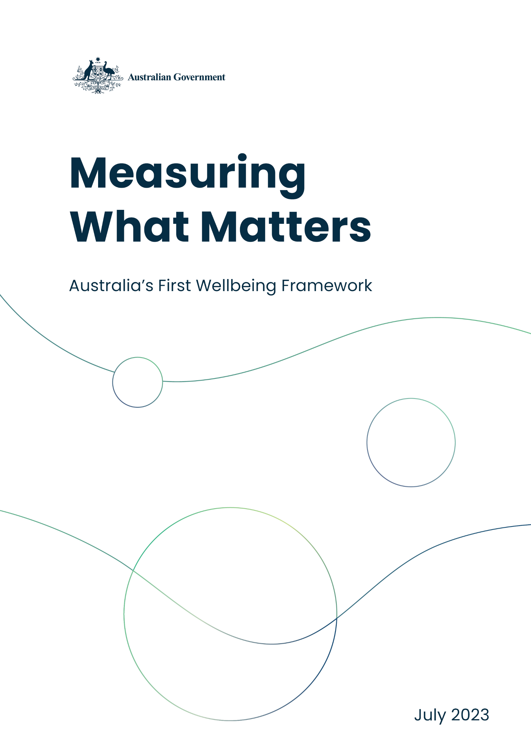
Measuring What Matters
  - Australia’s first wellbeing framework
  - July 2023

© Commonwealth of Australia 2023
ISBN: 978-1-925832-78-5
This publication is available for your use under a Creative Commons Attribution 3.0 Australia licence, with the exception of the Commonwealth Coat of Arms, the Treasury logo, photographs, images, signatures and where otherwise stated. The full licence terms are available from http://creativecommons.org/licenses/by/3.0/au/legalcode.
Use of Treasury material under a Creative Commons Attribution 3.0 Australia licence requires you to attribute the work (but not in any way that suggests that the Treasury endorses you or your use of the work).
Treasury material used ‘as supplied’
Provided you have not modified or transformed Treasury material in any way including, for example, by changing the Treasury text; calculating percentage changes; graphing or charting data; or deriving new statistics from published Treasury statistics – then Treasury prefers the following attribution:
Source: The Commonwealth of Australia
Derivative material
If you have modified or transformed Treasury material, or derived new material from those of the Treasury in any way, then Treasury prefers the following attribution:
Based on Commonwealth of Australia data
Use of the Coat of Arms
The terms under which the Coat of Arms can be used are set out on the Department of the Prime Minister and Cabinet website (see http://www.pmc.gov.au/government/commonwealth-coat-arms).
Other uses
Enquiries regarding this licence and any other use of this document are welcome at:
Manager
Media Unit
The Treasury
Langton Crescent
Parkes ACT 2600
Email: media@treasury.gov.au
Treasury acknowledges the Traditional Custodians of country throughout Australia and their connections to land, sea and community. We pay our respects to their Elders past and present and extend that respect to all Aboriginal and Torres Strait Islander peoples today.

Contents
Treasurer’s Foreword 1
Executive Summary 2
Measuring What Matters 4
Understanding What Matters to Australians 5
The Framework 7
Overall progress on Australian wellbeing 12
Healthy 13
Healthy throughout life 13
Equitable access to quality health and care services 17
Secure 22
Living peacefully and feeling safe 22
Having financial security and access to housing 27
Sustainable 31
Protect, repair and manage the environment 31
Resilient and sustainable nation 37
Cohesive 40
Having time for family and community 40
Valuing diversity, belonging and culture 44
Trust in institutions 48
Prosperous 51
Dynamic economy that shares prosperity 51
Access to education, skills development and learning throughout life 55
Broad opportunities for employment and well-paid, secure jobs 60
The early years of a child’s life and wellbeing 65
Child wellbeing 65
Government support for children in the early years and their families 66
The way ahead 68
Next steps 68
Appendix A: Strengthening the indicators 69
Appendix B: International approaches 71
Appendix C: Consultation 72
Public Submissions on Measuring What Matters 73
Appendix D: Selection of indicators 76
Glossary 77
Data dictionary 80
End Notes 86

Treasurer’s Foreword
I’m really pleased to be releasing Measuring What Matters – Australia’s first ever national wellbeing framework. It’s all about tracking our progress so we can better align our economic and social goals in our communities and right across our country.
Measuring What Matters helps us put people and progress, fairness and opportunity at the very core of our thinking about our economy and our society, now and into the future. We’ve chosen 50 different indicators to help us better understand how we are faring as we pursue a more healthy, secure, sustainable, cohesive and prosperous Australia. These measures are in addition to, not instead of, all the other traditional ways we measure our economy, like GDP and employment.
This will be an iterative process as we continue to consult and refine the Framework based on ongoing and welcome feedback as we go.
Our hope is that we can provide a better, more comprehensive foundation for understanding our economy and our society in ways that inform, interact with and underpin our policy making at all levels, including for example the Employment White Paper, the Intergenerational Report, and the National Strategy to Achieve Gender Equality, as well as our approach to Closing the Gap and the Early Years Strategy.
I’m delighted with the level of engagement and encouragement we’ve seen from around the country and around the world in recent years, as we worked towards this first wellbeing framework. I thank the hundreds of people and organisations who provided the submissions and participated in the roundtables that made it possible, my ministerial colleagues, and the dedicated Treasury team and officials from across the government who put it together.
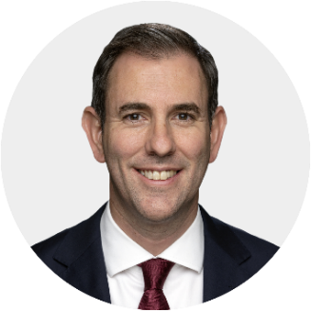
The Hon Jim Chalmers MP
Treasurer

Executive Summary
To be sure of our progress towards a more healthy, secure, sustainable, cohesive and prosperous Australia, we need to measure it. This Statement is our first attempt at outlining a framework that can help us to better understand how we’re tracking and inform how, as a country, we can make progress to improve wellbeing outcomes.
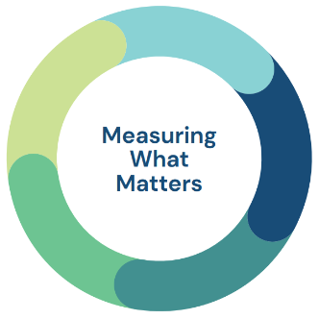

Traditional economic indicators have long been the focus of public debate and remain a vital part of measuring progress, but they are far from the whole story. Making use of additional metrics will deepen our understanding of how Australians are faring, support more informed discussions about what needs to be done to improve the lives of Australians and help better inform policy making across all levels of government.

The Measuring What Matters Framework
The Measuring What Matters Framework (the Framework) has been developed through extensive research and consultation to identify the best available indicators of Australia’s wellbeing. The consultation process, which included over 280 submissions from people and organisations and more than 65 meetings, including with other countries and international organisations, has informed the Framework with five wellbeing themes:
- Healthy: A society in which people feel well and are in good physical and mental health, can access services when they need, and have the information they require to take action to improve their health.
- Secure: A society where people live peacefully, feel safe, have financial security and access to housing.
- Sustainable: A society that sustainably uses natural and financial resources, protects and repairs the environment and builds resilience to combat challenges.
- Cohesive: A society that supports connections with family, friends and the community, values diversity, and promotes belonging and culture.
- Prosperous: A society that has a dynamic, strong economy, invests in people’s skills and education, and provides broad opportunities for employment and well-paid, secure jobs.
We need to pursue good outcomes in all of these themes if we’re to succeed in creating a society in which all Australians can thrive.
Our consultations also underscored the importance of inclusion, equity and fairness which are relevant to outcomes across all five themes.
These themes of the Framework are supported by 12 dimensions that describe aspects of the wellbeing themes and 50 key indicators, to monitor and track progress, which will be updated over time. The indicators have been selected for having consistent, comparable and reliable data, including logical alignment with available indicators already captured through existing strategies and plans.
Just like other countries around the world, Australia’s approach to Measuring What Matters will be an iterative, ongoing one – moulded through continuous conversation with the community and developments in how we collect and capture data. As part of this process, we will take feedback on how often the statement should be released.
Current indicators are available on an online dashboard which will be updated annually, and Appendix A discusses potential opportunities to improve the indicators.
As we refine our approach in future statements, the Government will also consider ways to better link policy decisions with consideration of wellbeing metrics and the broad set of considerations captured in this Framework. The impact of the Framework should also extend beyond the public sector, shaping the community’s understanding of Australia’s wellbeing and highlighting opportunities for improvement.
By providing an overarching national framework for understanding and tracking wellbeing outcomes, the Government hopes that this statement will underpin the broader efforts of business, community groups and others, to deliver better outcomes and opportunities for Australians.

View the online dashboard
https://treasury.gov.au/policy-topics/ measuring-what-matters/dashboard

Measuring What Matters
Measures beyond Gross Domestic Product (GDP), employment and other traditional economic indicators capture what is important to people, communities, and the country both now and in the future. The way we measure wellbeing drives public discussions and influences how we drive progress. The Framework can help inform discussions of the type of society we want to live in and how that may be achieved.

Traditional economic measures – such as GDP, inflation and employment – capture significant aspects of national wellbeing, including our overall prosperity and living standards. It is right that they receive significant attention.
But they are not the only factors that determine wellbeing in Australian society. For example, economic measures do not always adequately incorporate social or environmental outcomes, capture domestic and international risks, or show whether all Australians can access opportunities. It is also important to recognise that improvement in some of these broader measures – such as health outcomes – also support improved economic prosperity.
Internationally, governments have been slowly but increasingly recognising the value of broader measures of wellbeing. Countries such as Scotland, Wales, Canada, New Zealand and Germany have used wellbeing frameworks to raise the profile of non-economic outcomes and to improve policy making.
Australia has played a significant role in shaping global dialogue and international frameworks, including through our commitment to the United Nations 2030 Agenda for Sustainable Development, including the Sustainable Development Goals, and the Organisation for Economic Co-operation and Development (OECD) frameworks. Appendix B provides an overview of international developments.
Across Australia, some states and territories have also developed frameworks that acknowledge the breadth of what matters to their citizens. A national approach will complement these efforts, help us better understand our society, and support more informed policy making.
The way we measure wellbeing drives public discussions and brings attention to how we are progressing in areas valued by the community that are important for longer-term prosperity. That is why the Government is committed to refining the Framework over time, so that we properly take account of changing public perspectives, and developments in how we collect, analyse and use data.

Understanding What Matters to Australians
Australians told us that a broad and diverse set of factors are important to their wellbeing, and this Framework reflects that. The Framework is based on public consultations and the findings of other national and international wellbeing frameworks.

The 2022–23 October Budget explored what we can learn from international approaches to Measuring What Matters. It found that progress and wellbeing frameworks typically include a suite of objectives and indicators to monitor them, developed through extensive consultation over time.
Australia has a strong history of incorporating measurements of progress into policy making. Past efforts include the Treasury Wellbeing Framework and the Australian Bureau of Statistics’ (ABS) Measures of Australia’s Progress. A new integrated Framework will help us to build on these past efforts and complement other initiatives, such as the National Agreement on Closing the Gap and State of the Environment reports.
The OECD Framework for Measuring Well-being and Progress and the UN Sustainable Development Goals have provided a useful foundation for Australia’s Framework, which has been tailored to our own circumstances.

Consultation process
The Government has listened to the views of a broad range of people to capture the diversity of what different parts of our community value. This has involved discussions with various levels of government, private organisations, community groups, people, and international bodies. See Appendix C for a list of formal submissions.
The process has also included two phases of public consultation.
- The first submission process commenced with the 2022–23 October Budget and ran to 31 January 2023. 165 submissions were received in this initial phase.
- The second phase of public consultation ran from 14 April to 26 May 2023 and sought feedback on the emerging wellbeing themes. Around 120 submissions were received. As part of this phase, community groups, members of parliament and other organisations were asked to hold meetings to discuss whether the emerging wellbeing themes resonated.
Overall, submissions and stakeholder consultations supported the introduction of Measuring What Matters and the prospect of a role for the Government in monitoring and advancing progress across a broad range of wellbeing indicators.
The submissions emphasised the importance of including the experiences of different groups – such as women, First Nations people, veterans, people with disability, and age cohorts – and different geographic locations, across all themes.
The statement provides a chapter with a one-off spotlight on wellbeing as it relates to children in their early years. This spotlight has been chosen in response to a recurring view in the submissions that early childhood outcomes play an important role in driving wellbeing over a person’s lifetime and across generations

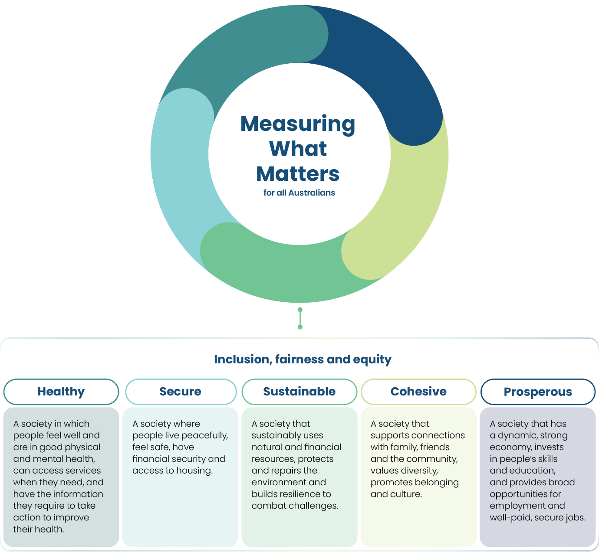

The Framework
Based on public consultations and the findings of other national and international wellbeing frameworks, this Framework focuses on five wellbeing themes – healthy, secure, sustainable, cohesive and prosperous. Inclusion, equity and fairness underpin each theme and are relevant to them all.

The Framework sets out the factors that are important to Australians’ individual and collective wellbeing across all phases of life in five broad themes – healthy, secure, sustainable, cohesive and prosperous.
All the themes are important and success in one can influence success in the others. For example, maximising the health of Australians will be helped by increasing prosperity, cohesion and promoting a sustainable environment.
The themes are supported by 12 dimensions which describe further aspects of wellbeing within the theme.

Cross-cutting dimension
Inclusion, equity and fairness are cross-cutting dimensions of the Framework. This reflects the need to ensure that wellbeing outcomes are fairly shared amongst the population. The alternative – high inequality and entrenched disadvantage – affects social cohesion and may hinder economic growth by limiting access to education and perpetuating disadvantage within communities and across generations.
Aggregate indicators can, at times, mask different experiences and outcomes for different groups of people in our society. Recognising this, indicators and metrics have been disaggregated by age, gender, ethnicity (including for First Nations people), where reliable data is available to highlight distributional differences. The Government will look to include further disaggregation in future iterations of the Framework, website and dashboard – which could include a more comprehensive regional lens.
City and regional data will remain available through the Progress in Australian Regions and Cities dashboard. Box 1 provides some additional detail on First Nations Australian’s wellbeing.

Indicators
The Framework consists of 50 indicators of the current status and long-term trends in Australian wellbeing – including a self-reported life satisfaction indicator – which is relevant to all themes (see Box 2).
While the indicators are organised according to the wellbeing themes in the Framework, they can often be relevant to more than one theme. The ‘making ends meet’ indicator, for example, provides a measure of financial security in the secure theme but could equally provide a measure of shared prosperity in the prosperous theme.
International experience highlights that to be most useful, wellbeing indicators should be readily understood, limited in number, measurable, comparable, reliable, and timely.
The indicators have been selected with those lessons in mind and with the aim of ensuring their logical alignment with available indicators already captured through existing strategies and plans. Appendix D details the criteria that was applied in the selection of indicators.
The table and discussion for each dimension provides an assessment of progress against each indicator. The assessment of progress for each indicator is generally the trend over the past two decades or from the first available comparison point. Where appropriate, progress is also assessed against historical and international benchmarks or towards agreed goals.

Managing complexity
The richness of what matters to Australians extends beyond the 50 indicators, and some things that matter do not always have quality and timely metrics. However, the more indicators that are included in the Framework, the harder it becomes to provide an understandable picture of our economy and society. Because of this, the Framework has been designed to be high-level and concise to ensure that it is accessible and meaningful to as many people as possible.
The Framework does not rank or weight wellbeing themes, dimensions or indicators. Nor does it create a composite index that expresses all metrics in equivalent terms (for example, GDP equivalence).

The relationship between the Framework and other wellbeing frameworks
The Framework does not canvas every aspect of wellbeing. Instead, it complements existing frameworks by providing an overarching national view of how our country and society is faring.
This Framework draws on, but does not replace, more detailed level indicator frameworks, including on:
- tailored indicators developed for life outcomes of First Nations peoples (the National Agreement on Closing the Gap) and the natural environment (the State of the Environment Report).
- existing indicators on the equity, effectiveness and efficiency of government services in Australia (such as those included in the Report on Government Services).
- work on different areas across Australia (such as the State of the Cities and State of the Regions reports which are currently under development).

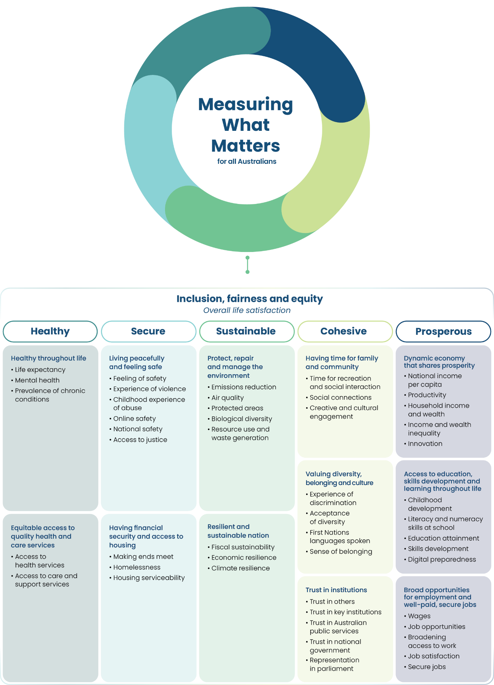
Box 1: Aboriginal and Torres Strait Islander people’s wellbeing
For First Nations people, the concept of wellbeing has always been the result of preserving and maintaining culture, which directly affects mental, physical and spiritual health.
This is anchored in ways of knowing and being that have existed and continued for tens of thousands of years, shared through complex kinship systems, and passed down through systems of law, lore, ceremony, and song.
Because of this, the whole of population indicators outlined in this Framework are not an accurate measure of First Nations wellbeing as they are limited in their ability to represent these intrinsic cultural differences or acknowledge the past practices that have had detrimental impacts.
However, this Measuring What Matters statement can supplement the National Agreement on Closing the Gap metrics and add to the work already being undertaken through the National Strategic Framework for Aboriginal and Torres Strait Islander Peoples’ Mental Health and Social and Emotional Wellbeing (2017–2023).
Efforts to improve First Nations people’s wellbeing should always be made in partnership with First Nations people, including through implementation of the Priority Reforms under the National Agreement on Closing the Gap.

Box 2: Overall life satisfaction
Considering both subjective and objective measures of what matters to people in Australia is important to understanding wellbeing. While this Framework proposes an introductory set of relevant, measurable and reliable metrics, they are balanced by an overarching subjective measure of how people evaluate their life and personal circumstances as a whole.
Overall life satisfaction is a summary measure of subjective wellbeing, reflecting how satisfied people are feeling with their lives in general. The ABS General Social Survey attempts to measure life satisfaction on a scale ranging from 0 to 10, where 0 means ‘not at all satisfied’ and 10 means ‘completely satisfied’. Results generally reflect a person’s experience in the past 12 months and their expectations for the future.
Between 2014 and 2020 the average overall life satisfaction in Australia (out of 10) was relatively stable at around 7.5 between 2014 to 2019 before declining slightly to 7.2 in 2020. The shift is likely associated with the impact of the COVID 19 pandemic on general wellbeing.
Across different age groups, Australians (70 years and over) have consistently had the highest level of average overall life satisfaction. Men and women reported similar levels of life satisfaction each year. People with disability have consistently had a lower average life satisfaction score than people with no disability, with an average difference of 0.7 points across the years. Similarly, average life satisfaction was comparatively lower compared to the general population for people with a long-term health condition (6.9) or a mental health condition (5.8).

Chart 1: Overall life satisfaction in 2020
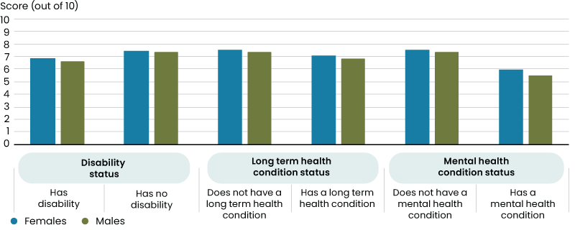
Source: ABS General Social Survey 2020.

Overall progress on Australian wellbeing
Progress across the five themes and 50 indicators has been mixed over recent decades. Many have improved, but some have shown little change and a significant number have deteriorated. Beyond the trends, there is scope for Australia to do better on all themes and indicators.

Over the past two decades, Australia has made progress in improving life expectancy, and reducing resource use. We are more accepting of diversity and have more trust in others. Over those decades, our incomes and job opportunities have improved.
However, we’ve made less progress on indicators such as mental health and real wages.
And some things have deteriorated – we have more chronic health conditions and are finding it harder to access health services. We perceive our national security to be lower and we face new threats online. Biological diversity and fiscal sustainability have declined. We are spending less time developing new skills and while school outcomes have improved, they are falling behind countries.
All in all – over recent decades – 20 of the indicators have improved, 7 have been stable or had little change and 12 have deteriorated. Eight indicators have mixed trends and three others do not have data for comparison over time.
Deteriorating performance is a sign that further attention is required. However, trends only tell part of the story.
Even in areas where progress has been made, we have the opportunity to do better.
For example, while experiences of physical violence have fallen, more needs to be done to ensure every Australian can live free from violence. While annual greenhouse gas emissions have fallen, substantial further progress needs to be made to reach Australia’s legislated commitment to reduce emissions by 43 per cent by 2030.
Everyone has a role in driving further improvements in wellbeing through the choices we make. This includes governments, businesses and other organisations as well as Australian communities and people.

Healthy
A society in which people feel well and are in good physical and mental health, can access services when needed, and have the information they require to take action to improve their health
“By measuring health through metrics that paint the clearest picture of health and wellbeing, we can better monitor health trends across the nation, intervene to address potential health threats, [and] reduce health inequities.”
– the Australian Academy of Health and Medical Science submission

Healthy throughout life
Indicator | Metric | Why this metric | Progress | Latest Value(I)
Life expectancy | Life expectancy at birth(a) | Life expectancy is one of the most used measures for the general state of health | Improved  2001–03 to 2019–21 | Female: 85.4 yrs  Male: 81.3 yrs
Life expectancy | Health adjusted life expectancy(b) | Health-adjusted life expectancy considers the quality of life lived, not just the length | Improved  2003 to 2022 | Female: 74.1 yrs  Male: 71.6 yrs
Mental health | Proportion of people who experienced high or very high levels of psychological distress(c) | This scale is a globally recognised measure of psychological distress and is one indicator of the mental health and wellbeing of the population | Stable  2004–05 to 2017‍–‍18 | 13.0%
Prevalence of chronic conditions | Proportion of people with one or more selected chronic health conditions(c) | Chronic conditions are an ongoing cause of substantial ill health, disability and premature death | Deteriorated  2007–08 to 2020‍–‍21 | 46.6%
Source: (a) ABS Life Tables
(b) The Australian Institute of Health and Welfare (AIHW) Australian Burden of Disease Study
(c) ABS National Health Survey
Note: (i) Unless specified the latest value is the last data point in the series

A healthy life is one that supports longevity, and physical and mental wellbeing.
The selected metrics in this section represent the starting point for measuring the health of Australians. These include life expectancy, mental health and the prevalence of chronic conditions.
Other determinants of health – not currently captured in this theme – include the social, environmental, structural, economic, cultural, biomedical, commercial and digital environments in which we live.
While overall, the health of Australia’s population has improved markedly, in recent years these gains have not been shared equally. Further effort is needed to address health inequities that exist amongst specific groups, including for First Nations people, women, people with disability and culturally and linguistically diverse Australians.

Life expectancy
Increased life expectancy is one of the great success stories of the 20th century and has underpinned sustained improvements in the wellbeing of people’s lives.
As a measurement, life expectancy at birth captures the average number of years a newborn can expect to live and has risen steadily over time.
A boy born between 2019–21 can expect to live to 81.3 years, while a girl can expect to live to 85.4 years. This is equal 4th highest life expectancy at birth in the world, as ranked by the OECD.
A gap exists in life expectancy between First Nations people and non-Indigenous people. In 2015–2017, First Nations life expectancy for men and women was lower than for non-Indigenous Australians by 8.6 and 7.8 years, respectively.
Health-adjusted life expectancy extends the concept of life expectancy by considering the length of time a person at birth could expect to live in full health without disease or injury. Men and women born in 2022 could expect to live an average of 88 per cent and 87 per cent of their lives in full health, respectively.
Between 2003 and 2022, health-adjusted life expectancy at birth increased by 2.2 years for men and 1.3 years for women. However, the average proportion of life spent in full health has decreased slightly for both men and women.

Chart 2: Health-adjusted life expectancy
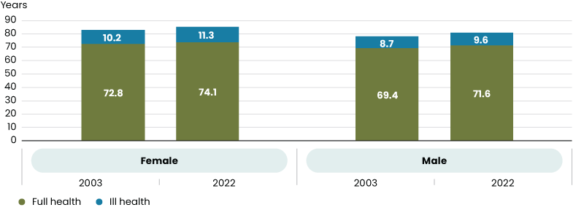
Source: AIHW Australian Burden of Disease Study 2022.

Mental health
Mental health is complex, influencing how people think, feel, and act – affecting every aspect of people’s lives. The experience of mental health and wellbeing is extremely diverse and unique to every person. Similarly, many factors can influence mental health including, for example, biological factors, life experiences, family history of mental ill-health, major stress and significant life changes.
One measure of the mental health and wellbeing of our population is provided by measuring levels of psychological distress.
In 2017–18, 13 per cent of Australians aged 18 years and over experienced high or very high levels of psychological distress – consistent with 2004–05 levels.
The experience of psychological distress varies between groups.
- In 2017–18, more women than men experienced high or very high levels of psychological distress – 14.5 per cent and 11.3 per cent respectively.
- 31 per cent of adult First Nations people experienced high or very high levels of psychological distress in 2018–19 (Kessler-5 Psychological Distress Scale).
- First Nations women were also more likely to experience high or very high levels of psychological distress than men.
More recently, the National Study of Mental Health and Wellbeing 2020–21 reported approximately 15 per cent of Australians aged 16‍–‍85 years experienced high or very high levels of psychological distress in 2020–21. This data was collected during the COVID-19 pandemic and might not reflect a long-term trend. Caution should be taken when comparing the 2020–21 result with the trend due to differences in survey methodology.
Over time, how we seek to capture changes in the mental health of the population will be impacted by new developments in how we understand the issue and its impact on people, families, and community.

Prevalence of chronic conditions
Chronic conditions are an ongoing cause of ill health and disability, and can limit the extent to which people can enjoy their lives – making them an important measure of national health and wellbeing in Australia.
Chronic conditions generally have long-lasting and persistent effects and include conditions such as coronary heart disease, cancer, and diabetes.
The prevalence of chronic conditions is increasing in Australia. This trend is associated with a number of factors, including the prevalence of modifiable risk factors, the fact that people are living longer and that improvements in the treatment and management of chronic conditions have extended life expectancies.
In 2020–21, nearly half of Australians of all ages (46.6 per cent) had one or more chronic conditions, and almost one in five (18.6 per cent) had two or more chronic conditions – a state of health known as multimorbidity.
Many chronic conditions have behavioural and biomedical risk factors that contribute to their development, for example, tobacco smoking, insufficient physical activity, poor diet, excess weight, and high blood pressure or cholesterol. While recognising these risks can be driven or reinforced by factors beyond a person’s control, the management of risk factors can reduce the likelihood of developing a chronic condition – resulting in health and wellbeing gains throughout the course of life.

Key Government initiatives to improve mental and physical health
- Strengthening the mental health and suicide prevention system, growing the workforce and laying the groundwork for future reform
- Stronger action to reduce smoking and vaping rates – particularly among young Australians – through stronger legislation, enforcement, education, and support
- Improving health outcomes through extending existing alcohol and drug programs in the community
- Establishing a national lung cancer screening program for those most at risk, maximising prevention and early detection for at-risk Australians
- Establishing the Australian Centre for Disease Control in response to health emergencies and other public health challenges
- National Aboriginal and Torres Strait Islander Health Plan 2021–2031
- Closing the Gap Social and Emotional Wellbeing Policy Partnership
- Developing the Gayaa Dhuwi (Proud Spirit) Declaration Implementation Plan
- National Preventive Health Strategy 2021–2030
- Refreshed National Strategic Framework for Aboriginal and Torres Strait Islander Peoples’ Social and Emotional Wellbeing

Equitable access to quality health and care services
Access to quality health and care services is critical if people are to receive the help that they need to manage conditions, make a full contribution to the community, and maximise their wellbeing.
The metrics outlined below will help us to make assessments of our success in making sure Australians have access to the support they require.

Indicator | Metric | Why this metric | Progress | Latest Value(i)
Access to health services(a) | Cost: proportion of people who at least once delayed or did not see a General Practitioner (GP) when needed due to cost | Cost and wait times provide an insight into how effectively Australia’s health services are operating | Improved  2013–14 to 2021–‍22 | 3.5%
Access to health services(a) | Cost: proportion of people who at least once delayed or did not see a medical specialist when needed due to cost |  | Stable  2013–14 to 2021–‍22 | 8.0%
Access to health services(a) | Wait times: proportion of people waiting longer than they felt acceptable for an appointment with a GP |  | Deteriorated  2013–14 to 2021–‍22 | 23.4%
Access to health services(a) | Wait times: proportion of people waiting longer than they felt acceptable for an appointment with a medical specialist |  | Deteriorated  2013–14 to 2021–‍22 | 26.7%
Access to care and support services(b) | Unmet needs: proportion of people (aged 0–64 years) living in households who receive disability support who felt their needs were not being met | Access to quality care and support services is fundamental for the quality of life for the recipients of these services | Deteriorated  2009 to 2018 | 37.5%  Disability
Access to care and support services(b) | Unmet needs: proportion of people (aged 65 years and over) living in households who receive aged care services and who felt their needs were not being met |  | Deteriorated  2015 to 2018 | 34.0%  Aged care
Access to care and support services(b) | Quality: proportion of people with disability (aged 15–64 years) who were satisfied with the quality of assistance |  | Deteriorated  2012 to 2018 | 76.6%  Disability
Access to care and support services(b) | Quality: proportion of people (aged 65 years or over) living in households, who were satisfied with the quality of assistance |  | Deteriorated  2012 to 2018 | 84.4%  Aged care
Source: (a) ABS Patient Experience Survey
(b) Productivity Commission analysis of ABS Survey of Disability, Ageing and Carers, Report on Government Services (Chapters 14, 15)
Note: (i) Unless specified the latest value is the last data point in the series

Access to health services
Health services are those which prevent, diagnose, treat, and manage health conditions.
While many factors determine accessibility, health service cost and wait times are two measures that provide an insight into how effectively Australia’s health services are operating.
Other factors that can inhibit access include distance, availability of services, time pressures, language difficulties and a person’s understanding of their health care needs.
In 2021–22, 3.5 per cent of people delayed or did not see a GP when needed due to cost an improvement from 4.9 per cent in 2013–14.
8 per cent of people delayed or did not see a medical specialist when needed due to cost – similar to 7.9 per cent in 2013–14.
The proportion of people waiting longer than they felt acceptable for an appointment with a GP or a medical specialist have both increased since 2013–14 – growing to 23.4 per cent and 26.7 per cent respectively.
Patient experience with access to health services differs substantively across cohorts and locations.
In 2021–22, those living in outer regional, remote, or very remote areas were more likely to report waiting longer than they felt acceptable for a GP appointment than those living in major cities – 28.7 per cent compared to 21.6 per cent – highlighting regional disparities.
These metrics do not cover all factors which affect the ability of Australians to access health services – others include, for example, the availability of hospitals, pharmaceuticals, diagnostic services, and allied health. GP and medical specialist services were selected as they represent two of the largest touchpoints within the health system for most people.

Chart 3: Proportion of people who delayed seeing a GP or a medical specialist due to cost when needed
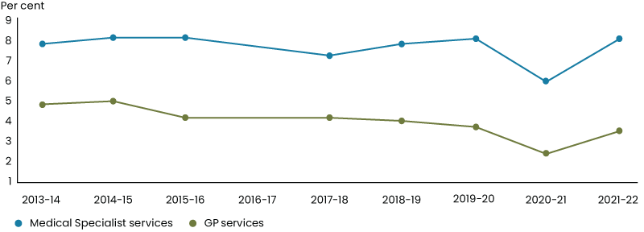
Source: ABS Patient Experience Survey

Access to care and support services
While there are many forms of care and support services in Australia, disability and aged care are two that many people will engage with at some time in their lives. Early childhood education and care is another important care and support service, and is discussed in the chapter The early years of a child’s life and wellbeing.
Measuring levels of unmet need, as well as client satisfaction is a key source of insight into the extent to which Australians have access to these services.
In 2018, 37.5 per cent of people (aged 0‍–‍64 years) who received formal disability assistance reported a need for more assistance than they were receiving – an increase from 31.9 per cent in 2009. The proportion of carers for people with disability who reported a need for further assistance in their caring roles also increased over this period – from 22.8 per cent to 32.0 per cent.
76.6 per cent of people (aged 15‍–‍64 years) who received formal disability support and 84.4 per cent of people (aged 65 years and over) living in households that received formal aged care services were satisfied with the quality in 2018.
However, between 2012 and 2018 there has been a decline in the proportion of people (aged 65 years and over) living in households who were satisfied with the quality of aged care assistance received. These metrics do not cover all factors which go towards access to and quality of care services. Others include the wellbeing outcomes generated by the significant amount of unpaid care activity in Australia.
As the most recent data point for these metrics is 2018, they do not capture the impact of investment in disability assistance and aged care services that has taken place since that time.
The Australian, state and territory governments are also working together to develop the National Disability Data Asset – a single source of information combining data from all levels of government. It will aim to give a more complete picture of the lived experience of people with disability.

Chart 4: The proportion of people who received formal disability or aged care assistance who were satisfied with the quality of assistance
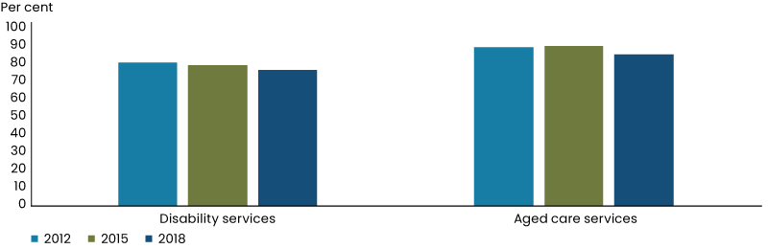
Source: Productivity Commission (PC) analysis of ABS Survey of Disability, Ageing and Carers, Report on Government Services
Key Government initiatives to expand access to health and care services
- Strengthening Medicare in the 2023–24 Budget, including:
- tripling bulk billing incentives to make care more affordable for children, pensioners and other Commonwealth concession card holders
- improving digital health to provide health professionals the digital and data tools they need to provide improved care
- enabling GPs, nurses, and allied health professionals to deliver multidisciplinary team care and work to their full scope of practice
- increase access to after hours care
- connecting frequent hospital users to general practices
- additional funding to support management of chronic disease, including longer consultations, new incentives, and the MyMedicare voluntary patient registration model
- more Medicare Urgent Care Clinics in more places to take pressure off hospitals with no out of pocket costs
- making hundreds of common medicines cheaper by reducing the cost for at least 6 million Australians
- growing the health workforce through more scholarships and training places
- Funding a 15 per cent pay rise on award wages for aged care workers
- Mandate that aged care facilities have a registered nurse onsite 24/7
- Increase to a mandatory sector wide average of 215 care minutes (including 44 minutes of registered nursing time) from 1 October 2024
- National Strategy for the Care and Support Economy
- National Autism Strategy (forthcoming)
- National Carer Strategy (forthcoming)
- National Disability Insurance Scheme Review (forthcoming)
- National Disability Insurance Scheme Workforce Strategy (forthcoming)
- National Disability Insurance Scheme Sustainability Strategy Framework
- Improving capability and systems in the National Disability Insurance Agency

Box 3: Valuing non-market transactions
Some stakeholders emphasised the importance of estimating and monitoring the monetary value of activities not captured by GDP.
GDP captures the production of a wide range of goods and services that contribute to wellbeing, but people’s wellbeing is affected by many factors that are ‘beyond GDP’. These factors include the benefits derived from environmental services – such as air filtration, water purification and flood mitigation – and the benefits from unpaid household service work – including cooking, cleaning, caring, and transportation.
Many of these benefits that are outside the scope of GDP can be quantified. For example, through time-use surveys we can estimate the amount of time that households undertake unpaid work. We can also consider measuring the quality of those benefits and how they impact people’s wellbeing.
These benefits are commonly referred to as non-market benefits. While estimating the monetary value for non-market benefits will not capture all of the importance of these activities to people’s wellbeing, the valuation can be relevant in supporting policy and decision making. For example, understanding the monetary value of unpaid household service work can support a better understanding of the trade-offs that households make in their allocation of time, and understanding the monetary value of environmental services can inform cost benefit analysis between alternative investments in the environment. Finding consistent ways to value these benefits and costs help policy makers to understand the relevant trade-offs that need to be balanced against each other.
Although developing monetary value of non-market activities has merit, it is not the purpose of this Framework. The focus is more on how well we achieve our goals or outcomes that contribute to wellbeing, such as the level of unmet needs or quality of care services.

Secure
A society where people live peacefully, feel safe, have financial security and access to housing.
“All Australians should live in safe, resilient and vibrant communities where they have equitable access to the necessary goods and services that underpin their health and wellbeing.”
– VicHealth submission

Living peacefully and feeling safe
Indicator | Metric | Why this metric | Progress | Latest Value(i)
Feeling of safety | Proportion of people who felt ‘safe’ or ‘very safe’ walking alone during the day and night(a) | Shows an overall subjective feeling of safety for people in their community | Improved  2012–13 to 2021–‍‍22 | 53.8% (night)  91.5% (day)
Experience of violence | Proportion of people who experienced physical violence in last 12 months(b) | Most common form of violence for men and women | Improved  2005 to 2021–‍22 | Female: 2.9%  Male: 6.1%
Experience of violence | Proportion of people who experienced violence by an intimate partner in last 12 months(b) | Shows incidences of personal violence where people should feel the safest | Stable  2005 to 2021‍–‍22(ii) | Female: 1.5%  Male: (iii)
Childhood experience of abuse | Proportion of people who have experienced physical or sexual abuse before the age of 15 years(b) | Provides an indication of the experience of abuse during childhood | Data not suitable for comparison over time | 14.1%
Online safety | Proportion of people who have experienced online harm or negative content in the last 12 months(c)(iv) | Provides a picture of the online environment in Australia | Deteriorated  2019–2022 | 75%
National safety | Proportion of Australians who feel ‘safe’ or ‘very safe’ based on views of world events(d) | Provides a measure of Australians’ feelings of national safety based on world events | Deteriorated  2005–2023 | 63%
Access to justice | Index of Australia’s performance in providing accessible and affordable civil courts and alternative dispute resolution mechanisms(e) (the index ranges from 0 to 1) (v) | Measures accessibility, affordability, and impartiality of the civil justice system in Australia | Stable  2012–13 to 2022 | 0.58 access and affordability  0.8 dispute resolution
Source: (a) Steering Committee for the Review of Government Service Provision, Report on Government Services 2023
(b) ABS Personal Safety Survey
(c) e-Safety Commissioner National Survey of Australian Adults’ Experiences Online
(d) The Lowy Institute, 2023 Lowy Institute Poll
(e) World Justice Project Rule of Law Index®
Note: (i) Unless specified the latest value is the last data point in the series
(ii) Trend does not factor in 2021–22 data point, due to impacts of COVID-19
(iii) According to the ABS, data for men has a high standard of error in 2021–22, unreliable to measure changes over time
(iv) Online harm can come in a variety of forms, including being sent unwanted content, scams, impersonation, and offensive communication
(v) A score of 1 in the index shows that Australia is performing well in terms of the access and affordability of civil justice or the access, impartiality and effectiveness of the Alternative Dispute Resolution mechanisms

Some people may find the contents of this chapter confronting or distressing.
Support services are available:
1800RESPECT – 1800 737 732 and Lifeline – 13 11 14.
Wellbeing is impacted by safety at home, online, at work, in the community and in the world. Physical or online crime and violence can lead to physical pain, stress, anxiety and loss of life and property. Even those not directly impacted can feel an increase in vulnerability, stress, and anxiety if they feel their safety is at risk.
The metrics in this section are intended to capture and track the various components of a safe, secure society – the feeling of safety, experiences of violence as an adult and during childhood, online safety, national safety, and access to justice.
Broadly, Australians’ experience of security and safety varies across groups. Understanding these issues in greater depth could be an area of further work in the future.

Feeling of Safety
A general indicator we can use to inform an overall sense of how safe Australians feel is whether they are comfortable to walk alone.
This indicator shows that while more than 9 in 10 Australians feel safe to do so during the day, only 1 in 2 feel the same at night – less than the OECD average. However, this indicator has improved from 49.8 per cent in 2012–13 to 53.8 per cent in 2021–22 – indicating some progress.
In general, more women feel unsafe walking alone at night compared to men. In the 2016 ABS Personal Safety Survey which includes a gender split, 25.6 per cent of women chose not to walk alone at night because they felt unsafe compared to 4.2 per cent of men.

Experience of violence
A counterpart to feeling safe is being free from violence. Violence is an incident where a person is harmed by another person. This takes on various forms, including but not limited to physical, emotional, and sexual abuse, and neglect.
In Australia, personal safety from physical violence has improved since 2005. The prevalence rate of physical violence has declined from 10.4 per cent for men and 4.7 per cent for women in 2005 to 6.1 per cent and 2.9 per cent respectively in 2021–22.
Violence by an intimate partner (physical and/or sexual), is more commonly experienced by women and impacts many aspects of wellbeing. The rate of intimate partner violence was 2.3 per cent in 2005 and 1.5 per cent in 2021‍–‍22 for women.
The impact of COVID-19 lockdowns should be taken into consideration when comparing the years and assessing the trends. Prior to 2021, the rates have remained stable and intimate partner violence remains a continual issue in Australian society.
Emotional abuse by a cohabiting partner was experienced at a greater rate for women (3.9 per cent) than men (2.5 per cent) in 2021–‍22. Prior to the COVID-19 pandemic, the prevalence rate has remained stable for women and increased for men.
The COVID-19 pandemic introduced new and unique stressors into people’s lives and may have exacerbated risk or vulnerability.
A 2021 Australian Criminology Institute study found that the COVID-19 pandemic has ‘coincided’ with increases in first-time violence, frequency and severity of violence. They found that around 3 in 5 women reported experiencing physical violence (57.1 per cent), sexual violence (61.1 per cent), or emotional abuse, harassing or controlling behaviours (66.2 per cent) for the first time, or an escalation in the frequency and severity of ongoing violence.

Childhood experience of abuse
Childhood experience of abuse has severe impacts on mental health and health risk behaviours throughout a person’s life. The Australian study found that people (aged 16 years and above) who experienced childhood maltreatment were 2.8 times more likely to experience a form of mental health disorder – at least one of four assessed in the study – than those who have not experienced maltreatment.
The number of people who experience abuse before the age of 15 is unacceptably high. The ABS Personal Safety Survey in 2021–22 found 14.1 per cent of people aged 18 years and over experienced abuse during their childhood. The proportion of women who experience abuse before the age of 15 is higher at 17.5 per cent compared to 10.6 per cent for men in 2021–22.

Key Government initiatives to make Australians safer
- National Plan to End Violence against Women and Children 2022–2032
- Extension to the Family, Domestic and Sexual Violence Responses National Partnership Agreement
- Support for migrant women and women on temporary visas to escape violence
- National Strategy to Prevent and Respond to Child Sexual Abuse 2021–2030
- Safe and Supported: the National Framework for Protecting Australia’s Children 2021–2031
- National Plan to Respond to the Abuse of Older Australians
- Cyber Security Strategy (forthcoming)
- Data and Digital Government Strategy
- National Action Plan to Combat Modern Slavery 2020–25
- Establishing a new National Anti-Scam Centre in the Australian Competition and Consumer Commission
- New anti-SMS scam rules
- Developing a new anti-scam industry code
- Sustainable biosecurity funding
- Investing in Australia’s agricultural traceability systems

Online safety
Operating in an online space is the norm for most people and affects many aspects of people’s lives. In 2016–17, 97 per cent of households with children aged under 15 years had access to the internet – making online safety increasingly important.
Negative online experiences can come in a variety of forms, including being sent unwanted content, scams, impersonation, and offensive communication. The proportion of adults with negative online experiences have increased from 58 per cent in 2019 to 75 per cent in 2022. Australian adults who identify as lesbian, gay, bisexual, transgender, queer/questioning, intersex, asexual or other sexually or gender diverse people (LGBTIQA+), culturally and linguistically diverse Australians, those living with disability, and First Nations people are more likely to have negative experiences online.

National Safety
National, regional and global events undoubtedly influence the individual and collective wellbeing of Australians. This has become especially apparent as global interconnectedness has increased since the second half of the twentieth century.
This development has created both benefits and risks to the wellbeing of Australians. We need international engagement to maintain a stable and open trading environment, as well as international peace and security. Australia’s security is underpinned by an Indo-Pacific region that is open, stable and prosperous, where sovereignty is respected.
Ensuring Australia’s prosperity and security in a more complex world requires all elements of statecraft – including diplomatic engagement and economic and development capability, underwritten by military capability, economic security, domestic resilience, and strong borders.
The Lowy Institute Poll 2023 shows that Australians’ feelings of safety – based on perceptions of world events – has trended down since 2005 and hit historic lows in 2020. In 2005, 91 per cent of polled Australians reported feeling ‘very safe’ or ‘safe’, this declined to a low of 50 per cent in 2020 – coinciding with onset of COVID-19 pandemic – and recovered to 63 per cent in 2023.

Key Government initiatives to make Australians more secure
- AUKUS investment in defence capability
- Defence Strategic Review
- Enhancing Pacific engagement and security cooperation
- Deeper partnerships across Southeast Asia and a forthcoming Southeast Asia Economic Strategy
- Australia’s New International Development Policy (forthcoming)
- Australian leadership in the World Trade Organization
- Trade and investment diversification through participation in Indo-Pacific Economic Framework, APEC, G20, OECD
- Australia’s candidacy for the UN Security Council for 2029–30
- Supporting people online through the eSafety Commissioner

Access to justice
Fair and equal access to justice is critical if people are to have their rights, freedoms, and the ability to pursue lives which enhance their wellbeing.
In Australia, the World Justice Project Rule of Law Index® indicates that the access people have to civil justice and whether alternative dispute resolution mechanisms are accessible, impartial, and effective, have remained relatively stable over the decade – with an average index score of 0.6 and 0.8 (out of 1) respectively between 2012–13 and 2022.

Chart 5: Fair and equal justice indexes
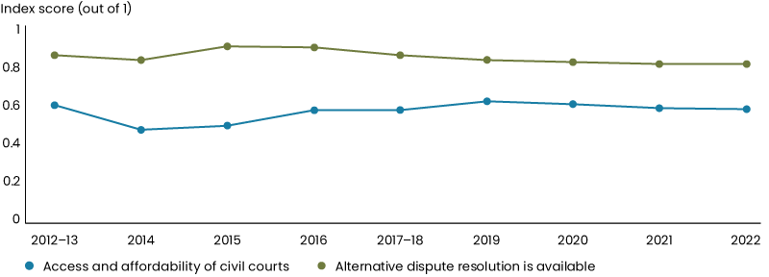
Source: World Justice Project Rule of Law Index® (2022)

Key Government initiatives to expand access to fair and equal justice
- National Legal Assistance Partnership 2020–2025
- Family Law reform
- National Strategic Framework for Legal Assistance
- Support for separating couples (in 2023–24 Budget)
- Scoping the establishment of a Federal Judicial Commission

Having financial security and access to housing
Indicator | Metric | Why this metric | Progress | Latest Value(i)
Making ends meet | Proportion of households who experienced a cash flow problem in the last 12 months(a) | Provides insights into the ability of Australians to meet basic financial commitments | Deteriorated  2006–2020 | 20.7%
Making ends meet | Proportion of households unable to raise $2,000(i) when needed(a) |  | Deteriorated  2006–2020 | 18.7%
Homelessness | Rate of people who are experiencing homelessness(b) | Financial insecurity and housing costs is a risk factor for homelessness | Deteriorated  2006–2021 | 48 per 10,000 people
Housing serviceability | Proportion of housing costs to household gross income, by tenure(c) | Housing constitutes a large part of the cost for households and plays a role in financial security | Deteriorated (renters)  Improved (mortgage holder)  2002–03 to  2019–20 | 20.2% renters from private landlord  19.5% renters from state or territory housing authority  15.5% (owned with mortgage)
Source: (a) ABS General Social Survey
(b) ABS Census of Population and Housing
(c) ABS Survey of Income and Housing
Note: (i) Unless specified the latest value is the last data point in the series
(ii) This is the nominal value, noting purchasing power of $2,000 is different in 2020 to what it was in 2006

Financial security and access to housing are important determinants of personal wellbeing. They reduce people’s vulnerability to income fluctuations and enable their full participation in social and economic activities.
The metrics outlined below will be used to track the financial security and access to housing of Australians over time according to their capacity to make ends meet, the extent of homelessness and housing serviceability trends.

Making ends meet
Financial stress indicators can provide an indication of how many Australians lack financial security.
The proportion of households experiencing financial stress has increased since 2006. In 2020, around one in five households experienced each of the two financial stress indicators: cash flow problems and unable to raise funds. The proportion of households experiencing cash flow problems also increased over this period from 18.5 per cent to 20.7 per cent. Similarly, the proportion of people unable to raise $2,000 within a week, when needed, has increased from 14.5 per cent in 2006 to 18.7 per cent in 2020.
Differing household composition is associated with different levels of reported financial stress. For example, in 2020 one parent families with dependent children were more likely to just break even most weeks than couple parent families with dependent children – 48.6 per cent compared to 34.4 per cent.
The impact of the COVID-19 pandemic, global price shocks, inflation and the impact of interest rate rises on households is not captured in the latest ABS release (2020). More recent survey data has highlighted these factors are placing additional pressure on household budgets and the number of Australians experiencing financial hardship.

Key Government initiatives to help make ends meet
- Cost of living relief package (2023–24 Budget):
- assisting with power bills
- cheaper medicines and reducing out-of-pocket health costs
- targeted support for single parents
- increasing the rate of income support payments
- more affordable housing, including increasing the maximum rate of Commonwealth Rent Assistance
- Targeting entrenched community disadvantage package (2023–24 Budget)
- Reinvigorating enterprise bargaining
- Supporting a pay increase for low-paid workers including funding 15 per cent pay rise on award wages for aged care workers
- Expanding Paid Parental Leave
- Supporting regional households and farmers in times of drought or natural disasters
- Cheaper childcare reforms

Homelessness
Homelessness can be defined as when a person does not have secure access to adequate housing. This includes people who: are not in a dwelling, in a dwelling that is not adequate or has uncertain tenure, living in a house that is severely crowded, or living in temporary lodging.
There has been little change in the rate of homelessness in Australia since 2006. The homelessness rate in 2006 was 45 per 10,000 people compared to 48 per 10,000 people in 2021. Both youth aged 12‍–‍24 years and First Nations people have a higher rate of homelessness compared to the national average.
The most common form of homelessness is living in severely crowded dwellings – with nearly two in five (39 per cent) people experiencing homelessness in 2021 living in these conditions. 52 per cent of men and 49 per cent of women aged 12‍–‍24 years who experience homelessness live in severely crowded dwellings.
The National Agreement on Closing the Gap recognises the importance of secure, appropriate and affordable housing that is aligned with First Nations people’s priorities and needs. In 2021, 81.4 per cent of Aboriginal and Torres Strait Islander people were living in appropriately sized (not overcrowded) housing – this was an increase from 78.9 per cent in 2016.

Housing Serviceability
Beyond homelessness, we have other ways of measuring housing stress, including serviceability.
Measuring housing serviceability is not straightforward since Australians rent, buy or access housing in a variety of ways. The simplest and most common measure of housing stress refers to the relationship between housing costs – that is, the prices of rent or mortgage payments – and household incomes.
In the past two decades, real absolute housing costs have increased for all tenure types. The most recent ABS release (2019–20) on housing is some years old. In it, the average weekly costs for housing were $379 for renters and $493 for owners with a mortgage.
However, since the COVID-19 pandemic, there has been a marked increase in housing costs across the board that is not captured in the ABS release. The median weekly cost for rent in June 2023 – according to CoreLogic data – was $589, while housing costs for many households with a mortgage have been affected by the current interest rate tightening cycle.
In 2019–20, the share of gross household income spent on housing was around 20.2 per cent for private renters, 19.5 per cent for renters from a housing authority and 15.5 per cent for owners with a mortgage. In that year around a third of Australian households either rented (31.4 per cent), owned their home outright (29.5 per cent) or were homeowners with mortgages (36.8 per cent).
These cost-to-income ratios have generally remained steady over the last several years prior to the COVID-19 pandemic. However, these averages can mask incidence of housing stress across different groups of households or regions. For instance, nearly half (46.7 per cent) of low-income earners who rent spend more than 30 per cent of their weekly income on housing costs.
In 2019–20, 17.4 per cent (or 618,400) of Australian household homeowners with mortgages spent more than 30 per cent of their gross household income on housing costs compared to only 2.8 per cent (or 79,800) of homeowners without mortgages.

Chart 6: Housing costs as a proportion of household income, 2019–20
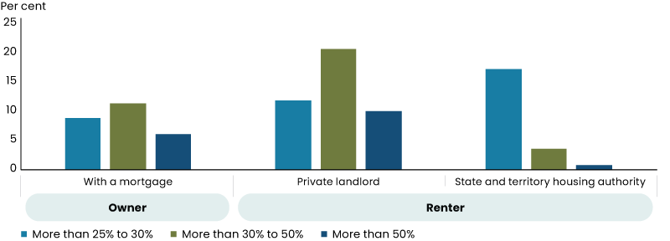
Source: ABS Survey of Income and housing 2019–20.
Note: Caution should be taken when using the more than 50 per cent figure for state and territory housing authority due to the high margin of error associated with this value.

Key Government housing initiatives
- National Housing Accord to build one million new well-located homes over 5 years from 2024
- $2 billion for social housing through the Social Housing Accelerator
- $10 billion Housing Australia Future Fund
- $410.4 million for critical investments in housing and infrastructure for First Nations communities
- Help to Buy Scheme
- Largest increase in Commonwealth Rent Assistance in over 30 years
- National Housing and Homelessness Plan
- Providing tax incentives to support build-to-rent developments
- Increasing the National Housing Finance and Investment Corporation’s (NHFIC) liability cap, supporting an additional 7,000 dwellings
- Broadening the National Housing Infrastructure Facility
- Strengthening Renters’ Rights
- Enhancements to the Home Guarantee Scheme
- Superannuation – expanding eligibility for downsizer contributions

Sustainable
A society that sustainably uses natural and financial resources, protects and repairs the environment and builds resilience to combat challenges.
“An environment with rich biodiversity, clean air and water, and sustainable natural capital stocks supports healthy, enriched lives.”
– Climateworks Centre Submission

Protect, repair and manage the environment
Indicator | Metric | Why this metric | Progress | Latest Value(i)
Emissions reduction | Proportion of reduction in Australia’s net greenhouse gas emissions from 2005 levels(a) | Together the metrics indicate progress on reducing emissions in a way that is comparable to Australia’s 2030 and 2050 emissions reduction goals | Improved  2005–2022 | 24.7% below year to June 2005 in year to December 2022
Emissions reduction | Renewable share of electricity generation(b)(ii) |  | Improved  2001–02 to 2021–22 | 30.9% (of electricity generation)
Air quality | Exposure to outdoor air pollution of PM2.5(c) | Particulate matter is commonly used as a proxy indicator for exposure to air pollution | Stable  2017–18 to 2021–22 | Varies by region
Protected areas | Proportion of land and water areas dedicated to the long-term conservation of nature, its ecosystem and cultural values(d) | Tracks the national target to protect and conserve 30 per cent of Australia’s landmass and marine areas by 2030 | Improved  2002–2022 | 22.1% of land  45% of marine
Biological diversity | Proportion of decline in Australia’s threatened and near threatened species from the ‘Threatened Species Index’(e) | Indicator of biodiversity lost and helps to gauge the success of conservation policies | Deteriorated  2002–2019 | 55% average decline in relative abundance for the 278 species represented since 1985
Resource use and waste generation | Waste generation per person(f) | Together these indicators measure resources disposed-of and recovered for further use | Improved  2006–07 to 2020–21 | 3.3% decline in waste generation per person
Resource use and waste generation | Proportion of waste recovered for reuse, recycling or energy(f) |  | Improved  2006–07 to 2020–21 | 63% of waste recovered
Source: (a) DCCEEW Quarterly Update of Australia’s National Greenhouse Gas Inventory: December 2022
(b) DCCEEW Australian Energy Statistics, Table O June 2023
(c) National Environment Protection Council National Environment Protection (Ambient Air Quality) Measure and unpublished data
(d) DCCEEW the Collaborative Australian Protected Areas Database, 2022
(e) Terrestrial Ecosystem Research Network the Threatened Species Network 2022
(f) DCCEEW National Waste Report 2022
Note: (i) Unless specified the latest value is the last data point in the series
(ii) This includes both on-grid and off-grid electricity generation

Protecting, repairing and managing a healthy and sustainable natural environment is essential for a strong economy, thriving industries, a healthy population, and quality of life. For many Australians – including First Nations people – the natural environment provides a source of cultural and spiritual connection.
Access to adequate, good-quality water is vital for our environment, communities, economy, and culture. Climate change threatens our water resources as severe droughts are projected to occur more frequently and last longer, extreme events become more frequent, and intense and cool-season rainfall is forecast to continue decreasing.
As the urgency of addressing climate change increases and the impacts of changes that have already occurred become more pronounced, the importance of progress on these measures has increased.
The metrics included in this section are intended to help us capture the elements that go towards greater sustainability: emissions reduction, air quality, protected areas, biological diversity and resource use.
They will complement the high-quality environmental information that will come from Environment Information Australia, which the Government is establishing.

Emissions reduction
Around the world, action to achieve net zero emissions has accelerated. This transformation is the most significant shift in the world’s economy since the industrial revolution. It is changing the value of countries’ natural endowments, disrupting trade patterns, creating new markets, requiring heightened adaptability and rewarding innovation.
Australia is among the countries best positioned to benefit from this transformation. Our abundance of sun, wind and land means Australia has potential to generate large volumes of cheap electricity to power our homes and industries, and to export. Reducing emissions and growing new low-carbon industries will be key to realising this economic opportunity. The costs of inaction or delaying action will far outweigh the costs of efficient mitigation.
In Australia, annual greenhouse gas emissions have fallen by 24.7 per cent since June 2005 –the baseline year for Australia’s 2030 target under the Paris Agreement – however, emissions per capita are higher than the OECD average. Substantial further progress needs to be made to reach Australia’s legislated commitment to reduce emissions by 43 per cent by 2030.
Recent declines have been driven largely by land use, land-use change and the forestry sector becoming a net carbon sink rather than a net source, along with the rapidly increasing share of renewables in electricity generation.

Box 4: Net Zero Authority
The global transformation to a net zero economy is a massive source of economic opportunity for Australia, its regions, industries and workers.
The Net Zero Authority will:
- Support workers in emissions-intensive sectors to access new employment, skills and support as the net zero transformation continues.
- Coordinate programs and policies across government to support regions and communities to attract and take advantage of new clean energy industries and set those industries up for success.
- Help investors and companies to engage with net zero transformation opportunities.

Electricity generated from renewable energy has increased from 7.7 per cent in 2001–02 to 30.9 per cent in 2021–22. This has been driven by an increase in electricity generated from wind from 0.2 per cent to 10.7 per cent and solar from less than 0.1 per cent to 12.8 per cent over the period. Australia’s electricity system is currently undergoing a historic transformation to reach the target of 82 per cent renewable energy by 2030.
The Government is developing a National Energy Performance Strategy to improve energy performance and affordability and reduce emissions. To measure progress, consideration is being given to the development metrics that track energy efficiency and productivity.
The Annual Climate Change Statement provides more detailed information on Australia’s progress in reducing emissions.

Chart 7: Australia’s net national greenhouse gas emissions
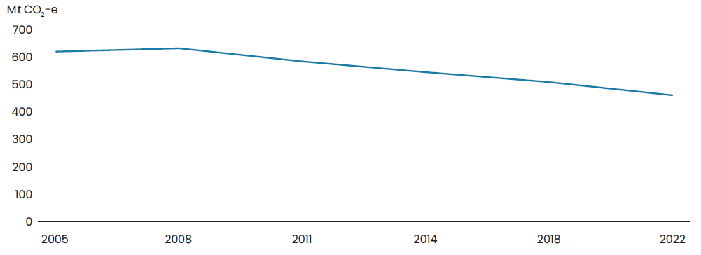
Source: DCCEEW Quarterly Update of Australia’s National Greenhouse Gas Inventory December 2022.
Key Government climate change initiatives
- Legislated emissions reduction targets of 43 per cent by 2030 and net zero emissions by 2050
- Safeguard Mechanism to reduce emissions from industry
- Powering Australia Plan
- Household Energy Upgrades Fund and Small Business Energy Incentive to support electrification and energy efficiency upgrades
- National renewable electricity target of 82 per cent by 2030
- National Electric Vehicle Strategy
- Net Zero Authority
- Community Energy Upgrades Fund
- National Energy Performance Strategy

Air quality
Clean air is critical to a healthy population. There is a strong body of evidence that long-term exposure to PM2.5 (particles with a diameter of 2.5 micrometres are less) – even at low concentrations – can cause a range of adverse health effects including cardiovascular and respiratory disease, reduced lung function, cancer, and reduced life expectancy.
There are geographical limitations on measuring air quality, so it is challenging to draw broad conclusions. 31 of the 35 monitoring stations for which data was available for both 2017–18 and 2021–22 improved. Air quality was negatively impacted by the Black Summer bushfires which caused a spike in PM2.5 particles in 2019–20.

Protected areas
The National Reserve System, with its network of protected areas, is conserving our biodiversity, protecting our ecosystems and providing opportunity for Australians to connect with nature – a critical part of our national identity and an essential part of First Nations culture.
Marine protected areas are recognised as one of the best ways to conserve and protect biodiversity in our oceans. Australia has a world-leading National Representative System of Marine Protected Areas, which contributes to the long-term viability of the marine environment. Progress has been made on the protection of the natural environment in Australia, with the proportion of protected landmass growing significantly since 1997. A large portion of the growth has come from the increase in Indigenous Protected Areas, which are managed by First Nations groups in accordance with Traditional Owners’ objectives.
Australia’s National Representative System of Marine Protected Areas was designed to create a comprehensive, adequate and representative system of protected areas, which contributes to the long-term viability of the marine environment. In 2022, this system covered 45 per cent of our ocean.

Biological diversity
Biodiversity – the variety and variability of living things including animals, plants, fungi and microorganisms like bacteria – is central to the health of natural ecosystems. A loss of biodiversity threatens the capacity of our environment to sustain and provide clean air, water, medicines and is contributing to the emergence and transmission of disease.
Australia’s threatened and near threatened species populations are continuing to decline, at an average rate of 55 per cent in relative abundance in 2019 compared to the 1985 baseline for the 278 species represented.

Chart 8: Australia’s Threatened Species Index
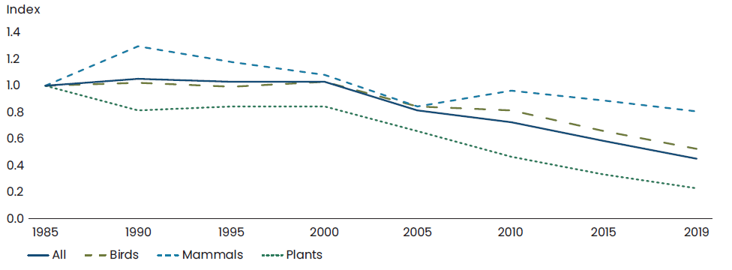
Source: Terrestrial Ecosystem Research Network, the Threatened Species Network 2022.

Resource use and waste generation
Australians are aware of the impact of using resources and are strongly invested in participating in a more sustainable economy where materials are recycled, reused and repaired.
There have been positive improvements in waste generation and recovery. Since 2006–07, waste generation on a per capita basis declined from 3.05 tonnes to 2.95 tonnes in 2020–21. Over the same time period, waste recovered for recycling, reuse and energy generation has increased markedly – from 50 per cent to 63 per cent. This equates to 45.4 million tonnes of materials recovered from 75.8 million tonnes of total waste generated.
Other upstream aspects of a sustainable economy – including resource use – require further focus.

Chart 9: Waste per person and portion of waste recovered
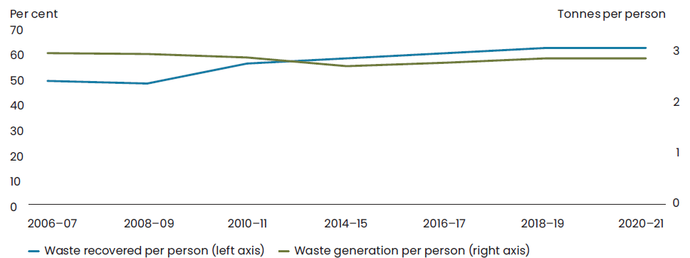
Source: DCCEEW National Waste Report, 2022.

Key Government initiatives to protect the environment
- Target to protect and conserve 30 per cent of our land and 30 per cent of our oceans by 2030
- Commitment to reform environmental laws
- National biodiversity targets under updated National Biodiversity Strategy and Action Plan
- Negotiation of a new global treaty to address plastic pollution
- Development of a national circular economy framework
- Development of a core set of environmental-economic accounts to help value nature.
- Establishing Environmental Protection Australia to restore confidence in Australia’s environmental protection system
- Establishing Environment Information Australia
- Climate-smart and sustainable agriculture programs through the Natural Heritage Trust
- Supporting the agriculture, fisheries and forestry industry to grow towards $100 billion by 2030
- The Regional Investment Framework

Resilient and sustainable nation
Indicator | Metric | Why this metric | Progress | Latest Value(i)
Fiscal sustainability | All levels of government gross debt as a share of GDP(a)(ii) | Stabilising and reducing debt as a share of the economy will help rebuild fiscal buffers, enhance the ability of governments to respond to shocks, and secure sustainable provision of government services. | Deteriorated  2001–02 to 2021–22 | 54.0% in 2021–22
Economic resilience | The Atlas of Economic Complexity’s Economic Complexity Index (ECI)(b) | The complexity of a country’s exports captures aspects of competitiveness and economic diversity and is found to highly predict current income levels. | Deteriorated  2002–2020 | Rank 91 of 133 countries measured in 2020
Climate resilience | Australian Disaster Resilience Index(c) | Disaster resilience reduces the effects of, and losses from natural disasters. | 2020  no previous comparisons | 84% of people live in areas with moderate to high capacity for disaster resilience
Source: (a) ABS Government Finance Statistics and Treasury
(b) The Atlas of Economic Complexity’s ECI
(c) Parsons et al, Australian Disaster Index Volume 1, State of Disaster Resilience Report (2020)
Note: (i) Unless specified the latest value is the last data point in the series
(ii) The consolidated level comprises the Australian Government, state and local governments and multi-jurisdictional sector. Adjustments are made to avoid double counting between these sectors

The wellbeing of Australians needs to be resilient and able to withstand the challenges that will come at us from around the world.
This section of the Statement explores some measurements that can help us track the extent to which we are making improvements in the resilience of our economy and society by boosting the dynamism of our broader economy, working towards a more sustainable Budget and protecting Australians from the damages of climate change.

Fiscal sustainability
Fiscal sustainability improves the economic wellbeing of Australians by supporting a strong and stable economy and ensuring the sustained provision of essential government services. A sustainable fiscal position enables government to respond to changes in economic conditions and buffer the economy and Australians against adverse shocks.
One measure of fiscal sustainability is the government gross debt to GDP ratio across all levels of government, which captures the amount Australian governments owe. The level of the government gross debt as a share of GDP has risen significantly over recent decades reflecting the impacts of global shocks, a pandemic, and intensifying structural spending pressures on the budget. Despite this, government gross debt in Australia remains well below debt levels in many other advanced economies.
The Government maintains a triple-A credit rating from all three major credit rating agencies, meaning it is considered a safe and reliable borrower.
The Government’s responsible economic and fiscal management is helping to deliver a stronger, more resilient, and more sustainable fiscal position. The Government is directing most of the improvements in tax receipts to budget repair, restraining spending growth, improving the quality of spending, undertaking meaningful tax reform, and focusing investments on building the productive capacity of the economy.
As a result of this responsible fiscal management, a budget surplus is now expected for 2022–23 – the first surplus in 15 years. Projected deficits and debt as a share of GDP are lower across the medium term – compared to when the Government came to office – avoiding additional interest costs and helping to rebuild fiscal buffers and resilience against future shocks.

Chart 10: All levels of government gross debt as a share of GDP
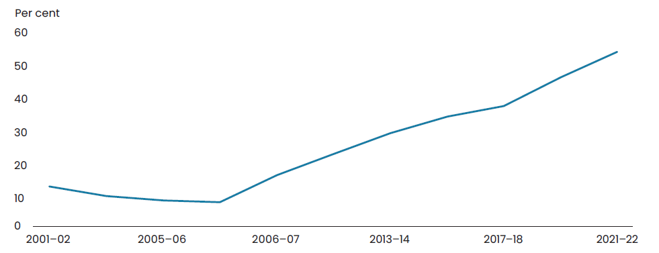
Source: ABS Government Finance Statistics, and Treasury

Economic resilience
Over the past few years, the Australian economy has been subject to multiple international shocks that have impacted on our capacity to improve the living standards of Australians. In a global economy, Australia cannot avoid the effects of these shocks, but boosting the diversity and adaptability of our economy improves our resilience.
The net zero transformation will impact all aspects of Australia’s economy and society, bringing significant opportunities for employment and investment but also near-term challenges as the economy adapts and faces climatic disruptions. Cheap, clean and reliable energy reduces Australia’s exposure to international commodity prices and boosts the competitiveness of low-carbon industries.
Geoeconomic fragmentation could raise barriers to international trade and investment, testing our crucial supply chains. The investments being made in Australia’s industrial capacity through the National Reconstruction Fund will improve resilience to such shocks.
More productive, dynamic, and competitive economies with strong institutions are better able to withstand and adapt to such shocks.
Governments can contribute to an economic environment that supports informed and well-functioning markets that adjust to structural changes. Australia’s strong economic institutions and economic frameworks – for example its flexible exchange rate, independent monetary policy and responsible fiscal management – provide important buffers against future shocks.
While many of these factors are important for economic resilience, one indicator that can be readily measured is the extent to which a country has diversified sources of economic activity. Greater economic diversification can strengthen resilience to shocks and better enable countries to manage and take advantage of big structural shifts. The ECI ranking attempts to measure this, based on the diversity of exports a country produces and their abundance, or the number of other countries able to produce them.
In 2020, Australia ranks as the 91st most complex country of the 133 countries considered in the ECI ranking. Compared to a decade prior, Australia’s economy has become less complex, worsening 8 positions in the ECI ranking.

Climate resilience
Even as the world is taking action to reduce emissions, the physical impacts of climate change will increase due to past emissions. Action is needed to build resilience and protect the environment, communities and the economy from the worst of the impacts of climate change. This means we must anticipate, manage and adapt to climate risks.
The Australian Disaster Resilience Index, released in 2020, found that 52 per cent of the population live in areas with moderate capacity for disaster resilience, 32 per cent in areas with high capacity and 16 per cent in areas with low capacity.
Work is underway across Government and the economy more broadly to develop new ways of measuring and tracking climate risk and resilience. The National Climate Risk Assessment will identify and prioritise things that Australians value the most that are of national significance and are at risk of climate change, and a National Adaptation Plan will be developed to adapt to the identified risks. The Australian Climate Service is working to provide extensive climate and natural hazard data, information and advice into a single national view. Efforts are also being made to measure affordability of insurance for housing, in the light of growing climate change risk.

Key Government initiatives to support a resilient and sustainable nation
- Delivering substantial improvements in the Australian Government’s forecast fiscal position, including the first surplus budget in 15 years for 2022–23 and lower projected deficits and debt
- Working with states and territories to deliver cheap, clean, reliable energy through the National Energy Transformation Partnership
- Meaningful tax reform including to multinational tax, the Petroleum Resource Rent Tax, and improving the equity and sustainability of the superannuation system
- Ensuring Australians have sufficient access to gas at reasonable prices through the Gas Code of Conduct and Future Gas Strategy
- Supporting regions to decarbonise through the Powering the Regions Fund
- Establishing the Powering Australia Industry Growth Centre
- Trade 2040 Taskforce
- Southeast Asia Economic Strategy
- Ministerial Council for Trade and Investment
- Australia’s Fair Trade Agreement (FTA) networks
- Critical Mineral Strategy
- National Reconstruction Fund
- Net Zero Authority

Cohesive
A society that supports connections with family, friends and the community, values diversity and promotes belonging and culture.
‘… relationships are integral to the human experience and therefore understanding the health of these relationships is part of a holistic view of wellbeing.’
– Relationships Australia submission

Having time for family and community
Indicator | Metric | Why this metric | Progress | Latest Value(i)
Time for recreation and social interaction | Average time spent on recreation and leisure, and social and community interaction(a) | Recreation and social interaction enrich people’s lives. Activities including sport, music, socialising and leisure contribute to social cohesion | Stable  2020–21 | Females: 5 hours and 12 minutes per day  Males: 5 hours and 43 minutes per day
Social connections | Proportion of people who agreed with the statement ‘I often feel very lonely’(b) | Loneliness is a symptom of the absence of interpersonal relationships. It is also a risk factor which influences mental health | Improved  2001–2019 | 18.6%
Social connections | Proportion of people who undertake voluntary work(c) | Voluntary work is a measure of social connection, which is essential for feeling satisfaction with life | Deteriorated  2006–2020 | 24.8% unpaid voluntary work through an organisation  32% volunteered informally
Creative and cultural engagement | Proportion of people who participated in at least one cultural activity (d) | Creative and cultural engagement has social and economic impacts including boosting health and wellbeing, supporting educational outcomes, as well as fostering social inclusion | Stable  2017–18 to 2021–22 | 32.2%
Creative and cultural engagement | Proportion of people who attended at least one cultural venue or event (d)(ii) |  | Deteriorated  2017–18 to 2021–22 | 63.8%
Source: (a) ABS Time Use Survey
(b) Household, Income and Labour Dynamics in Australia (HILDA) Survey
(c) ABS General Social Survey
(d) ABS Cultural participation and attendance survey
Note: (i) Unless specified the latest value is the last data point in the series
(ii) The reference period for the ABS Cultural and Creative Activities 2021–22 spans from July 2020 to June 2022. As such, these data, particularly in relation to attendance rates at cultural and creative events, may have been impacted by COVID-19 disruptions, such as border closures, social distancing requirements and audience confidence levels post-COVID 19 restrictions. Caution should be exercised when comparing with previous iterations.

In a socially cohesive society, people can connect with their family and friends and participate fully in the community through cultural, social and religious activities.
The following section outlines the measurements we can use to track the time Australians have for the activities that matter, as well as more specific metrics that capture the extent to which they are making social connections and participating in cultural activities.

Time for recreation and social interaction
One way we can capture the availability of free time is the average amount that people spend on recreation and leisure, plus social and community interaction.
In 2020–21, most Australians (96 per cent) spent on average 5 hours 27 minutes of their day on free time which was used for activities including watching television, sport and exercise, social interaction and reading.
Women had 31 minutes less free time on average per day than men 5 hours and 12 minutes compared with 5 hours and 43 minutes. The gap is largest for people aged 15 to 24 years, with women having 1 hour and 17 minutes less free time than their male counterparts.
People aged 65 years and over had the most time for recreation and leisure with an average 5 hours and 58 minutes a day. People aged 35 to 44 had the least time for recreation and leisure with an average of 3 hours and 14 minutes per day. The average time spent on recreation and leisure activities is consistent across major cities and regional areas 4 hours and 25 minutes.

Chart 11: Average time per day of people who participated in the activity, 2020–21
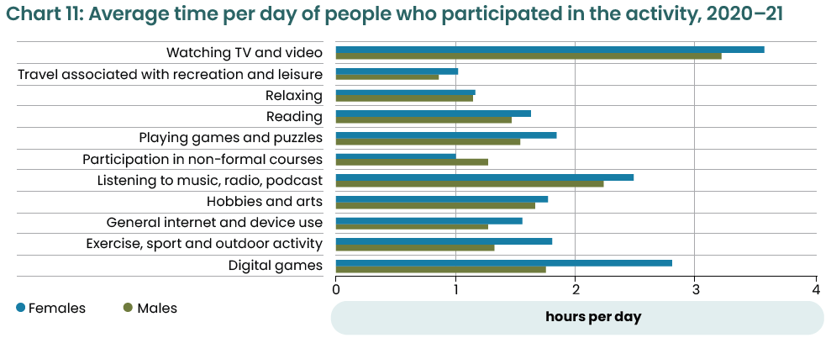
Source: ABS Time Use Survey 2020–21.

Social connections
One reason that people value free time is because it can be used to pursue social connection, which is critical to overall wellbeing.
We can measure whether Australians have access to the relationships and social connection that they need by tracking the presence of loneliness in the community.
The Household, Income and Labour Dynamics in Australia Survey data shows that the overall proportion of Australians experiencing loneliness at any one time as declined slightly from a high of 21 per cent in 2001 to a low of 16 per cent in 2009. Rates have remained relatively stable at around 18 per cent for the past 7 years.
Other surveys undertaken during the COVID-19 pandemic found that people reported that they felt more lonely since the start of the pandemic – young people were more likely than other age groups to have felt this.
One-way Australians may seek to maintain social connections is volunteering.
One quarter (25 per cent) of Australians aged 15 years and over participated in unpaid voluntary work through an organisation in 2020 – lower than the 30 per cent in 2019. One third (32 per cent) of people volunteered informally in 2020, compared with 33 per cent in 2019.
People aged 4054 years volunteered through an organisation at the highest rate of any age group (30.5 per cent). This was followed closely by people aged 70 years and over (28 per cent). Rates of volunteering through an organisation was similar for men (23 per cent) and women (26 per cent). The COVID-19 pandemic is one factor that may have affected volunteering patterns as a significant number of volunteering positions were closed during this period for example, hospitals.

Chart 12: Proportion of people who have undertaken unpaid voluntary work in the last 12 months
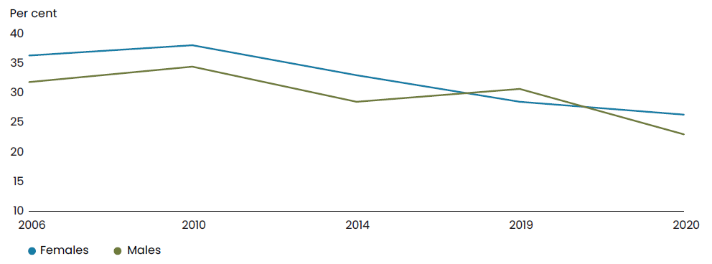
Source: ABS General Social Survey 2020.

Creative and cultural engagement
Participation in creative and cultural activities enriches people’s lives and can also have broader positive social and economic impacts.
One third (32 per cent) of adults participated in at least one cultural activity in 2021–22 such as visual arts, music, dance and craft.
For children, creative activities – including drama, music, dancing, art and craft activities, creative writing and creating digital content –were popular, with a participation rate of 59 per cent in 2021–22.
Between 2017–18 and 2021–22 attendance at cultural venues or events fell from 82 per cent to 64 per cent of adults, and 94 per cent to 80 per cent of children. The COVID-19 pandemic is one factor that has affected attendance rates over this period.
People living in greater capital cities were more likely to attend a cultural venue or event (65 per cent) when compared with people living in other regions of Australia (61 per cent).
Most audiences continue to attend events amid cost of living pressures, but the profile of those attending and their attendance preferences are changing. In April 2023, industry data indicated three quarters of past attendees (76 per cent) attended a cultural activity, which is consistent with October 2022 and August 2022. Older audiences (those aged 55+) are the most likely to be attending events right now (78 per cent). Younger audiences (those under 35) are least likely to have attended a cultural activity recently (67 per cent) – a notable decline since October 2022 (77 per cent).

Key Government initiatives to support social connections and stronger community
- Not-for-profit Sector Development blueprint
- Productivity Commission Philanthropy Inquiry to enhance philanthropic giving in Australia
- Additional indexation funding for community organisations so that they can keep delivering for people in need
- Package to target entrenched community disadvantage, including an extension of place based initiatives, the co-design of an Outcomes Fund to fund projects that deliver outcomes in communities, and support for organisations such as social enterprises
- Creation of a new deductible gift recipient category to support the work of Community Foundations in empowering local giving and participation
- Progress to harmonise fundraising laws and streamline applications for tax deductible status

Valuing diversity, belonging and culture
Indicator | Metric | Why this metric | Progress | Latest Value(i)
Experience of discrimination | Proportion of people who experienced some form of discrimination in the previous 12 months (a) | Experiences of discrimination can have wide ranging negative effects on a person’s general wellbeing, physical and mental health | Improved  2014–2020 | 13.3%
Acceptance of diversity | Proportion of people who used a language other than English at home(b) | Cultural diversity provides a strong foundation for the continuous integration of diverse groups into the broader community and expands the way we see and engage with the world.  Ongoing acceptance of multiculturalism and immigrants from diverse countries contributes to people feeling safe and able to share in available opportunities | Improved  2006–2021 | 22.3%
Acceptance of diversity | Proportion of people who agree or strongly agree accepting immigrants from many different countries makes Australia stronger(c) |  | Improved  2018–2022 | 78%
First Nations languages spoken | Number of First Nations people who speak a First Nations language at home(d) | Speaking First Nations languages improves the connection of First Nations people to family, country, and community. | Improved  2001–2021 | 76,978
Sense of belonging | Proportion of First Nations people who recognise an area as their homelands or traditional country(e) | Strong connections to land, family and language are central to First Nations people’s culture and a foundation for social, economic, and individual wellbeing. | Improved  2002 to 2018–‍19 | 74.4%
Sense of belonging | The Social Cohesion Index: Sense of belonging measure(f) | Sense of belonging measures the sense of pride and belonging in Australia. | Deteriorated  2007–2022 | 81 points out of 100
Source: (a) ABS General Social Survey
(b) ABS Census of Population and Housing
(c) Scanlon Foundation Research Institute Mapping Social Cohesion Surveys
(d) ABS Census of Population and Housing
(e) ABS National Aboriginal and Torres Strait Islander Health Surveys and Social Surveys
(f) Scanlon Foundation Research Institute The Scanlon Monash Index
Note: (i) Unless specified the latest value is the last data point in the series.

A cohesive society values diversity and equity, supports belonging, and protects its unique cultural heritage.
In Australia, this involves maintaining and valuing the contribution of First Nations people; their languages, culture and customs, in addition to promoting the benefits of our multicultural society.
The metrics outlined in this section are intended to track our progress against the key indicators of a society that values diversity: levels of discrimination, acceptance, First Nations languages spoken, and whether people have a sense of belonging.

Experience of discrimination
Experiences of discrimination can have wide ranging negative effects on a person’s general wellbeing, physical and mental health.
In 2020, 13.3 per cent of Australians experienced some form of discrimination in the past year – a decrease from 18.7 per cent in 2014. The 2022 Mapping Social Cohesion Report found that 16 per cent of people reported experiencing race or religion-based discrimination over the last 12 months. These findings suggest the experience of discrimination in 2020 may have been affected by the COVID-19 pandemic.
People who described themselves as gay, lesbian, or bisexual were more likely to experience discrimination than heterosexual people – 30.1 per cent compared to 12.5 per cent. One in five (20.8 per cent) people with a mental health condition reported having experienced some form of discrimination. People with disability were also more likely to report having experienced discrimination compared to those with no disability – 15.8 per cent compared with 12.4 per cent. 16.1 per cent of people born overseas reported discrimination compared with 11.9 per cent of those born in Australia.
In 2022, Reconciliation Australia found that 60 per cent of First Nations people have experienced at least one form of racial prejudice in the past 6 months – 52 per cent in 2020 from 43 per cent in 2018.
Racial discrimination undermines social cohesion within the community. The Australian Human Rights Commission is developing a National Anti-Racism Framework that will be a central reference point for anti-racism action by governments, business, community, and all sectors of society.

Chart 13: Australians who experienced discrimination in the last 12 months, 2020
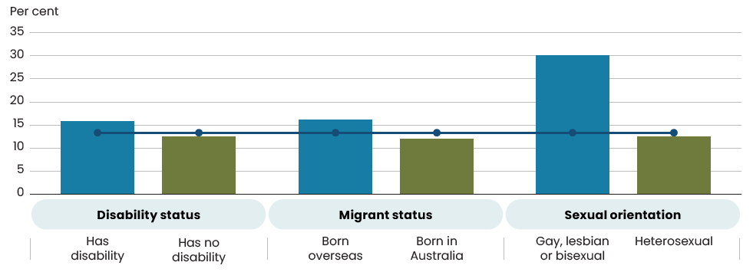
Source: ABS General Social Survey 2020.

Acceptance of diversity
Cultural diversity is one of the greatest assets of our multicultural society. It provides a cornerstone for continuous integration of migrants from diverse ethnic, linguistic and faith backgrounds into our social fabric. It also plays an important role in our prosperity, enriching our schools and workplaces and deepening our connections with the world.
Linguistic ability is a proxy for whether a society celebrates diversity. In 2021, 5.8 million people (22.8 per cent) reported speaking a language other than English at home – this was an increase from 4.9 million people (21.6 per cent) in 2016.
Of the 1.6 million Australian-born people who spoke a language other than English, in 2021, most had one or both parents born overseas, and almost half were children aged under 15 years. The top five most common languages in Australia other than English are Mandarin, Arabic, Vietnamese, Cantonese and Punjabi.
Ongoing acceptance of multiculturalism and immigrants from a diverse range of countries is a key indicator of cohesion. This helps protect our society from social divisions, including those seen in other parts of the world.
In 2022, 78 per cent of Australians agreed that accepting immigrants from many different countries makes Australia stronger – up from 63 per cent in 2018.

Key Government initiatives on diversity, belonging and culture
- Revive: a place for every story, a story for every place – Australia’s national cultural policy for the next five years
- Multicultural Framework Review
- National Settlement Framework (forthcoming)
- Australian Human Rights Commission National Anti-Racism Framework (forthcoming)

First Nations languages spoken
Speaking a First Nations language improves First Nations people’s wellbeing, by making their connection to family, community and country stronger.
The National Agreement on Closing the Gap recognises the importance of Aboriginal and Torres Strait Islander cultures and languages which are strong, supported and flourishing. Under the National Agreement on Closing the Gap, by 2031, there should be a sustained increase in number and strength of Aboriginal and Torres Strait Islander languages being spoken.
Nationally, in 2021, 76,978 First Nations people were reported as using a First Nations language at home – this is an increase of 20.7 per cent (from 63,754 people) since 2016. In 2021, almost one-third of language users were aged 25‍–‍44 years (22,972) and over one-quarter were aged 0–14 years (21,952).
In 2018–19, the National Indigenous Languages Survey found that there were 123 Aboriginal and Torres Strait Islander languages in use or being revitalised. However, only 14 of these languages were spoken fluently, in everyday life and across generations.

Sense of belonging
A sense of belonging, a feeling of being part of a larger group or connected to a broader community is an important determinant of wellbeing. The acceptance of diversity, the celebration of culture, and appreciation of custom, can support a sense of belonging.
The National Agreement on Closing the Gap recognises that these unique bonds are fundamental to improved life outcomes for First Nations people.
We can capture the extent to which First Nations people are sustaining this connection with country by tracking the proportion who recognise an area as their homelands.
In 2018–19, almost three quarters (74.3 per cent) of First Nations people recognised a traditional country – an increase from 69.9 per cent in 2002.
First Nations people living in remote areas are more likely to report a connection to country. In 2018–19, 90 per cent of First Nations people living in remote areas recognised an area as homeland or traditional county and 47 per cent live there.
The Mapping Social Cohesion survey has found a sense of belonging and pride in Australian culture of the general population has declined since 2007, from 100 points to 81 points in 2022.

Key Government initiatives for working with First Nations people
- Implementing the Uluru Statement from the Heart in full. Australians will have the opportunity to have their say on recognising the First Peoples of Australia in the Constitution through an Aboriginal and Torres Strait Islander Voice.
- The Dedicated Aboriginal and Torres Strait Islander Action Plan to address women and children’s safety
- The National Agreement on Closing the Gap
- Development of a First Nations Foreign Policy (forthcoming)
- Appointment of Ambassador for First Nations People
- Plan for a better, safer future for Central Australia

Trust in institutions
Indicator | Metric | Why this metric | Progress | Latest Value(i)
Trust in others | Proportion of people who report having general trust in others(a) | Generalised trust, indicates whether people in the community are trusting of others | Improved  2006–2020 | 61.4%  Others
Trust in key institutions | Proportion of people who report having trust in healthcare system(a) | Measures the belief that the healthcare system and the police will provide the intended services – which are key to wellbeing | Stable  2019–2020 | 76.4%  Healthcare
Trust in key institutions | Proportion of people who have trust in police(a) |  | Stable  2019–2020 | 79.3%  Police
Trust in Australian public services | Proportion of people who trust in Australian public services(b) | Whether people trust the public services to be reliable and conduct their service with integrity | Improved  2019–2022 | 61.0%
Trust in national government | Proportion of the population that express confidence in the national government(c) | Trust in government is linked to political participation, social cohesion and collaboration in tackling societal challenges | Deteriorated  2006–2022 | 49.9%
Representation in parliament | Proportion of Federal Australian Parliamentarians who are women(d) | Inclusivity of women in parliament relates to equality of representation political system | Improved  2002–2023 | 45.1%  May 2023
Source: (a) ABS General Social Survey
(b) Department of the Prime Minister and Cabinet, survey of Trust in Australian public services, 2019–2022
(c) OECD How’s Life? Well-being database
(d) Australian Parliamentary Library and ABS Gender Indicators
Note: (i) Unless specified the latest value is the last data point in the series.

People have more satisfying lives when they live in an environment where they have trust in each other and their institutions, and where those institutions are strong and effective. Trust also creates the conditions necessary for a society to make progress in pursuing policy that can improve the wellbeing of all people.
The following metrics will help us to measure progress in maintaining trust across our society according to five key indicators: trust in others, institutions, public services, national government, and representation in parliament.

Trust in others
In 2020, 3 out of 5 Australians reported having general trust in others – slightly higher than the previous year of more than half (55.6 per cent). Trust in others has increased since 2006, from 54.1 per cent to 61.4 per cent in 2020. Older people aged 70 years and over are more likely to trust others compared to younger people (aged 15–24).

Trust in key institutions
Currently, we have two metrics which can help us to get a sense of whether Australians trust key institutions. These are the extent to which people trust in the police and our healthcare systems.
In 2020, nearly four in five (79.3 per cent) Australians agreed that the police can be trusted, while more than three quarters (76.4 per cent) trusted the healthcare system.
There is some regional variation in levels of trust. For example, trust in the healthcare system was higher in major cities (77.6 per cent) than outer regional and remote areas (69.6 per cent).

Trust in Australian public services
Trust in Australian public services is a signal of good governance. In June 2022, 61 per cent of Australians agreed that they trust public services – compared to 57 per cent prior to the COVID-19 pandemic (June 2019). Trust is high across all services, however, it does vary by service agency and also across life events. People who use public services express greater trust in the services than people who do not.

Trust in national government
Trust in government measures the share of people aged 15 and over who report having confidence in the national government.
Australia is ranked 16 out of 38 and is above the OECD average (43 per cent in 2020). Performance has slightly worsened over time – from 53.2 per cent to 49.9 per cent between 2006 to 2022. However, confidence has improved compared to pre-COVID-19 levels, from 46.9 per cent in 2019.

Key Government initiatives on governance
- National Anti-Corruption Commission
- Strengthening our economic institutions, including implementing the Review of the RBA and committing to refresh the Productivity Commission
- Delivering Australia’s First National Wellbeing Framework, Measuring What Matters
- Establishing an Australian Centre for Evaluation
- Re-engaging employers, employees and education providers in workforce planning by establishing Jobs and Skills Australia
- Australian Public Service reform including an APS Integrity Taskforce
- Transparency requirements under the Australian Government Guide to Policy Impact Analysis
- A New Code of Conduct for Ministers
- Implementation of the Set the Standard Report across the Parliament
- Consideration of political donations legislative reform
- Establishing a new tribunal to restore public trust and confidence in Australia’s system of federal administrative review
- Introducing new measures requiring all Commonwealth entities to take steps to prevent corruption

Representation in parliament
Public institutions must be representative of the Australian community they serve if trust in them is to be maintained and grown.
One indicator of adequate representation in politics is the share of women parliamentarians.
The number of Federal women parliamentarians as a share of total filled seats (lower/single house of parliament) has improved from 25.3 per cent to 39.1 per cent between 2002 to 2023 – higher than the OECD average of 33.8 per cent in 2023. In the same period, representation of women parliamentarians in the Senate has been higher than the lower house – which sits at 57.3 per cent in May 2023. The proportion of women federal parliamentarians for both houses is 45.1 per cent in May 2023. Despite the recent rise in women parliamentarians in 2023, Australia still lags behind similar countries like Canada and New Zealand in the cultural diversity of parliamentarians. While there has been an increase in First Nations people since 2002 (0.4 per cent to 4.8 per cent) and LGBTIQA+ people (0 per cent to 3.5 per cent) in federal parliament, there is still an under representation for those with non-European ancestry.

Chart 14: Proportion of women federal parliamentarians (combined upper and lower house)
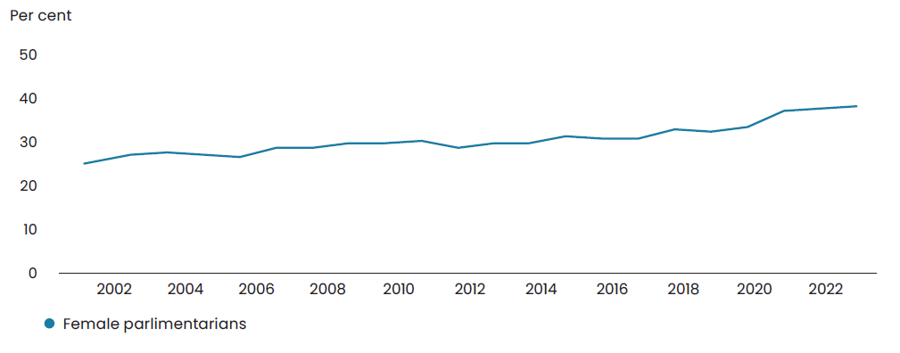
Source: Australian Parliamentary Library and ABS Gender Indicators 2023
Note: The time series is created from data as of the 1st of January of each year.

Prosperous
A society that has a dynamic, strong economy, invests in people’s skills and education, and provides broad opportunities for employment and well-paid, secure jobs.
‘Breaking the cycle of entrenched disadvantage begins with education.’
– Taskforce Community Agency submission

Dynamic economy that shares prosperity
Indicator | Metric | Why this metric | Progress | Latest Value(i)
National income per capita | Real Net National Disposable Income (RNNDI) per capita(a) | Broadly captures living standards by measuring the amount of real income per person earned domestically and overseas | Improved  2002–03 to 2021–22 | $68,092
Productivity | The current 20-year average labour productivity growth compared to the 20-year average growth 10 years earlier(b) | Labour productivity (GDP per hours worked) is the most used indicator for economic efficiency and underpins improvements in living standards in the longer term | Deteriorated  2001–02 to 2021–22 | Around 1.2% average 20-year growth
Household income and wealth | Median equivalised weekly disposable household income(c) | Provides an indication of the financial resources of people | Improved  2007–08 to 2019–20 | $959
Household income and wealth | Net worth per household(d) | Provides an indication of the financial resources of people | Improved  2003–04 to 2021–22 | $1.4 m
Income and wealth inequality | Gini coefficient for income and wealth(c) | Measure of how income and wealth are shared amongst the population. The Gini coefficient can range between 0 and 1, and a lower Gini coefficient represents greater equality | Stable  Income: 2007–‍08 to 2019–20  Wealth: 2009–‍10 to 2019–20 | 0.32 income  0.61 wealth
Innovation | Number of patent and trade mark applications in Australia (made by both domestic and overseas applicants) (e) | Provides a leading indicator of economic development and the creation and introduction of new products and services that improve the lives of Australians | Improved  2003–2022 | 32,292 patents  78,833 trade marks
Sources: (a) ABS National Accounts: National Income, Expenditure and Product
(b) ABS Australian System of National Accounts
(c) ABS Survey of Income and Housing
(d) ABS Australian National Accounts: Distribution of Household Income, Consumption and Wealth
(e) IP Australia
Note: (i) Unless specified the latest value is the last data point in the series

An economy which supports employment, good incomes, financial security, aspiration, and freedom to make choices, will also support the broader wellbeing of Australians.
The following section outlines a range of metrics that can be used to track the progress of the economy in delivering these outcomes.
Broadly, they relate to five indicators: national income per capita, productivity, household income and wealth, income and wealth inequality, and innovation.

National income per capita
Real net national disposable Income (RNNDI) per capita measures real income available across the economy to spend and save per person.
This is a broader measure of prosperity than the commonly cited measure of real GDP, since it also includes income of Australian residents generated overseas and excludes income of non-residents generated in Australia. This means it is more closely related to the average lived experience and prosperity of Australians.
Over the past 20 years, RNNDI per capita increased by 1.4 times from $48,538 in 2002‍–‍03 to $68,092 in 2021–22. While annual growth has fluctuated for RNNDI per capita, the average annual growth over the past two decades has been moderate at 1.8 per cent.
Annual growth has bounced back following a drop in 2019–20 due to the COVID-19
pandemic, although recent outcomes are being impacted by cost-of-living pressures. As this indicator is a whole of economy measure, it does not capture differences in individual or household experiences.

Productivity
Labour productivity is a driver of economic growth, real wages, and overall living standards.
Short term movements in productivity are subject to volatility, so it is most appropriately examined by considering trends over time.
Labour productivity growth has slowed in Australia since the mid-2000s. In the decade to 2020, Australia’s productivity growth was the slowest in 60 years. Average productivity growth over the past 20 years to 2021–22 was around 1.2 per cent.
The slowdown in Australia’s labour productivity growth is not unique and is broadly consistent with the experience of most other advanced economies. Revitalising productivity growth will require building Australians’ skills, improving business dynamism, boosting digital adoption, and realising the opportunities of the net zero transformation and growth of the care economy. Given the extended period of poor productivity performance, it will take some time for these policies to improve productivity.

Chart 15: Labour productivity over the four decades to 2020
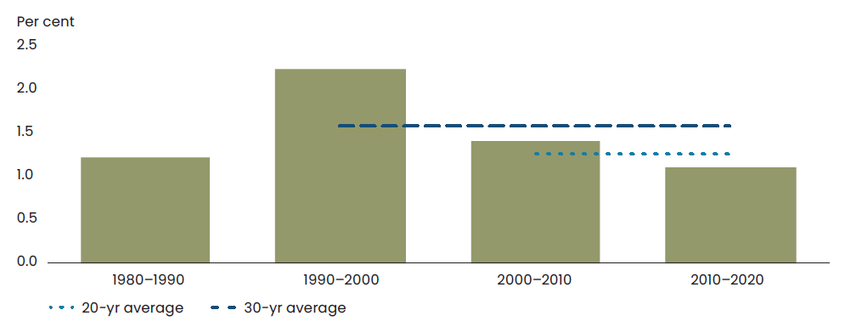
Source: ABS Australian System of National Accounts 2021–22

Household income and wealth
Income or wealth are the economic resources that households use to buy necessary goods and services for a decent living.
Households, on average, have more income and wealth than in the past. Median equivalised disposable household income, an income measure that adjusts for household size, was $959 per week in 2019–20, although experience varies across households. This is after a period of not growing between 2013‍–‍14 and 2017–18. Average household net worth has also increased from $514,058 in 2003‍–‍04 to $1.4 million in 2021–22.

Income and wealth inequality
The distribution of income and wealth is an important aspect of community wellbeing. One measure to assess how equally income and wealth is distributed across the community is the Gini coefficient. A Gini coefficient can range between 0 and 1, with a lower Gini coefficient representing a more equal distribution.
Income inequality has remained relatively steady since 2007–08, with the Gini coefficient for equivalised disposable household income sitting at 0.32 in 2019–20. In 2020, Australia’s Gini coefficient for income indicated that Australia had the 14th highest level of inequality of the 28 OECD countries for which data was available for that year.
Wealth is typically distributed less equally than income. Wealth inequality has remained steady over time, with the Gini coefficient for wealth increasing marginally from 0.60 in 2009–10 to 0.61 in 2019–20.

Innovation
If the Australian economy is to keep on delivering the improved living standards and prosperity that we need it to, innovation is key.
Innovation is a complex concept to measure. One way to track progress is the rate at which inventive activity occurs, represented through the number of filings for patents and trade marks.
Innovation investments in Australia were resilient during the COVID-19 crisis, with the total number of patent and trade mark applications both reaching record highs in 2021. While there has been a decline in 2022 from these peaks, levels remain relatively strong.
This measure captures a fairly limited aspect of Australia’s innovation but provides useful insights on the innovation and introduction of new products and services that can improve the lives of Australians.

Key Government initiatives to lay the foundations for future growth
- National Reconstruction Fund, and the Industry Growth Program
- Australia’s plan to become a Renewable Energy Superpower, including Rewiring the Nation fund, Hydrogen Headstart program and the Capacity Investment Scheme for electricity generation
- Critical Technologies Strategy and associated investments technologies including AI, Quantum and Robotics
- Expansion to Paid Parental Leave
- A new National Skills Agreement
- Fee-free TAFE places
- A new Australian Skills Guarantee
- A new Australian Universities Accord
- National Broadband Network including the Better Connectivity Plan for Regional and Rural Australia
- Cheaper Child Care reforms

Access to education, skills development and learning throughout life
Indicator | Metric | Why this metric | Progress | Latest value(i)
Childhood development | Proportion of children who are developmentally on track in all five domains of the Australian Early Development Census(a) | Early childhood development is a key determinant of future health, wellbeing and prosperity | Improved  2009–2021 | 54.8%
Literacy and numeracy skills at school | Average Year 3 NAPLAN scores for literacy and numeracy(b) | Literacy and numeracy skills developed during school years are critical to participating in all aspects of life | Improved  2008–2022 | Mixed results across curriculum areas
Education attainment | Proportion of people aged 20‍–‍24 with Year 12 or equivalent | Education attainment shows the education status of Australia and provides a measure of the skills and capabilities of the population | Improved  2013–2022 | 86.2%
Education attainment | Proportion of people aged 25–‍34 with a qualification at Certificate III level or above(c) |  | Improved  2013–2022 | 73.0%
Skills development | The share of adults (aged 15 to 74) who in the previous 12 months, participated in:  formal study which led to a qualification recognised by the Australian Qualifications Framework, and  non-formal learning (structured training or courses) that did not lead to a formal qualification(d) | Access to training and upskilling better enables people to take advantage of emerging job opportunities throughout their working lives.  Measuring participation in study and training also helps estimate the future composition of skills and capabilities in the workforce | Deteriorated  2013 to 2020–‍21 | 42.1%
Digital preparedness | An aggregate score of digital inclusion based on access, affordability and digital ability(e) | The Digital Inclusion Index indicates access, affordability, digital ability and barriers to a sustainable and inclusive digitally connected society | Improved  2020 to 2023 | 73 out of 100 (with 100 being fully accessible)
Source: (a) Department of Education Australian Early Development Census
(b) Australian Curriculum Assessment and Report
(c) ABS Survey of Education and Work
(d) ABS Work-Related Training and Adult Learning
(e) RMIT Swinburne University of Technology and Telstra, Australian Digital Inclusion Index
Note: (i) Unless specified the latest value is the last data point in the series

Education and training creates opportunity for Australians, enables them to make a full contribution to the community, and underpins the development of aspiration and purpose.
The five determinants of access to education map to various stages of a person’s life: childhood development, foundational skills including literacy and numeracy, education attainment, skills development, and access to digital technology (crucial for learning and the future of work).
The following metrics are intended to help us track our progress against these indicators.

Childhood development
Early childhood development sets the stage for future health, wellbeing and prosperity.
The 2021 Australian Early Development Census indicated that the majority of children were ‘on track’ in all five domains of physical health and wellbeing, social competence, emotional maturity, language and cognitive skills, and communication skills and general knowledge.
In 2021, there was a slight decline in this figure for the first time since 2009 – from 55.4 per cent in 2018 to 54.8 per cent. This was most likely due to the impact of COVID-19-related disruptions on early childhood development. This decline was more pronounced for groups already experiencing disadvantage, revealing how experiences of entrenched disadvantage may have been exacerbated or compounded by COVID-19 disruptions.

Literary and numeracy skills at school
Language, literacy, numeracy and digital skills, as well as general skills like organising, problem solving and teamwork, are critical to participating in all aspects of life and are required to engage in work and further learning.
Attainment of these foundation skills is uneven across our population. OECD data from 2012 suggest that around one-fifth of adult Australians have low literacy and/or numeracy skills and are
more likely to come from disadvantaged backgrounds, and older age groups. A more contemporary assessment of adult foundation skills is being developed by Jobs and Skills Australia.
Literacy and numeracy skills among young Australians are improving. Average NAPLAN Year 3 scores have increased across all domains since NAPLAN started in 2008. There have been statistically significant improvements in most domains for Year 3 and Year 5 students, although performance at Year 7 and Year 9 has been more varied. Numeracy, reading and writing mean performance for all students has remained largely stable nationally, but there is a growing gap for disadvantaged students.
While Australia was once a top performer across the OECD Programme for International Student Assessment rankings, the performance of 15-year-olds in science, reading and maths has slipped compared with other OECD countries. This may partly reflect an increased share of 15-year-olds in Australia being in lower grade levels (that is, one less year of schooling) compared with earlier rankings for Australia.
The Australian, state and territory education ministers introduced major changes to NAPLAN in 2023. NAPLAN results from 2023 onwards will not be directly comparable to the results from 2008 to 2022 displayed here. Following these changes, NAPLAN will more clearly and simply show parents and schools the students who need additional support.

Chart 16: Average NAPLAN Year 3 scores
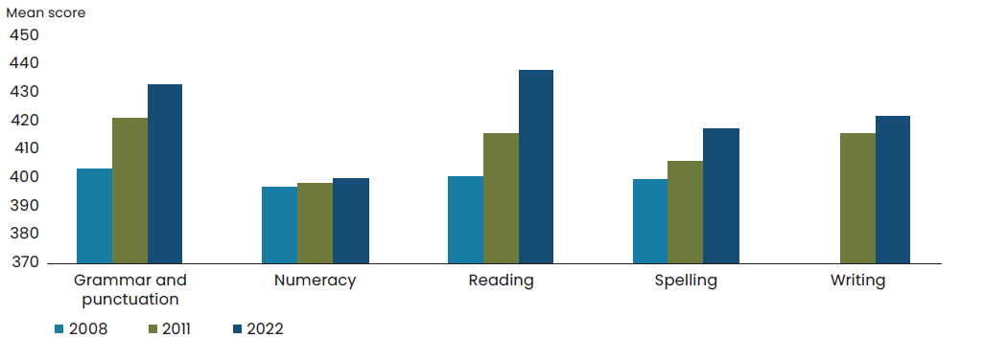
Source: NAPLAN data.
Note: Writing assessment (based on persuasive writing) was not introduced until 2011 – hence there is a gap in 2008 for data on writing scores.

Education attainment
Beyond foundation skills development, more Australians are getting educated than ever before.
From 2013 to 2022, the share of people aged 20–24 years that completed Year 12 or equivalent, has increased from 77.2 per cent to 86.2 per cent. Over the same period, the proportion of people aged 25–34 years that attained a qualification at Certificate III level or above increased from 65.7 per cent to 73.0 per cent.
The education indicators will evolve for future Statements to align with targets for Australia’s education system that emerge from the major education reviews currently underway. These reviews include the Productivity Commission’s review into Early Childhood Education and Care, the review to Inform a Better and Fairer Education System, and the Australian Universities Accord. These reviews will place high priority on ensuring targets emphasise improving equity outcomes.

Chart 17: Proportion of people aged 20–24 years with Year 12 or equivalent and proportion of people aged 25–34 years with qualification at Certificate III level or above
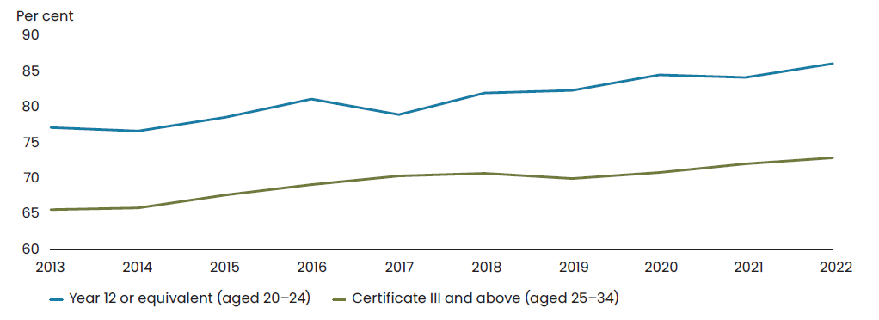
Source: ABS Education and Work.

Skills development
It is important for Australians to have access to training and upskilling so they can take advantage of emerging job opportunities throughout their working lives. This will also help to ensure that people and businesses can adapt to change.
In 2020–21, 42.1 per cent of Australians aged 15 to 74 years participated in learning over the past 12 months. This was a decrease from 46.4 per cent in 2013. The decline in skills development is driven by the fall in non-formal training from 32.1 per cent to 27.4 per cent over the same period.
In addition to a domestic skills agenda, targeted and well-managed migration can provide access to specialist skill sets to support emerging sectors and drive knowledge transfer, innovation, and productivity. Informed by strengthened labour force analysis, the forthcoming Migration Strategy will include a focus on ensuring Australia has the right skills for the future.

Chart 18: Proportion of people aged 15–74 years participating in formal and non-formal learning
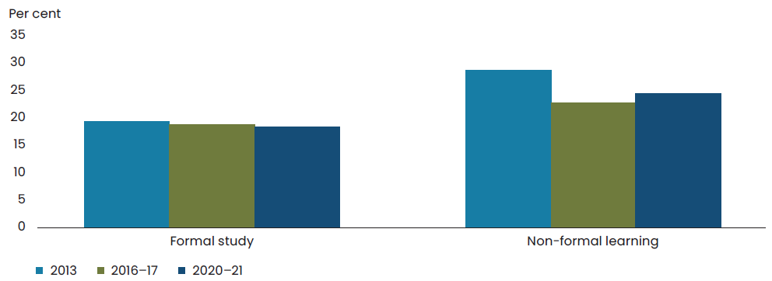
Source: ABS Work-Related Training and Adult Learning.

Key Government initiatives to invest in education, skills and training
- A new National School Reform Agreement in 2025
- National Early Years Strategy
- Cheaper Child Care reforms
- National Teacher Workforce Action Plan
- A new National Skills Agreement
- Fee-free TAFE places
- A new Australian Skills Guarantee
- A new Australian University Accord
- Review of the Migration Strategy
- Review of the impact of COVID-19 on students with a disability
- Better outcomes for First Nations Students
- Productivity Commission inquiry into Early Childhood Education and Care
- Australian Competition and Consumer Commission Childcare inquiry
- Targeted support for Apprentices
- Review to Inform a Better and Fairer Education System
- Skills for Education and Employment program
- Jobs and Skills Australia national study on adult literacy, numeracy, and digital skills
- Preschool Reform Agreement

Digital preparedness
One of the big factors which will determine whether we succeed in improving the productivity, competitiveness and resilience of our economy is how well we manage the digital transformation. Digital technology is critical for online learning and developing skills for the future of work.
One measure of that is digital inclusion.
In 2023 (compared to 2020) digital inclusion across Australia increased for most social groups and regions. The number of highly excluded Australians has declined (but remains substantial).
Furthermore, while the divide between city, regional and remote areas has narrowed, it remains marked. In addition, access, affordability and digital ability remain a central barrier to closing the digital gap, including for First Nations people, Australians aged 75 years and over and Australians with disability.

Key Government initiatives for the digital economy
- National Broadband Network including the Better Connectivity Plan for Regional and Rural Australia
- Cyber Security Strategy (forthcoming)
- Establishing the Coordinator of Cyber Security
- Improving security of critical infrastructure
- Training cyber wardens to build capability in small businesses and reduce exposure to cyber attacks
- School Students Broadband Initiative
- First Nations Digital Inclusion Advisory Group
- Digital Skills initiative
- Be Connected Program
- National Artificial Intelligence Centre to support digital adoption, as part of the Digital Economy Strategy
- Enabling new, digital markets through the Consumer Data Right in the banking and energy sectors, while expanding digital ID

Broad opportunities for employment and well-paid, secure jobs
Indicator | Metric | Why this metric | Progress | Latest Value(i)
Wages | Growth in the wage price index adjusted for inflation, as measured by the consumer price index(a) | Increases in real wages allow households to increase the volume or quality of consumption, improving their wellbeing outcomes | Stable to 2020  Volatile  2020–2023 | -3.1%  March quarter 2023
Job opportunities | Unemployment rate(b) | Provides an indication of those people who want a job or who want to work more hours | Improved  2003–May 23 | 3.6%
Job opportunities | Long-term unemployment rate(b) |  | Improved  2003–May 23 | 0.6%
Job opportunities | Underutilisation rate (hours-based)(c) |  | Improved  2003–May 23 | 5.3%
Broadening access to work | Employment rate, population aged 15–64(b) | Measures access to employment opportunities | Improved  2003–May 23 | 80.8% males, May–‍23  74.3% females, May–23  52.2%(d) First Nations, 2021
Broadening access to work | Employment rate, population aged 15–64(b) | Measures access to employment opportunities | Stable  2009–2018 | 47.8%(e) people with disability
Broadening access to work | Participation rate, population aged 15–64(b) | Measures the proportion of people working or seeking work | Improved  2003–May 23 | 84.0% males  77.0% females
Broadening access to work | Gender pay gap(f) | Measures difference in average pay for men and women working full-time, as a proportion of men’s earnings | Improved  1994–2022 | 13.3%
Job satisfaction | Self-reported measure of how workers perceive their job(g) | Job satisfaction provides a measure of job quality | Improved  2001–2021 | 7.9 out of 10
Secure jobs | The proportion of employed people who expect to not remain in the same job in 12 months’ time due to involuntary reasons(h) | Captures the central factors that contribute to job security | Stable  2014–2022 | 1.6%
Secure jobs | The proportion of employees that had irregular working arrangements(h) | Captures the central factors that contribute to job security | Stable  2014–2022 | 28.2%
Secure jobs | The proportion of employees that did not have access to paid leave entitlements(b) | Captures the central factors that contribute to job security | Stable  2014–2023 | 22.2%
Source: (a) ABS Consumer Price Index, Australia; Wage Price Index, Australia and Treasury
(b) ABS Labour Force Survey (this is the latest data point available at the time of finalising the report)
(c) ABS Labour Account and Treasury
(d) ABS Census of Population and Housing
(e) ABS Disability, Ageing and Carers
(f) ABS Average Weekly Earnings
(g) Household, Income and Labour Dynamics in Australia.
(h) ABS Characteristics of Employment
Note: (i) Unless specified the latest value is the last data point in the series

Well-paid, secure jobs provide much more than a source of income. They open up opportunities to broaden and deepen relationships, are a source of self-esteem and can underpin a sense of purpose.
Widespread access to employment is the key to a healthy, happy and prosperous society.
Small businesses play a significant role here, accounting for around 40 per cent of employment in the private sector.
In Australia, employment is strong across the economy, but more can be done to dismantle barriers to work for particular groups.
The following metrics are intended to help us analyse how we’re faring in creating employment opportunities and an economy where good jobs can be accessed by as many Australians as possible.
These issues will be explored further in the Employment White Paper, due to be released in September 2023.

Wages
After recording sustained growth since the 1990s, real wages stagnated in the years prior to the COVID-19 pandemic.
Declining real wage performance negatively impacts the welfare of households as it means pay rises are not keeping up with the price of goods and services.
While inflation was low prior to the pandemic, wage growth was subdued, resulting in sluggish real wage growth.
Nominal wages have picked up and are currently growing at the fastest rate in over a decade. However, over the most recent years real wages have been impacted by high inflation. As inflation moderates over the period ahead, real wages are expected to return to growth.
There are a range of measures of wage growth available including National Accounts based measures of earnings that include broader drivers of wages growth including increases from productivity improvements and changing jobs.
Real wages are only one source of income, others that also influence financial security include for example pension incomes. Other aspects of household income and wealth are also discussed further in the Prosperous theme.

Job opportunities
Unemployment is a measure that captures the extent to which people looking for work, can get it. Currently, in Australia it’s sitting near 50-year lows at just 3.6 per cent.
The duration of unemployment also matters for wellbeing. The long-term unemployment rate (those who have been unemployed for a year or more) is at its lowest level since 2008.
Underutilisation includes those who are currently working but wish to work more hours.
The hours-based underutilisation rate is close to historic lows at 5.3 per cent. This rate measures additional hours sought by people who are unemployed or underemployed as a share of total hours worked or sought.

Chart 19: Unemployment and long-term unemployment rates
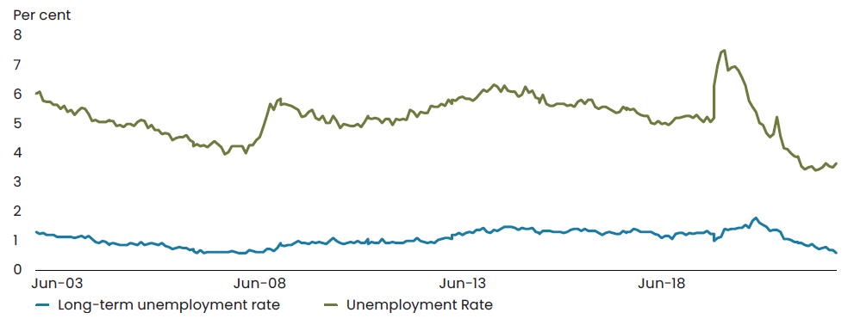
Source: ABS Labour Force Survey.

Chart 20: Underutilisation rate (hours-based)
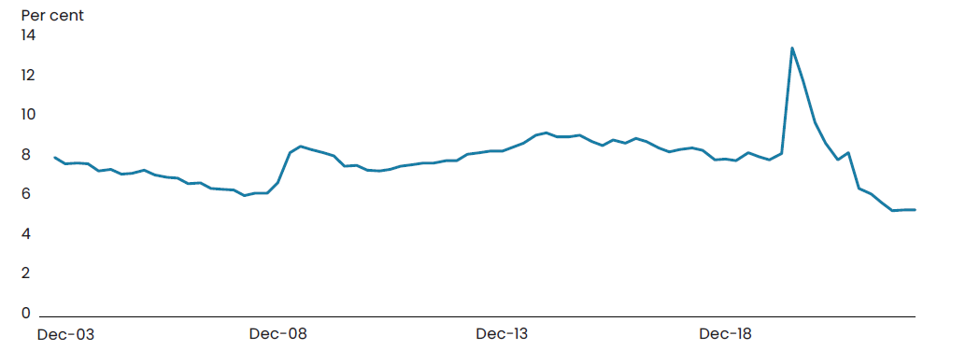
Source: ABS Labour Account.

Broadening access to work
The participation rate, which expresses the labour force as a share of the population, has increased substantially over recent decades and has recently been around record high levels.
The rise in overall participation can be largely attributed to increased women’s workforce participation driven by changes in social attitudes, workplace flexibility, and improved education opportunities and outcomes.
With employment rates at record highs, more people than ever before have broadening access to work opportunities.
Despite strong employment outcomes at a whole-of-economy level, labour market inequalities persist for many groups.
- Employment rates for people with disability have remained persistently low over the past decade.
- While the employment rate for First Nations people (aged 15–64) has increased over time, from 48 per cent in 2006 to 52 per cent in 2021, it is still 22 percentage points lower than for other Australians in 2021.
- Women have lower labour force participation, lower average hours worked and experience a persistent gender pay gap. The gender pay gap has fallen only 2.9 percentage points in 28 years, to 13.3 per cent in November 2022.

Job satisfaction
Most employed Australians report being relatively satisfied with their job. The average job satisfaction rating has been relatively stable
since 2001, although it has been increasing since 2017. Since 2001, women have had higher average job satisfaction ratings than men – although rates converged around 2020.

Chart 21: Average job satisfaction rating, all employed Australians, by sex
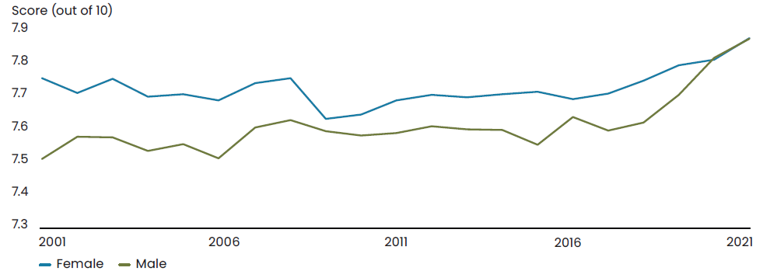
Source: Treasury analysis of HILDA Survey Release 21.0.

Secure jobs
Job security is a broad and multi-faceted concept. Elements of a job that contribute to job security include, but are not limited to, the likelihood of a worker keeping their job, access to paid leave entitlements, and regularity of hours or a minimum number of hours. The Employment White Paper will discuss job security further and potential opportunities to measure it better.
There are several ways of measuring job security. Looking at a selection of measures suggests some workers may not have adequate job security. Over the past decade, most metrics of job security have remained stable:
- The proportion of employed people who expect to not remain in the same job in 12 months’ time due to involuntary reasons has been relatively steady since August 2015, ranging from 1.5 per cent to 2.1 per cent.
- The proportion of employees that had irregular working arrangements has been stable from 2014 to 2022 at around 27 to 29 per cent.
- The proportion of employees that did not have access to paid leave entitlements has been relatively stable over the past decade, with between 22 and 26 per cent of all employees not having access to paid leave entitlements.

Key Government initiatives to broaden opportunities for secure, well-paid jobs
- Employment White Paper (forthcoming)
- Cheaper Child Care reforms
- Enhanced Paid Parental Leave
- Reform of the workplace relations system including the Secure Jobs package, Better Pay Act 2022, the Protecting Worker Entitlements Act 2023, and the forthcoming Closing the Loopholes Bill
- National Strategy to Achieve Gender Equality (forthcoming)
- Inquiry into Workforce Australia Employment Services
- National Agreement on Closing the Gap
- Reform to Disability Employment Services, including introduction of the Disability Employment Services Quality Framework
- Supporting ABS to improve data on barriers and incentives to participation
- Reforms to address migrant worker exploitation

The early years of a child’s life and wellbeing
Every child deserves the opportunity for the best start to life, setting a strong foundation to achieve their goals and dreams, no matter where they are born or raised.

Child wellbeing
In a one-off spotlight, this chapter takes a deeper look at what matters to children’s wellbeing, particularly in the early years.
A child’s wellbeing has a variety of different elements. Of those frameworks developed in Australia and internationally, there are common elements such as feeling safe, loved and valued, having what they need to live life, being healthy, having the opportunity to learn and develop, and developing a sense of identity and belonging.
Measuring these aspects for the early years –from pre-birth to the year before school (0–5) – is challenging due to conceptual and data limitations. For example, measuring secure, nurturing and stable relationships with caring adults that are essential for a child’s healthy development and wellbeing with one or two metrics, is not straightforward.

The early years are profoundly formative
The early years are a critical window of opportunity to positively influence a child’s development, sense of identity, health, learning, safety and happiness.
In these first few critical years of life, brain development occurs more quickly than at any other time in a child’s life.
Enriching early years experiences will support children to flourish and reach their full potential. This has broader positive implications for our communities, the economy, and the nation across current and future generations.
In contrast, adverse experiences in the early years can have lifelong negative impacts.
A child’s wellbeing is nurtured by the behaviours of parents, families, carers and kin, and the environmental settings in which they live and play. Their relationships and care actively shape their lifetime health, learning, and identity. Wellbeing metrics for younger children are, therefore, often based on the behaviours of people, and the type of environment in which a child lives.

A healthy environment for a child
Good health is vital to how children feel and can determine how they participate in family life, at school, and in society.
That begins with immunisation and the antenatal period. Immunisation rates are around 94 per cent for children aged one year old (just below the national target), and few mothers are smoking during their pregnancy.
As they grow older, good dietary habits increase a child’s chances of enjoying physical health. In 2017–18, the proportion of children 2‍–‍3 years consuming the recommended daily fruit intake was 97 per cent but only 19 per cent consumed the recommended vegetable serves each day. Most children 2‍–‍3 years do not consume sugar sweetened drinks (82 per cent) but 4 per cent consume these drinks daily.

Learning and development
Another critical factor which determines childhood wellbeing is access to a stimulating learning environment – in either informal settings or through early childhood education programs.
In 2017, almost 4 in 5 children aged 0‍–‍2 were regularly read to or told stories by a parent (on 3 or more days in the previous week). In 2017, 44 per cent of children aged 0–2 had between 25 and under 100 children’s books in the home.
The quality of early childhood education and care services has consistently risen in recent years, with 89 per cent of the 17,000 early childhood education and care services in Australia meeting or exceeding the National Quality Standards.
The Australian Early Development Census measures how well a child has developed, as assessed by their teacher upon entry to school. It evaluates a child’s development as being ‘on track’, ‘at risk’ or ‘vulnerable’ across five domains: physical health and wellbeing, social competence, emotional maturity, language and cognitive skills, and their communication and general knowledge.
As outlined above, the proportion of children developmentally on track in all five domains steadily increased from between 2009 and 2018, growing from 50.7 per cent to 55.4 per cent. However, there was a slight decline in this figure in 2021, for the first time since 2009, to 54.8 per cent, revealing the impact of COVID-19 related disruptions on early childhood development. This decline was more pronounced for groups already experiencing disadvantage, demonstrating how experiences of entrenched disadvantage may have been exacerbated or compounded by COVID-19 disruptions.

Safety of children
While most children in Australia grow up in families that provide them with environments where they are safe, happy, and healthy, some children are the subject of abuse and/or neglect.
The ABS Personal Safety Survey in 2021‍–‍22 found, of people aged 18 years and over, 14.1 per cent experienced abuse and 13.3 per cent witnessed violence towards a parent during their childhood (before the age of 15).
Unfortunately, child abuse and neglect can have a wide range of significant adverse impacts on a child’s wellbeing and later outcomes, including impaired language ability, reduced social skills, poor school performance, negative physical health outcomes, mental health issues, and a higher likelihood of criminal offending.

Government support for children in the early years and their families
The Government funds health, maternal and child health and wellbeing programs, and early intervention health services. It supports the family law system and coordinates national policy frameworks for preventing and responding to child sexual abuse, child maltreatment and domestic family and sexual violence. It offers direct financial support to families, including paid parental leave, as well as funding programs supporting the capacity of families and carers with young children across diverse societies and cultures in Australia.
Through a mix of direct and indirect funding mechanisms, the Government aims to provide all young children with access to affordable quality early childhood education and care and enrich home-based learning environments through programs such as play groups and toy libraries. The Productivity Commission is currently undertaking an inquiry into the early childhood education and care sector and will consider options to improve and support developmental and educational outcomes for children.
In addition, the Government invests in measures to improve the health, development, and education of First Nations children to reduce systemic and multi-generational disadvantage. There are also programs of support for children with developmental delays or disability, as well as those at risk of disadvantage due to displacement, poverty, or traumatic experiences.

Place-based approaches can support improved outcomes for children and families
Place-based approaches can help improve outcomes by recognising the unique needs of individual communities and galvanising efforts around a long-term vision for community change. Place-based approaches typically focus on breaking down silos and integrating services within a community, building community capability to implement reforms at the local level, and supporting community-led decision-making.
The Australian Government, along with states and territories, currently works in partnership with communities through initiatives such as Stronger Places, Stronger People, Connected Beginnings, and Empowered Communities. Many of these partnerships have a focus on improving child and family wellbeing, including through maternal and child health supports, efforts to reduce domestic, family and sexual violence, and supporting families’ engagement with early childhood education and care.
Place-based approaches can also complement nationally coordinated policy frameworks that aim to protect children, by supporting communities to implement solutions to complex policy problems in their local context. Relevant policy frameworks for the early years include the National Plan to End Violence Against Women and Children 2022–23, Safe and Supported: National Framework to Protect Australia’s Children 2021–31 and the National Strategy to Prevent and Respond to Child Sexual Abuse 2021–2030.
In the 2023–24 Budget, the Government committed to delivering a whole of government Framework to Address Community Disadvantage that will identify strategic objectives and key principles to guide how the Government will work in partnership with communities. The Framework will have a focus on maximising the impact of government investment, including through better alignment of existing policies and programs, enabling greater use of tailored, place-based approaches, and supporting greater community access to data and opportunities for community-led decision-making.
The Government has also committed to partner with philanthropy through the Investment Dialogue for Australia’s Children, with the goal of improving the wellbeing of children, young people and their families, including through place-based approaches. The partnership will support a more coordinated, and targeted approach to intergenerational disadvantage in Australia.
The Government is also developing an Early Years Strategy that will be a road map to guide policies and programs for the next decade, providing a vision of what Australia wants to achieve for children and families in the early years. The forthcoming strategy will seek to foster a more holistic approach to early childhood development that is focused on opportunities for coordination, collaboration, and partnership to provide the best possible start for Australia’s children. It will be informed by community perspectives and experiences and will reflect the diverse needs of families and children across Australia.

The way ahead
Measuring What Matters is a living Framework that will continue to evolve and improve over time to reflect ongoing feedback from the community, new research, improved data availability, and changing community views.

This Framework will help us to track progress in the wellbeing themes: healthy, secure, sustainable, cohesive, and prosperous.

Next steps
The Government will be looking to continuously improve the Framework and welcomes comments on what is presented in this statement and the online dashboard.
As part of this process of refinement, ongoing engagement with community, business, experts, and groups such as First Nations people, will help us to consider whether wellbeing is improving.
The dashboard will be updated regularly to take stock of progress and identify priorities for future action. A key focus will be on exploring greater disaggregation, to better reflect the experience of different groups. Some of the possible opportunities here are discussed at Appendix A.
Consistent with our international counterparts, we will be looking for opportunities to embed the Framework into government decision making. This will involve guidance for agencies to inform policy development and evaluation. The Framework could also be used in areas of policy that require different levels of government to work together.
This will complement existing initiatives the Government has in train. A new Australian Centre for Evaluation is currently being established to better understand the economic, environmental and social impacts of Government policies. Additionally, policies in the 2023–24 Budget included gender analysis and analysis of impacts on groups such as First Nations Australians and Australians in regional areas. From the 2023–24 MYEFO, the Government will extend gender responsive budgeting across the budget processes.
But the Framework’s usefulness will extend beyond government. It has been specifically designed to be drawn upon by business, academia, and the community, to support their efforts to create better lives for all Australians.
With the introduction of the first iteration of the Framework, the Government has delivered an important foundation on which we can build – to understand, measure, and improve on the things that matter to Australians.

Appendix A:
Strengthening the indicators

This Framework focuses on measurements of things that matter. However, there are many things that matter which are not measured, or not fully measured. In many cases this relates to data limitations and the technical difficulties of measuring some aspects of wellbeing outcomes.
While the ABS produces monthly labour market indicators and quarterly economic indicators such as GDP, many social indicators of wellbeing are only available every few years. Many indicators for First Nations people are only produced every five years, and data for cohorts such as for culturally and linguistically diverse people and LGBTIQA+ people vary by data source.
More frequent data can improve the Government’s ability to monitor current conditions and barriers that some cohorts face to improving wellbeing, as well as monitor the impacts of policy changes. Improving the coverage of statistical products and longitudinal datasets will enable better monitoring of wellbeing outcomes over time and is an opportunity to enrich the indicators and the distributional analysis that could be monitored in this Framework.
To this end, the Government provided funding in the 2022–23 October Budget to the ABS to publish more frequent information on barriers and incentives to labour force participation. This work also aims to provide information on barriers for women, unpaid carers, people with disability, older people, First Nations people, culturally and linguistically diverse people, and those living in remote areas.
Further, the Australian state and territory governments are working together to develop the National Disability Data Asset, a single source of information combining data from all levels of government which will aim to give a more complete picture of the life experiences of people with disability – to see, hear and understand people with disability as a diverse community with specific needs and goals. This will help us to improve research, policy development and service delivery to ensure investment is best targeted to achieve outcomes for people with disability, their carers, and the community.
The consultations undertaken to develop this Framework identified areas across all the themes of wellbeing where there may be opportunities to deepen the measurement of things that matter. Some of the potential improvements that have been suggested are:
Considerations of the averaging effect of national statistics and their ability to hide the true magnitude and nature of issues at a regional or cohort level.
Overall wellbeing indicators could benefit from better coverage of cohorts, such as people with disability, unpaid carers, First Nations people, children and youth outcomes, culturally and linguistically diverse people (including refugees), and LGBTIQA+ people. Additionally, more spatial and geographic analysis may assist in variances from region to region.
Healthy indicators could benefit from improved coverage of access to green and blue spaces for promoting health and recreation activity when the data limitations are addressed and improved measures become available. Access to blue and green spaces is also vital to mental and physical health. Health and financial literacy, or actions to improve Australians’ literacy in these areas may add value to future updates.
Prosperous indicators could be improved by further developing holistic concepts of full employment, measures of the quality of skill formation, investing in ways to better measure employment and economic participation of particular cohorts such as First Nations people, and improved coverage of risk taking and insolvency. A new National School Reform Agreement is likely to include measures that reflect the experience of children and young people during their time at school, and the work currently underway will inform future iterations of this Framework. A new national study on adult literacy, numeracy, and digital skills led by Jobs and Skills Australia could be included in the future. Additionally, broad consideration for access to public transport in the context of employment, the economy, health, equity, and inclusiveness. More consistent measures of access to digital service and connection may also provide foundational visibility for a prosperous society.
Sustainable indicators could be improved through better coverage of material footprint, domestic material consumption, and resource productivity (including the resources used in production and consumption). Environmental resilience (including to natural disasters and impacts on green and blue spaces) should also be a priority as well as the condition and value of ecosystem assets consistent with the UN System of Environmental Economic Account.
Cohesive indicators could be improved by considering barriers to participation and engagement alongside the levels of participation. Greater consistency in data capture would also benefit the ability for improved distributional analysis.
Secure indicators could be improved through new indicators of the level of national security and greater coverage of democratic resilience. Additionally, the safety of more groups in Australia could be considered through indicators on experience of violence for Australians aged 70 years and over, and indicators on child safety.
The Government will consider these suggestions, along with other consultation responses to this Framework, as it looks at how to ensure Australia’s data system provides the most valuable means to measure indicators across this and other frameworks.

Appendix B: International approaches

Many countries have introduced wellbeing or progress frameworks. Some are relatively recent, and others have been in place for several years. While many are based on the OECD wellbeing framework and the United Nations Sustainable Development Goals, they have different policy wellbeing themes or domains and indicators. Also, the frameworks are used differently to influence policy settings.
New Zealand has a Living Standards Framework comprised of 12 domains of individual and collective wellbeing, six domains of wellbeing related to institutions and governance and four capitals of wealth. The NZ framework is applied to inform budget priorities and analyse budget bids for funding. In addition, they publish an independent wellbeing report every four years to track progress, with the first released in 2022. The NZ framework sits alongside the He Ara Waiora, which provides a Māori perspective on wellbeing.
Wales has taken a whole-of-government approach to wellbeing, legislated through the Wellbeing of Future Generations Act 2015. The Act aims to promote structural changes by integrating wellbeing goals into the pre-existing policies, practices, and decision-making processes of government. Progress is monitored by indicators (currently 50) and milestones published annually. Every five years, the Future Generations Commissioner releases the Future Generations Report, which assesses the improvements public bodies have made against the wellbeing objectives.
The United Kingdom produces Measures of National Well-being, an online set of statistics to help monitor national wellbeing. It has 10 domains and 52 indicators. Wellbeing guidance has been added to the ‘Green Book’, which provides information on how to appraise policies, spending proposals and programs, and the ‘Levelling Up’ policy initiative, which seeks to reduce geographic disparities across various policy areas.
India uses the Transforming India Performance dashboard to monitor progress on a range of government schemes, such as toilets constructed, and villages electrified. It highlights well-performing jurisdictions allowing the sharing of best practice strategies.
Canada’s Quality of Life Framework is relatively new, being established in 2021. It has 84 indicators organised into five domains. It uses wellbeing evidence and impact reporting in its budget process. Canada is working with its First Nations people to bring their perspectives to their framework.
The United Nations is also progressing a Beyond GDP framework, to better ‘value what counts’ including people’s wellbeing, the environment and inequality.

Appendix C: Consultation
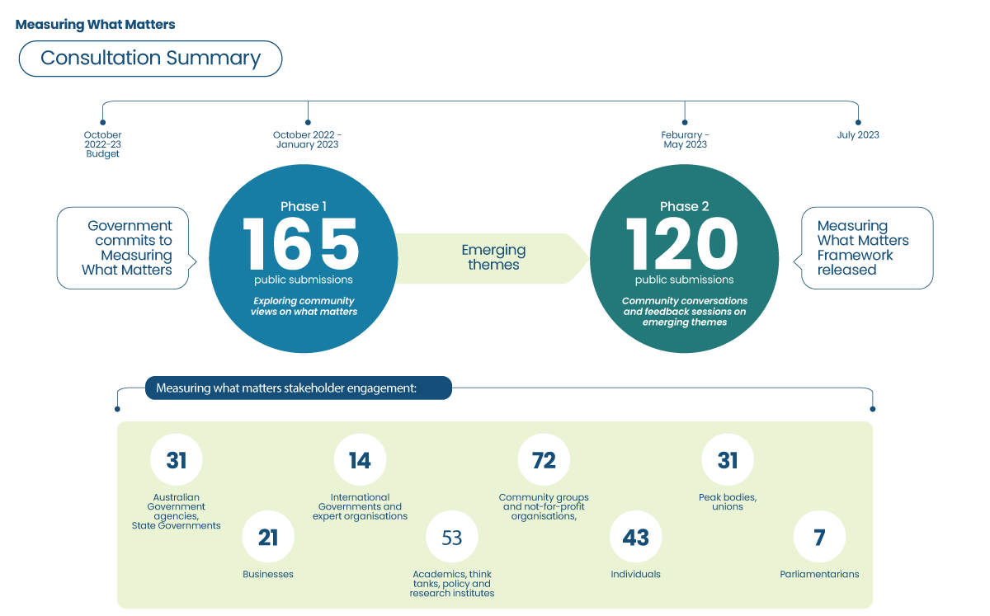

Public Submissions on Measuring What Matters
Thank you to the hundreds of people and organisations that made submissions to the Measuring What Matters public consultation rounds. A list of Phase 1 submissions is available below (except for those that requested anonymity or made private submissions).
While around 120 submissions were received in Phase 2 of the public consultation, we do not have permission to publish the names of people and organisations who participated in meetings, townhalls or provided feedback through email or the feedback survey form at this time. We acknowledge the effort of these groups and recognise the value of their contribution to the development of this Framework.

Organisations
4 Day Week Australia
A New Approach
Academy of the Social Sciences in Australia
Actuaries Institute
AIA Australia Limited
Alliance Social Enterprises
Anglicare Australia
Anti-Poverty Week
Australian Academy of Health and Medical Sciences
Australia Council for the Arts
Australia reMADE
Australian Association of Social Workers
Australian Centre on Quality of Life
Australian Community Futures Planning
Australian Council of Social Service
Australian Death Studies Society
Australian Dental Association
Australian Digital Inclusion Alliance
Australian Health Promotion Association
Australian Healthcare and Hospital Association
Australian Human Rights Commission
Australian Institute of Family Studies
Australian Institute of Superannuation Trustees
Australian Land Conservation Alliance
Australian Manufacturing Workers’ Union
Australian Men’s Health Forum
Australian National Development Index
Australian Nursing and Midwifery Federation
Australian Psychological Society
Australian Red Cross
Australian Research Alliance for Children and Youth
Australian Small Business and Family Enterprise Ombudsman
Australian Unity
Auswakeup Media
B Lab Australia and Aotearoa New Zealand
Beyond Blue
Black Dog Institute
Brotherhood of St. Laurence
Centre for Excellence in Child and Family Welfare, Centre for Mental Health, Melbourne School of Population and Global Health, University of Melbourne
The Centre for Optimism
Centre for Policy Development
Centre for Social Impact, University of New South Wales
Centre for Urban Research, RMIT University
Centre for Urban Transitions, Swinburne University of Technology
Chartered Accountants Australia and New Zealand
Children’s Policy Centre, Australian National University
City of Onkaparinga Administration
Climate and Health Alliance
Climateworks Centre
Cohealth
Commissioner for Children and Young People, South Australia
Community Broadcasting Association of Australia
Community Housing Industry Association
Community Mental Health Australia
Consumer Policy Research Centre
Council on the Ageing
CSIRO: Commonwealth Scientific and Industrial Research Organisation
Dietitians Australia
eHealthier
Ending Loneliness Together
Equity Economics
Everybody’s Home Campaign
Federation of Ethnic Communities’ Councils of Australia
Fenner School of Environment and Society, Australian National University
Flinders Institute for Mental Health and Wellbeing
Foundation for Rural and Regional Renewal
George Institute for Global Health, University of New South Wales
Griffith Criminology Institute, Griffith University
Health and Wellbeing Queensland
Health Justice Australia
Health Research Institute and Centre for Environmental Governance, University of Canberra
Healthy Male
Huber Social
Humane Society International
Institute for Sustainable Futures, University of Technology Sydney
Kimberley Aboriginal Law & Cultural Centre
Korus Connect
KPMG
Medtronic Australasia
Melbourne Climate Futures and the Melbourne School of Population and Global Health
Mental Health Australia
Mental Wealth Initiative, The University of Sydney
Menzies Centre for Health Governance, Australian National University
Menzies Institute for Medical Research, University of Tasmania
Minderoo Foundation
National Aboriginal Community Controlled Health Organisation
National Legal Aid
National Mental Health Commission
National School Chaplaincy Association
National Shelters
Neami National
Northern Beaches Council
Northern Sydney Local Health District – Population Health Promotion
Obesity Policy Coalition
Orygen
PHN Cooperative
Public Health Association of Australia
Public Service Association of SA Inc
Queensland Alliance for Mental Health
Queensland Nurses and Midwives’ Union
Regional Australia Institute
Relationships Australia
Reshaping Wellbeing
Royal Australian and New Zealand College of Psychiatrists
Safe Work Australia
Salvation Army
Sanofi
School Efficiency Metrics Australasia
School of Public Health, Faculty of Medicine and Health, ARC Centre of Excellence in Population Ageing Research, The University of Sydney
Shared Value Project
Social Enterprise Australia
Social Impact Measurement Network of Australia
Spiritual Health Association
Spur
Steady State ACT
Suicide Prevention Australia
SwitchDin
Systems science in Public Health and Health Economics Research, University of Glasgow
TaskForce Community Agency
Tasmanian Council of Social Service Inc
The Culture Advantage
The Office of the Children’s Commissioner Northern Territory
The Royal Australasian College of Physicians
The Wilderness Society
Think Impact
UNICEF Australia
UnitingCare Australia
Vic Health
Victorian Council of Social Service
Volunteering ACT
Volunteering Australia
Volunteering Tasmania
Wellbeing and Prevention Coalition

People who made submissions
Aden Date
Aiden Parisi
Andrew Barr MLA Chief Minister of the Australian Capital Territory
Brenton White
David Banham
David Hall
David Kalisch
David McEwen
David Spicer
Erin Remblance
Evan Hadkins
F. Simpson
Ian McAuley and James Guthrie
Jackie Ohlin
James Jackson
Jennifer Lanham
Kate Chaney MP Federal Member for Curtin
Kate Sollis
Martha Knox-Haly
Neil Halliday
Norm de Plumette
Peta Murphy MP Federal Member for Dunkley
Penelope Fox
Peter Heywood and John Watson
Ray Johnson
Rhonda Kerr
Russel Cooper
Siobhain O’Leary

Appendix D: Selection of indicators

The Measuring What Matters Framework includes 50 indicators of the current status and long-term trends in Australians’ wellbeing.
The indicators have been selected for having consistent, comparable and reliable data, including logical alignment with indicators already captured through existing strategies and plans. Where possible and where supporting input is available, indicators have been chosen to provide information that captures the different experiences and outcomes of people across Australia.
The indicators have been selected to focus on wellbeing outcomes of people. In cases where there are not ideal indicators for an outcome, indicators have been selected that focus on factors that influence, or are a proxy for, that outcome. The indicators and metrics will continue to evolve in future iterations of this Framework. Appendix A discusses steps that have been taken to strengthen measurement and opportunities that may exist to further strengthen wellbeing indicators.
Indicators were selected according to the OECD and the internationally accepted Civitas initiative guidelines, that is, indicators should be:
- Relevant: indicators should be relevant to policy priorities.
- Complete: indicators should adequately cover all policy priorities.
- Measurable: indicators should have the potential for objective measurement.
- Comparable: indicators should be defined and measured consistently to enable comparisons within a country and internationally.
- Reliable: preference should be given to indicators underpinned by objective and accurate data, which is not subject to different interpretations.
- Understandable: indicators should be unambiguous, easy to understand by decision-makers and key stakeholders and be standardised where possible.
In addition, an effective wellbeing framework will minimise the number of core indicators to support decision-making by avoiding unnecessary complexity.
The 50 indicators in this Framework, balance the breadth of outcomes that matter most to Australians’ wellbeing while also minimising complexity and providing completeness. The number of indicators included in similar frameworks developed around the world varies significantly. For example the UK’s framework has 38 indicators and Italy’s has 153. Similar to most other national frameworks, our Framework has more metrics than the 36 headline indicators included in the OECD Framework for Measuring Well-being and Progress. This allows our Framework to reflect a more extensive set of outcomes that matter in an Australian context.
Most of the Framework’s indicators focus on how well we achieve our goals or outcomes (such as living a long life as measured by life expectancy). However, data limitations mean this was only sometimes possible.
In cases where outcomes are more challenging to measure and may be slow to change, indicators have been identified that influence outcomes, such as contributing, protective or risk factors. For example, access barriers to health care, such as the cost of attending a General Practitioner, is a relevant factor in broader health outcome measures. These types of indicators can provide early warnings and assist in timely intervention.
In other cases, proxy indicators have been used due to the absence of data on the primary issue of interest. For example, data on whether people have sufficient time to build connections is not available; instead, this Framework uses an indicator measuring the average time spent on recreation, leisure, and social and community interaction. Data is not always available on a regular basis, for example, indicators based on Australian Census data is available only every 5 years.

Glossary
ABS | Australian Bureau of Statistics
AIHW | Australian Institute of Health and Welfare
Australian Early Development Census | The Australian Early Development Census measures how well a child has developed, as assessed by their teacher upon entry to school. It evaluates a child’s development as being ‘on track’, ‘at risk’ or ‘vulnerable’ across five domains: physical health and wellbeing, social competence, emotional maturity, language and cognitive skills, and their communication and general knowledge.
Cross-cutting dimension | The cross-cutting dimension acknowledges that areas of inclusion, equity and fairness are relevant to all of the wellbeing themes.
Care and support economy | The care and support economy is the provision of paid care and support in the aged care, disability support, early childhood education and care and veteran care sectors.
Chronic conditions | Chronic conditions generally have long-lasting and persistent effects, for example, arthritis, asthma, back pain, cancer, cardiovascular disease, chronic obstructive pulmonary disease, diabetes, kidney disease, mental health conditions, and osteoporosis.
Culturally and Linguistically Diverse (CALD) | The phrase ‘culturally and linguistically diverse’ is a broad term used to describe communities with diverse languages, ethnic backgrounds, nationalities, traditions, societal structures and religions.
DCCEEW | Department of Climate Change, Energy, the Environment and Water
Dimensions | The Measuring What Matters wellbeing themes are supported by 12 elements which describe further aspects of wellbeing.
Early Years Strategy (forthcoming) | The Australian Government is developing an Early Years Strategy to shape its vision for the future of Australia’s children and their families.
Employed | Employment is the state of having paid work. The ABS considers a person be in employment if they have worked at least 1 hour in the reference week.
Employment rate | The employment rate (also known as the employment to population ratio) is the number of employed persons to number of persons in the population.
Employment White Paper (forthcoming) | The Government’s Employment White Paper will provide a labour market roadmap for Australia, focusing on achieving full employment and productivity growth for the benefit of all Australians. This will be published later in 2023.
Equivalised disposable household income | Disposable household income is the income available to a household after income tax, Medicare levy and Medicare levy surcharge (if applicable) have been deducted. Equivalised disposable household income is disposable household income adjusted by the application of an equivalence scale to facilitate comparison of income levels between households of differing size and composition, reflecting that a larger household would normally need more income than a smaller household to achieve the same standard of living.
Formal study | Formal study leads to a qualification recognised by the Australian Qualifications Framework such as a degree, diploma or certificate and also includes study at school.
Gini coefficient | An indicator designed to measure inequality of income and wealth. It ranges from zero, which indicates perfect equality, with every household earning or owning exactly the same, to one, which implies absolute inequality, with a single household earning a country’s entire income or owning all its wealth.
Gross domestic product (GDP) | A measure of the amount of economic activity that occurs within a given time period and often reported in terms of the growth of economic activity over a year.

Health services | Health services support people’s wellbeing by preventing, treating, and managing health conditions.
Indicators | Indicators track the aspects of what Australians have described as fundamental to their wellbeing.
Inflation | The change in the price of goods and services that households buy. It is often reported as the change in prices over a year.
Intergenerational Report (forthcoming) | The Australian Government produces intergenerational reports. These reports project outlooks for the economy and the Australian Government’s budget over the next 40 years. The next report is expected to be released in 2023.
Initial phase of public consultation | The initial phase of public consultation refers to the call for submissions for the development of the Measuring What Matters Framework. The initial phase commenced with the October Budget 2022–23 and ran from 25 October 2022 to 31 January 2023.
Labour force | For any group, persons who were employed or unemployed.
LGBTIQA+ | LGBTIQA+ is an acronym that stands for lesbian, gay, bisexual, transgender, intersex, queer/questioning, asexual and other sexually or gender diverse people.
Measuring What Matters Framework | The framework developed by the Australian Government – informed by feedback from the Australian community – outlines the outcomes and factors that influence the wellbeing of Australian people. Progress is measured through monitoring changes in economic, social and environmental statistics.
National Agreement on Closing the Gap | The National Agreement on Closing the Gap sets out ambitious outcomes and new priority reforms that will change the way governments work to improve life outcomes for Aboriginal and Torres Strait Islander people.
National Strategy to Achieve Gender Equality (forthcoming) | The National Strategy to Achieve Gender Equality will guide whole-of-community action to make Australia one of the best countries in the world for a gender-equal society. It will be an important mechanism to elevate and prioritise actions that will achieve gender equality.
Non-formal learning | Non-formal learning activities are structured training or courses that do not form part of an award or qualification (such as a degree or certificate) recognised by the Australian Qualification Framework.
Non-market transactions | Non-market transactions are goods or services that people or organisations provide to others for free or at prices that are not economically significant.
Net zero transformation | The net zero transformation is the orderly and positive economic transformation associated with achieving net zero emissions (that is, achieving an overall balance between greenhouse gas emissions produced and greenhouse gas emissions taken out of the atmosphere).
OECD | Organisation for Economic Co-operation and Development
OECD Framework for Measuring Well-Being and Progress | This is a framework developed by the Organisation for Economic Co-operation and Development to measure societal progress related to the quality of life of people and households, through monitoring changes in economic, social and environmental statistics.
Participation rate | For any group, the labour force expressed as a percentage of the civilian population aged 15 years and over in the same group.
Real Net National Disposable Income | Real net national disposable income (RNNDI) is a preferred measurement of the economic wellbeing of Australians rather than GDP as it takes into account factors that are not included in GDP that are relevant to Australians’ wellbeing (such as changes in the terms of trade).
Second phase of public consultation | The second phase of public consultation sought feedback on the emerging wellbeing themes from the initial phase. It ran from 14 April to 26 May 2023.

Terms of trade | The price of a country’s exports, relative to that of its imports.
The Framework | Australian Government’s national framework on wellbeing: Measuring What Matters
Underutilisation rate  (hours based) | The hours-based underutilisation rate measures additional hours sought by the unemployed or underemployed as a share of total hours worked or sought.
Unemployed | Persons aged 15 years and over who were not employed during the reference week, and:  had actively looked for full-time or part-time work at any time in the four weeks up to the end of the reference week and were available for work in the reference week; or  were waiting to start a new job within four weeks from the end of the reference week and could have started in the reference week if the job had been available then.
Unemployment rate | For any group, the number of unemployed persons expressed as a percentage of the labour force in the same group.
United Nations Sustainable Development Goals | The Sustainable Development Goals are a collection of seventeen interlinked objectives designed to serve as a shared blueprint for peace and prosperity for people and the planet, now and into the future.
Wellbeing themes | Wellbeing themes, in the Measuring What Matters Framework, set out the aspects and resources that are important to Australians’ individual and collective wellbeing across all phases of life in five broad themes: healthy, secure, sustainable, cohesive, prosperous.

Data dictionary

Overall life satisfaction
Indicator | Metric | Source
Overall life satisfaction | Overall life satisfaction is a summary measure of subjective wellbeing, reflecting how satisfied people are feeling with their lives in general. | ABS General Social Survey

Healthy
Indicator | Metric | Source
Healthy throughout life
Life expectancy | Life expectancy at birth – measures the average number of years a newborn can expect to live | ABS Life Tables
Life expectancy | Health-adjusted life expectancy – the length of time a person at birth could expect to live in full health without disease or injury | AIHW, Australian Burden of Disease Study
Mental health | Proportion of people who experienced high or very high levels of psychological distress | ABS, National Health Survey
Prevalence of chronic conditions | Proportion of people with one or more selected chronic conditions | ABS, National Health Survey
Equitable access to quality health and care services
Access to health services | Cost: Proportion of people who at least once delayed or did not see a General Practitioner (GP) when needed due to cost | ABS, Patient Experience Survey
Access to health services | Cost: Proportion of people who at least once delayed or did not see a medical specialist when needed due to cost | ABS, Patient Experience Survey
Access to health services | Wait times: Proportion of people waiting longer than they felt acceptable for an appointment with a GP | ABS, Patient Experience Survey
Access to health services | Wait times: Proportion of people waiting longer than they felt acceptable for an appointment with a medical specialist | ABS, Patient Experience Survey
Access to care and support services | Unmet needs: Proportion of people (aged 0‍–‍64 years) living in households who receive disability support who felt their needs were not being met | Productivity Commission (PC) analysis of ABS Survey of Disability, Ageing and Carers, Report on Government Services
Access to care and support services | Unmet needs: Proportion of people (aged 65 years and over) living in households who receive aged care services and who felt their needs were not being met
Access to care and support services | Quality: The proportion of people with disability (aged 15‍–‍64 years) who were satisfied with the quality of assistance in the last six months
Access to care and support services | Quality: the proportion of people (aged 65 years or over) living in households, who were satisfied with the quality of assistance in the last six months

Secure
Indicator | Metric | Source
Living peacefully and feeling safe
Feeling of safety | Proportion of people who felt ‘safe’ or ‘very safe’ walking alone during the day and night | Steering Committee for the Review of Government Service Provision, Report on Government Services
Experience of violence | Proportion of people who experienced physical violence or abuse in the last 12 months | ABS, Personal Safety Survey
Experience of violence | Proportion of people who experienced violence by an intimate partner in the last 12 months | ABS, Personal Safety Survey
Childhood experience of abuse | Proportion of people who have experienced physical or sexual abuse before the age of 15 years | ABS, Personal Safety Survey
Online safety | Proportion of people who have experienced online harm or negative content in the last 12 months | eSafety Commissioner, National Survey of Australian adults’ experiences online
National safety | Proportion of polled Australians who feel ‘safe’ or ‘very safe’ based on views of world events | The Lowy Institute, The Lowy Institute Poll 2023
Access to justice | Index of Australia’s performance in providing accessible and affordable civil courts and alternative dispute resolution mechanisms | World Justice Project, Rule of Law Index®
Having financial security and access to housing
Making ends meet | Proportion of households who experienced a cash flow problem in the last 12 months | ABS, General Social Survey
Making ends meet | Proportion of households unable to raise $2,000 when needed | ABS, General Social Survey
Homelessness | Rate of people who are experiencing homelessness | ABS, Census of Population and Housing
Housing serviceability | Ratio of housing costs to household gross income, by tenure | ABS, Survey of Income and Housing

Sustainable
Indicator | Metric | Source
Protect, repair and manage the environment
Emissions reduction | Proportion of reduction in Australia’s net greenhouse gas emissions from 2005 levels | DCCEEW, Quarterly Update of Australia’s National Greenhouse Gas Inventory: December 2022
Emissions reduction | Renewable share of electricity generation | DCCEEW, Australian Energy Statistics
Air quality | Exposure to outdoor air pollution of PM2.5 | National Environment Protection Council, National Environment Protection (Ambient Air Quality) Measure and unpublished data
Protected areas | Proportion of lands and waters dedicated to the long-term conservation of nature, its ecosystem and cultural values | DCCEEW, The Collaborative Australian Protected Areas Database
Biological diversity | Proportion of decline in Australia’s threatened and near threatened species from the “Threatened Species Index” | Terrestrial Ecosystem Research Network, the Threatened Species Network
Resource use and waste generation | Waste generation per person | DCCEEW, National Waste Report
Resource use and waste generation | Proportion of waste recovered for reuse, recycling or energy | DCCEEW, National Waste Report
Resilient and sustainable nation
Fiscal sustainability | All levels of Government gross debt as a share of GDP | ABS Government Finance Statistics, Treasury
Economic resilience | The Atlas of Economic Complexity’s Economic Complexity Index | The Atlas of Economic Complexity’s Economic Complexity Index
Climate resilience | Australian Disaster Resilience Index | Parsons et al, Australian Disaster Index, Volume 1, State of Disaster Resilience Report 2020

Cohesive
Indicator | Metric | Source
Having time for family and community
Time for recreation and social interaction | Average time spent on recreation and leisure, and social and community interaction | ABS Time Use Survey
Social Connections | Proportion of people who agreed with the statement ‘I often feel very lonely’ | Household, Income and Labour Dynamics in Australia Survey
Social Connections | Proportion of people who undertake voluntary work | ABS General Social Survey
Creative and cultural engagement | Proportion of people who participated in at least one cultural activity | ABS Cultural participation and attendance survey
Creative and cultural engagement | Proportion of people who attended at least one cultural venue or event | ABS Cultural participation and attendance survey
Valuing diversity, belonging and culture
Experience of discrimination | Proportion of people who experienced some form of discrimination in the previous 12 months | ABS General Social Survey
Acceptance of diversity | Proportion of people who used a language other than English at home | ABS Census of Population and Housing
Acceptance of diversity | Proportion of people who agreed or strongly agree accepting immigrants from many different countries makes Australia stronger | Scanlon Foundation Research Institute, Mapping Social Cohesion Survey
First Nations languages spoken | Number of First Nations people who speak a First Nations language at home | ABS Census of Population and Housing
Sense of belonging | Proportion of First Nations people who recognise an area as their homelands or traditional country | ABS National Aboriginal and Torres Strait Islander Health, and Social Surveys
Sense of belonging | The Social Cohesion Index: Sense of belonging measure | Scanlon Foundation Research Institute, The Scanlon Monash Index
Trust in institutions
Trust in others | Proportion of people who report having general trust in others | ABS General Social Survey
Trust in key institutions | Proportion of people who report having trust in healthcare system | ABS General Social Survey
Trust in key institutions | Proportion of people who have trust in police | ABS General Social Survey
Trust in Australian public services | Proportion of people who trust in Australian public services | APS Reform Office, Trust in Australian public services
Trust in national government | Proportion of the population that express confidence in the national government | OECD How’s Life? Well-being database
Representation in parliament | Proportion of Federal Australian Parliamentarians who are women | Australian Parliamentary Library

Prosperous
Indicator | Metric | Source
Dynamic economy that shares prosperity
National income per capita | Real Net National Disposable Income (RNNDI) per capita | ABS Australian System of National Accounts
Productivity | The current 20-year average labour productivity growth compared to the 20-year average growth 10 years earlier | ABS Australian System of National Accounts
Household income and wealth | Median weekly equivalised disposable household income | ABS Survey of Income and Housing
Household income and wealth | Net worth per household | ABS Australian National Accounts: Distribution of Household Income, Consumption and Wealth
Income and wealth inequality | Gini coefficient for income and wealth | ABS Survey of Income and Housing
Innovation | Number of patent and trade mark applications in Australia (made by both domestic and overseas applicants) | Intellectual Property Report 2023
Access to education, skills development and learning throughout life
Childhood development | Proportion of children who are developmentally on track in all five domains of the Australian Early Development Census | Department of Education, Australian Early Development Census
Literacy and numeracy skills at school | Average Year 3 NAPLAN scores for literacy and numeracy | Australian Curriculum Assessment and Report
Education attainment | Proportion of people aged 20–24 with Year 12 or equivalent | ABS Survey of Education and Work
Education attainment | Proportion of people aged 25–34 with a qualification at Certificate III level or above | ABS Survey of Education and Work
Skills development | The share of people who in the previous 12 months, participated in:  formal study which leads to a qualification recognised by the Australian Qualifications Framework, and  non-formal learning (structured training or courses) that do not lead to a formal qualification | ABS Work-Related Training and Adult Learning
Digital preparedness | An aggregate score of digital inclusion based on access, affordability and digital ability | RMIT Swinburne University of Technology and Telstra, Australian Digital Inclusion Index

Prosperous (continued)
Indicator | Metric | Source
Broad opportunities for employment and well-paid, secure jobs
Wages | Growth in the wage price index adjusted for inflation, as measured by the consumer price index | ABS Consumer Price Index  ABS Wage Price Index
Job opportunities | Unemployment rate | ABS Labour Force Survey
Job opportunities | Long-term unemployment rate | ABS Labour Force Survey
Job opportunities | Underutilisation rate (hours-based) | ABS Labour Account and Treasury
Broadening access to work | Employment rate, population aged 15–64 | ABS Labour Force Survey
Broadening access to work | Participation rate, population aged 15–64 | ABS Labour Force Survey
Broadening access to work | Gender pay gap | ABS Average Weekly Earnings
Job satisfaction | Self-reported measure of how workers perceive their job | Household, Income and Labour Dynamics in Australia Survey*
Secure jobs | The proportion of employed people who expect to not remain in the same job in 12 months’ time due to involuntary reasons | ABS Characteristics of Employment
Secure jobs | The proportion of employees that had irregular working arrangements | ABS Characteristics of Employment
Secure jobs | The proportion of employees that did not have access to paid leave entitlements | ABS Labour Force Survey
* Household, Income and Labour Dynamics in Australia. This report used unit record data from the Household, Income and Labour Dynamics in Australia Survey conducted by the Australian Government Department of Social Services (DSS). The findings and views reported in this paper, however, are those of the authors and should not be attributed to DSS, or any of DSS’ contractors or partners. DOI:10.26193/24EJST.

End Notes

Organisation for Economic Co-operation and Development, (2014), All on board: making inclusive growth happen, OECD website. https://doi. org/10.1787/9789264218512-en
Department of Infrastructure, Transport, Regional Development, Communications and the Arts (2021) Progress in Australian Regions and Cities Dashboard, DITRDCA website, accessed 12 July 2023.
Salmon, M., Doery, K., Dance, P., Chapman, J., Gilbert, R., Williams, R. & Lovett, R. (2019) ‘Defining the Indefinable: Descriptors of Aboriginal and Torres Strait Islander Peoples’ Cultures and Their Links to Health and Wellbeing, Aboriginal and Torres Strait Islander Health Team, Research School of Population Health’, Lowitja Institute website, The Australian National University, Canberra.
Organisation for Economic Co-operation and Development (2023), Programme for international student assessment (PISA) results from PISA 2018, OECD website.
Australian Academy of Health and Medical Science (2023) AAHMS submission to the Australian Government Treasury’s Measuring What Matters consultation Submission to Measuring What Matters, Department of Treasury, Treasury website.
Note: 2020-21 chronic conditions data sourced from Australian Bureau of Statistics ‘National Health Survey 2020-21’ were collected online during the COVID-19 pandemic and represents a break in the time series. Chronic conditions 2020-21 has been included to show current rates, however caution should be taken when comparing to previous periods.
Department of Health and Aged Care (2021) National Preventive Health Strategy 2021-2030, DHAC website.
Australian Institute of Health and Welfare (2006) Health inequities in Australia: morbidity, health behaviours, risk factors and health service use, AIHW website.
Australian Bureau of Statistics (2023) Life tables, ABS Website, accessed 22 June 2023.
Organisation for Economic Co-operation and Development (2023) OECD Data; Life Expectancy at Birth, OECD website, accessed 06 July 20203.
Australian Bureau of Statistics (2018) Life Tables for Aboriginal and Torres Strait Islander Australians, ABS Website, accessed 11 July 2023.
Australian Institute of Health and Welfare (2021) Australian Burden of Disease Study: Methods and supplementary material 2018, AIHW website, accessed 22 June 2023.
Australian Institute of Health and Welfare (2023) Deaths in Australia, AIHW website, accessed 13 July 2023.
Department of Health and Aged Care (2022) About mental health, DHAC website, accessed 04 July 2023.
Australian Bureau of Statistics (2018) National Health Survey 2017-18, ABS Website, accessed 10 July 2023.
Australian Bureau of Statistics (2019) National Aboriginal and Torres Strait Islander Health Survey, ABS Website, accessed 13 July 2023.
Australian Bureau of Statistics (2022) National Study of Mental Health and Wellbeing, ABS Website, accessed 10 July 2023.
Australian Institute of Health and Welfare (2023) Chronic Disease, AIHW website, accessed 22 June 2023.
Australian Institute of Health and Welfare (2022) Chronic conditions and multimorbidity, AIHW website, accessed 22 June 2023.
Australian Bureau of Statistics (2022) National Health Survey 2020-21, ABS Website, accessed 10 July 2023.
Australian Bureau of Statistics (2022) Patient Experiences Survey, ABS Website, accessed 28 June 2023.
Department of the Prime Minister and Cabinet (2023) Draft National Strategy for the Care and Support Economy, PM&C website, accessed 04 July 2023.
Productivity Commission (2023) Report on Government Services, PC website, accessed 14 July 2023.
VicHealth (2023) Attention: VicHealth response to the Measuring What Matters Consultation, Submission to Measuring What Matters, Department of Treasury, Treasury website.
Organisation for Economic Co-operation and Development, (n.d.) Safety – Australia, OECD Better Life Index, OECD website, accessed 05 July 2023.
Productivity Commission (2023) Report on Government Services, 6 Police Services, Perception of Safety, PC website, accessed 28 June 2023.
Australian Bureau of Statistics (2016) Personal Safety, Australia, ABS website, accessed 28 June 2023.
Australian Bureau of Statistics (202021) Personal safety, Australia methodology, ABS website, accessed 28 June 2023.
Boxall, H., & Morgan, A. (2021). Intimate partner violence during the COVID-19 pandemic: A survey of women in Australia (Research report, 03/2021). Australia’s National Research Organisation for Women’s Safety, ANROWS website.
Haslam D, Mathews B, Pacella R, Scott JG, Finkelhor D, Higgins DJ, Meinck F, Erskine HE, Thomas HJ, Lawrence D, Malacova E. (2023). The prevalence and impact of child maltreatment in Australia: Findings from the Australian Child Maltreatment Study: Brief Report. Australian Child Maltreatment Study, Queensland University of Technology, ACMS website.
Australian Bureau of Statistics (201617), Household use of Information technology, ABS website, accessed 28 June 2023.
eSafety Commissioner (2020), Adults’ negative online experiences, eSafety website.
The Lowy Institute (2023) Lowy Institute Poll 2023, accessed 13 July 2023.
Australian Bureau of Statistics (2021), Estimating Homelessness: Census, ABS website, accessed 13 July 2023.
Australian Bureau of Statistics (2020), General Social Survey: Summary Results, Australia, ABS website, accessed 13 July 2023.
Australian Bureau of Statistics (2020) ‘Table 15.3 All Households, Household Income and Wealth–By Family composition of household, proportion of households’, General Social Survey: Summary Results, Australia, ABS website, accessed 6 July 2023.
National Australia Bank (2022) NAB Consumer Insights Survey: Financial Hardship – Q4 2022, NAB Business website, accessed 6 July 2023.
Australian Bureau of Statistics (2021), Estimating homelessness census methodology, ABS website, accessed 28 June 2023.
Australian Bureau of Statistics (2021), Estimating Homelessness: Census, ABS website, accessed 13 July 2023.
Productivity Commission (n.d.) Closing the gap; Socioeconomic outcome area 9 – Aboriginal and Torres Strait Islander people secure appropriate, affordable housing that is aligned with their priorities and need, PC website, accessed 28 June 2023.
Australian Bureau of Statistics (2019-20) Housing occupancy and Costs, ABS website, accessed 28 June 2023
Corelogic (2023) Quarterly Rental Review, accessed 13 July 2023.
Climateworks (2023) Climateworks Centre Submission on Measuring What Matters, Submission to Measuring What Matters, Department of Treasury, Treasury website.
Australian Institute of Health and Welfare (2022) Natural environment and health, Australia’s health 2022, AIHW website, accessed 28 June 2023.
The data is sourced from jurisdictional monitoring undertaken in compliance with the National Environment Protection (Ambient Air Quality) Measure. The NEPM includes technical, performance and location requirements that must be met by monitoring stations. Data is made public annually in National Environment Protection Council annual reports, however currently only data up until the 2018-19 period is publicly available. The subsequent data sets are unpublished and have been sourced directly.
Department of Climate Change, Energy, the Environment and Water (2022) Collaborative Australian Protected Areas Database, DCCEEW website, accessed 28 June 2023.
Indigenous Protected Areas (IPAs) are areas of land and sea Country managed by First Nations groups in accordance with Traditional Owners’ objectives.
World Health Organisation (2015) Biodiversity and Health, WHO website, accessed 28 June 2023.
Terrestrial Ecosystem Research Network (2023) The State of Play: Australia’s Threatened Species Index for 2022, TERN website, accessed 28 June 2023.
Department of Climate Change, Energy, the Environment and Water (2022) National Waste Report 2022, DCCEEW website.
Paddam S, Liu C and Philip S, (2022), Home insurance affordability and socioeconomic equity in a changing climate, Actuaries Institute website.
Relationships Australia (2023) Measuring what matters – consultation – Relationships Australia submission, Submission to Measuring What Matters, Treasury website.
Australian Bureau of Statistics (2020) General Social Survey, ABS website, accessed 14 July 2023.
Australian Bureau of Statistics (2021-22) Cultural participation and attendance survey, ABS website, accessed 12 July 2023.
Australia Council for the Arts, Audience Outlook Monitor April 2023, ACA website, accessed 6 July 2023.
Australian Bureau of Statistics (2020) General Social Survey, ABS website, accessed 14 July 2023.
Scanlon Foundation Research Institute (2022) Mapping Social Cohesion Survey 2022, Scanlon Institute website, accessed 5 July 2023.
Reconciliation Australia (2020) 2022 Australian Reconciliation Barometer, Reconciliation Australia website, accessed 6 July 2023.
Scanlon Foundation Research Institute (2022) Mapping Social Cohesion Survey 2022, Scanlon Institute website accessed 5 July 2023.
Department of Infrastructure, Transport, Regional Development and Communications and the Arts (2020) National Indigenous Languages Report, Arts website, accessed 14 July 2023.
Allen, Kelly-Ann (2019), Making Sense of Belonging, InPsych 41, (no. 3), accessed 28 June 2023.
Australian Bureau of Statistics (2020) General Social Survey, ABS website, accessed 14 July 2023.
Department of the Prime Minister and Cabinet (2022) Trust in Australian public services, PM&C website.
Organisation for Economic Co-operation and Development (2020) ‘16. Social Capital’, How’s life 2020 Measuring Well-being, OECD website, accessed 11 July 2023.
Commonwealth parliamentary library (2023) ‘Gender composition in Australian parliaments by party and chamber: As at 1 May 2023’, Gender composition of Australian parliaments by party: a quick guide, Parliament of Australia website
Organisation for Economic Co-operation and Development, (2023) Women in politics (indicator), OECD website, accessed 10 July 2023.
Percapita (2019), Comparative research study on Federal parliamentarians cultural diversity, gender, and a number of other demographics, accessed 10 July 2023. Percapita (2022), Comparative research study on Federal parliamentarians cultural diversity, gender, and a number of other demographics, accessed 10 July 2023.
Taskforce Community Agency (2023) Measuring What Matters Submission by Taskforce Community Agency, Submission to Measuring What Matters, Department of Treasury, accessed 28 June 2023.
Organisation for Economic Co-operation and Development Data (2020) Income inequality, OECD website, accessed 03 July 2023.
Australian Early Development Census National Report (2021) AEDC 2021 National Report, AEDC website, accessed 22 June 2023.
Productivity Commission notes that “declines in Australia’s results in international testing of reading and mathematics among 15 year old students likely overstate the deterioration of these skills among that age group” because of these changes. See Productivity Commission (2022), Study report – Review of the National School Reform Agreement, PC website.
Australian Digital Inclusion Index, ADII website, access 19 July 2023.
Australian Small Business and Family Enterprise Ombudsman (2023), Small Business Matters, ASBFEO website.
Organisation for Economic Co-operation and Development (2021), Measuring What Matters for Child Well-being and Policies, OECD website
Australian Research Alliance for Children and Youth and UNICEF Australia (2023), The Wellbeing of Australia’s Children, UNICEF website
New Zealand Government (2019), Child and Youth Wellbeing Strategy, DPM&C New Zealand website;
Commissioner for Children and Young People Western Australia (n.d.), Indicators of Wellbeing, CCYP webpage, accessed 25 June 2023; Queensland Government (2020), Early Years Plan, Education Qld website.
Department of Health and Aged Care (2023), Childhood immunisation coverage, Health website, accessed 25 June 2023
Australian Institute of Health and Welfare (2022), Australia’s mothers and babies, accessed 25 June 2023.
Australian Bureau of Statistics (2018), ‘table 17.3 Children’s consumption of fruit, vegetables, and selected sugar sweetened and diet drinks.’ National Health Survey 2017-18, ABS website, accessed 25 June 2023.
Australian Institute of Health and Welfare (2022), Australia’s children, Early learning: reading to children, AIHW website, accessed 25 June 2023.
Australian Children’s Education and Care Quality Authority (2023), 89% of children’s education and care services meeting or exceeding standards, ACECQA website, accessed 25 June 2023.
Australian Early Development Census National Report (2021) AEDC 2021 National Report, AEDC website.
Organisation for Economic Co-operation and Development (2011), ‘Compendium of OECD Well-being indicators‘, OECD website;
Civitas (2020), ‘CIVITAS 2020 process and impact evaluation framework‘, European Union website.

