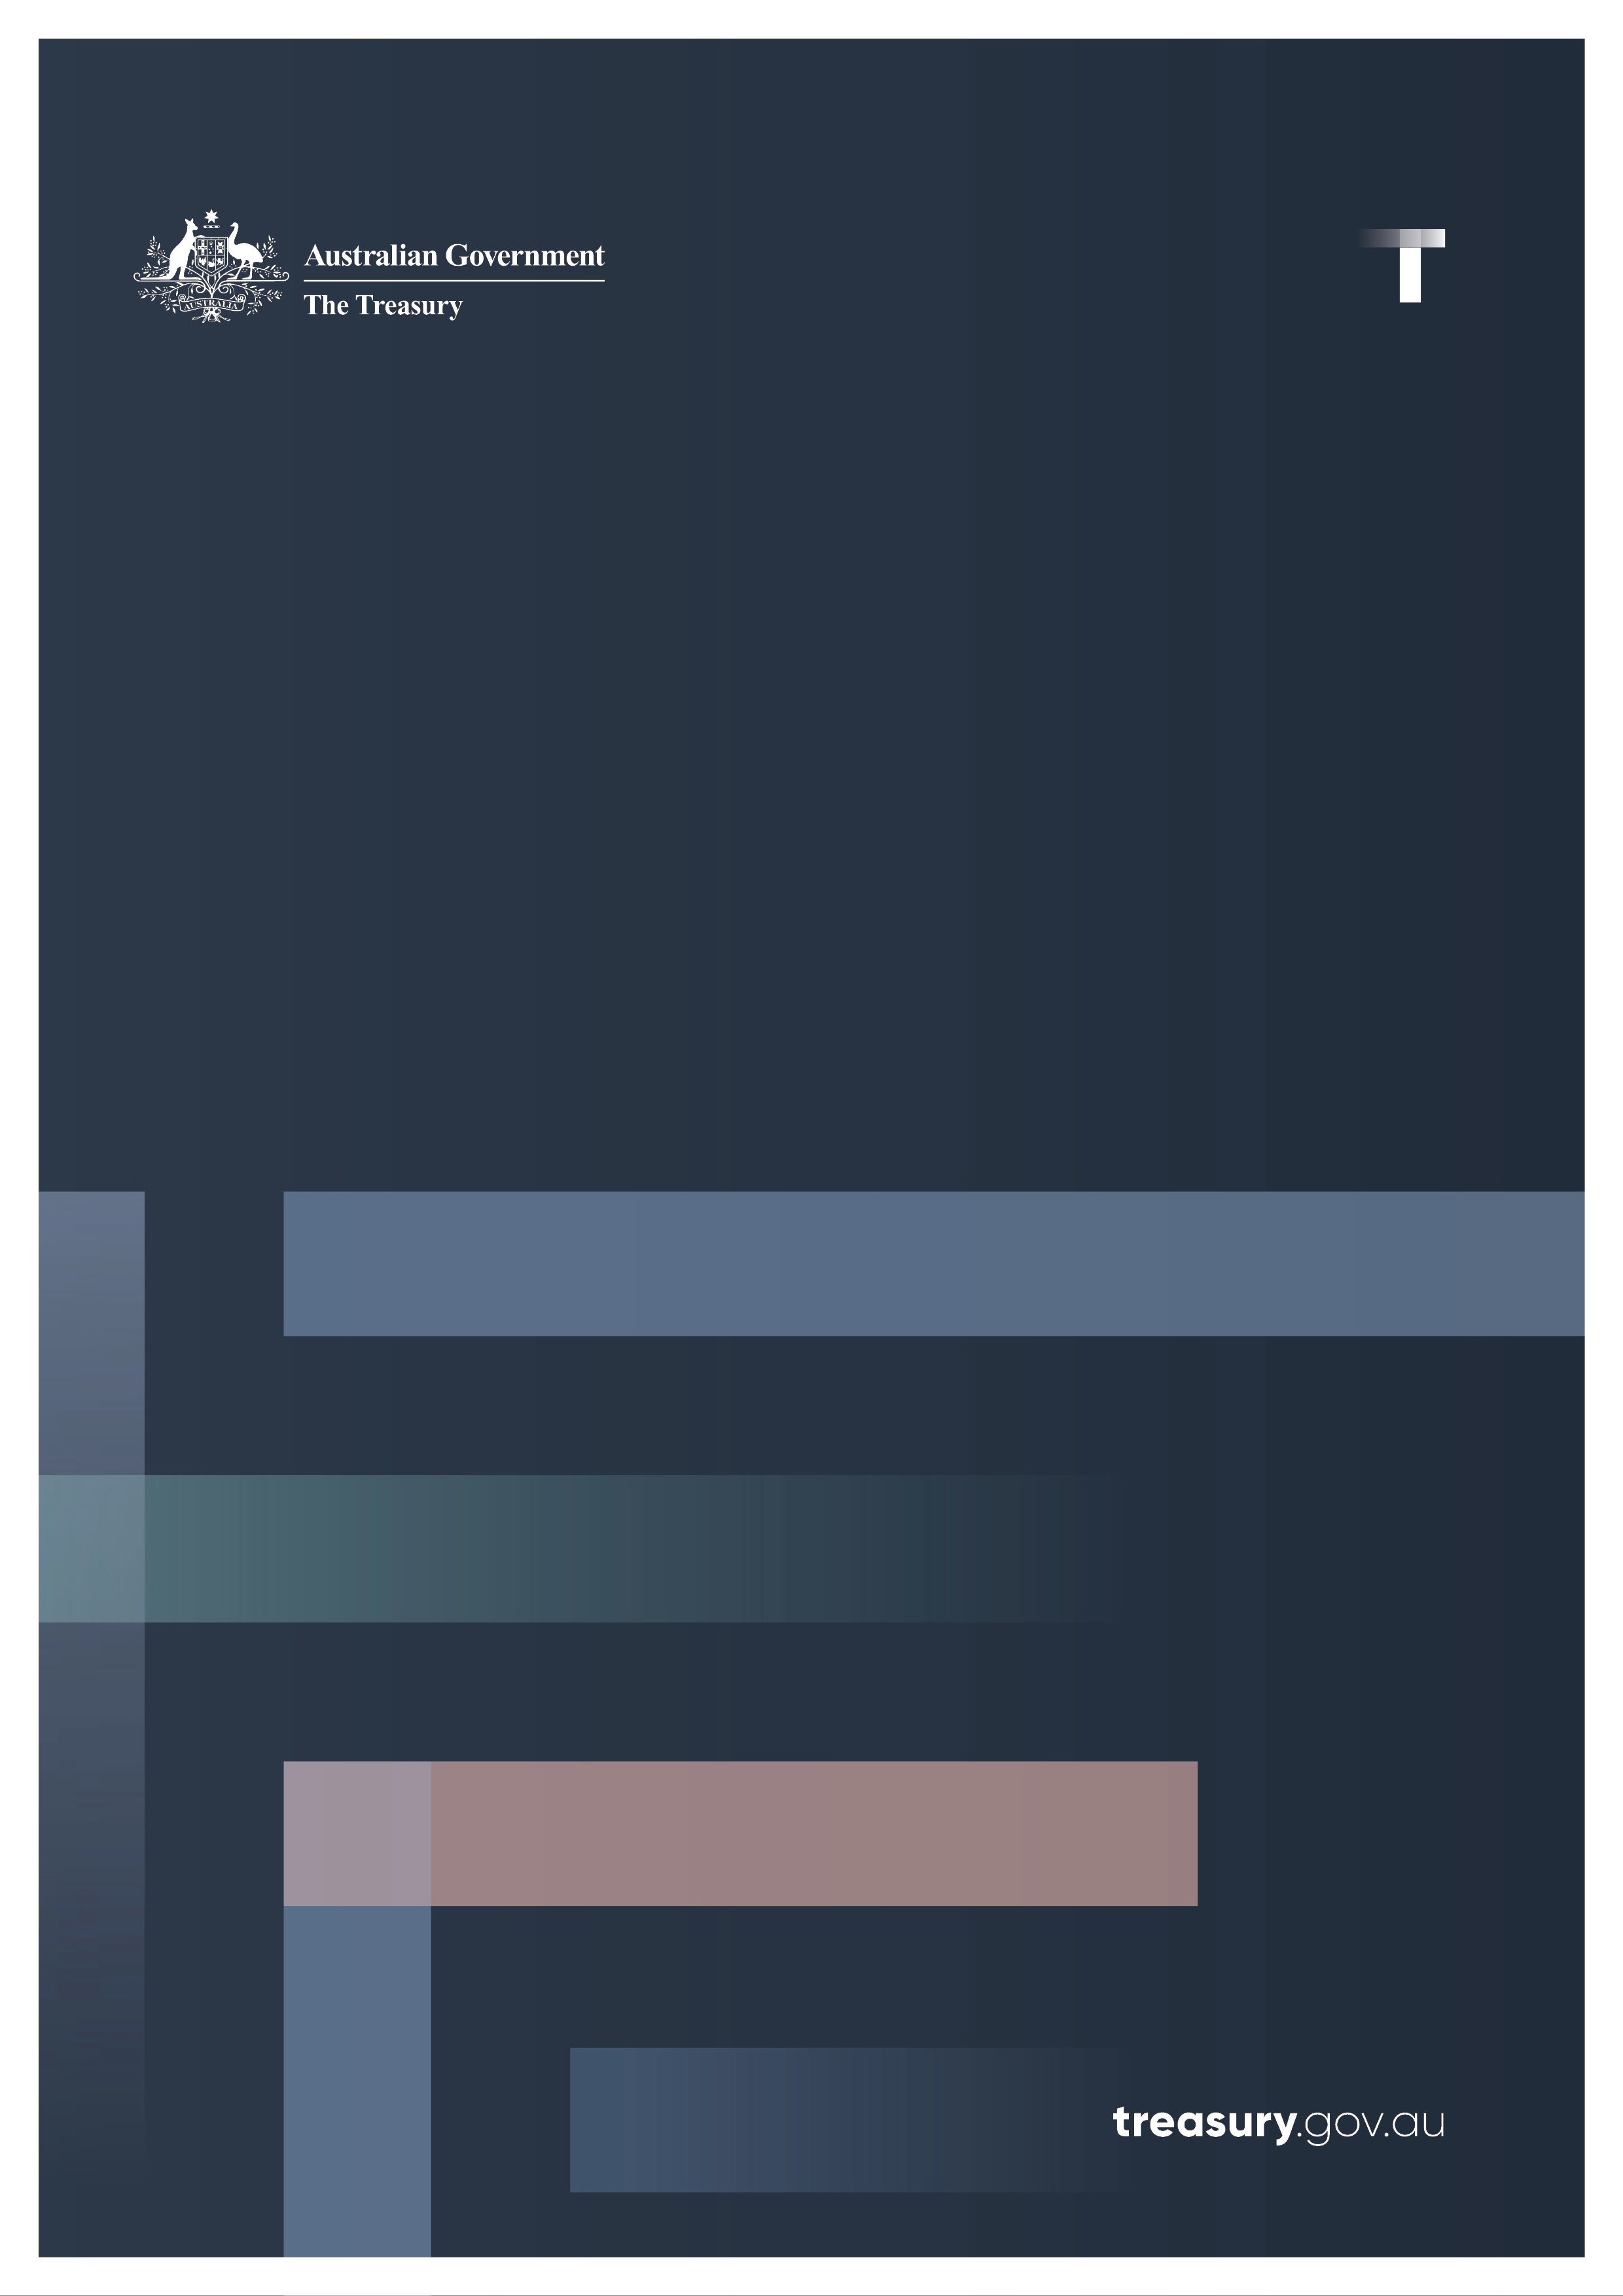

Small Business and Mental Health
  - Through the Pandemic
December 2022

© Commonwealth of Australia 2022
ISBN: 978-1-925832-62-4
This publication is available for your use under a Creative Commons Attribution 3.0 Australia licence, with the exception of the Commonwealth Coat of Arms, the Treasury logo, photographs, images, signatures and where otherwise stated. The full licence terms are available from http://creativecommons.org/licenses/by/3.0/au/legalcode.
Use of Treasury material under a Creative Commons Attribution 3.0 Australia licence requires you to attribute the work (but not in any way that suggests that the Treasury endorses you or your use of the work).
Treasury material used ‘as supplied’.
Provided you have not modified or transformed Treasury material in any way including, for example, by changing the Treasury text; calculating percentage changes; graphing or charting data; or deriving new statistics from published Treasury statistics – then Treasury prefers the following attribution:
Source: The Australian Government the Treasury.
Derivative material
If you have modified or transformed Treasury material, or derived new material from those of the Treasury in any way, then Treasury prefers the following attribution:
Based on The Australian Government the Treasury data.
Use of the Coat of Arms
The terms under which the Coat of Arms can be used are set out on the Department of the Prime Minister and Cabinet website (see http://www.pmc.gov.au/government/commonwealth-coat-arms).
Other uses
Enquiries regarding this licence and any other use of this document are welcome at:
Manager
Media Unit
The Treasury
Langton Crescent
Parkes ACT 2600
Email: media@treasury.gov.au

Contents
Key findings snapshot 1
Introduction 1
Background 2
Objectives 2
Methodology 3
Mental health and the small business sector 4
Small business owners continue to experience high rates of mental illness 4
Small business owners feel acute pressure to ‘do it all’ 6
Stigma about mental illness within the small business sector 7
Some small business owners recognise mental health as a workplace issue 9
Some small business owners feel more comfortable talking about mental illness since COVID-19 9
Balancing work, family and personal life is a key stressor for small business owners 10
Small business owners often turn to family first when concerned about business matters 13
Family often remains the key source of support for small business owners concerned about their mental health 15
‘Just deal with it’ is a common strategy for monitoring and maintaining mental health 18
Small business owners tend to prefer face-to-face or online support 18
Cost and lack of time remain key barriers to accessing support 19
Awareness of tailored small business mental health services remains low 20
Nearly a quarter of respondents feel they are missing out on mental health support 22
The impact of COVID-19 25
COVID-19 has affected the way small businesses operate 25
Some small businesses have had to cease operations 27
COVID-19 presented some small businesses with growth opportunities 27
COVID-19 has created new pressures and stresses for small business owners 29
Conclusion 30
Appendix A: Questionnaire 31
Quantitative questionnaire 31

Summary of charts and tables

Charts
Chart 1: Level of concern about own mental health by industry 6
Chart 2: Small business owner attitudes toward mental health 8
Chart 3: Stressors ranked by average score out of 10, 2022 Survey 10
Chart 4: Sources of support when feeling anxious or concerned about the business 13
Chart 5: Sources for support if anxious or concerned about business in 2020 and 2022 14
Chart 6: Sources of support when anxious or concerned about own mental health 15
Chart 7: Barriers to seeking help 19
Chart 8: Awareness of support services 20
Chart 9: Barriers to mental health support 22
Chart 10: In what way have you changed the way you operate? 25
Chart 11: Percentage of small businesses that changed the way they operate by state. 26
Chart 12: Small business growth opportunities 28

Tables
Table 1: Comparison between top 4 stressors in 2020 and 2022 surveys 12
Table 2: Sources of support if concerned about own mental health in 2020 and 2022 17
Table 3: Satisfaction with mental health support, 2020 and 2022 survey comparison 23

Key findings snapshot
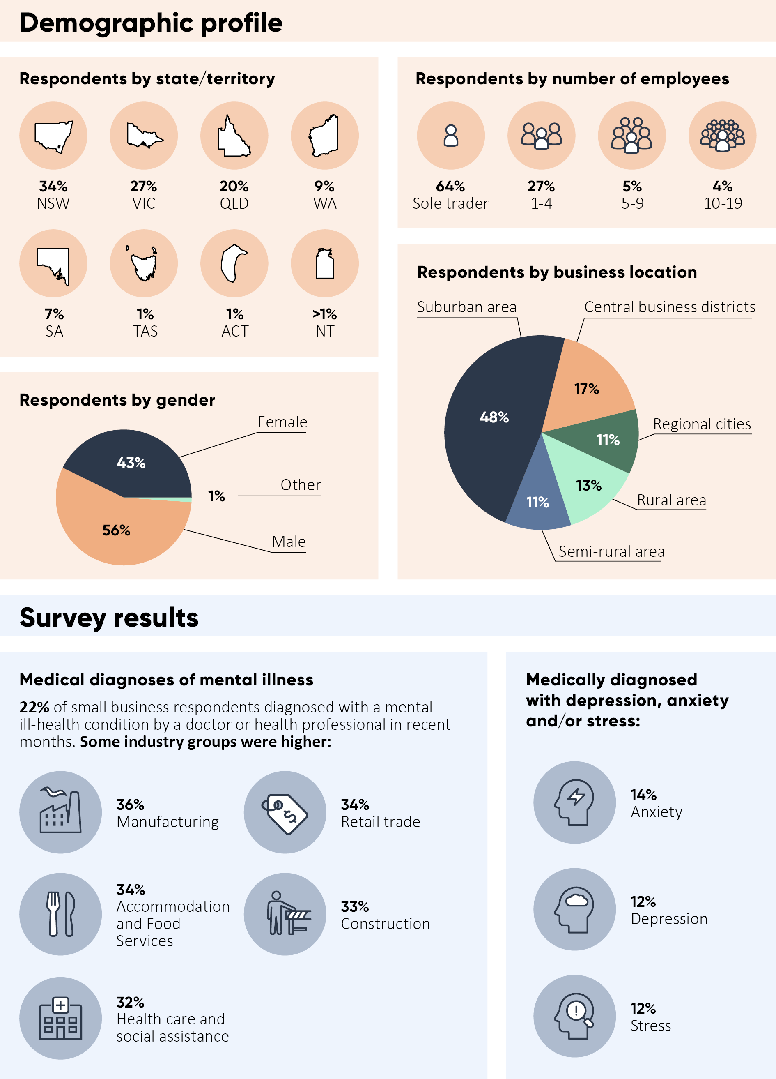
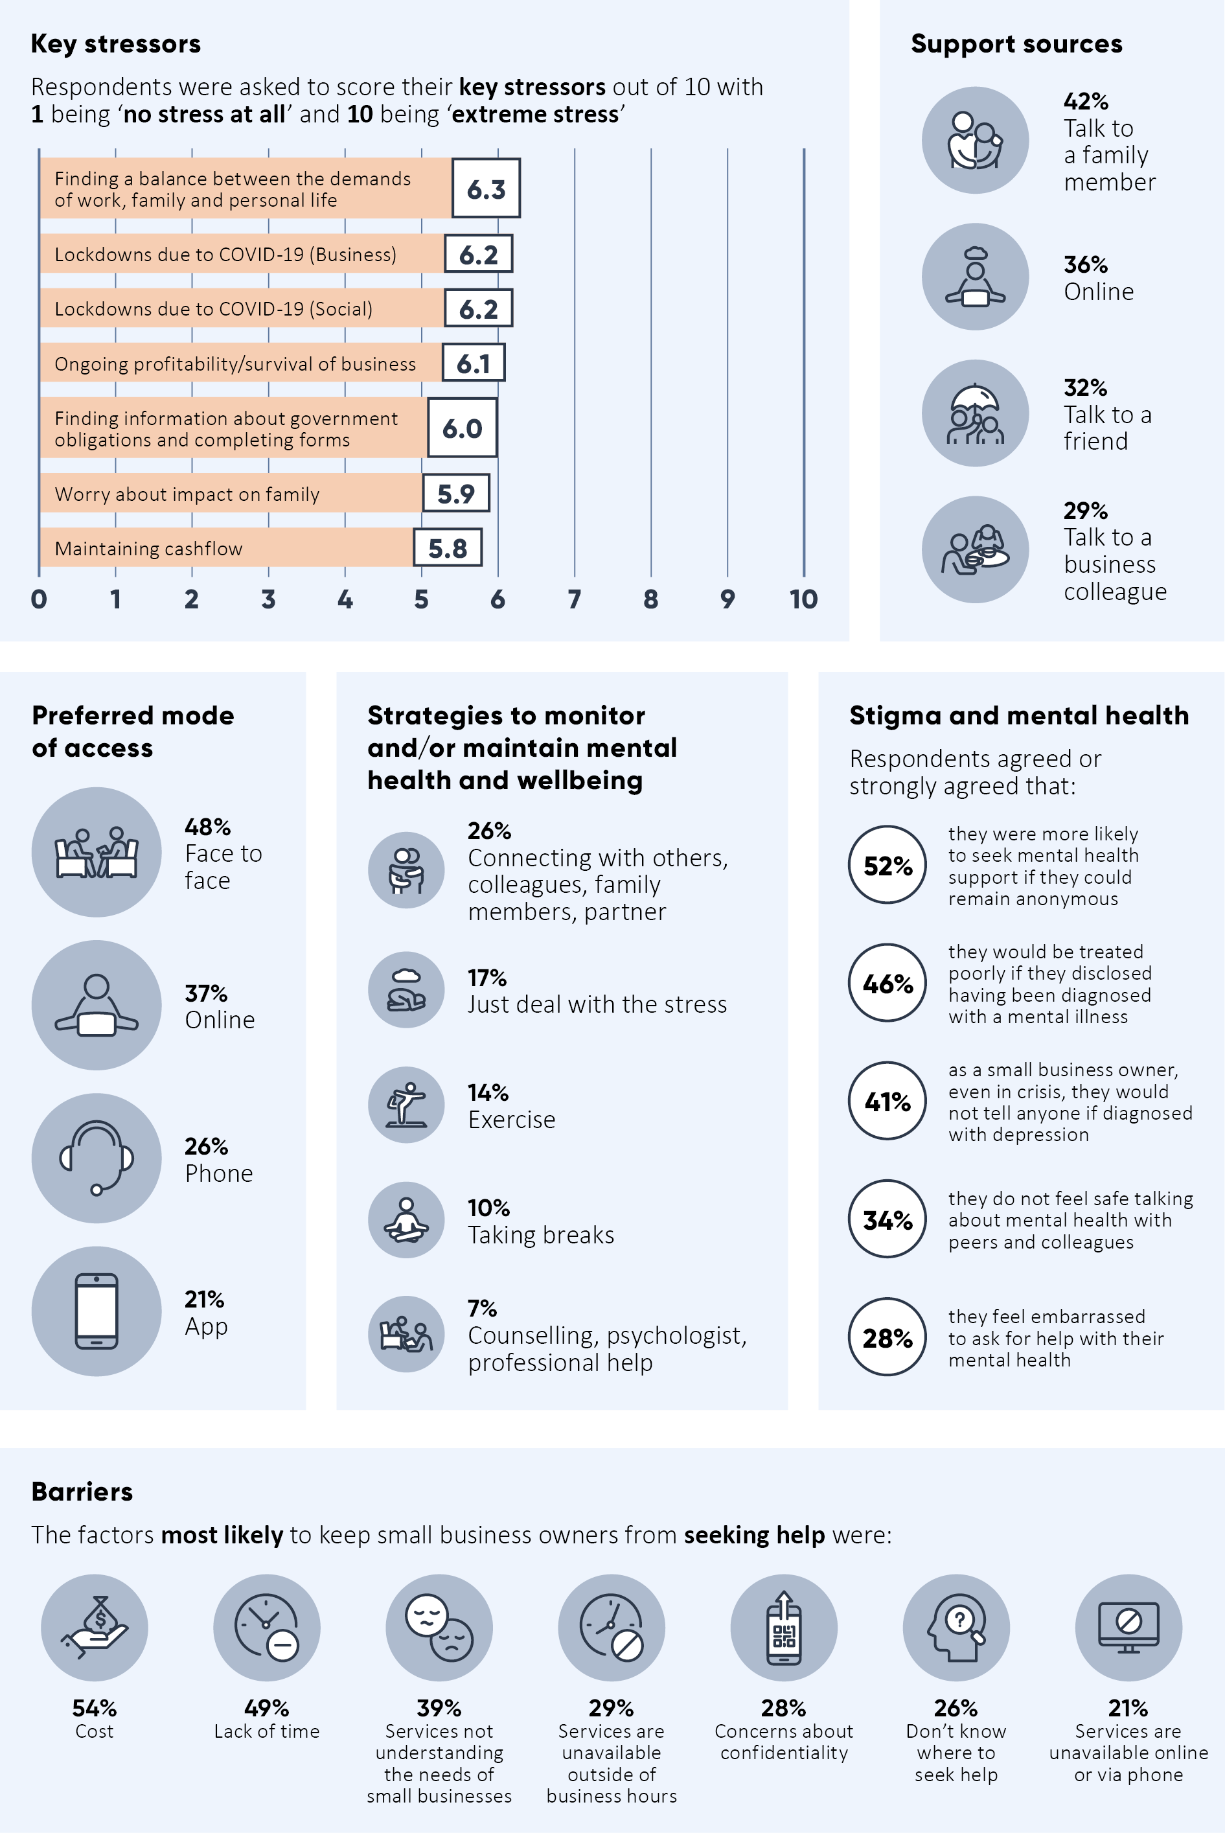

Introduction
The past two years have been tough for small business owners across Australia. Successive waves of COVID-19, compounded by a series of natural disasters and events, significantly impacted many in the small business sector.
The Australian Treasury contacted small business owners around Australia to find out how they and their businesses were faring, how their mental health was tracking, and what supports and services they needed.
This report is based on the findings of a survey conducted in January and February 2022 (the 2022 Survey) of 1,007 small business owners across Australia. The 2022 Survey built on an earlier survey conducted in April and May 2020 (the 2020 Survey) of 1,015 small business owners and 35 in-depth interviews with small business owners at the onset of the COVID-19 pandemic. The findings of the 2020 Survey were published in the report, Small Business Mental Health: Supporting Small Business when they are Facing Challenges.
Mental ill-health remains a key issue for small business owners and many of the findings identified in the 2020 Survey remain. Small business owners continue to face barriers to accessing support and lack effective strategies to monitor and maintain their mental health. This is despite increasing Government investment in tailored small business mental health supports. Stigma toward mental ill-health within the small business sector remains high. This stigma is likely to contribute to low rates of small business respondents seeking support from their doctor or other health professionals.
Interestingly, fewer small business respondents identified ‘a downturn in business’ as a significant stressor in the 2022 Survey compared with the 2020 Survey. The downturn-in-business stressor fell 20 percentage points, from 31 per cent in 2020 to 11 per cent in 2022. This aligns with other research showing concern about COVID-19 and its impacts remains, but the small business sector is optimistic about a gradual recovery – at least, at this point in time.
The 2020 Survey findings provided evidence to support the initial $7 million BusinessBalance initiative announced in the 2020–21 Budget that funded both NewAccess for Small Business Owners run by Beyond Blue and Counting on U run by Deakin University. The research has also been used by state and territory governments to guide policy development, by universities, small business mental health providers and small business peak bodies. Findings from this 2022 report supported the extension of the NewAccess for Small Business Owners program and the Small Business Debt Helpline for a further two years as announced in the 2022-23 Budget.

Background
Small businesses accounted for over 97 per cent of the 2.6 million Australian businesses in 2021-22. In 2020-21, they employed over 5 million people and generated around a third of private sector output, a $438 billion economic contribution.
The Australian Government is providing direct economic support to businesses and has co-operated with states and territories on a wide range of joint measures to assist small businesses. Despite this, the Australian Bureau of Statistics (ABS) Business Conditions and Sentiments Survey (June 2022) found almost a third of employing businesses were having trouble finding staff, were facing increased operating expenses, and more than 2 in 5 (41 per cent) were experiencing supply chain disruptions. The impact of the pandemic also varied widely across different industries, with accommodation and food services particularly affected by staffing issues.

Objectives
The primary objectives of this research project were to:
- determine the state of small business owners’ mental health and wellbeing
- identify key factors that affect small business owners’ mental health and wellbeing
- identify gaps in the provision of mental health supports
- inform effective and targeted policy development.

Methodology
A quantitative survey was determined to be the most appropriate method to collect primary data as the study needed to reflect the methods used in the 2020 Survey. The questionnaire consisted of attitudinal and behavioural questions and statements and allowed for open-ended verbatim responses.
A research protocol and plan were prepared by McNair yellowSquares and submitted for ethics approval. Ethics approval was granted by Bellberry Limited (Application No: 2021-11-1302). Data was collected via an online survey. The survey was conducted according to the specifications of the International Standard for Market and Social Research (ISO 20252).
The survey was conducted nationally over 6 weeks between 12 January 2022 and 24 February 2022. At this time, small business owners had faced repeated lockdowns, nationwide border restrictions, supply chain issues, labour shortages, price increases on raw materials and wholesale goods, and changing COVID-19 regulations.
The quantitative survey was conducted nationally among a representative sample of 1,007 small business owners, including in regional centres and regional and remote areas. The project aimed to engage with stakeholders from a range of industries, business sizes and diverse communities such as culturally and linguistically diverse (CALD) Australians and Indigenous small business owners.
McNair yellowSquares primary sample source was respondents to the 2020 Small Business and Mental Health: Supporting Small Business when they are Facing Challenges research who consented to be recontacted. McNair then supplemented the remaining sample with a purchased database of small business owners. The database was made up of businesses employing 19 or fewer people with an annual turnover between $70,000 and $10 million. The survey included adults aged 18 years and older.
McNair yellowSquares used quota sampling based on location and industry data from the latest ABS census (2016) to estimate numbers required by region and industry. Post-stratification weights were applied to adjust for different response rates by state and business size, and different response rates across the industry categories.
Results were tested for significance. The significance level for a given hypothesis test is a value for which a P-value less than or equal to is considered statistically significant.
Typical values tested are 0.1, 0.05, and 0.01. These values correspond to the probability of observing such an extreme value by chance. All tests in the current report were tested at 0.05 value. In other words, for a sample size of 1,000, at the 95 per cent confidence level, this corresponds to an approximate margin of error of +/- 1.8 per cent. To put it simply, the results are accurate to within approximately 2 percentage points, 95 times out of 100.
Where statistically significant results are mentioned, it is possible individual results for ‘very satisfied’ and ‘satisfied’ are not statistically significant but are statistically significant when combined.

Mental health and the small business sector

Small business owners continue to experience high rates of mental illness
Both the 2020 and 2022 surveys asked small business owners whether they had received a medical diagnosis of mental ill-health.
The 2022 Survey results indicate that small business owners continue to experience high levels of mental ill-health. Twenty-two per cent – just over 1 in 5 – small business respondents reported having been diagnosed with a mental ill-health condition by a doctor or health professional in recent months: 14 per cent reported an anxiety diagnosis; 12 per cent a diagnosis of depression; and 12 per cent were diagnosed with a stress-related problem (respondents could provide multiple responses).
Some sectors of the small business community reported a much higher proportion of medical diagnoses of mental ill-health. More than one-third of small business respondents from the manufacturing (36 per cent), retail trade (34 per cent), accommodation and food services (34 per cent) industries had received a medical diagnosis of mental ill-health. One-third of respondents in construction (33 per cent), and just under one-third of respondents in the health care and social assistance industries (32 per cent), also received a medical diagnosis of mental ill-health.
It is recognised that other industries such as arts and recreation services, education and training, public administration and safety, and information media and telecommunications gave indications of high to very high levels of medical diagnoses of mental ill-health, however, survey response rates were not high enough to include these findings.
Other categories with high proportions of mental ill-health diagnoses are:
- small businesses in South Australia (38 per cent)
- small businesses with employees:
  - 1 to 4 employees (28 per cent)
  - 5 to 8 employees (31 per cent), and
  - 9+ employees (28 per cent)
- small businesses in semi-rural areas (30 per cent)
- small businesses in the pre-profit stage (41 per cent)
- small businesses in the established but stressed stage (32 per cent)
- small businesses that have closed (29 per cent)
The overall proportion of small business respondents reporting a mental ill-health diagnosis between the 2020 and the 2022 surveys decreased 6 percentage points (from 28 per cent to 22 per cent).
These survey results may underrepresent the prevalence of mental ill-health conditions in the small business sector. It is worth noting that this survey specifically asked small business respondents to indicate whether they had had a medical diagnosis of mental ill-health, this differs from many other surveys that ask self-referencing questions about mental ill-health. The figure of 22 per cent of small business respondents with a mental ill-health diagnosis should therefore be considered in context. Of the 1,007 small business owners surveyed, 58 per cent said that they would not consider turning to a GP, psychologist, counsellor, or other mental health professional.

Survey insights: small business owners’ experience of mental illness
- My husband and I have both seen a doctor since the pandemic began. I have been diagnosed with anxiety and my husband also with depression.
- I have used a mental health plan via my GP. I use some of the tools taught to me to help maintain a level head from time to time.
- I have struggled with mental health in the past and when COVID hit, and lockdowns began, my mental health took a huge dive…
- COVID caused so much stress I now have severe depression.
Small business respondents were asked to indicate how concerned they were about their own mental health. Respondents gave an average score of 3.9 out of 10, indicating small business respondents did not have high levels of concern when it came to their own mental health. This aligns with the 2020 findings which also had an average concern of 3.9 out of 10.
For many industries, however, small business repondents’ concern about their own mental health was higher. Respondents in the administrative and support services, manufacturing, retail trade, other services, and accommodation and food service industries had higher levels of concern than the overall average, as did construction and financial and insurance services (as shown in Chart 1).

Chart 1: Level of concern about own mental health by industry

Source: Small Business Mental Health survey data, 2022. Weighted base n=1007; Small Business Mental Health survey data, 2020. Weighted base n=1015, only industries with sample sizes >35 included

Small business owners feel acute pressure to ‘do it all’
A strong theme emerged from small business respondents that they felt they needed to ‘do it all’. Small business respondents felt they had to keep up the appearance of being fine even when they were struggling with their mental health and wellbeing because others – family, business partners, employees, and suppliers – depended on them. As one respondent commented, ‘it all rests with me’.
Survey insights: it all rests with me
- It is difficult to burden my family and friends who have their own different stressors, such as home schooling, loss of work, illness. Need to have a positive attitude for staff and customers even when exhausted. There is limited physical support available.
- I am the only one to keep the business running so all of the stress is on me and no time for anything else.
- Our company has consistently reduced its production runs over the past year and reduced overheads by subletting factory space, leaving it a very lean structure which leaves little time to address non-profit issues.

Stigma about mental illness within the small business sector
The 2022 Survey indicates that stigma about mental illness remains a key issue in the small business sector. Fifty-two per cent of small business respondents ‘agreed’ or ‘strongly agreed’ they were more likely to seek mental health support if they could remain anonymous. Forty-six per cent of small business respondents ‘agreed’ or ‘strongly agreed’ they would be treated poorly if they disclosed being diagnosed with a mental illness.
Forty one per cent of small business respondents ‘agreed’ or ‘strongly agreed’ with the statement ‘as a small business owner, even in crisis, I would not tell anyone if I had been diagnosed with depression’. More than one in three small business respondents (34 per cent) ‘disagreed’ or ‘strongly disagreed’ with the statement ‘I feel safe talking about my mental health with peers and colleagues’. More than a quarter of small business respondents (28 per cent) reported feeling embarrassed to ask for help with their mental health.
As indicated in Chart 2 (below), there has been an overall improvement in attitudes to mental health between small business respondents over the last 2 years. The proportion of small business respondents who reported feeling comfortable talking about their mental health increased by 10 percentage points between 2020 and 2022 (from 27 per cent to 37 per cent).
Furthermore, fewer small business respondents felt the need to remain anonymous, slightly fewer felt embarrassed to ask for mental health support, and more small business respondents indicated they felt safe discussing their mental health with colleagues.

Chart 2: Small business owner attitudes toward mental health

Source: Small Business Mental Health survey data, 2022. Weighted base n=1007; Small Business Mental Health survey data, 2020. Weighted base n=1015

While there are small but positive signs that small business attitudes to mental ill-health are gradually changing, it is important to note that CALD small business owners’ responses differ.
Small business respondents who are CALD were more concerned with the stigma associated with mental ill-health than those from a non-CALD small business background. For example, only 17 per cent of CALD small business respondents feel safe discussing their mental ill-health concerns with peers and work colleagues, compared with 36 per cent from a non-CALD background.

Some small business owners recognise mental health as a workplace issue
Small business respondents appeared more accepting of their colleagues’ or employees’ mental ill-health status than they were of their own – a finding consistent with the results of the 2020 Survey.
Findings suggest that mental ill-health status remains a considerable barrier to employment in the small business sector. Twelve per cent of small business respondents agreed with the statement: ‘I would not want to work with someone if I knew they had been diagnosed with a mental illness.’ This figure has barely moved over the two-year period between surveys (13 per cent in 2020). While, fortunately, this percentage is low, it clearly shows that stigma around mental illness is still a key issue in the workplace.

Some small business owners feel more comfortable talking about mental illness since COVID-19
COVID-19 has increased public discourse around mental health issues, raised awareness and increased crucial services. The 2022 Survey found 37 per cent of respondents felt more comfortable talking about their mental health since the COVID-19 pandemic.
Small business respondents most comfortable talking about mental health since COVID-19 were:
- those with 5 to 8 employees (58 per cent)
- those with 9+ employees (56 per cent)
- those in the 18 to 39-year age bracket (48 per cent).
Those least comfortable talking about mental health since COVID-19 were:
- small businesses with 1 to 4 employees (31 per cent)
- sole traders (36 per cent).

Survey insights: attitudes to mental health
- I think mental health and wellbeing is really important. You can’t be successful in business if you aren’t thinking with a clear and focused mind. To be successful, you must see your vision clearly, so it is important to monitor your mental health.
- I am 100 per cent focused on my business right now. I don’t have time for the warm and fuzzies.
- I haven’t always had a good work/life balance but have found it increasingly important to do it in the last few years and now guard it fiercely.
- …[I] have not prioritised mental health, [I] always just get on with the job.

Balancing work, family and personal life is a key stressor for small business owners
We asked small business owners to rank their stress levels across 17 different areas (see Chart 3). Stressors were ranked on a scale from 1 to 10. Small business owner respondents reported their biggest stressor was finding a balance between the demands of work, family, and personal life – giving this stressor an average score of 6.3/10.

Chart 3: Stressors ranked by average score out of 10, 2022 Survey

Note: The arrows indicate where a response was significantly above or below average. Source: Small Business Mental Health survey data, 2022. Weighted base n=1007

Respondents who work in the health care and social assistance industry and manufacturing rated higher levels of stress on this measure (both 7.6/10).
Notably, small business respondents from Western Australia reported a significantly lower average level of stress in finding a balance between work, family, and personal life (4.7/10), than their counterparts in Victoria, New South Wales, Queensland and South Australia (who averaged 6.4, 6.4, 6.4 and 6.7/10 respectively).
Those living in rural areas (4.9/10) were less stressed about finding a balance between work, family, and personal life than those in central business districts (6.6/10), suburban areas (6.6/10), semi-rural areas (6.6/10) or regional cities (6.0/10).
The business cycle is an important factor in the overall impact on the mental ill-health of small businesses. Small business respondents most stressed about finding a balance between work, family and personal life were in the established but stressed business category (7.3/10), and the declining business category (7.3/10). Least stressed about this measure were small business respondents in the established and stable category (5.3/10).
CALD small business respondents were also more likely than those from a non-CALD background to find balancing the demands of work, family, and personal life stressful. CALD respondents gave this stressor an average score of 6.7/10 compared to 6.2/10 for non-CALD respondents.
Looking at the stressors more generally, the manufacturing sector had the highest scores across the industries for many of the other stressors, including:
- Ongoing profitability/survival of business 7.5/10
- Maintaining cashflow 7.1/10
- Worry about impact on family 7.1/10
- Receiving payments on time 7.0/10
- Difficulties accessing Government information and small business support such as JobKeeper, and COVID-19 financial assistance 6.9/10.
- Accessing/securing, or maintaining affordable finance 6.7/10
- Developing knowledge and skills to operate your business in a changing business environment 6.6/10
- Worry about impact on others (e.g. friends, community members, employees etc.) 6.0/10
CALD small business respondents rated their stress levels higher than average than those from a non-CALD background for 15 out of the 17 potential stressors that were put to them. They found lockdowns particularly hard.
The biggest difference from a gender perspective was accessing/securing or maintaining affordable finance. Female small business respondents were more stressed in relation to this stressor (5.7/10) than males (4.9/10).
The main stressor for small business respondents changed between the 2020 and 2022 surveys. In the 2020 Survey respondents indicated their main stressor was ongoing profitability and survival of their business (6.6/10). In 2022, the main stressor was finding a balance between the demands of work, family, and personal life (6.3/10).
Another important change between the 2020 and 2022 survey findings was a dramatic decrease in concern about the downturn in business. It fell 20 percentage points, from 31 per cent in the 2020 Survey to 11 per cent in the 2022 Survey.
Other changes worth noting are:
- decreased concern about economic and financial uncertainty – a drop of 13 percentage points (from 19 per cent to 6 per cent)
- decreased concern about future recovery – a drop of 5 percentage points (from 9 per cent to 4 per cent)
- decreased concern about health and wellbeing – a drop of 5 percentage points (from 9 per cent to 4 per cent)
- decreased concern about changing work conditions, working from home, no face-to-face – a drop of 5 percentage points (from 9 per cent to 4 per cent).
- increased concern about government restrictions on trade and regulations on business activity – an increase of 9 percentage points (from 2 per cent to 11 per cent)
- increased concern about COVID-19 – an increase of 4 percentage points (from 3 per cent up to 7 per cent).

Table 1: Comparison between top 4 stressors in 2020 and 2022 surveys
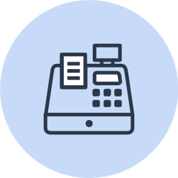 | Top stressors: 2020 Survey  - Ongoing profitability or survival of the business (6.9/10)  - Maintaining cash flow (6.6/10)  - Attracting and/or retaining customers (6.6/10)  - Worry about impact on family (6.6/10)
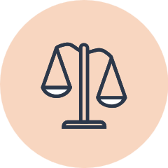 | Top stressors: 2022 Survey  - Finding a balance between the demands of work, family, and personal life (6.3/10)  - Lockdowns due to COVID-19 (business impact) (6.2/10)  - Lockdowns due to COVID-19 (social impact) (6.2/10)  - Ongoing profitability/survival of business (6.1/10)
Note: The measures ‘lockdowns due to COVID-19 (business impact)’ and ‘lockdowns due to COVID-19 (social impact)’ were not included among the available list of stressors in the 2020 Survey.
Source: Small Business Mental Health survey data, 2022. Weighted base n=1007; Small Business Mental Health survey data, 2020. Weighted base n=1015

Small business owners often turn to family first when concerned about business matters
Small business respondents are still turning to family for support, with 42 per cent turning to family ‘often’ or ‘on most occasions’ when anxious and concerned about their business. This compares with 45 per cent of respondents who indicated they turn to family ‘often’ or ‘on most occasions’ for support in the 2020 Survey. Interestingly just over half of female small business respondents (51 per cent) reported turning to a family member when concerned about their business – more so than male small business respondents at 35 per cent.

Chart 4: Sources of support when feeling anxious or concerned about the business

Note: The arrows indicate where a significantly higher or lower response rate occurred. Source: Small Business Mental Health survey data, 2022. Weighted base n=1007

After family, 36 per cent of small business respondents to the 2022 Survey ‘often’ or ‘on most occasions’ conducted research online when anxious or concerned about their business. The third most common source of support for small business respondents was talking to a friend (32 per cent).
The responses to the overall results were different for CALD small business respondents who were less likely to turn to family (31 per cent) than those from non-CALD small business backgrounds. They were also more likely to talk to their supplier about their concerns (29 per cent), compared with those from a non-CALD background (18 per cent).
Survey findings also suggest that small business respondents prefer to seek support from those with an understanding of what it is like to run a small business. One respondent, for example, commented that ‘it is easier to talk to my partner than a health provider as she is intimately aware of my business and its stresses.’ Another commented: ‘We don’t feel like a business or an organisation because we don’t employ anyone other than ourselves and we simply see the business as a job to earn income for our family. It is simply an extension of our marriage, and we deal with everything in house.’
Accountants remain an important source of support, with almost one in 5 small business respondents (18 per cent) turning to an accountant when they are feeling anxious or concerned about their business. However, there has been a drop of 7 percentage points between the 2020 and 2022 surveys in the proportion of small business respondents seeking support from their accountant when feeling anxious or concerned about their business (down from 25 per cent in 2020).

Chart 5: Sources for support if anxious or concerned about business in 2020 and 2022

Source: Small Business Mental Health survey data, 2022. Weighted base n=1007; Small Business Mental Health survey data, 2020. Weighted base n=1015

Family often remains the key source of support for small business owners concerned about their mental health
Overall, small business respondents are most likely to look for information or support when concerned about their mental health from family (34 per cent), from friends (24 per cent), online (21 per cent) and from their GP (19 per cent).
Twice as many female small business respondents (30 per cent) go online for information or support when concerned about mental health compared to their male counterparts (15 per cent). Female small business respondents are also more likely than their male counterparts to turn to family – 42 per cent compared to 29 per cent.
For CALD small business respondents 23 per cent say they go to family, 16 per cent to a friend, but 24 per cent would go online when concerned about their mental health. Only 5 per cent of CALD small business respondents would turn to their GP and only 6 per cent would turn to a psychologist.

Chart 6: Sources of support when anxious or concerned about own mental health

Source: Small Business Mental Health survey data, 2022. Weighted base n=1007

The findings indicate that many of the small business owners surveyed would not turn to some of the key, front line, mental health support services if they were concerned about their own mental health and wellbeing. For example:
- 87 per cent indicated that they would ‘never’ or only ‘on rare occasions’ seek support from a support line
- 85 per cent indicated that they would ‘never’ or only ‘on rare occasions’ seek support from a chemist
- 80 per cent indicated that they would ‘never’ or only ‘on rare occasions’ seek support from a counsellor
- 80 per cent indicated that they would ‘never’ or only ‘on rare occasions’ seek support from a mental health professional (not including a psychologist, counsellor, or GP)
- 79 per cent indicated that they would ‘never’ or only ‘on rare occasions’ seek support from a smart phone app
- 78 per cent indicated that they would ‘never’ or only ‘on rare occasions’ seek support from a psychologist
- 53 per cent, or over half, indicated that they would ‘never’ or only ‘on rare occasions’ seek support from a GP.
Despite the above results, there does appear to be a shift over the last 2 years in small business respondents’ willingness to seek support from a range of sources, as shown in Table 2. Notably, the percentage of small business respondents seeking support from a psychologist has doubled in 2 years (from 6 per cent to 12 per cent).

Table 2: Sources of support if concerned about own mental health in 2020 and 2022
Source of support | ‘Agree’ or ‘Strongly Agree’ 2020 | ‘Agree’ or ‘Strongly Agree’ 2022 | Percentage point change
Family | 32% | 34% | ↑2
Friend/s | 21% | 24% | ↑3
Online | 16% | 21% | ↑5
GP | 13% | 19% | ↑6
Psychologist | 6% | 12% | ↑6
Peer network | 7% | 10% | ↑3
Counsellor | 3% | 6% | ↑3
Other mental health professional | 2% | 5% | ↑3
Smart Phone App | 5% | 5% | N/A
Chemist | 3% | 3% | N/A
Support Line | 3% | 3% | N/A
Religious leader | 3% | 3% | N/A
Source: Small Business Mental Health survey data, 2022. Weighted base n=1007; Small Business Mental Health survey data, 2020. Weighted base n=1015

‘Just deal with it’ is a common strategy for monitoring and maintaining mental health
Just over a quarter (26 per cent) of small business respondents choose to connect with colleagues, family members or a partner as their strategy to monitor and maintain their mental health. The next most common strategy was to exercise (14 per cent).
Twenty-two per cent of small business respondents had no strategy in place to monitor and maintain their mental health, and 17 per cent indicated that their strategy was to ‘just deal with it’.
Of those small business respondents who ‘just deal’ with the stress, more are male (64 per cent) than female (36 per cent).
Of the small business respondents who said they had ‘no stress’, 85 per cent were male and 15 per cent were female.

Survey insights: strategies for monitoring and maintaining mental health
- When I feel anxious or concerned, I usually talk to someone I trust. Those include my friends and family. They are supportive whenever I need them.
- I speak with a counsellor each week to help manage my mental health and keep calm. I have also limited time in the office with more hours working from home to balance family life.
- I am very good at communicating and am fortunate enough to be surrounded by excellent people. I have found my accountants and senior work colleagues have been incredibly supportive and have certainly helped me navigate this situation.
- I did not [have strategies] until I experienced suicidal depression. Only then did I access support.
- This is a ridiculous concern when it comes to being a business owner. Mental health is probably the last thing on the priority list when you have to keep the business afloat. I just want to sit in silence if I’m stressed about the business.

Small business owners tend to prefer face-to-face or online support
Face-to-face is still the preferred mode of access to support for small business owners in 2022. Almost half of all small business respondents like to access support face-to-face (48 per cent). The 2020 Survey found just under half (47 per cent) of participants rated a face-to-face method of accessing information services as most favourable.
This compares with 37 per cent of respondents who would prefer to access support online, 26 per cent who would prefer to access support via phone and 21 per cent who prefer to access support via an app. Respondents could select multiple responses when identifying their preferences for accessing support.
The findings indicate that age plays a part in preferences. Small business respondents aged 65 years or more, were much more likely to prefer to access face-to-face support, while small business respondents aged 18 to 39 years were much less likely to prefer face-to-face contact.

Cost and lack of time remain key barriers to accessing support
There are several barriers to small business owners accessing support. Respondents were asked which of the following (outline in Chart 7 below) would prevent them from seeking help. The factors most likely to prevent them from seeking help were:
- cost (54 per cent)
- lack of time (49 per cent)
- services not understanding the needs of small business (39 per cent).

Chart 7: Barriers to seeking help

Source: Small Business Mental Health survey data, 2022. Weighted base n=1007

Results from the 2022 Survey are very similar to the 2020 Survey with perceived cost being the number one barrier (54 per cent for both surveys). Lack of time was cited by 49 per cent in the 2022 Survey, up from 46 per cent in the 2020 Survey. There is still a strong preference for support services that understand what it is like to run a small business. This is particularly so for small business respondents in regional cities (53 per cent).
Others find it a struggle to know where to look, or simply do not have the energy, time, or resources to search effectively. There is also the concern or embarrassment felt by small business owners if others find out they are seeking help.

Awareness of tailored small business mental health services remains low
Survey results indicate that while there is awareness within the small business sector of general mental health services, awareness of tailored small business mental health support services remains low.
Awareness of the following services by small business respondents:
- mental health support services, such as Head Space or Lifeline (70 per cent)
- Beyond Blue Heads Up (62 per cent)
- Australian Small Business and Family Enterprise Ombudsman (24 per cent)
- NewAccess for Small Business Owners mental health coaching (12 per cent)
- Counting on U mental health training (8 per cent)
- Everymind Ahead for Business (5 per cent)

Chart 8: Awareness of support services

Source: Small Business Mental Health survey data, 2022. Weighted base n=1007

Of the small business owners who participated in this survey, 87 per cent were unaware of NewAccess for Small Business Owners (NASBO). Only 1 per cent were aware and have accessed the NASBO service.
While 90 per cent of small business owners were unaware of the Counting on U program, this is not surprising, as this program is targeted at trusted small business advisors, such as accountants rather than small business owners generally.
Ninety-four per cent of respondents were unaware of Everymind’s Ahead for Business, while only 1 per cent were aware and had accessed this support service.
Survey insights: awareness of support services
- I didn’t even know there was mental health support specifically for small business owners.
- …no mental health support options were publicised widely.
- I didn’t even know there was support regarding mental health for business owners. When our incomes dropped I also couldn’t have afforded it.
- We live in the country. We heard all about government financial assistance, but I was unaware of mental health initiatives.

Tailored small business mental health and financial wellbeing support
NewAccess for Small Business Owners
The NewAccess for Small Business Owners (NASBO) program delivered by Beyond Blue, provides free, accessible, and tailored coaching to help small business owners manage the pressures associated with owning a business.
https://www.beyondblue.org.au/get-support/newaccess/newaccess-for-small-business-owners
Counting on U
Counting on U is a free program delivered by Deakin University which builds the mental health literacy of trusted business advisers such as accountants and bookkeepers and integrates mental health first aid training with a relationship centred business mentoring approach.
https://blogs.deakin.edu.au/counting-on-u/
Ahead for Business
Ahead for Business program delivered by Everymind provides a bespoke digital hub designed to promote the wellbeing of small business owners.
https://aheadforbusiness.org.au/
Small Business Debt Helpline
The Small Business Debt Helpline (SBDH) delivered by Financial Counselling Australia, is a free and confidential national phone-based financial counselling service for small business owners. Support includes advice on avoiding bankruptcy, negotiating payment plans, debt waivers, grant applications and insolvency.
https://sbdh.org.au/

Nearly a quarter of respondents feel they are missing out on mental health support
There is still an issue around cost, location, accessibility and finding information about mental health support.
While just over half of small business respondents felt that mental health services were available to them (57 per cent), many thought information about mental health support services difficult to find and access, and they felt that costs were not affordable.
- 29 per cent agreed or strongly agreed that it was difficult to find information about mental health support services available to small business owners with 12 per cent unsure
- 26 per cent agreed or strongly agreed that it is difficult to access mental health support services available to small business owners with 18 per cent unsure
- Only 27 per cent agreed or strongly agreed that costs associated with mental health support services are affordable, with 17 per cent unsure, leaving a large proportion of small business respondents feeling that these services are not affordable.

Chart 9: Barriers to mental health support

Source: Small Business Mental Health survey data, 2022. Weighted base n=1007

Overall, small business respondents rated their satisfaction levels with mental health support during the COVID-19 pandemic at 5.5/10.
As shown in Table 3, there is a perception among small business respondents that mental health services are not easily accessible. It is interesting to note that between 2020 and 2022, there has been a 10 per cent drop in respondents who ‘agreed’ or ‘strongly agreed’ that ‘mental health support services are accessible to me’.

Table 3: Satisfaction with mental health support, 2020 and 2022 survey comparison
Indicator | ‘Agree’ or ‘Strongly Agree’ 2020 | ‘Agree’ or ‘Strongly Agree’ 2022 | Percentage point change
Mental health support services are accessible to me | 67% | 57% | ↓10
Costs associated with mental health services are affordable | 25% | 27% | ↑2
Mental health support services are conveniently located or accessible online | 44% | 37% | ↓7
It is difficult to access mental health support services available to small business owners | 22% | 26% | ↑4
It is difficult to find information about mental health support services available to small business owners | 29% | 29% | N/A
Source: Small Business Mental Health survey data, 2022. Weighted base n=1007; Small Business Mental Health survey data, 2020. Weighted base n=1015

CALD small business respondents were more likely to think mental health services and supports were not accessible, not affordable, not convenient, and difficult to access than non-CALD small business respondents.
- Only 27 per cent of CALD small business respondents agreed, or strongly agreed, that mental health support services were accessible to them. This compared with 61 per cent from a non-CALD small business background. This indicates that 73 per cent of CALD small business respondents do not feel mental health support is accessible.
- Only 9 per cent of those from a CALD small business background agreed, or strongly agreed, that mental health support services were affordable. This compared with 30 per cent among non-CALD small business respondents.
- Only 20 per cent of CALD small business respondents agreed that mental health support services were conveniently located or easily accessible. This compared with 39 per cent of small business respondents from a non-CALD background.
Female small business respondents (61 per cent) were more concerned about the potential cost associated with seeking help than male small business respondents (40 per cent).
There were mixed responses to questions about a gap in mental health support for small businesses – some said no, many said they were unsure or did not know, while others were obviously desperate for help. The respondents also outlined some of the difficulties they faced trying to access help.

Survey insights: accessing mental health support
- No one knows exactly what small business owners do, how busy we are and how little time we have to deal with feelings when we have more tangible problems in front of us. Mental health providers just give stupid platitudes like ‘you have to make time’ which is unhelpful to us so the whole experience becomes a waste of time.
- I didn’t even know there was mental health support specifically for small business owners.
- When you’re stretched thin to breaking point already the thought of looking for someone to talk to feels like more work that I don’t have time for. My business needs me working in it, not taking time away from it, as this would just be more stressful.
- I was unable to negotiate the paperwork involved as I was too anxious and depressed.

The impact of COVID-19

COVID-19 has affected the way small businesses operate
Of those small business owners who participated in the 2022 Survey, 90 per cent reported their businesses were still operational. Of those who participated in both the 2020 and 2022 surveys, 86 per cent were still in operation.
Thirty-seven per cent of respondents indicated that COVID-19 had caused them to change the way they operated. The main changes were:
- company operating online (31 per cent)
- working remotely (10 per cent)
- reducing employee shifts, and laying off employees (8 per cent)
- changed interactions with customers/clients including Zoom calls, contactless payments, contactless delivery (8 per cent)
- working with protective equipment, including enforcing use by staff and clients (8 per cent).

Chart 10: In what way have you changed the way you operate?

Source: Small Business Mental Health survey data, 2022. Weighted base n=1007

Other changes included:
- working from home, including cutting costs by closing commercial offices
- downsizing, including reducing staff, reducing staff hours, or reducing business hours
- changes to the delivery of goods and services, including pivoting to new markets or finding new customers and expanding services and products and introducing home delivery.
Respondents also identified several COVID-19-related impacts that changed the way they operated, including:
- supplying Personal Protective Equipment to staff
- additional cleaning costs
- COVID-19 testing for employees, including issues related to access to and cost of rapid antigen tests
- lost staffing hours due to COVID-19 isolation requirements
- keeping up with changing rules and regulations.
While small business respondents in each state and territory reported that they had made changes to the way they operate, the pandemic led more businesses to change in some states and territories than in others as outlined in Chart 11.

Chart 11: Percentage of small businesses that changed the way they operate by state.

Source: Small Business Mental Health survey data, 2022. Weighted base n=1007. An insufficient sample size was collected from the Northern Territory, the Australian Capital Territory and Tasmania to include.

Small businesses with the highest rate of change in operations were retail trade (53 per cent), rental, hiring and real estate services (48 per cent), and health care and social assistance (46 per cent).
Small businesses with more than 9 employees were more likely to change how they operated (52 per cent).

Some small businesses have had to cease operations
Ten per cent of small business respondents were no longer operating, with 13 per cent of sole traders no longer operating. Of the small businesses no longer operating 82 per cent closed their business permanently.

Survey insights: business closures due to COVID-19
- We have been totally decimated. We now have no staff and are currently unable to operate at all.
- …transitioning to winding up after 25 years.

COVID-19 presented some small businesses with growth opportunities
For some small business respondents, the pandemic provided opportunities for growth – 18 per cent of 2022 Survey respondents reported finding growth opportunities during the pandemic. This has remained steady compared to the 2020 Survey, in which 17 per cent of respondents said they had found some growth opportunities since the pandemic.
The biggest opportunity for growth was identified as online sales and services (30 per cent).
Survey insights: online sales and services
- New technology has allowed us to deal with more clients no matter where they live. More than 50 per cent of our clients do not live in our home state.
- A lot more people are looking for things online now, so we have been able to sell online with no contact.
Fifteen per cent indicated that they had found an opportunity to expand their client or customer base.
Survey insights: expanding client or customer base
- …more customers seem happier to support local businesses.
- [We are] getting our business known in local community and neighbouring communities.
- Because customers cannot travel, we have seen an increase in our customers and an increase in the demand for our services.
Eleven per cent of respondents had expanded their products or made changes to their services.
Survey insights: expanding products or changes to services
- We changed our product line.
- I found that many of my clients have appreciated the additional services that we have offered.
- [We found growth opportunities by] diversifying into other business streams that are outside the core business operations up until now.

Other growth opportunities included taking advantage of a strong market (when opportunities arose) and reviewing and adapting business strategies.
Small business respondents from a non-CALD small business background found more growth opportunities (20 per cent) compared with those from a CALD background (8 per cent).

Chart 12: Small business growth opportunities

Source: Small Business Mental Health survey data, 2022. Weighted base n=1007

COVID-19 has created new pressures and stresses for small business owners
Small business respondents were asked to identify their most significant stressor directly related to the COVID-19 pandemic with 19 stressors to choose from. This was to find out if COVID-19 had added to the stresses of being a small business owner, and if so, in what specific way. Almost all small businesses acknowledged a main stressor directly caused by COVID-19. Only 6 per cent said COVID-19 had not come with any additional stressors.
Key themes included isolation and social distancing (14 per cent), government restrictions on trade and regulations on business activity including international trade and travel (11 per cent), and a downturn in business (11 per cent). Other key themes that caused additional stress included:
- supply chain issues such as shipping delays, material shortages and increases in costs of materials
- issues directly relating to COVID-19 such as the fear of being infected, new variants, compliance (includes enforcing COVID-19 rules and being abused by customers), and changing restrictions
- the uncertainty that made running a business, and business planning, extremely difficult.
A significant finding in the ‘main stressor directly related to COVID-19’ question found that stress caused by a downturn in business was higher than expected for CALD small business respondents at 31 per cent – almost a third of CALD respondents. In contrast it was lower than expected among those from a non CALD small business background at only 7 per cent.

Survey insights: key stressors as a direct result of COVID-19
- Not able to afford staff due to low revenue impacted by people staying home and afraid to come out. Equally, being the business owner and working 100+ hour weeks and feeling exposed to catching the virus and falling ill. High rents from landlords are also stressing as it was almost impossible to meet that with reduced cashflow.
- Constant changing in rules, lockdowns, border closures created uncertainty in the event industry and made people very nervous about committing to in-person events due to financial losses.
- The constant changes… We don’t have enough resources, people are stressed, burnt out and completely exhausted at changing, changing constantly.

Conclusion
While there are many similarities between the 2020 and the 2022 surveys there are some important differences. The impact of the pandemic is affecting everything from supply chains to the delivery of services and products. It has created a new set of staffing issues and it has changed the relationships between small business owners and customers. In response, small businesses have developed numerous strategies to adapt including turning in large numbers to technology to ensure their survival, and moving their businesses partially, or even wholly, online.
Lockdowns too have been tough on small businesses, enforcing a new isolation and working from home conditions. A key small business stressor has shifted from ongoing profitability concerns and survival of the business in the 2020 Survey to the struggle to find a balance between the demands of work, family, and personal life in the 2022 Survey.
Despite everything, small businesses are resilient. At the time the 2022 Survey was conducted there was, overall, an increase in the underlying sense of optimism about future recovery and economic and financial uncertainty. This was despite more concern about COVID-19 and government restrictions on trade and business. Almost a fifth of small business respondents found growth opportunities in ways they never expected.
While there have been some positives throughout the pandemic. Since the 2020 Survey, more small business respondents are seeking support from family, more are looking online for support, and more are going to a GP or a mental health professional, there is still work to be done to help address the stigma associated with the need for mental health support. While COVID-19 has opened up conversations about mental health, change in attitudes towards mental ill-health is slow and most small business owners do not seem to feel comfortable discussing their concerns, particularly with professionals in the field.
While only a small percentage of small business respondents were aware of targeted and tailored small business mental health services, work is underway to increase awareness and increase take up of these services. Overcoming the stigma associated with seeking mental health support has an important role to play here.
There were some key differences between CALD and non-CALD small business owners. The 2022 Survey has shown that those from a CALD background do not necessarily think and act in the same ways as those from a non-CALD background.
There were also some key differences between genders. Men and women can have different approaches to thinking about mental health issues – many male small business owners tend to ‘just deal’ with it, while more female small business owners try to connect with others. Male and female small business owners differ in relation to who they talk to, how they maintain their wellbeing, how willing they are to talk about their mental ill-health, and how they seek help. The survey did not receive sufficient survey responses from those that do not identify as either male or female for any non-binary findings to be included in the report.
The 2022 Survey results, as compared with the 2020 Survey, indicate that small business owners are generally continuing to experience high levels of mental ill-health, with some industries and locations being particularly affected. While there have been inroads into improving small business owners’ mental health, and services have become more tailored, further nuancing of supports is needed to take account of the complexity of ways small business owners react to and interact with their environments; differences in approaches to mental health and wellbeing; and the diversity and richness of the small business community.

Appendix A: Questionnaire

Quantitative questionnaire
(10 – 12 minutes)
This survey is being conducted by McNair yellowSquares on behalf of the Australian Government Department of the Treasury.
This survey is looking at the stressors faced by small business owners, particularly during the COVID-19 pandemic. We are interested in what supports are useful, what supports are widely known about, and if there is a gap in supports for small business owners. This is a follow up to a survey sent out last year in April and May 2020 that collected data on small business owners supports and services available to support small business owners’ wellbeing at crisis points, such as the bushfires and COVID-19.
A copy of this report is available on the Treasury website: https://treasury.gov.au/publication/small-business-and-mental-health-supporting-small-business-when-they-are-facing
The information you provide will assist us to understand stressors on Australian small business and what effective supports are needed to provide future assistance.
The information you provide will be anonymous and confidential. Whether you choose to participate or not will in no way affect your business.
The survey will ask you a range of questions about your small business. It will also ask about the extent of impact on your business from COVID-19, including if and how you have to operate your business differently.
We understand that some of these questions may be difficult for you to answer but we value your direct input and appreciate your contribution at a time that is confronting for many people. The quality of this survey depends on participants from small business like you. We know that your time is valuable. The survey will take no more than 10 minutes.
Results of this survey will be made available.

A. Part one: qualifying questions
A.1. Are you a current or former business owner (including part owner)?
Yes -> proceed to Question 2.
No -> Pop-up text:
‘This survey is designed for current or former small business owners. As you do not currently or have not previously owned a business, this survey does not apply. Thank you for your time’. [END SURVEY]
A.2. Is/was your business a small business (i.e., employs/employed 19 or less people AND have an annual turnover between $70,000 and $10,000,000 in the most recent completed financial year)?
Yes -> proceed to PART TWO.
No -> Pop-up text:
‘This survey is designed for current or former small business owners. For the purposes of this survey, your business is not classified as ‘small’, and this survey does not apply to you. Thank you for your time.’ [END SURVEY]

B. Part two: small business stressors during the COVID-19 pandemic
B.1. Please rate the level of stress that you have experienced with the following issues related to owning a business (Single Response)

 | n/a | No stress at all |  |  |  |  |  | Extreme stress
Business A
Accessing/securing, or maintaining affordable finance | n/a | 1 | 2 | 3 | 4 | 5 | 6 | 7 | 8 | 9 | 10
Receiving payments on time | n/a | 1 | 2 | 3 | 4 | 5 | 6 | 7 | 8 | 9 | 10
Maintaining cashflow | n/a | 1 | 2 | 3 | 4 | 5 | 6 | 7 | 8 | 9 | 10
Ongoing profitability/survival of business | n/a | 1 | 2 | 3 | 4 | 5 | 6 | 7 | 8 | 9 | 10
Lockdowns due to COVID-19 | n/a | 1 | 2 | 3 | 4 | 5 | 6 | 7 | 8 | 9 | 10
Social B
Worry about impact on family | n/a | 1 | 2 | 3 | 4 | 5 | 6 | 7 | 8 | 9 | 10
Worry about impact on others (e.g., friends, community members, employees etc.) | n/a | 1 | 2 | 3 | 4 | 5 | 6 | 7 | 8 | 9 | 10
Finding a balance between the demands of work, family, and personal life | n/a | 1 | 2 | 3 | 4 | 5 | 6 | 7 | 8 | 9 | 10
Lockdowns due to COVID-19 | n/a | 1 | 2 | 3 | 4 | 5 | 6 | 7 | 8 | 9 | 10
Staffing issues C
Hiring, terminating and/or keeping employees | n/a | 1 | 2 | 3 | 4 | 5 | 6 | 7 | 8 | 9 | 10
finding/applying the correct awards/conditions | n/a | 1 | 2 | 3 | 4 | 5 | 6 | 7 | 8 | 9 | 10
managing interpersonal issues and performance | n/a | 1 | 2 | 3 | 4 | 5 | 6 | 7 | 8 | 9 | 10
Looking after staff during COVID-19 | n/a | 1 | 2 | 3 | 4 | 5 | 6 | 7 | 8 | 9 | 10
Government Requirements D
Finding information about government obligations and completing forms | n/a | 1 | 2 | 3 | 4 | 5 | 6 | 7 | 8 | 9 | 10
Skills Development and Accessing Assistance E
Developing knowledge and skills to operate your business in a changing business environment | n/a | 1 | 2 | 3 | 4 | 5 | 6 | 7 | 8 | 9 | 10
Difficulties accessing professional business assistance (e.g., accountant, financial adviser, bank manager, business coaches, etc). | n/a | 1 | 2 | 3 | 4 | 5 | 6 | 7 | 8 | 9 | 10
Difficulties accessing Government information and small business support such as JobKeeper, and COVID-19 financial assistance | n/a | 1 | 2 | 3 | 4 | 5 | 6 | 7 | 8 | 9 | 10
Other
Other (please specify) | n/a | 1 | 2 | 3 | 4 | 5 | 6 | 7 | 8 | 9 | 10

Thinking about how your business has been affected by the recent challenging times brought on by the COVID-19 pandemic, please answer the following questions.
B.2. Is your business still operating?
a. Yes
b. No
B.3. If NO (Code b in B.2.), Is your business closed permanently or temporarily?
a. Permanently (Go to B.8)
b. Temporarily (Go to B.8)
B.4. If YES (Code a in B.2.), Have you changed the way you operate?
a. Yes
b. No
B.5. If YES (Code a in B.4.), In what way have you changed the way you operate? (Open Box)
B.6. Have you found any growth opportunities?
a. Yes
b. No
B.7. If YES (Code a in B.6.), What are these growth opportunities? (Open Box)
B.8. What has been the main stressor directly related to the COVID-19 pandemic? (Open Box)

C. Part three: current resources
C.1. How often do you do the following when you are anxious and concerned about your business?
 | Never | In Rare Occasions | On Some Occasions | Often | On Most Occasions
Talk to a family member | 1 | 2 | 3 | 4 | 5
Do research online | 1 | 2 | 3 | 4 | 5
Seek advice from an accountant | 1 | 2 | 3 | 4 | 5
Research learning and development options to adapt to changing business conditions | 1 | 2 | 3 | 4 | 5
Talk to a business colleague | 1 | 2 | 3 | 4 | 5
Talk to a friend | 1 | 2 | 3 | 4 | 5
Talk to a supplier / trading partner | 1 | 2 | 3 | 4 | 5
C.2. Do you have strategies in place to monitor and/or maintain your mental health and wellbeing during the times you are feeling anxious and concerned? (For example, talking about your feelings, being part of a peers’ support group, taking regular breaks, applying more flexible working conditions in terms of location and hours… etc) (open text field)
C.3. Please help us understand why you answered the previous question the way you did?
C.4. How often do you, or would you, look to the following for information or support if you’re concerned about your own mental health and wellbeing? (Single Response)
 | Never | In Rare Occasions | On Some Occasions | Often | On Most Occasions
Online | 1 | 2 | 3 | 4 | 5
Family | 1 | 2 | 3 | 4 | 5
Friend/(s) | 1 | 2 | 3 | 4 | 5
Peer network | 1 | 2 | 3 | 4 | 5
GP | 1 | 2 | 3 | 4 | 5
Chemist | 1 | 2 | 3 | 4 | 5
Psychologist | 1 | 2 | 3 | 4 | 5
Counsellor | 1 | 2 | 3 | 4 | 5
Other mental health professional | 1 | 2 | 3 | 4 | 5
Smart Phone App | 1 | 2 | 3 | 4 | 5
Support Line | 1 | 2 | 3 | 4 | 5
Religious leader | 1 | 2 | 3 | 4 | 5
C.5. On a scale from 1 to 5, where 1 is very unlikely and 5 is very likely, how likely is it that you would access support if you are concerned about your mental health through the following modes: (Single Response)
 | Very unlikely |  |  |  | Very likely
Face-to-face | 1 | 2 | 3 | 4 | 5
Online | 1 | 2 | 3 | 4 | 5
Phone | 1 | 2 | 3 | 4 | 5
App | 1 | 2 | 3 | 4 | 5
C.6. Which of the following would keep you from seeking help? Please select the top four factors that would keep you from seeking help. (Multiple response)
a. Lack of time
b. The cost associated to help services
c. Inaccessibility – services are too far from where I am
d. Inaccessibility – lack of transport available to make appointments
e. Services are unavailable online or via phone
f. Services are unavailable outside of business hours
g. Unable to re-schedule appointments
h. Don’t know where to seek help
i. Concerns about confidentiality
j. Services not understanding the needs of small business
C.7. Please rank the following modes in the order of your preference to access information services (for example: information about small business support services, Mental health support services for small business owners, councillors, etc…). (Multiple Response)
a. Face-to-face
b. Online
c. Telephone
d. App

C.8. Which of the following modes would you prefer to access support services (for example: information about small business support services, mental health support services for small business owners, counsellors, etc…).? (Single Response)
a. Face-to-face
b. Online
c. Telephone
d. App
e. Online peer support networks – anonymous
f. Other (Please Specify____________)
C.9. If online peer support networks (code e in QC.8), Why would you prefer peer support networks? (open text field)
C.10. What is your level of awareness of the following support services? (Single Response)
 | Unaware |  | Aware |  | Aware of and have accessed
NewAccess for Small Business Owners mental health coaching | 1 |  | 2 |  | 3
Counting on U mental health training for small business advisers | 1 |  | 2 |  | 3
Everymind’s Ahead for Business | 1 |  | 2 |  | 3
Australian Small Business and Family Enterprise Ombudsmen (e.g., My Business Health) | 1 |  | 2 |  | 3
Beyond Blue Heads Up | 1 |  | 2 |  | 3
Mental Health support services, e.g., Head Space, Lifeline, Black Dog Institute, Head to Health | 1 |  | 2 |  | 3

D. Part four: barriers to access, usefulness of resources and gaps
D.1. On a Scale from 1 to 10 where 1 is not at all concerned and 10 is extremely concerned, how concerned are you about your own mental health at the moment? (Single Response)
Not at all concerned |  |  |  |  | Extremely Concerned
1 | 2 | 3 | 4 | 5 |  | 6 | 7 | 8 | 9 | 10
D.2. In the last few months have you been told by a doctor or a health professional that you have any of the following conditions? (Select as many as applicable)
a. Anxiety
b. Depression
c. A stress related problem
d. Any other mental health problem (Please Specify______________)
e. None
f. Don’t know
g. Prefer not to say
D.4. To what extent do you agree or disagree with the following statements: (Single Response)
I would not want to work with someone if I knew that they had been diagnosed with mental illness | Strongly disagree | Disagree | Neither nor | Agree | Strongly Agree | Unsure
As a small business owner, even in a crisis, I would not tell anyone if I had been diagnosed with depression | Strongly disagree | Disagree | Neither nor | Agree | Strongly Agree | Unsure
Small business owners will be treated poorly if they were to disclose they had been diagnosed with a mental illness | Strongly disagree | Disagree | Neither nor | Agree | Strongly Agree | Unsure
I feel safe discussing my mental health with peers and work colleagues | Strongly disagree | Disagree | Neither nor | Agree | Strongly Agree | Unsure
I would be more likely to seek mental health support if my identity would remain anonymous | Strongly disagree | Disagree | Neither nor | Agree | Strongly Agree | Unsure
I would feel embarrassed to ask for help with my mental health | Strongly disagree | Disagree | Neither nor | Agree | Strongly  Agree | Unsure
Since the COVID-19 pandemic I feel more comfortable talking about my mental health than I have done previously | Strongly disagree | Disagree | Neither nor | Agree | Strongly  Agree | Unsure

D.12. How satisfied are you with the level of mental health support available to you as a small business owner during the COVID-19 pandemic? (Single Response)
Very dissatisfied |  |  |  |  | Very satisfied
1 | 2 | 3 | 4 | 5 |  | 6 | 7 | 8 | 9 | 10
D.13. Did you feel your business missed out on support? (open text field)
D.14. Please help us understand why you answered the previous question the way you did
(open text field)
D.15. To what extent do you agree or disagree with the following statements in relation to you as a small business owner: (Single Response)
Mental health support services are accessible to me | Strongly disagree | Disagree | Neither nor | Agree | Strongly Agree | Unsure
Costs associated with mental health support services are affordable | Strongly disagree | Disagree | Neither nor | Agree | Strongly Agree | Unsure
Mental health support services are conveniently located or easily accessible online | Strongly disagree | Disagree | Neither nor | Agree | Strongly Agree | Unsure
It is difficult to access mental health support services available to small business owners | Strongly disagree | Disagree | Neither nor | Agree | Strongly Agree | Unsure
It is difficult to find information about mental health support services available to small business owners | Strongly disagree | Disagree | Neither nor | Agree | Strongly Agree | Unsure
D.16 Do you think there is a gap in mental health support for small business, and if so, what would it be?

E. Part five: demographics and current health status
E.1. Please select your current age:
a. 15 – 17 -> (Terminate) Pop-up text
b. 18 – 39 years
c. 40 – 64 years
d. 65 years and over
‘This survey is designed for current or former small business owners aged 18 years and older. As you are currently under 18 years of age, this survey does not currently apply. Thank you for your time’. [END SURVEY]
E.2. Please select your gender:
a. Male
b. Female
c. Other
E.4. In which country were you born?
E.5. Do you identify as an Aboriginal or Torres Strait Islander person?
a. No
b. Yes, Aboriginal
c. Yes, Torres Strait Islander
d. Yes, both Aboriginal and Torres Strait Islander
e. Prefer not to say
E.6. Do you speak any language other than English?
a. No
b. Yes (Please Specify______________)
E.7. Where does/did your business operate?
a. Central business districts
b. Suburban area
c. Semi-rural area
d. Regional cities
e. Rural area

E.8. What is/was the postcode for your business?
E.9. To which industry does/did your business belong? (open text field)
E.10. How many employees does/did your business have?
a. 0 (Sole trader)
b. 1–4
c. 5–9
d. 9+
E.11. When was your business established?
a. Within the last 12 months
b. 1–2 years ago
c. 3–5 years ago
d. 6–10 years ago
e. 11–15 years ago
f. 15+ years ago
E.12. Is this the first small business that you owned?
a. Yes
b. No
E.13. How would you describe your business?
a. Start-up stage
b. Pre-profit
c. Profitable and growing
d. Established and growing
e. Established and stable
f. Established but stressed
g. Declining
h. Closed

E.14. (if E13 =h, skip to E15), Do you expect the number of your employees to increase, stay the same or decrease over the next 12 months?
a. Increase
b. Stay the same
c. Decrease
E.16. How often have you spoken with or socialise online with your friends and/or extended family members in the past few months?
a. Never
b. A few times a month
c. Less than once a month
d. At least once a week
e. Almost every day
f. Don’t know
g. Prefer not to say

Closing
Thank you very much for participating. This survey was conducted on behalf of the Australian Government by McNair yellowSquares. All responses are strictly confidential and will be presented in a format that does not allow any individual answers to be identified.
Finally, this research study consists of multiple stages, are you happy for us to contact you for further research at later stages of the study if required? You will still have to the chance to decline to take part when approached if you so choose.
a. Yes
b. No
Would like a copy of the report emailed to you?
a. Yes
b. No
If Yes, please confirm your email address _________________________________
In April and May of 2020, just as the effects of COVID-19 were beginning to be felt in Australia, the Small and Family Business Division, now part of the Department of the Treasury, commissioned McNair yellowSquares to conduct research into gaps in mental health support and services for small business owners during critical business challenge points. We wanted to hear from small business owners in relation to both their business health and mental health.
The resultant research report, ‘Small Business and Mental Health: Supporting Small Business when they are Facing Challenges’, has provided a solid evidence base for government policy development aimed at improving small business supports and services across Australia.
It has been approximately 18 months since the first survey and since then the small business environment has been severely impacted by the ongoing COVID-19 pandemic. We are keen to hear, once again, from small business owners of their experiences during this very challenging time.
Thank you for your time. A quick reminder, we are McNair yellowSquares and we assure you that your answers are used only for statistical purposes and cannot be identified back to you.
If some of the questions in this survey caused some concern, please see below the numbers of some support services.
You can read more about how McNair yellowSquares protects your privacy at www.mcnair.com.au/privacy or contact McNair on 1800 669 133 or via email on solutions@mcnair.com.au.
Or if you want any of the support services numbers refer to:
Lifeline – 13 11 14
Adult Mental Health Service –13 14 65
Beyond Blue – 1300 22 4636

Commonwealth of Australia (2020) Small Business and Mental Health: Supporting Small Business When they are Facing Challenges Report, prepared for the Department of Industry, Science, Energy and Resources by McNair yellowSquares.
Xero (2022) ‘New Xero Data Shows Australian small businesses on gradual path to rebuild’, Xero media release, 31 March
ABS (2022) Counts of Australian Businesses, including Entries and Exits, July 2018-June 2022, released 25 August; ABS (2022) Australian Industry, 2020-21 financial year, released 27 May
ABS (2022), Business Conditions and Sentiments: Insights into Australian business conditions and sentiments, June 2022
According to data compiled by the Black Dog Institute, 54 per cent of people with mental illness do not access any treatment. Black Dog Institute (un-dated) Facts and Figures About Mental Health, Black Dog Institute; Australian Bureau of Statistics (2009) National Survey of Mental Health and Wellbeing: Summary of Results, 4326.0, 2007. ABS: Canberra.
Nealon, M (2021) The Pandemic Accelerant: How COVID-19 Advanced Our Mental Health Priorities, United Nations, October

