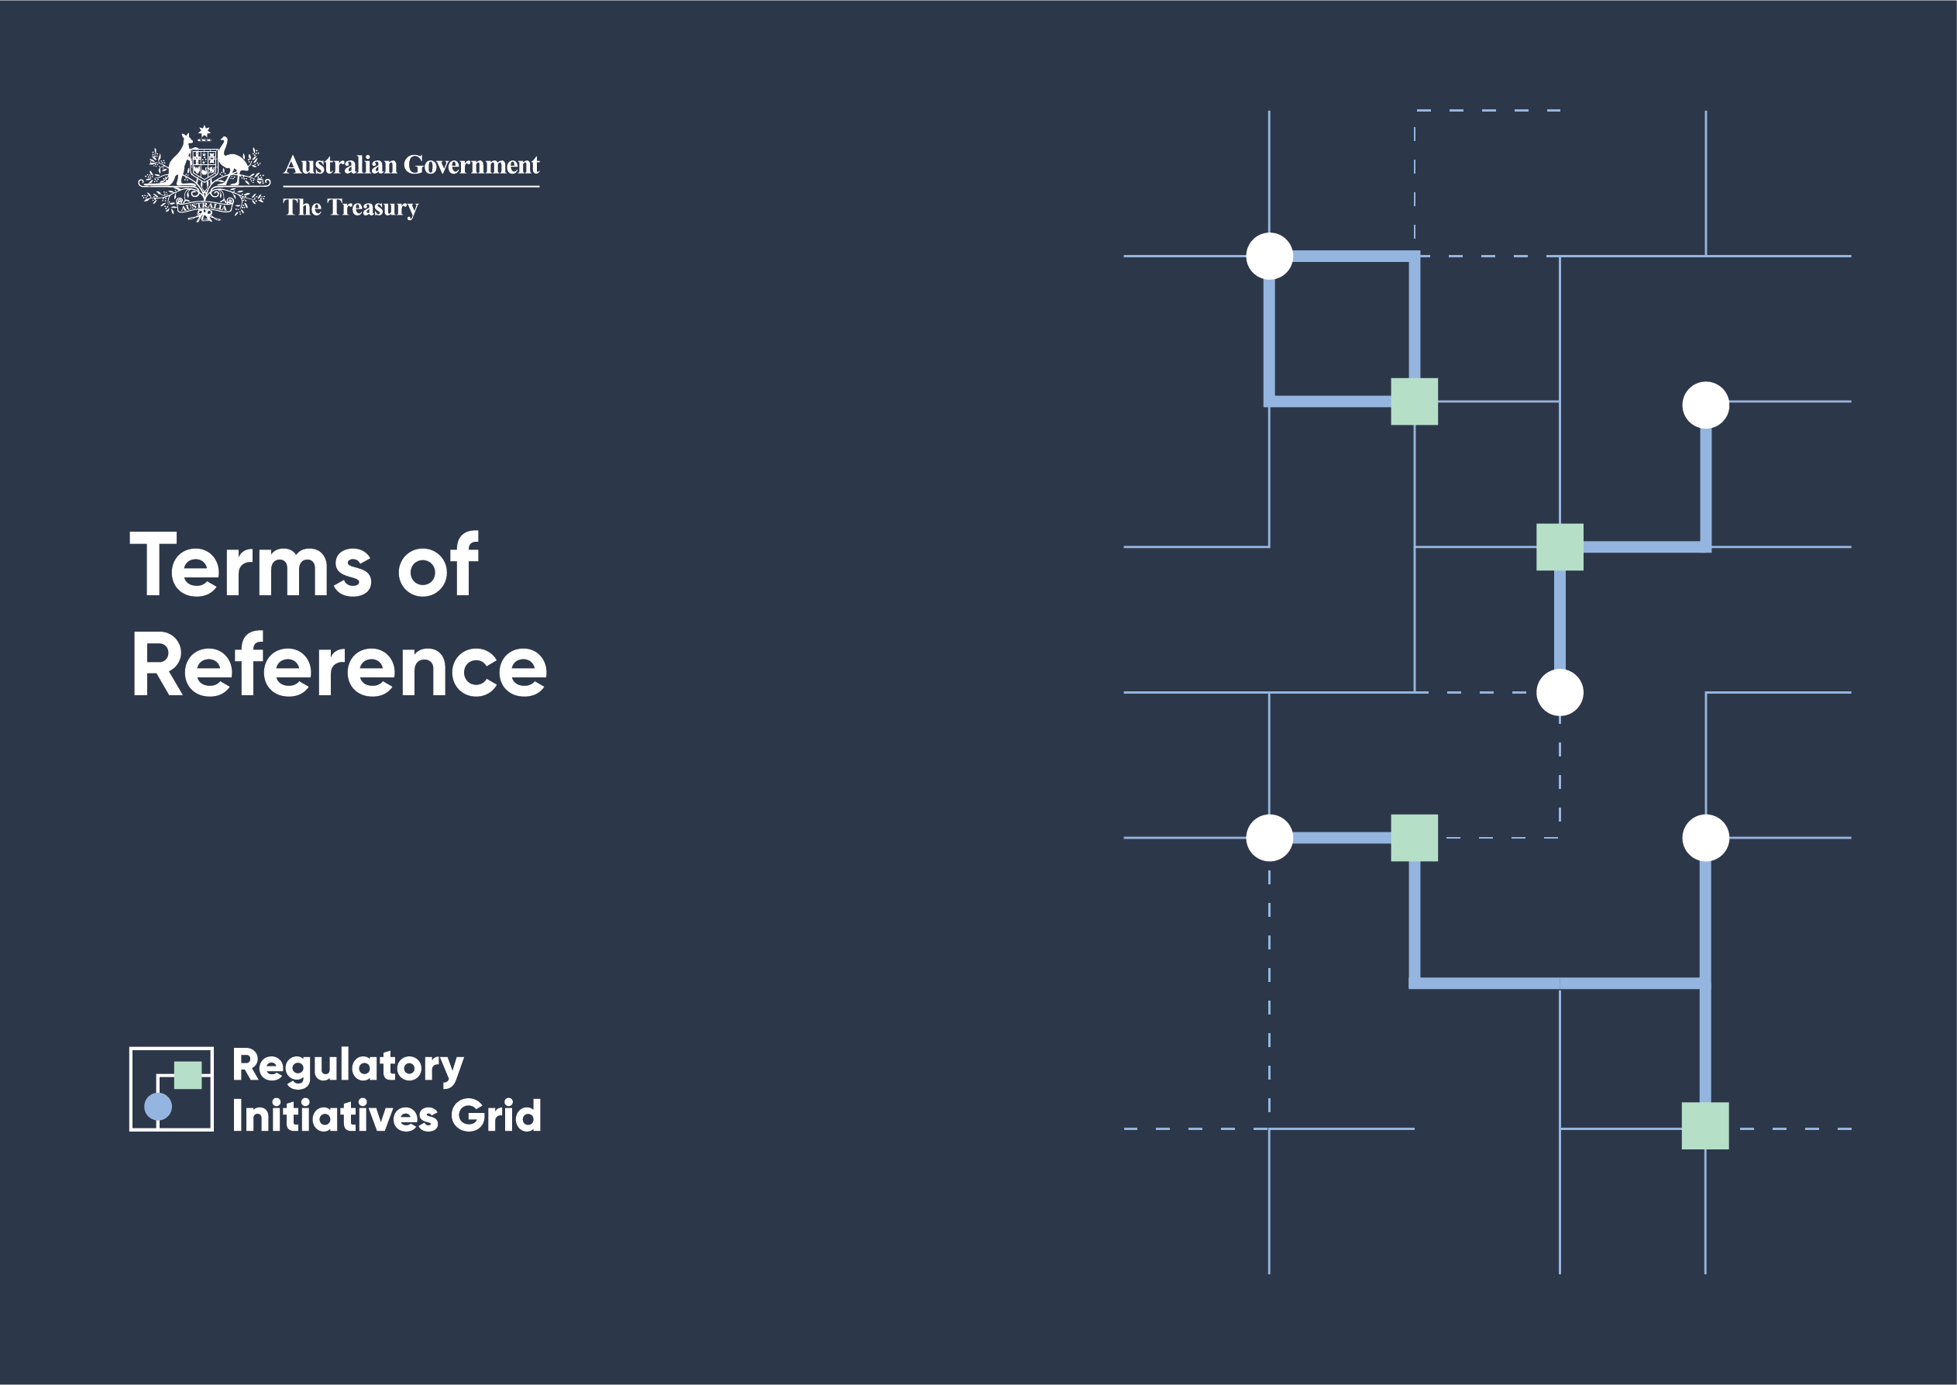

# RIG Terms of Reference

## Introduction

The Australian Government announced the introduction of a financial sector Regulatory Initiatives Grid (RIG) in March 2024.

These Terms of Reference were developed by the Treasury, in consultation with contributing agencies, to support the establishment and ongoing operation of the RIG. The Terms of Reference will be periodically updated to reflect ongoing stakeholder feedback.

## Role and purpose

The RIG forms part of the Government’s priority to support productivity and competition, which contribute to the economic dynamism and resilience of Australia’s financial sector.

The RIG will provide the financial sector with greater transparency of the regulatory landscape by listing reform priorities and initiatives that will materially affect the financial sector over the next 2 years. Publishing these measures in a single source and in a consistent format provides many benefits. It better informs stakeholders about the strategic direction of regulatory reform. It supports more effective engagement between the financial sector, government and regulators. It makes it easier to identify common challenges and risks, and collaborate on priorities. It also supports change management in the financial sector, including by helping businesses to plan and reduce costs of engaging with proposed reforms and regulatory efforts.

The RIG will support gradual improvements to coordination over the long term.

## Governance

The Treasury established the RIG and releases its publications. The following agencies contribute to the RIG:

* The Treasury
* Attorney‑General’s Department (AGD) (limited to matters relating to the regulatory frameworks administered by AUSTRAC and AFSA – that is, money laundering, terrorism financing, and other financial crimes frameworks, the personal insolvency and bankruptcy regimes, and the Personal Property Securities Register)
* Australian Competition and Consumer Commission (ACCC) (limited to matters relating to the financial sector)
* Australian Financial Security Authority (AFSA)
* Australian Prudential Regulation Authority (APRA)
* Australian Securities and Investments Commission (ASIC)
* Australian Taxation Office (ATO) (limited to matters relating to the superannuation guarantee and self‑managed superannuation funds)
* Australian Transaction Reports and Analysis Centre (AUSTRAC)
* Reserve Bank of Australia (RBA)

The RIG operates alongside existing mechanisms, particularly the Council of Financial Regulators (CFR), to support ongoing coordination of regulatory effort. The RIG does not duplicate, circumvent or reconsider the coordination considerations and decisions made by these existing mechanisms.

## Scope

The scope of the RIG is limited to publicly communicated initiatives and activities that will materially affect the financial sector in the 2 years from the RIG’s publication date.

The RIG has a strategic focus and only includes initiatives that will materially affect the financial sector. The RIG is not intended to be exhaustive. It does not include day‑to‑day work undertaken by regulators. The RIG does not include:

* regulatory investigations relating to significant compliance or enforcement activities
* non‑regulatory initiatives and activities (such as undertaking research, strengthening financial literacy, and engaging with the financial sector to explore opportunities to enhance existing systems)
* multi‑agency simulation activities to test preparedness and crisis response
* standard or long‑standing processes or activities that are well understood by industry stakeholders
* initiatives led by international bodies or international organisations, unless a contributing agency is responsible for implementing measures that satisfy the inclusion criterion.

## Future updates

The RIG will be refined in response to stakeholder feedback to ensure it remains fit for purpose.

Treasury plans to publish the first RIG update in September 2025. After this, the RIG will be published twice a year (March and September).